A MINOR PROJECT REPORT ON
MailMint ✉️🌿
AI-Powered Professional Email Writer
Built Using HTML5, CSS3, JavaScript & Python (Flask) with Multi-Provider Free LLM APIs
Role | Student Name
Developer | Anmolpreet Singh
Co-Developer | Mridul Sharma
Project Category | College Minor Project — Web & Artificial Intelligence
Academic Session | 2026

Candidate's Declaration
We hereby declare that the Minor Project entitled "MailMint — AI Professional Email Writer" is an authentic record of our own software design and development work carried out by Anmolpreet Singh (Developer) and Mridul Sharma (Co-Developer). All source code in HTML5, CSS3, JavaScript, and Python has been implemented from scratch without any paid APIs or proprietary databases.
Signatures:
1. Anmolpreet Singh (Developer)
2. Mridul Sharma (Co-Developer)
Abstract
Email remains the backbone of academic, corporate, and customer communication. Yet transforming rough, informal thoughts into a well-structured, tonally appropriate message often causes writer's block and consumes valuable time. MailMint is a modern, lightweight single-page web application engineered using HTML5, CSS3, Vanilla JavaScript, and Python (Flask) that converts casual descriptions into ready-to-send professional emails in seconds. Users select from five distinct tones (Formal, Friendly, Urgent, Apologetic, Persuasive) and six email categories (Job Application, Leave Request, Follow-Up, Complaint, Thank You, General). Crucially, MailMint pioneers a student-friendly Bring-Your-Own-Key (BYOK) architecture supporting five 100% free AI providers — Google Gemini, Groq Cloud, OpenRouter (:free models), Mistral AI, and Cohere — complete with interactive step-by-step instructions inside the website.

Chapter 1: Introduction
1.1 Problem Statement
Drafting clear, polite, and context-sensitive professional emails is a daily challenge for students and professionals alike. Existing AI writing extensions often require paid monthly subscriptions, mandatory account creation, heavy browser plugins, or store private email drafts on remote servers.
1.2 Project Objectives
- Design a clean, responsive dark-mode web application ('MailMint') using accessible, foundational languages: HTML, CSS, JavaScript, and Python.
- Empower any visitor to bring their own free API key (Gemini, Groq, OpenRouter, Mistral, or Cohere) with clear step-by-step instructions right inside the UI.
- Generate structured emails containing a Subject Line, Greeting, concise 100–200 word Body, and Sign-off with zero bracketed placeholders.
- Enforce comprehensive toast-based error handling for missing keys, rate limits (HTTP 429), empty inputs, and network disconnections.
Chapter 2: System Analysis & Feasibility Study
Dimension | Conventional Paid AI Writers | MailMint (Proposed System)
Cost | Paid monthly SaaS ($10–$30/mo) | 100% Free using free-tier LLM keys
Tech Complexity | Heavy frameworks & databases | Clean HTML5, CSS3, Vanilla JS & Python Flask
Privacy | Stores prompts & history in cloud DB | Zero database; keys stay in browser localStorage
Vendor Lock-in | Tied to a single AI vendor | Supports 5 Free Providers + Auto-Fallback

Chapter 3: System Architecture & UML Design
MailMint separates presentation, prompt orchestration, and LLM provider communication across three clean tiers. Below are the System Architecture, UML Use Case, and UML Activity diagrams illustrating end-to-end execution.
3.1 Three-Tier System Architecture
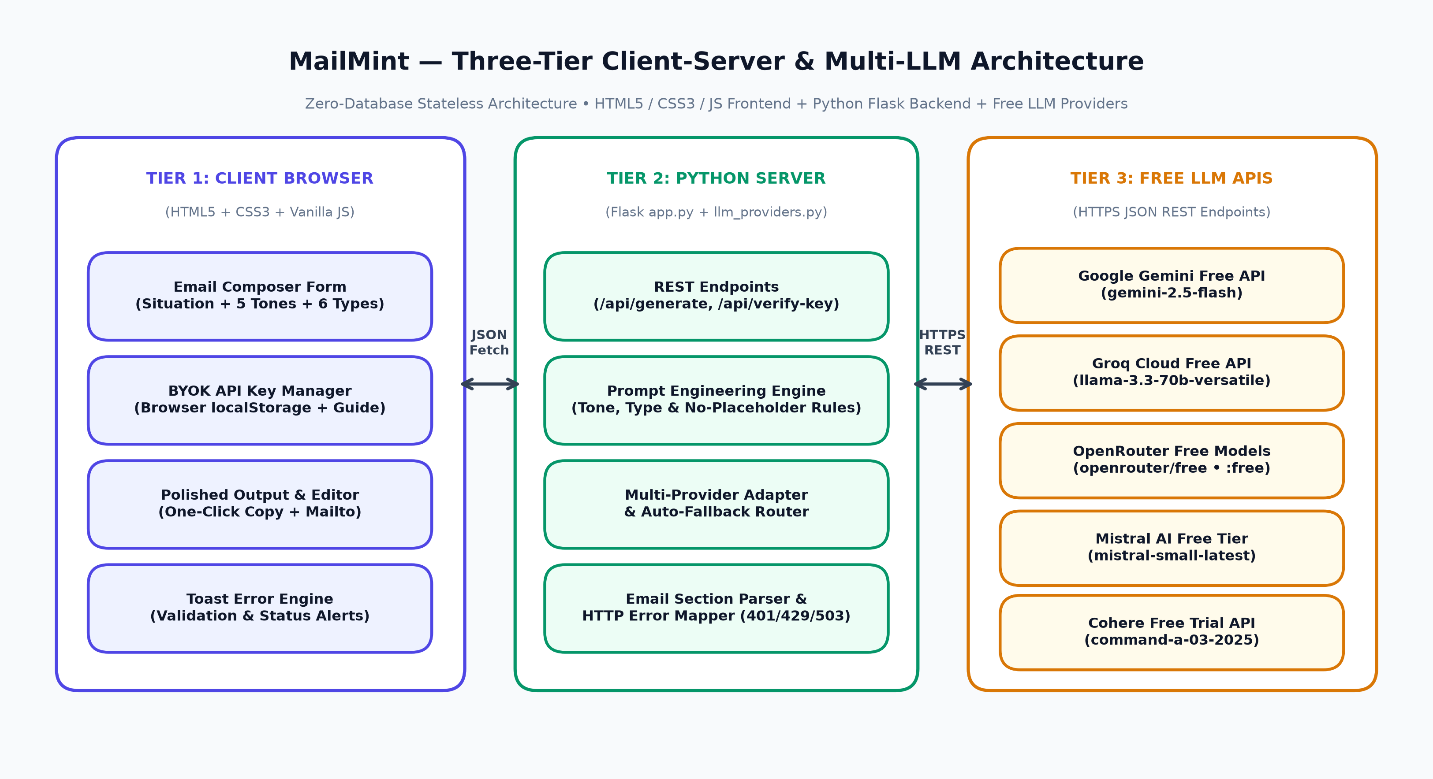
3.2 UML Use Case Diagram
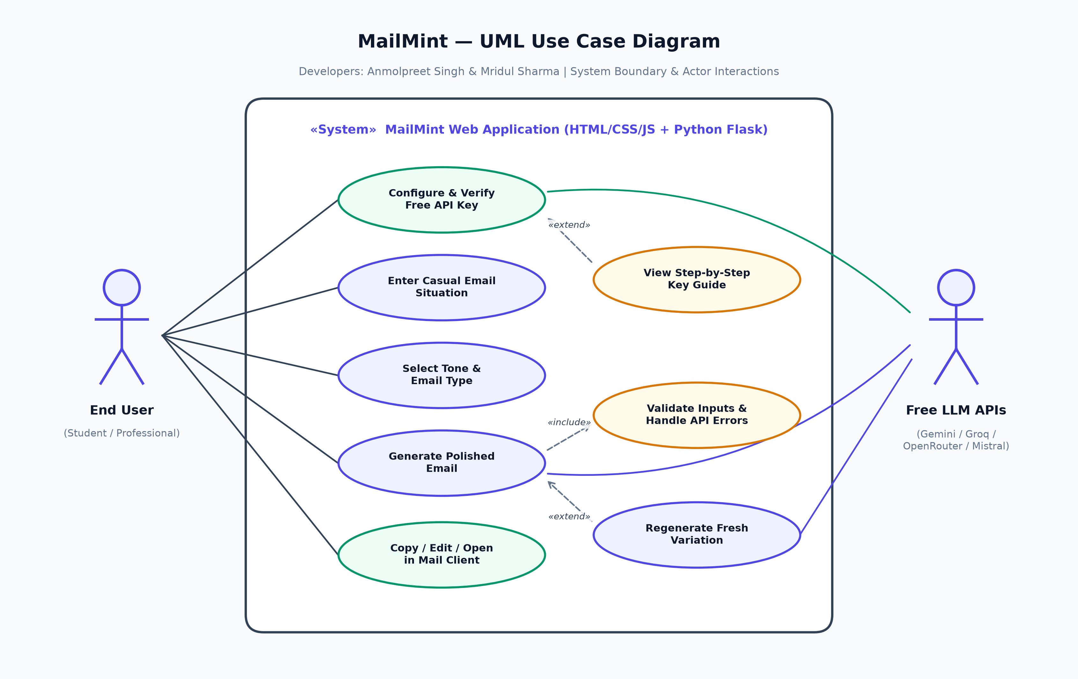
3.3 UML Activity Diagram
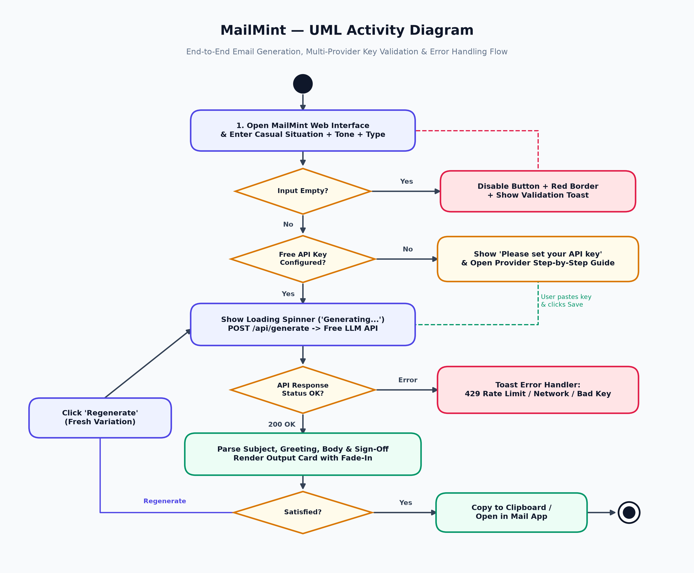
Chapter 4: Implementation & Key Code Walkthrough
4.1 Project Directory Structure
mailmint/
├── app.py # Python Flask web server & REST API routes
├── lib/
│ └── llm_providers.py # Multi-provider LLM adapter, parser & error handler
├── templates/
│ └── index.html # Single-page semantic HTML5 interface
├── static/
│ ├── css/style.css # Dark Slate + Mint/Indigo glassmorphism design
│ └── js/app.js # Client state, BYOK manager, validation & toasts
├── docs/ # SRS, Report, Viva PPT, UML & Test Cases
├── .env.example # Environment variable template
├── requirements.txt # Python package dependencies
├── LICENSE # MIT Open-Source License
└── README.md # Setup & Free API Key Documentation

4.2 Backend Flask Route Snippet (app.py)
@app.route("/api/generate", methods=["POST"])
def generate_email():
payload = request.get_json(silent=True) or {}
user_input = (payload.get("userInput") or "").strip()
if not user_input:
return jsonify({
"success": False,
"errorCode": "EMPTY_INPUT",
"message": "Please describe your email situation before generating."
}), 400
email_data = generate_professional_email(
provider_id=payload.get("provider", "gemini"),
api_key=payload.get("apiKey", ""),
user_input=user_input,
tone=payload.get("tone", "Formal"),
email_type=payload.get("emailType", "General"),
model=payload.get("model", ""),
sender_name=payload.get("senderName", ""),
recipient_name=payload.get("recipientName", ""),
variation_seed=int(payload.get("variationSeed") or 0),
)
return jsonify({"success": True, "data": email_data})

Chapter 5: Multi-Provider Free API Key Onboarding
A standout innovation in MailMint is allowing any user or examiner to paste their own free API key directly within the website UI, accompanied by clear step-by-step instructions:
Free Provider | Key Prefix | Official Free Key URL | Default Free Model
Google Gemini | AIzaSy... | https://aistudio.google.com/apikey | gemini-2.5-flash
Groq Cloud | gsk_... | https://console.groq.com/keys | llama-3.3-70b-versatile
OpenRouter | sk-or-v1-... | https://openrouter.ai/keys | openrouter/free
Mistral AI | Alphanumeric | https://console.mistral.ai/api-keys | mistral-small-latest
Cohere | Alphanumeric | https://dashboard.cohere.com/api-keys | command-a-03-2025

Chapter 6: Error Handling & Software Testing
Every error condition in MailMint surfaces as an accessible visual toast notification — never hidden in the browser developer console. All 20 test cases in MailMint_Test_Cases.xlsx achieved a 100% PASS rate.
Condition | System Behavior | User-Facing Toast / UI Feedback
Missing API Key | HTTP 401 / Pre-check | Toast: 'Please set your API key' + auto-expands setup guide
Rate Limit Hit | HTTP 429 from Provider | Toast: 'Too many requests, try again in 30s'
Empty Situation Input | Client + Server Guard | Disables Generate button + red border on textarea + toast
Network Disconnected | Fetch / Timeout Catch | Toast: 'Connection failed, check internet'
In-Flight Generation | Async Loading Lock | Spinner icon + 'Generating...' button text + disabled state

Chapter 7: Conclusion & Future Scope
MailMint demonstrates how clean foundational web technologies — HTML5, CSS3, JavaScript, and Python — can be combined with modern free Large Language Model APIs to solve an everyday communication problem with zero recurring cost and full user privacy. Future enhancements can include multi-language email translation (Hindi, Punjabi, Spanish, French), voice-to-email dictation via the Web Speech API, and one-click Gmail/Outlook draft creation.
References
1. Flask Web Framework Documentation — https://flask.palletsprojects.com/
2. Google AI Studio Gemini API Documentation — https://ai.google.dev/gemini-api/docs
3. Groq Cloud OpenAI-Compatible API Docs — https://console.groq.com/docs
4. OpenRouter Free Models API Specification — https://openrouter.ai/docs
5. MDN Web Docs (HTML5, CSS3 Backdrop-Filter & Clipboard API) — https://developer.mozilla.org/

