SOFTWARE REQUIREMENTS SPECIFICATION (SRS)
MailMint ✉️🌿 — AI Professional Email Writer
College Minor Project Specification (IEEE Std 830 Structure)
Version 1.0 • November 2026
Field | Details
Project Name | MailMint — AI Professional Email Writer
Developer | Anmolpreet Singh (Developer)
Co-Developer | Mridul Sharma (Co-Developer)
Technology Stack | HTML5, CSS3, Vanilla JavaScript (ES6+), Python 3 (Flask)
AI Integration | Bring-Your-Own Free API Keys (Google Gemini, Groq, OpenRouter, Mistral, Cohere)
Database / Auth | Stateless (Zero Database, Zero Paid Services, Browser localStorage Key Vault)

1. Introduction
1.1 Purpose
This Software Requirements Specification (SRS) defines the complete functional, architectural, interface, and non-functional requirements for MailMint — a lightweight, zero-cost AI-powered web application that converts informal or casual user notes into polished, structured professional emails.
1.2 Project Scope
Students, job seekers, and working professionals frequently struggle to strike the right tone when writing formal communications such as leave requests, job applications, complaints, or follow-ups. MailMint solves this through a single-page dark-mode interface powered by simple, maintainable web technologies (HTML, CSS, JavaScript, and Python Flask) integrated with five 100% free Large Language Model (LLM) API providers.
1.3 Definitions, Acronyms, and Abbreviations
Acronym | Expansion & Meaning
LLM | Large Language Model used to synthesize context-aware professional prose.
BYOK | Bring Your Own Key — architecture allowing users to use their own free API keys in-browser.
REST API | Representational State Transfer JSON endpoints connecting the JS UI and Python server.
UI / UX | User Interface and User Experience following mobile-first dark glassmorphism design.

2. Overall Description
2.1 Product Perspective & Stateless Architecture
MailMint follows a clean three-tier stateless client-server model. The frontend is built with semantic HTML5, custom CSS3 variables, and Vanilla JavaScript without heavy frontend build toolchains. The Python Flask backend exposes lightweight JSON endpoints (/api/providers, /api/verify-key, /api/generate) that normalize requests across Google Gemini, Groq Cloud, OpenRouter (:free models), Mistral AI, and Cohere.
2.2 User Classes & Characteristics
- College Students & Fresh Graduates: Writing internship applications, leave letters to faculty, and thank-you notes.
- Corporate Employees & Freelancers: Drafting urgent escalations, polite follow-ups, and executive updates.
- Evaluators & Examiners: Testing multi-provider free AI keys directly inside the web UI using the built-in step-by-step guide.
2.3 Design & Implementation Constraints
- Simple Languages Mandate: Built strictly with HTML5, CSS3, JavaScript, and Python.
- Zero Cost Mandate: Uses only 100% free-tier LLM APIs and open-source Python packages.
- Zero Database & Privacy First: User API keys are saved exclusively in browser localStorage and never persisted on any backend database.
3. Functional Requirements
Req ID | Feature | Functional Specification
FR-01 | Casual Situation Input | Provide a multi-line textarea (up to 3,000 chars) with live character count, clear action, and 5 one-click sample scenarios.
FR-02 | Tone Selection | Allow selecting 1 of 5 tones: Formal, Friendly, Urgent, Apologetic, or Persuasive.
FR-03 | Email Type Selection | Allow selecting 1 of 6 email types: Job Application, Leave Request, Follow-Up, Complaint, Thank You, or General.
FR-04 | BYOK Multi-Provider Setup | Allow users to enter, save locally, verify, or clear free API keys for Gemini, Groq, OpenRouter, Mistral, and Cohere.
FR-05 | In-App Free API Key Guide | Display dynamic 4-step instructions and direct portal links explaining how to get free API keys for each provider.
FR-06 | Auto-Detect Key Prefix | Automatically switch active provider tab when user pastes keys starting with 'AIza' (Gemini), 'gsk_' (Groq), or 'sk-or-' (OpenRouter).
FR-07 | Structured Email Synthesis | Generate placeholder-free output containing Subject Line, Greeting, 100-200 word Body, and Sign-off.
FR-08 | One-Click Clipboard Copy | Provide one-click 'Copy to Clipboard' for full email and 'Copy Subject' with instant visual & toast confirmation.
FR-09 | Regeneration & Draft History | Allow regenerating fresh variations and switching across up to 5 session drafts client-side.
FR-10 | Mandatory 6-Case Error Handling | Display accessible toast notifications for missing API key, 429 rate limit, empty input (with red border), network failure, invalid key, and loading state.

3.1 UML Use Case Model
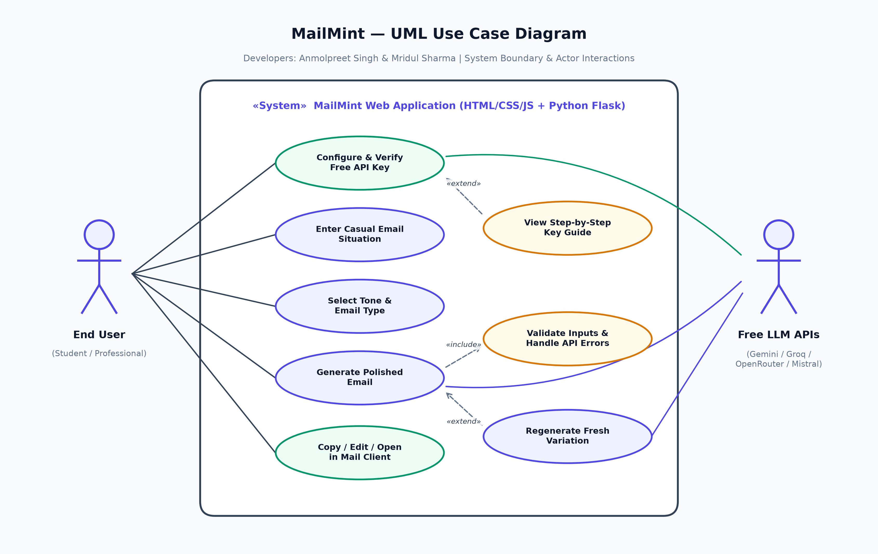
4. External Interface Requirements
4.1 User Interface Requirements
Default Slate-900 (#0f172a) dark theme with Indigo-500 (#6366f1) primary buttons, Emerald/Mint-400 (#34d399) brand accents, Inter typography, rounded-xl glassmorphism cards, centered single-column layout (max-width 720px), and full responsiveness from 320px mobile screens to widescreen desktops.
4.2 Backend & External LLM API Interfaces
Provider | REST Endpoint | Default Free Model
Google Gemini | https://generativelanguage.googleapis.com/v1beta/models/{model}:generateContent | gemini-2.5-flash
Groq Cloud | https://api.groq.com/openai/v1/chat/completions | llama-3.3-70b-versatile
OpenRouter | https://openrouter.ai/api/v1/chat/completions | openrouter/free (:free models)
Mistral AI | https://api.mistral.ai/v1/chat/completions | mistral-small-latest
Cohere | https://api.cohere.com/v2/chat | command-a-03-2025

5. Non-Functional Requirements
- Performance: Initial HTML/CSS/JS load completes under 250ms locally; LLM generation typically completes in 0.8s–4.5s depending on selected provider.
- Security & Privacy: Zero server-side storage of user API keys or personal email drafts; HTTPS TLS used for all upstream LLM API requests.
- Usability: Step-by-step free key onboarding enables first-time users to configure a free API key in under 60 seconds.
- Reliability: OpenRouter integration includes automatic fallback from retired model slugs to 'openrouter/free' so user requests stay resilient.

