**Day 4 of the Bioinformatics Internship at Bversity**

**Objective**

The primary focus for Day 4 was to analyze the 3D conformer of a biomolecule. The session emphasized calculating the Root Mean Square Deviation (RMSD), scoring the conformer based on energy or similarity metrics, and generating a heatmap to visualize molecular properties and interactions.

**Workflow and Steps**

**1. Overview of 3D Conformers**

* Participants were introduced to the concept of 3D conformers, which are three-dimensional spatial representations of molecules.
* The significance of 3D conformers in molecular docking, drug design, and structural biology was highlighted.
* Discussion on differences between 2D and 3D conformers and their respective roles in computational analysis.

**2. Dataset Preparation**

* Molecule data was obtained in SDF format, which included:
  + Atom connectivity
  + 3D coordinates
  + Molecular properties (e.g., energy levels, charges)
* A check was performed to ensure data quality, with proper validation for errors or inconsistencies.

**3. Tools and Environment Setup**

* Tool such as **RDKit** were introduced.
* Computational environment was set up with all necessary dependencies.

**4. 3D Conformer Generation**

* The generation of the 3D conformer involved:
  + Loading the molecule into RDKit
  + Embedding the molecule in 3D space using algorithms
  + Optimization of molecular geometry to minimize energy using force field methods

**5. RMSD Calculation**

* **RMSD (Root Mean Square Deviation)** measures the structural similarity between two conformers or the deviation of the generated conformer from a reference structure.
* Steps:
  + Defined the reference structure
  + Used RDKit functions to calculate RMSD values.
  + Analyzed RMSD values to assess the quality of the generated conformer:
    - Lower RMSD values indicated high similarity or better alignment.

**6. Scoring the Conformer**

* Scores were calculated based on energy minimization or similarity metrics.
* Energy scoring:
  + The potential energy of the conformer was evaluated after optimization.
  + Scores reflected the stability of the structure (lower energy = more stable).
* Similarity scoring:
  + Compared the conformer with a known active structure.
  + Higher similarity scores indicated closer alignment to the target.

**7. Heatmap Visualization**

* A heatmap was created to visualize molecular interactions, distances, or property distributions:
  + Pairwise atomic interactions or distances were calculated and stored in a matrix.
  + JFreeChart library was used to generate the heatmap with color gradients indicating interaction strength or proximity.
* Interpretation:
  + Darker regions in the heatmap represented stronger interactions or closer proximity.
  + Insights were drawn on molecular binding sites or interaction hotspots.

**8. Analysis and Interpretation**

* Participants analyzed the following outputs:
  + **RMSD**: Evaluated structural fidelity of the 3D conformer.
  + **Score**: Assessed the stability and suitability of the conformer for docking studies.
  + **Heatmap**: Identified significant molecular interactions and potential areas of interest.
* Challenges faced and troubleshooting:
  + High RMSD values indicated the need for better force field parameters or alignment methods.
  + Adjustments in visualization parameters improved heatmap clarity.

**9. Practical Applications**

* Real-world relevance of 3D conformer analysis was discussed:
  + In drug design, identifying low-energy, stable conformers aids in understanding molecular interactions with target proteins.
  + RMSD and scoring are critical in evaluating docking results and predicting ligand-receptor binding.

**10. Documentation and Reporting**

* Participants compiled their findings:
  + Included RMSD values, energy scores, and annotated heatmaps.
  + Summarized interpretations of the conformer quality and molecular properties.

**Key Learnings**

* Proficiency in generating and optimizing 3D conformers using computational tools.
* Understanding and calculating RMSD and energy-based scoring metrics.
* Visualizing and interpreting heatmaps for molecular interactions.

**Conclusion**

Day 4 provided an in-depth exploration of 3D conformer analysis, equipping participants with skills to evaluate molecular structures computationally. The combination of RMSD calculations, scoring, and heatmap visualizations reinforced the importance of 3D conformers in bioinformatics and drug discovery workflows.

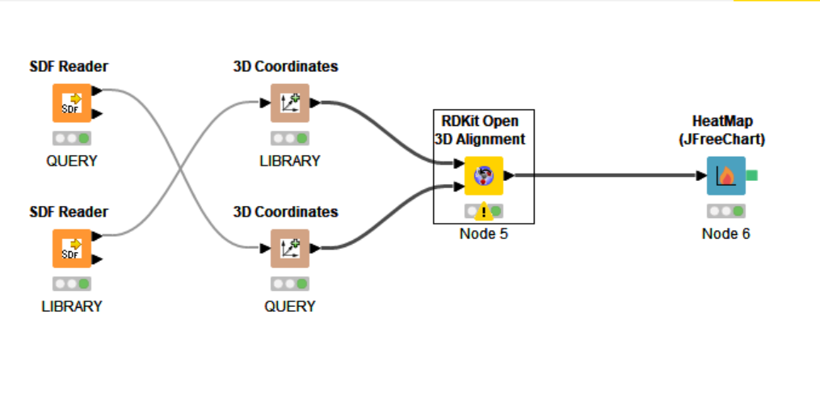 WORKFLOW OF 3D CONFORMER

HEATMAP OBTAINED:

