ABSTRACT
The Project FOOD DONATION SYSTEM is a web application developed to
prevent food insecurity, a lack of access to healthy and affordable food. The donor can be either individual, or from restaurants and function halls. The donation recipient can be either from orphanages, old homes, shelters, etc. The purpose of this application is to connect the users without any intermediary service. The focus of the project is to develop a web application that uses data analysis to visualize the impact of excess food, thus reducing food wastage. People donate food manually by visiting each organization number of times so as to scale back the issues of food wastage. It shows the potential for avoiding the wastage of food. The users need to register into the application and can offer or request for donation of food. The notification will be sent to the other so that they can either
accept or deny the service given. This can be tracked by the participants to ensure the food delivery. This way the web application helps the needy and averts food wastage and hunger.

2. SYSTEM CONFIGURATION

2.1 HARDWARE REQUIREMENT
• System : Pentium Dual Core
• Hard Disk : 120 GB
• Monitor : 15 LED
• Input Devices : Keyboard, Mouse
• Ram : 2GB

2.2 SOFTWARE REQUIREMENT
• Operating system : Windows 10
• Tools : Dreamweaver (Editor/IDE)

2.3 USER REQUIREMENTS
•HTML, CSS, JavaScript, Bootstrap, PHP and MySQL
2.3.1 FRONT END SOFTWARE
HTML: HTML is used to create and save web document. For example,
content could be structured within a set of paragraphs, a list of bulleted
points, or using images and data tables.
CSS: Cascading Style Sheets Create attractive Layout HTML (the Hypertext Markup
Language) and CSS (Cascading Style Sheets) are two of the core technologies for
building Web pages. HTML provides the structure of the page, CSS the (visual and
aural) layout, for a variety of devices.
JavaScript: JavaScript is a text-based programming language used both on theclientside
and server-side that allows you to make web pages interactive.
Food Donation System

2.3.2 BACK END SOFTWARE
MySQL: MySQL is a relational database management system based on SQL –
Structured Query Language. The application is used for a wide range of purposes,
including data warehousing, e-commerce, and logging applications.

PHP: Hypertext Pre-processor (PHP) is a technology that allows software developers
to create dynamically generated web pages, in HTML, XML, or other document types,
as per client request. PHP code is usually processed on a web server by a PHP
interpreter. Php offers simplicity, efficiency, security, flexibility and familiarity. Php
ins integrated with a number of popular databases inducing MySQL, Oracle etc. Php
syntax is C-like. Php support large number of protocols such as POP3, IMAP etc.
Modules
The system comprises of 5 major modules and their sub modules as follows:
1.Admin
2.Auditoriums
3.Public
4.Restaurants
5.Charity

MODULE DESCRIPTION

Admin:
Admin have the id to enter inside this stand-alone system and controls the
system, take the decision about event to proceed or reject the pending event and also has the power to look over the donation request. Also, the Admin can update few facilities to the system about the function and remove the facilities or add new facilities to the web application.
Auditoriums:
Auditoriums have unique id to enter inside the system. The members of this
module can donate foods to charity by using functionality of searching the
charity by name or location and donate the food according to the availability of
the food and need of the charity.
Public:
The public module can donate food or money to charity. This can be done by
using functionality of searching charity by name or location and then donating the food or money according to their preferences.
Restaurants:
The restaurant can donate food to charity. This can be done by using
functionality of searching charity by name or location and then donate according to the availability of food and need of food by charity.
Charity:
The charity receives the notifications regarding the donations made by users,
restaurants, or auditoriums. It can decide to either accept of reject it according to their need and also have the option to provide the feedback regarding the service.

APPENDIX

ER DIAGRAM
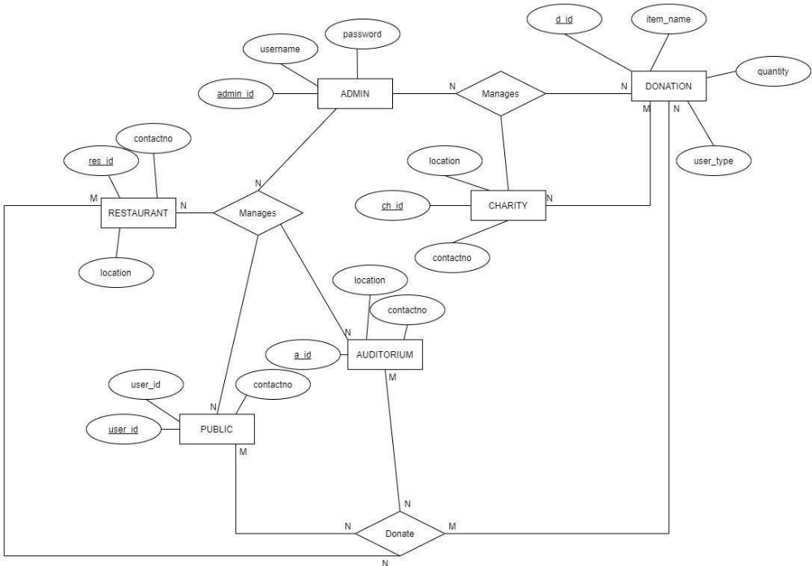
DATA FLOW DIAGRAM
Level 0
Level 1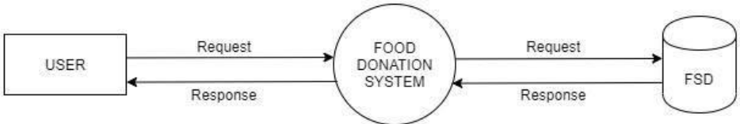
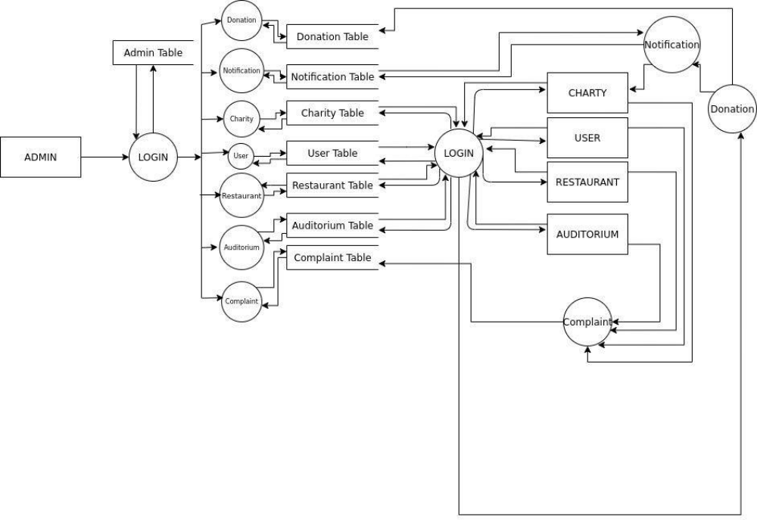

Level 2
Admin
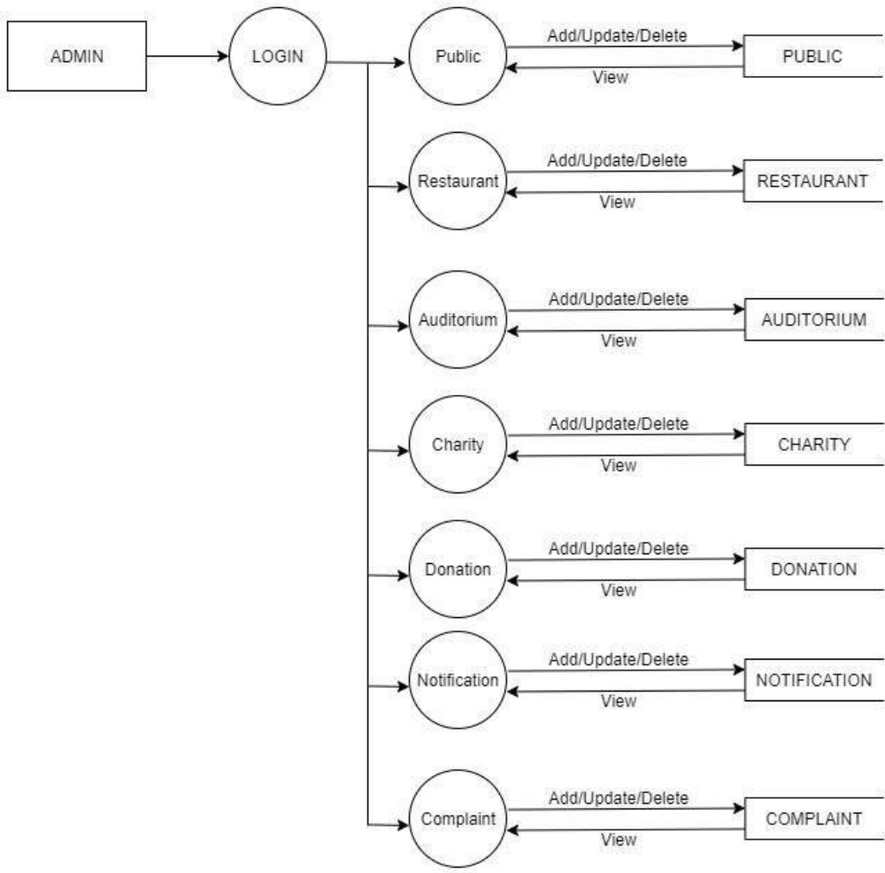

Level 2
Auditorium
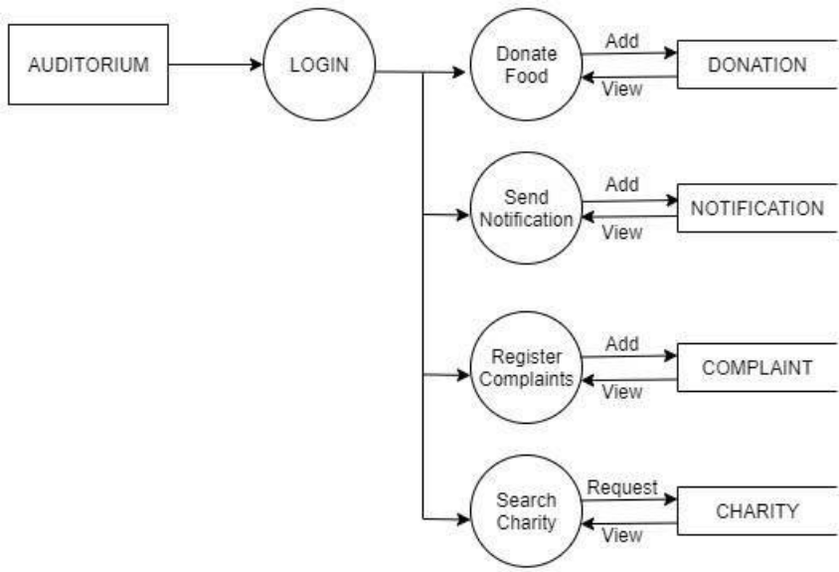
Level 2
Charity
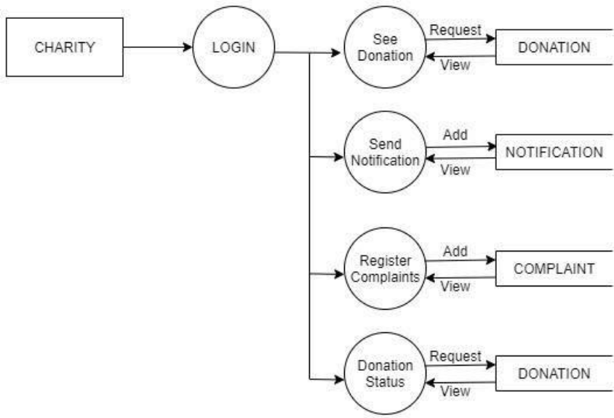

Level 2
Restaurant
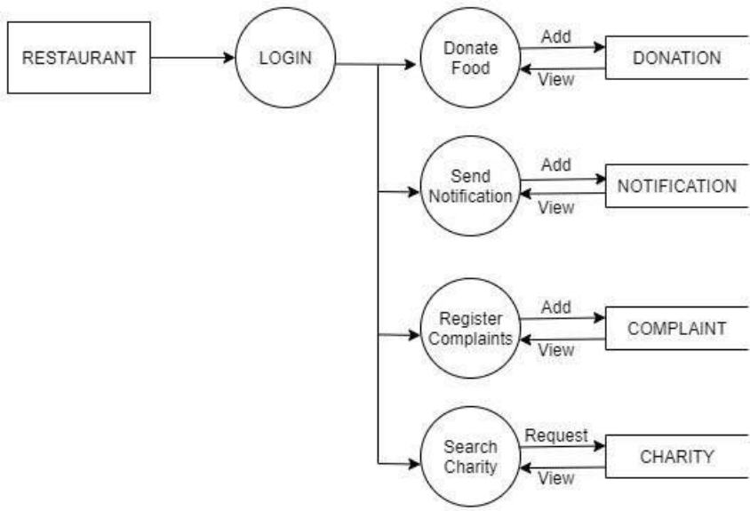
Level 2
Public
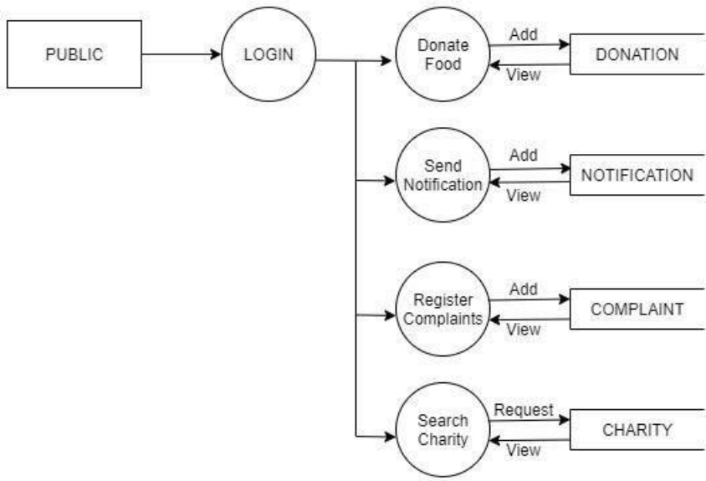

SAMPLE SCREENSHOTS
