16. What is the base class of Error and Exception? Differentiate between throw and throws. (1+4)
Ans. In Java, both Error and Exception are subclasses of the Throwable class, which is the base class for all errors and exceptions in Java. Here's the hierarchy:
Hierarchy:
- java.lang.Object
  - java.lang.Throwable
    - java.lang.Error
    - java.lang.Exception

There are many differences between throw and throws keywords. A list of differences between throw and throws are given below:
Sr. no. | Basis of Differences | throw | throws
1. | Definition | Java throw keyword is used throw an exception explicitly in the code, inside the function or the block of code. | Java throws keyword is used in the method signature to declare an exception which might be thrown by the function while the execution of the code.
2. | Usage | Type of exception Using throw keyword, we can only propagate unchecked exception i.e., the checked exception cannot be propagated using throw only. | Using throws keyword, we can declare both checked and unchecked exceptions. However, the throws keyword can be used to propagate checked exceptions only.
3. | Syntax | The throw keyword is followed by an instance of Exception to be thrown. | The throws keyword is followed by class names of Exceptions to be thrown.
4. | Declaration | throw is used within the method. | throws is used with the method signature.
5. | Internal implementation | We are allowed to throw only one exception at a time i.e. we cannot throw multiple exceptions. | We can declare multiple exceptions using throws keyword that can be thrown by the method. For example, main() throws IOException, SQLException.

18. What are the “thread state”.
Life cycle of a Thread (Thread States)
In Java, a thread always exists in any one of the following states. These states are:
- New
- Active
- Blocked / Waiting
- Timed Waiting
- Terminated
Explanation of Different Thread States
New: Whenever a new thread is created, it is always in the new state. For a thread in the new state, the code has not been run yet and thus has not begun its execution.
Active: When a thread invokes the start() method, it moves from the new state to the active state. The active state contains two states within it: one is runnable, and the other is running.
- Runnable: A thread, that is ready to run is then moved to the runnable state. In the runnable state, the thread may be running or may be ready to run at any given instant of time. It is the duty of the thread scheduler to provide the thread time to run, i.e., moving the thread the running state.
A program implementing multithreading acquires a fixed slice of time to each individual thread. Each and every thread runs for a short span of time and when that allocated time slice is over, the thread voluntarily gives up the CPU to the other thread, so that the other threads can also run for their slice of time. Whenever such a scenario occurs, all those threads that are willing to run, waiting for their turn to run, lie in the runnable state. In the runnable state, there is a queue where the threads lie.
- Running: When the thread gets the CPU, it moves from the runnable to the running state. Generally, the most common change in the state of a thread is from runnable to running and again back to runnable.
Blocked or Waiting: Whenever a thread is inactive for a span of time (not permanently) then, either the thread is in the blocked state or is in the waiting state.
For example, a thread (let's say its name is A) may want to print some data from the printer. However, at the same time, the other thread (let's say its name is B) is using the printer to print some data. Therefore, thread A has to wait for thread B to use the printer. Thus, thread A is in the blocked state. A thread in the blocked state is unable to perform any execution and thus never consume any cycle of the Central Processing Unit (CPU). Hence, we can say that thread A remains idle until the thread scheduler reactivates thread A, which is in the waiting or blocked state.
When the main thread invokes the join() method then, it is said that the main thread is in the waiting state. The main thread then waits for the child threads to complete their tasks. When the child threads complete their job, a notification is sent to the main thread, which again moves the thread from waiting to the active state.
If there are a lot of threads in the waiting or blocked state, then it is the duty of the thread scheduler to determine which thread to choose and which one to reject, and the chosen thread is then given the opportunity to run.
Timed Waiting: Sometimes, waiting for leads to starvation. For example, a thread (its name is A) has entered the critical section of a code and is not willing to leave that critical section. In such a scenario, another thread (its name is B) has to wait forever, which leads to starvation. To avoid such scenario, a timed waiting state is given to thread B. Thus, thread lies in the waiting state for a specific span of time, and not forever. A real example of timed waiting is when we invoke the sleep() method on a specific thread. The sleep() method puts the thread in the timed wait state. After the time runs out, the thread wakes up and start its execution from when it has left earlier.
Terminated: A thread reaches the termination state because of the following reasons:
- When a thread has finished its job, then it exists or terminates normally.
- Abnormal termination: It occurs when some unusual events such as an unhandled exception or segmentation fault.
A terminated thread means the thread is no more in the system. In other words, the thread is dead, and there is no way one can respawn (active after kill) the dead thread.
The following diagram shows the different states involved in the life cycle of a thread.
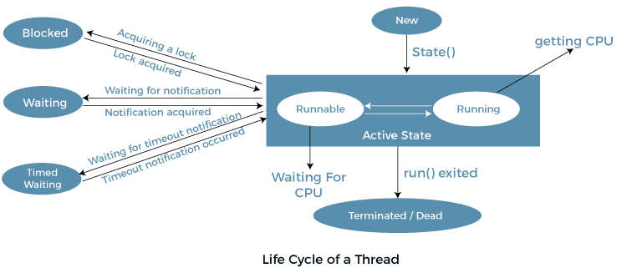
Implementation of Thread States
In Java, one can get the current state of a thread using the Thread.getState() method. The java.lang.Thread.State class of Java provides the constants ENUM to represent the state of a thread. These constants are:
19. What are the two methods to create threads? Compare them. Explain them with an example java program.
Ans. Java, there are two primary methods to create threads:
- Extending the Thread class:
  - In this method, a new class is created by extending the Thread class, and the run() method is overridden to define the code that constitutes the new thread.
- Implementing the Runnable interface:
  - In this method, a class implements the Runnable interface and provides an implementation for the run() method. Then, an instance of Thread is created by passing the Runnable instance to its constructor.
Comparison with example :
1) Java Thread Example by extending Thread class
- In this method, a class extends the Thread class and overrides the run() method. The run() method contains the thread's business logic.
- Steps:
  - Extend the Thread class and override the run() method.
  - Create an instance of the class and call the start() method to start the thread.
FileName: Multi.java
class Multi extends Thread{
public void run(){
System.out.println("thread is running...");
}
public static void main(String args[]){
Multi t1=new Multi();
t1.start();
}
}

Output:
thread is running...
2) Java Thread Example by implementing Runnable interface
- In this method, a class implements the Runnable interface, which requires overriding the run() method. The run() method contains the code that will be executed by the thread.
- Steps:
  - Implement the Runnable interface and override the run() method.
  - Create an instance of the Thread class, passing the Runnable object as an argument.
  - Call the start() method on the Thread object to execute the thread.
FileName: Multi3.java
class Multi3 implements Runnable{
public void run(){
System.out.println("thread is running...");
}
public static void main(String args[]){
Multi3 m1=new Multi3();
Thread t1 =new Thread(m1); // Using the constructor Thread(Runnable r)
t1.start();
}
}

Output:
thread is running...
20. What is a local and remote applet? What is a no-args constructor?
Ans. Types of Applets in Java
A special type of Java program that runs in a Web browser is referred to as Applet. It has less response time because it works on the client-side. It is much secured executed by the browser under any of the platforms such as Windows, Linux and Mac OS etc. There are two types of applets that a web page can contain.
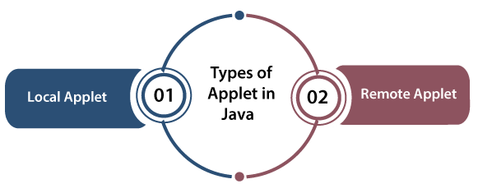
- Local Applet
- Remote Applet

Let's understand both types of Applet one by one:
Local Applet
Local Applet is written on our own, and then we will embed it into web pages. Local Applet is developed locally and stored in the local system. A web page doesn't need the get the information from the internet when it finds the local Applet in the system. It is specified or defined by the file name or pathname. There are two attributes used in defining an applet, i.e., the codebase that specifies the path name and code that defined the name of the file that contains Applet's code.
Specifying Local applet
- <applet
- codebase = "tictactoe"
- code = "FaceApplet.class"
- width = 120
- height = 120>
- </applet>
Remote Applet
A remote applet is designed and developed by another developer. It is located or available on a remote computer that is connected to the internet. In order to run the applet stored in the remote computer, our system is connected to the internet then we can download run it. In order to locate and load a remote applet, we must know the applet's address on the web that is referred to as Uniform Recourse Locator(URL).
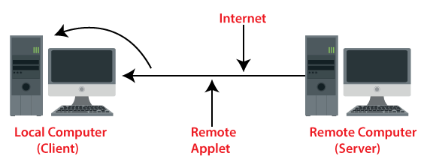
Specifying Remote applet
- <applet
- codebase = "http://www.myconnect.com/applets/"
- code = "FaceApplet.class"
- width = 120
- height =120>
- </applet>

A no-args constructor (or no-argument constructor) is a constructor in a class that does not take any parameters. It is either provided explicitly by the programmer or automatically by the compiler if no other constructors are defined.
A no-args constructor (or no-argument constructor) is a constructor in a class that does not take any parameters. It can be:
- Default Constructor: Automatically provided by the Java compiler if no constructors are defined in the class.
- Explicit No-args Constructor: Defined by the programmer if there are other constructors (with parameters) in the class.
Example:
class MyClass {
// No-args constructor
MyClass() {
System.out.println("No-args constructor called!");
}
// Parameterized constructor
MyClass(int x) {
System.out.println("Parameterized constructor called with value: " + x);
}
}
public class ConstructorExample {
public static void main(String[] args) {
MyClass obj1 = new MyClass(); // Calls no-args constructor
MyClass obj2 = new MyClass(10); // Calls parameterized constructor
}
}

Output:
No-args constructor called!
Parameterized constructor called with value: 10

In this example, the no-args constructor initializes the object with default behavior when called.

21. What is delegation model in Java Applet.
Ans. Delegation Event Model in Java
The Delegation Event model is defined to handle events in GUI programming languages. The GUI stands for Graphical User Interface, where a user graphically/visually interacts with the system.
The GUI programming is inherently event-driven; whenever a user initiates an activity such as a mouse activity, clicks, scrolling, etc., each is known as an event that is mapped to a code to respond to functionality to the user. This is known as event handling.
In this section, we will discuss event processing and how to implement the delegation event model in Java. We will also discuss the different components of an Event Model.

Event Processing in Java
Java support event processing since Java 1.0. It provides support for AWT ( Abstract Window Toolkit), which is an API used to develop the Desktop application. In Java 1.0, the AWT was based on inheritance. To catch and process GUI events for a program, it should hold subclass GUI components and override action() or handleEvent() methods. The below image demonstrates the event processing.
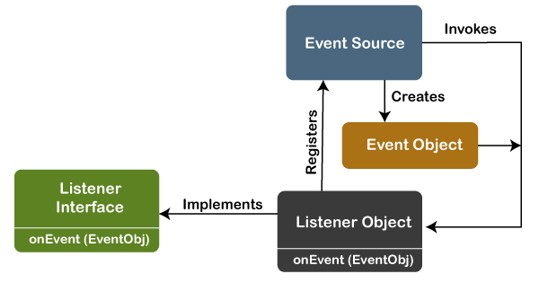
But, the modern approach for event processing is based on the Delegation Model. It defines a standard and compatible mechanism to generate and process events. In this model, a source generates an event and forwards it to one or more listeners. The listener waits until it receives an event. Once it receives the event, it is processed by the listener and returns it. The UI elements are able to delegate the processing of an event to a separate function.
The key advantage of the Delegation Event Model is that the application logic is completely separated from the interface logic.
In this model, the listener must be connected with a source to receive the event notifications. Thus, the events will only be received by the listeners who wish to receive them. So, this approach is more convenient than the inheritance-based event model (in Java 1.0).
In the older model, an event was propagated up the containment until a component was handled. This needed components to receive events that were not processed, and it took lots of time. The Delegation Event model overcame this issue.
Basically, an Event Model is based on the following three components:
- Events
- Events Sources
- Events Listeners

Events
The Events are the objects that define state change in a source. An event can be generated as a reaction of a user while interacting with GUI elements. Some of the event generation activities are moving the mouse pointer, clicking on a button, pressing the keyboard key, selecting an item from the list, and so on. We can also consider many other user operations as events.
The Events may also occur that may be not related to user interaction, such as a timer expires, counter exceeded, system failures, or a task is completed, etc. We can define events for any of the applied actions.

Event Sources
A source is an object that causes and generates an event. It generates an event when the internal state of the object is changed. The sources are allowed to generate several different types of events.
A source must register a listener to receive notifications for a specific event. Each event contains its registration method. Below is an example:
- public void addTypeListener (TypeListener e1)
From the above syntax, the Type is the name of the event, and e1 is a reference to the event listener. For example, for a keyboard event listener, the method will be called as addKeyListener(). For the mouse event listener, the method will be called as addMouseMotionListener(). When an event is triggered using the respected source, all the events will be notified to registered listeners and receive the event object. This process is known as event multicasting. In few cases, the event notification will only be sent to listeners that register to receive them.
Some listeners allow only one listener to register. Below is an example:
- public void addTypeListener(TypeListener e2) throws java.util.TooManyListenersException
From the above syntax, the Type is the name of the event, and e2 is the event listener's reference. When the specified event occurs, it will be notified to the registered listener. This process is known as unicasting events.
A source should contain a method that unregisters a specific type of event from the listener if not needed. Below is an example of the method that will remove the event from the listener.
- public void removeTypeListener(TypeListener e2?)
From the above syntax, the Type is an event name, and e2 is the reference of the listener. For example, to remove the keyboard listener, the removeKeyListener() method will be called.
The source provides the methods to add or remove listeners that generate the events. For example, the Component class contains the methods to operate on the different types of events, such as adding or removing them from the listener.

Event Listeners
An event listener is an object that is invoked when an event triggers. The listeners require two things; first, it must be registered with a source; however, it can be registered with several resources to receive notification about the events. Second, it must implement the methods to receive and process the received notifications.
The methods that deal with the events are defined in a set of interfaces. These interfaces can be found in the java.awt.event package.
For example, the MouseMotionListener interface provides two methods when the mouse is dragged and moved. Any object can receive and process these events if it implements the MouseMotionListener interface.

Types of Events
The events are categories into the following two categories:
The Foreground Events:
The foreground events are those events that require direct interaction of the user. These types of events are generated as a result of user interaction with the GUI component. For example, clicking on a button, mouse movement, pressing a keyboard key, selecting an option from the list, etc.
The Background Events :
The Background events are those events that result from the interaction of the end-user. For example, an Operating system interrupts system failure (Hardware or Software).
To handle these events, we need an event handling mechanism that provides control over the events and responses.

The Delegation Model
The Delegation Model is available in Java since Java 1.1. it provides a new delegation-based event model using AWT to resolve the event problems. It provides a convenient mechanism to support complex Java programs.

Design Goals
The design goals of the event delegation model are as following:
- It is easy to learn and implement
- It supports a clean separation between application and GUI code.
- It provides robust event handling program code which is less error-prone (strong compile-time checking)
- It is Flexible, can enable different types of application models for event flow and propagation.
- It enables run-time discovery of both the component-generated events as well as observable events.
- It provides support for the backward binary compatibility with the previous model.
Let's implement it with an example:

Java Program to Implement the Event Deligation Model
The below is a Java program to handle events implementing the event deligation model:
TestApp.java:
import java.awt.*;
import java.awt.event.*;

public class TestApp {
public void search() {
// For searching
System.out.println("Searching...");
}

public void sort() {
// for sorting
System.out.println("Sorting....");
}

static public void main(String args[]) {
TestApp app = new TestApp();
GUI gui = new GUI(app);
}
}

class Command implements ActionListener {
static final int SEARCH = 0;
static final int SORT = 1;
int id;
TestApp app;

public Command(int id, TestApp app) {
this.id = id;
this.app = app;
}

public void actionPerformed(ActionEvent e) {
switch(id) {
case SEARCH:
app.search();
break;
case SORT:
app.sort();
break;
}
}
}

class GUI {

public GUI(TestApp app) {
Frame f = new Frame();
f.setLayout(new FlowLayout());

Command searchCmd = new Command(Command.SEARCH, app);
Command sortCmd = new Command(Command.SORT, app);

Button b;
f.add(b = new Button("Search"));
b.addActionListener(searchCmd);
f.add(b = new Button("Sort"));
b.addActionListener(sortCmd);

List l;
f.add(l = new List());
l.add("Alphabetical");
l.add("Chronological");
l.addActionListener(sortCmd);
f.pack();

f.show();
}
}

Output:
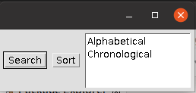
Searching...

22. Discuss Applet life-cycle indicating the functions.
Ans. Applet Life Cycle in Java
In Java, an applet is a special type of program embedded in the web page to generate dynamic content. Applet is a class in Java.
The applet life cycle can be defined as the process of how the object is created, started, stopped, and destroyed during the entire execution of its application. It basically has five core methods namely init(), start(), stop(), paint() and destroy().These methods are invoked by the browser to execute.
Along with the browser, the applet also works on the client side, thus having less processing time.
Methods of Applet Life Cycle
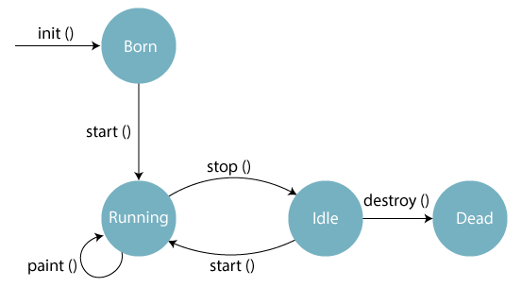
There are five methods of an applet life cycle, and they are:
- init(): The init() method is the first method to run that initializes the applet. It can be invoked only once at the time of initialization. The web browser creates the initialized objects, i.e., the web browser (after checking the security settings) runs the init() method within the applet.
- start(): The start() method contains the actual code of the applet and starts the applet. It is invoked immediately after the init() method is invoked. Every time the browser is loaded or refreshed, the start() method is invoked. It is also invoked whenever the applet is maximized, restored, or moving from one tab to another in the browser. It is in an inactive state until the init() method is invoked.
- stop(): The stop() method stops the execution of the applet. The stop () method is invoked whenever the applet is stopped, minimized, or moving from one tab to another in the browser, the stop() method is invoked. When we go back to that page, the start() method is invoked again.
- destroy(): The destroy() method destroys the applet after its work is done. It is invoked when the applet window is closed or when the tab containing the webpage is closed. It removes the applet object from memory and is executed only once. We cannot start the applet once it is destroyed.
- paint(): The paint() method belongs to the Graphics class in Java. It is used to draw shapes like circle, square, trapezium, etc., in the applet. It is executed after the start() method and when the browser or applet windows are resized.

28. What is the difference between Exception and Error? Show with an example. What is the difference between throw and throws? Write a program to handle different types of exceptions using multiple catch statement. When do we use finally block? (3+1+4+5+2)
Ans.
Difference Between Exception and Error
In Java, Error, and Exception both are subclasses of the Java Throwable class that belongs to java.lang package.
Basis of Comparison | Exception | Error
Recoverable/ Irrecoverable | Exception can be recovered by using the try-catch block. An error cannot be recovered.
Type | It can be classified into two categories i.e. checked and unchecked. | All errors in Java are unchecked.
Occurrence | It occurs at compile time or run time. | It occurs at run time.
Package | It belongs to java.lang.Exception package. | It belongs to java.lang.Error package.
Known or unknown | Only checked exceptions are known to the compiler. | Errors will not be known to the compiler.
Causes | It is mainly caused by the application itself. | It is mostly caused by the environment in which the application is running.
Example | Checked Exceptions: SQLException, IOException  Unchecked Exceptions: ArrayIndexOutOfBoundException, NullPointerException, ArithmaticException | Java.lang.StackOverFlow, java.lang.OutOfMemoryError

In Java, both throw and throws are used for exception handling, but they serve different purposes. Here’s a breakdown of each, along with examples to illustrate their differences.

throw
- The throw statement is used to explicitly throw an exception from a method or any block of code.
- It is followed by an instance of Throwable (i.e., an exception object).
- This is how you can indicate that an error has occurred in your program.

Example of throw:
public class ThrowExample {
public static void main(String[] args) {
try {
checkAge(15);
}
catch (IllegalArgumentException e) {
System.out.println(e.getMessage());
}
}
static void checkAge(int age) {
if (age < 18) {
throw new IllegalArgumentException("Age must be at least 18");
}
System.out.println("Access granted.");
}
}

Output:
Age must be at least 18

throws
- The throws keyword is used in a method declaration to specify that the method can throw exceptions.
- It indicates that the method does not handle the exception and that the caller of the method must handle it.
- It can be followed by multiple exception types separated by commas.
Example of throws:
public class ThrowsExample {
public static void main(String[] args) {
try {
divide(10, 0);
}
catch (ArithmeticException e) {
System.out.println("Cannot divide by zero!");
}
}
static void divide(int a, int b) throws ArithmeticException {
if (b == 0) {
throw new ArithmeticException("Division by zero");
}
System.out.println("Result: " + (a / b));
}
}
Output:
Cannot divide by zero!

Starting from Java 7.0, it is possible for a single catch block to catch multiple exceptions by separating each with | (pipe symbol) in the catch block.
Catching multiple exceptions in a single catch block reduces code duplication and increases efficiency. The bytecode generated while compiling this program will be smaller than the program having multiple catch blocks as there is no code redundancy.
Note: If a catch block handles multiple exceptions, the catch parameter is implicitly final. This means we cannot assign any values to catch parameters.
Syntax:
try {
// code
}
catch (ExceptionType1 | Exceptiontype2 ex){
// catch block
}
Flow Chart of Java Multiple Catch Block
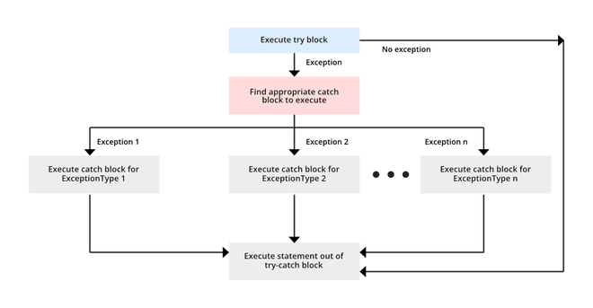
- program to handle different types of exceptions using multiple catch statement
- // A Java program to demonstrate
- // multicatch feature
- import java.util.Scanner;
- public class Test
- {
- public static void main(String args[])
- {
- Scanner scn = new Scanner(System.in);
- try
- {
- int n = Integer.parseInt(scn.nextLine());
- if (99%n == 0)
- System.out.println(n + " is a factor of 99");
- }
- catch (NumberFormatException | ArithmeticException ex)
- {
- System.out.println("Exception encountered " + ex);
- }
- }
- }

Input 1:
GeeksforGeeks
Output 1:
Exception encountered java.lang.NumberFormatException:
For input string: "GeeksforGeeks"
Input 2:
0
Output 2:
Exception encountered
java.lang.ArithmeticException: / by zero
A catch block that handles multiple exception types creates no duplication in the bytecode generated by the compiler. That is, the bytecode has no replication of exception handlers.

Java finally block is a block used to execute important code such as closing the connection, etc.
Java finally block is always executed whether an exception is handled or not. Therefore, it contains all the necessary statements that need to be printed regardless of the exception occurs or not.
- finally block in Java can be used to put "cleanup" code such as closing a file, closing connection, etc.
- The important statements to be printed can be placed in the finally block.

Case 1: When an exception does not occur
Case 2: When an exception occurr but not handled by the catch block
Case 3: When an exception occurs and is handled by the catch block

29. (a) What is run time exception? (b) What is the difference between throws and throw? (c) Define a user defined exception handling program which will throw exceptions if you entered a negative number. (d) Write a java program that will handle multiple exception at the same time. Use nested try catch block. (e) Explain ‘this’ and ‘super’ keyword. (2+5+5+3)
Ans.
a) A runtime exception is an exception that occurs during the execution of a program, specifically under the subclass java.lang.RuntimeException. Unlike checked exceptions, runtime exceptions are unchecked, meaning they do not need to be declared or handled.
Example :
public class RuntimeExceptionExample {
public static void main(String[] args) {
int[] numbers = {1, 2, 3};
// This will throw ArrayIndexOutOfBoundsException
System.out.println(numbers[5]);
}
}
Output:
Exception in thread "main" java.lang.ArrayIndexOutOfBoundsException: Index 5 out of bounds for length 3
b) There are many differences between throw and throws keywords. A list of differences between throw and throws are given below:
Sr. no. | Basis of Differences | throw | throws
1. | Definition | Java throw keyword is used throw an exception explicitly in the code, inside the function or the block of code. | Java throws keyword is used in the method signature to declare an exception which might be thrown by the function while the execution of the code.
2. | Usage | Type of exception Using throw keyword, we can only propagate unchecked exception i.e., the checked exception cannot be propagated using throw only. | Using throws keyword, we can declare both checked and unchecked exceptions. However, the throws keyword can be used to propagate checked exceptions only.
3. | Syntax | The throw keyword is followed by an instance of Exception to be thrown. | The throws keyword is followed by class names of Exceptions to be thrown.
4. | Declaration | throw is used within the method. | throws is used with the method signature.
5. | Internal implementation | We are allowed to throw only one exception at a time i.e. we cannot throw multiple exceptions. | We can declare multiple exceptions using throws keyword that can be thrown by the method. For example, main() throws IOException, SQLException.

c) Here's a simple Java program that takes user input and throws a custom exception if a negative number is entered:
import java.util.Scanner;
// Custom Exception Class
class NegativeNumberException extends Exception {
public NegativeNumberException(String message) {
super(message);
}
}
// Main Class
public class UserDefinedExceptionExample {
// Method to check for negative numbers
public static void checkNumber(int number) throws NegativeNumberException {

if (number < 0) {
throw new NegativeNumberException("Negative numbers are not allowed:
" +number);
}
System.out.println("You entered: " + number);
}
public static void main(String[] args) {
Scanner scanner = new Scanner(System.in);
System.out.print("Enter a number: ");
int number = scanner.nextInt();
try {
checkNumber(number);
}
catch (NegativeNumberException e) {
System.out.println("Exception caught: " + e.getMessage());
}
scanner.close();
}
}

Example Output
Enter a number: 10
You entered: 10
Enter a number: -5
Exception caught: Negative numbers are not allowed: -5

d) this keyword in Java
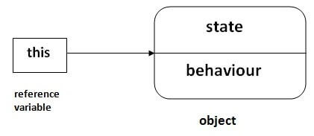
There can be a lot of usage of Java this keyword. In Java, this is a reference variable that refers to the current object.

Usage of Java this keyword
Here is given the 6 usage of java this keyword.
- this can be used to refer current class instance variable.
- this can be used to invoke current class method (implicitly)
- this() can be used to invoke current class constructor.
- this can be passed as an argument in the method call.
Example :
- class Student{
- int rollno;
- String name;
- float fee;
- Student(int rollno,String name,float fee){
- this.rollno=rollno;
- this.name=name;
- this.fee=fee;
- }
- void display(){System.out.println(rollno+" "+name+" "+fee);}
- }
- class TestThis2{
- public static void main(String args[]){
- Student s1=new Student(111,"ankit",5000f);
- Student s2=new Student(112,"sumit",6000f);
- s1.display();
- s2.display();
- }
- }

Output:
ankit 5000.0
sumit 6000.0

Super Keyword in Java
The super keyword in Java is a reference variable which is used to refer immediate parent class object.
Whenever you create the instance of subclass, an instance of parent class is created implicitly which is referred by super reference variable.
Usage of Java super Keyword
- super can be used to refer immediate parent class instance variable.
- super can be used to invoke immediate parent class method.
- super() can be used to invoke immediate parent class constructor.
Example:
- class Animal{
- String color="white";
- }
- class Dog extends Animal{
- String color="black";
- void printColor(){
- System.out.println(color);//prints color of Dog class
- System.out.println(super.color);//prints color of Animal class
- }
- }
- class TestSuper1{
- public static void main(String args[]){
- Dog d=new Dog();
- d.printColor();
- }
- }
Output:
Black
White

31. (a) Create an Applet to add two integers and display result. Two numbers can be accepted through a text field. (b) Write a java program to show use of abstract class and interface. (c) What are the different applet and application program? (d) Differentiate between protected and friendly access specifier.
Ans. a) JAVA APPLET Program to Find Sum of Two Numbers
Java Program (program file sum.java)
- import java.awt.*;
- import java.awt.event.*;
- import java.applet.*;
- public class sum extends Applet implements ActionListener
- {
- TextField t1 = new TextField(10);
- TextField t2 = new TextField(10);
- TextField t3 = new TextField(10);
- Label l1 = new Label("FIRST NO=:");
- Label l2 = new Label("SECOND NO:");
- Label l3 = new Label("SUM:");
- Button b = new Button("ADD");
- public void init()
- {
- t1.setForeground(Color = Red);
- add(l1);
- add(t1);
- add(l2);
- add(t2);
- add(l3);
- add(t3);
- add(b);
- b.addActionListener(this);
- }
- public void actionPerformed(ActionEvent e)
- {
- if (e.getSource() == b)
- {
- int n1 = Integer.parseInt(t1.getText());
- int n2 = Integer.parseInt(t2.getText());
- t3.setText(" " + (n1 + n2));
- }
- }
- }

HTML Code
- <HTML>

- <HEAD>
- <TITLE>WELCOME TO JAVA APPLET</TITLE>
- </HEAD>

- <BODY>
- <CENTER>
- <H1>WELCOME TO THE APPLET</H1> </CENTER>
- <BR>
- <APPLET CODE=sum.class WIDTH=400 HEIGHT=400> </APPLET>
- </BODY>

- </HTML>

OUTPUT
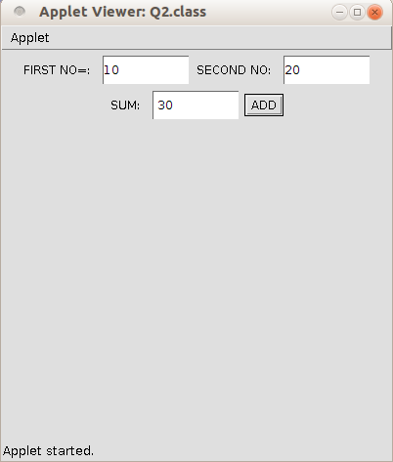

b) Here’s an example demonstrating the use of both an abstract class and an interface in Java. In this example, an abstract class Vehicle defines a common behavior for all vehicles, while the interface FuelType adds more specific functionality for fuel-based vehicles.
Java Program:
// Define an interface for fuel type behavior
interface FuelType {
void fuel();
}

// Define an abstract class representing a vehicle
abstract class Vehicle {
String brand;
int wheels;

// Constructor to initialize vehicle
public Vehicle(String brand, int wheels) {
this.brand = brand;
this.wheels = wheels;
}

// Abstract method to be implemented by subclasses
abstract void start();

// A concrete method common to all vehicles
public void showInfo() {
System.out.println("Brand: " + brand);
System.out.println("Wheels: " + wheels);
}
}

// Car class extends Vehicle and implements FuelType interface
class Car extends Vehicle implements FuelType {
public Car(String brand, int wheels) {
super(brand, wheels);
}

// Implementing the abstract method from Vehicle
@Override
public void start() {
System.out.println("The car is starting.");
}

// Implementing the method from FuelType interface
@Override
public void fuel() {
System.out.println("The car uses gasoline.");
}
}

// Bicycle class extends Vehicle but does not use the FuelType interface
class Bicycle extends Vehicle {
public Bicycle(String brand, int wheels) {
super(brand, wheels);
}

// Implementing the abstract method from Vehicle
@Override
public void start() {
System.out.println("The bicycle is ready to ride.");
}
}

// Main class to run the program
public class Main {
public static void main(String[] args) {
// Create a Car object
Car myCar = new Car("Tesla", 4);
myCar.showInfo();
myCar.start();
myCar.fuel();

System.out.println();

// Create a Bicycle object
Bicycle myBicycle = new Bicycle("Giant", 2);
myBicycle.showInfo();
myBicycle.start();
}
}

Output:
Brand: Tesla
Wheels: 4
The car is starting.
The car uses gasoline.

Brand: Giant
Wheels: 2
The bicycle is ready to ride.

Explanation:
- Vehicle Abstract Class:
  - Contains an abstract method start() that each specific vehicle (e.g., car, bicycle) must implement.
  - Includes a concrete method showInfo() to display common vehicle properties.
- FuelType Interface:
  - Specifies that any class implementing it must define the fuel() method, which indicates the type of fuel the vehicle uses.
- Car Class:
  - Extends the Vehicle abstract class and implements the FuelType interface.
  - Implements both start() from Vehicle and fuel() from FuelType.
- Bicycle Class:
  - Extends the Vehicle abstract class but does not implement FuelType since bicycles don't need fuel.
c) Java Application Vs. Java Applet
Parameters | Java Application | Java Applet
Meaning | A Java Application also known as application program is a type of program that independently executes on the computer. | The Java applet works on the client side, and runs on the browser and makes use of another application program so that we can execute it.
Requirement of main( ) method | Its execution starts with the main( ) method only. The use of the main( ) is mandatory. | It does not require the use of any main() method. Java applet initializes through init( ) method.
Execution | It cannot run independently, but requires JRE to run. | It cannot start independently but requires APIs for use (Example. APIs like Web API).
Installation | We need to install the Java application first and obviously on the local computer. | Java applet does not need to be pre-installed.
Connectivity with server | It is possible to establish connections with other servers. | It cannot establish connection to other servers.
Operation | It performs read and write tasks on a variety of files located on a local computer. | It cannot run the applications on any local computer.
File access | It can easily access a file or data available on a computer system or device. | It cannot access the file or data found on any local system or computer.
Security | Java applications are pretty trusted, and thus, come with no security concerns. | Java applets are less reliable. So, they need to be safe.

d) The Protected access specifier is visible within the same package and also visible in the subclass whereas the Default is a package level access specifier and it can be visible in the same package.

Protected Access Specifier
- Protected will acts as public within the same package and acts as private outside the package.
- Protected will also act as public outside the package only with respect to subclass objects.
- Protected fields or methods cannot be used for classes and Interfaces.
- The Fields, methods, and constructors declared as protected in a superclass can be accessed only by subclasses in other packages.
- The classes in the same package can also access protected fields, methods and constructors as well, even if they are not a subclass of the protected member’s class.

Example
public class ProtectedTest {
// variables that are protected
protected int age = 30;
protected String name = "Adithya";

/**
* This method is declared as protected.
*/
protected String getInfo() {
return name +" is "+ age +" years old.";
}
public static void main(String[] args) {
System.out.println(new ProtectedTest().getInfo());
}
}

Output
Adithya is 30 years old.

Default Access Specifier
- Any member of a class mentioned without any access specifier then it is considered that as Default.
- The Default will act as public within the same package and acts as private outside the package.
- The Default members of any class can be available to anything within the same package and can not be available outside the package under any condition.
- The Default restricts the access only to package level, even after extending the class having default data members we cannot able to access.

Example
public class DefaultTest {
// variables that have no access modifier
int age = 25;
String name = "Jai";

/**
* This method is declared with default aacees specifier
*/
String getInfo() {
return name +" is "+ age +" years old.";
}
public static void main(String[] args) {
System.out.println(new DefaultTest().getInfo());
}
}

Output
Jai is 25 years old.

34. What is multi-threading? Write a program that can run a main thread and a child thread simultaneously. What does synchronized keyword do? Briefly describe with example.
Ans. Multithreading is a Java feature that allows concurrent execution of two or more parts of a program for maximum utilization of CPU. Each part of such program is called a thread. So, threads are light-weight processes within a process.
Threads can be created by using two mechanisms :
- Extending the Thread class
- Implementing the Runnable Interface
We can achieve this in Java by creating a main thread and a child thread using the Thread class or by implementing the Runnable interface. Here's an example using Thread Class:
class ChildThread extends Thread {
@Override
public void run() {
for (int i = 1; i <= 5; i++) {
System.out.println("Child Thread: " + i);
try {
Thread.sleep(500); // Sleep for 500 milliseconds
} catch (InterruptedException e) {
System.out.println(e.getMessage());
}
}
}
}

public class MainThread {
public static void main(String[] args) {
ChildThread childThread = new ChildThread();
childThread.start(); // Start the child thread

for (int i = 1; i <= 5; i++) {
System.out.println("Main Thread: " + i);
try {
Thread.sleep(1000); // Sleep for 1000 milliseconds
} catch (InterruptedException e) {
System.out.println(e.getMessage());
}
}
}
}

Output:
Main Thread: 1
Child Thread: 1
Child Thread: 2
Main Thread: 2
Child Thread: 3
Child Thread: 4
Main Thread: 3
Child Thread: 5
Main Thread: 4
Main Thread: 5

The synchronized keyword in Java is used to control access to a method or block of code by multiple threads. It ensures that only one thread can access the synchronized code at a time, preventing data inconsistency and ensuring thread safety.
Key Points
- Mutual Exclusion: When a method or block is marked as synchronized, only one thread can execute it at a time for a given object or class.
- Locks: A thread must acquire a lock (monitor) before executing a synchronized method or block, and it releases the lock when it exits the synchronized section.

Example
Here's a simple example demonstrating the use of the synchronized keyword:
class Counter {
private int count = 0;

// Synchronized method to increment the count
public synchronized void increment() {
count++;
}

public int getCount() {
return count;
}
}

public class SynchronizedExample {
public static void main(String[] args) {
Counter counter = new Counter();

// Create multiple threads to increment the counter
Thread t1 = new Thread(() -> {
for (int i = 0; i < 1000; i++) {
counter.increment();
}
});

Thread t2 = new Thread(() -> {
for (int i = 0; i < 1000; i++) {
counter.increment();
}
});

// Start the threads
t1.start();
t2.start();

try {
// Wait for threads to finish
t1.join();
t2.join();
} catch (InterruptedException e) {
e.printStackTrace();
}

// Print the final count
System.out.println("Final Count: " + counter.getCount());
}
}

Output
The expected output after both threads finish would be:
Final Count: 2000

Explanation
- In this example, the Counter class has a synchronized method increment() that increments the count variable.
- Two threads (t1 and t2) are created to increment the counter 1000 times each.
- The synchronized keyword ensures that even with concurrent access, the count variable remains consistent, and the final count will correctly reflect the increments from both threads.

35. (a) What is multithreading? What is the difference between creation of user thread by extending thread class and implementing Runnable interface? Which one is better? Give example. (b) What is thread synchronization? Why it is needed? (c) Discuss the difference between an Applet and Application. (d) List various attributes of Applet tag used in HTML. ((2+6)+3+2+2)
Ans. a) Multithreading in Java is a process of executing multiple threads simultaneously.
A thread is a lightweight sub-process, the smallest unit of processing. Multiprocessing and multithreading, both are used to achieve multitasking.
However, we use multithreading than multiprocessing because threads use a shared memory area. They don't allocate separate memory area so saves memory, and context-switching between the threads takes less time than process.
Java Multithreading is mostly used in games, animation, etc.

The differences between creating a user thread by extending the Thread class and implementing the Runnable interface:
Feature | Extending Thread Class | Implementing Runnable Interface
Inheritance | Cannot extend another class (single inheritance). | Can extend another class (multiple inheritance allowed).
Thread Execution | Override the run() method in the subclass; start with start(). | Implement run() in the class; create a Thread object to start.
Resource Sharing | Each thread instance is independent. | Allows sharing of a single Runnable instance across multiple threads.
Use Cases | Simpler use cases where a dedicated thread is needed. | Preferred for complex applications to separate thread behavior from other functionalities.
Flexibility | Less flexible due to single inheritance. | More flexible, supporting better design patterns and code organization.

Using the Runnable interface is generally better for creating threads in Java due to its flexibility and design advantages. It allows for multiple inheritance, enabling a class to implement various interfaces alongside being a thread. This separation of thread logic from execution enhances modularity, making the code easier to maintain and test. Additionally, a single Runnable instance can be shared across multiple threads, promoting efficient resource management and synchronization. Overall, the Runnable interface is the preferred choice for robust and scalable multithreaded applications.
1. Extending the Thread Class
Advantages:
- Simple to implement when you need to create a thread quickly.
- Directly access Thread class methods.
Disadvantages:
- You cannot extend another class since Java does not support multiple inheritance. If you need to extend another class, you cannot use this approach.
- class MyThread extends Thread {
- public void run() {
- System.out.println("Thread using Thread class: " + Thread.currentThread().getName());
- }
- }

- public class ExtendThreadExample {
- public static void main(String[] args) {
- MyThread thread1 = new MyThread();
- thread1.start();
- }
- }
Output:
- mathematica
- Copy code
- Thread using Thread class: Thread-0

2. Implementing the Runnable Interface
Advantages:
- Allows for multiple inheritance since you can implement multiple interfaces.
- Separation of thread logic from the thread execution, which is more flexible and modular.
Disadvantages:
- You have to create a Thread object explicitly to start the thread.
- class MyRunnable implements Runnable {
- public void run() {
- System.out.println("Thread using Runnable interface: " + Thread.currentThread().getName());
- }
- }

- public class RunnableExample {
- public static void main(String[] args) {
- MyRunnable myRunnable = new MyRunnable();
- Thread thread = new Thread(myRunnable);
- thread.start();
- }
- }
Output:
- csharp
- Copy code
- Thread using Runnable interface: Thread-0

b) Synchronization in Java

Synchronization in Java is the capability to control the access of multiple threads to any shared resource.

Java Synchronization is better option where we want to allow only one thread to access the shared resource.

Why use Synchronization?
The synchronization is mainly used to
- To prevent thread interference.
- To prevent consistency problem.

Types of Synchronization
There are two types of synchronization
- Process Synchronization
- Thread Synchronization
Here, we will discuss only thread synchronization.

Thread Synchronization
There are two types of thread synchronization mutual exclusive and inter-thread communication.
- Mutual Exclusive
  - Synchronized method.
  - Synchronized block.
  - Static synchronization.
- Cooperation (Inter-thread communication in java)

C) Java Application Vs. Java Applet
Parameters | Java Application | Java Applet
Meaning | A Java Application also known as application program is a type of program that independently executes on the computer. | The Java applet works on the client side, and runs on the browser and makes use of another application program so that we can execute it.
Requirement of main( ) method | Its execution starts with the main( ) method only. The use of the main( ) is mandatory. | It does not require the use of any main() method. Java applet initializes through init( ) method.
Execution | It cannot run independently, but requires JRE to run. | It cannot start independently but requires APIs for use (Example. APIs like Web API).
Installation | We need to install the Java application first and obviously on the local computer. | Java applet does not need to be pre-installed.
Connectivity with server | It is possible to establish connections with other servers. | It cannot establish connection to other servers.
Operation | It performs read and write tasks on a variety of files located on a local computer. | It cannot run the applications on any local computer.
File access | It can easily access a file or data available on a computer system or device. | It cannot access the file or data found on any local system or computer.
Security | Java applications are pretty trusted, and thus, come with no security concerns. | Java applets are less reliable. So, they need to be safe.

d) HTML <applet> tag specifies an applet. It is used for embedding a Java applet within an HTML document.
Syntax
<applet code="URL" height="200" width="100">
...
</applet>

attributes:
Attribute Values | Description
align | Specifies the alignment of an applet.
alt | Specifies an alternate text for an applet.
archive | Specifies the location of an archive file.
border | Specifies the border around the applet panel.
codebase | Specifies a relative base URL for applets specified in the code attribute.
height | Specifies the height of an applet.
hspace | Defines the horizontal spacing around an applet.
mayscript | Indicates whether the Java applet is allowed to access the scripting objects of the web page.
name | Defines the name for an applet (to use in scripts).
vspace | Defines the vertical spacing around an applet.
width | Specifies the width of an applet.

36. What are the five essential methods used for the structure of any Applet. Develop an applet that receives three numeric values as inputs from the user and then display the largest of three on the screen, write a HTML program and test the applet. (6+9)
Ans. The five essential methods used in the structure of any Java Applet are:
- init():
This method is called when the applet is first loaded. It is used to initialize the applet, set up variables, and prepare the applet for execution.
- start():
This method is invoked after init() and whenever the applet becomes active. It is used to start or resume the applet’s execution, especially for animations or tasks that need to continue running while the applet is active.
- stop():
This method is called when the applet is no longer active or is stopped. It is used to pause the execution of the applet, like suspending animations or stopping tasks when the applet moves out of view.
- destroy():
This method is invoked when the applet is about to be removed from memory, typically when the applet is closed. It is used for cleanup tasks, such as releasing resources or saving data.
- paint(Graphics g):
This method is responsible for rendering the applet’s visual elements. It is called whenever the applet needs to redraw itself, such as when it is resized or uncovered.

To develop an applet that receives three numeric values as inputs and displays the largest, you can follow these steps:
Java Program (LargestNumberApplet.java):
import java.awt.*;
import java.awt.event.*;
import java.applet.*;

public class LargestNumberApplet extends Applet implements ActionListener {
TextField t1 = new TextField(10); // Text field for first number
TextField t2 = new TextField(10); // Text field for second number
TextField t3 = new TextField(10); // Text field for third number
Label l1 = new Label("First Number: ");
Label l2 = new Label("Second Number: ");
Label l3 = new Label("Third Number: ");
Label resultLabel = new Label("Largest Number: ");
TextField resultField = new TextField(10); // Result field
Button findLargestButton = new Button("Find Largest"); // Button to trigger action

public void init() {
// Setting up the applet components
setLayout(new FlowLayout());

add(l1);
add(t1);

add(l2);
add(t2);

add(l3);
add(t3);

add(resultLabel);
add(resultField);

add(findLargestButton);

// Add action listener for the button
findLargestButton.addActionListener(this);

resultField.setEditable(false); // The result field should be read-only
}

public void actionPerformed(ActionEvent e) {
// Action when the button is pressed
if (e.getSource() == findLargestButton) {
try {
// Get values from the text fields
int num1 = Integer.parseInt(t1.getText());
int num2 = Integer.parseInt(t2.getText());
int num3 = Integer.parseInt(t3.getText());

// Find the largest number
int largest = Math.max(num1, Math.max(num2, num3));

// Display the largest number
resultField.setText(String.valueOf(largest));
} catch (NumberFormatException ex) {
resultField.setText("Invalid Input");
}
}
}
}

2. HTML Code (appletTest.html)
<!DOCTYPE html>
<html>
<head>
<title>Largest Number Applet</title>
</head>
<body>
<center>
<h1>Find the Largest Number Applet</h1>
<br>
<applet code="LargestNumberApplet.class" width="400" height="400">
</applet>
</center>
</body>
</html>

Input Example:
- First Number: 45
- Second Number: 72
- Third Number: 53

Applet Screen:
mathematica
Copy code
First Number: [ 45 ]
Second Number: [ 72 ]
Third Number: [ 53 ]

Largest Number: [ 72 ]

[ Find Largest Button ]

Output after clicking "Find Largest":
javascript
Copy code
Largest Number: 72

37. a) How is applet different from frame and page? b) How are threads made to communicate with each other? Explain with example. c) Explain any three events with suitable example. (5+5+5)
Ans. a) Here’s an updated comparison table including examples for Java Applets, Java Frames, and HTML Pages:
Feature | Java Applet | Java Frame | HTML Page
Definition | A Java program that runs in a web browser or an applet viewer. | A standalone window in a desktop application. | A document that is displayed in a web browser.
Execution Context | Runs in a web browser or applet viewer; requires Java plugin. | Runs on the Java Virtual Machine (JVM) as part of a desktop application. | Runs in a web browser without the need for a Java plugin.
User Interface | Typically embedded within HTML pages, relies on the browser's UI. | Provides a rich graphical user interface (GUI) independent of a web browser. | Uses HTML/CSS for layout and design, limited to web standards.
Deployment | Requires the browser to support Java applets; often deprecated. | Deployed as a standalone application or part of a larger application. | Deployed on web servers and accessed via URLs.
Graphics | Uses AWT and Swing libraries for graphical components. | Uses AWT, Swing, or JavaFX for GUI components. | Uses HTML/CSS for presentation, JavaScript for interactivity.
Event Handling | Uses event listeners to handle user interactions (e.g., button clicks). | Similar event handling using listeners, but can be more complex due to the desktop environment. | Uses JavaScript for dynamic behavior and event handling.
Persistence | Data is transient and does not persist between sessions. | Can save state and data locally or connect to databases. | Can persist data using cookies, local storage, or backend databases.
Security | Runs in a restricted environment due to security risks. | Less restricted, but still subject to Java security policies. | Subject to web security policies and restrictions (e.g., CORS).
Lifecycle Management | Managed by the browser; methods like init(), start(), stop(), and destroy(). | Managed by the application; methods like show() and dispose() are used. | Managed by the browser; no explicit lifecycle methods.
Example | Java code:  import java.applet.Applet;  import java.awt.Graphics;  public class HelloWorldApplet extends Applet { public void paint(Graphics g) {  g.drawString("Hello, Applet!", 20, 20);  }  }  HTML CODE:  <applet code="HelloWorldApplet.class" width="300" height="300"></applet> | import javax.swing.JFrame;  import javax.swing.JLabel;  public class HelloWorldFrame { public static void main(String[] args) {  JFrame frame = new JFrame("Hello  Frame");  JLabel label = new JLabel("Hello,  Frame!", JLabel.CENTER);  frame.add(label);  frame.setSize(300, 200);  frame.setDefaultCloseOperation(JFrame.EXIT_ON_CLOSE); frame.setVisible(true); } } | <!DOCTYPE html>  <html lang="en">  <head>  <meta charset="UTF-8">  <meta name="viewport" content="width=device-width, initial-scale=1.0">  <title>Hello Page</title>  </head>  <body>  <h1>Hello, Page!</h1>  </body>  </html>

b) Inter-thread communication or Co-operation is all about allowing synchronized threads to communicate with each other.
Cooperation (Inter-thread communication) is a mechanism in which a thread is paused running in its critical section and another thread is allowed to enter (or lock) in the same critical section to be executed.It is implemented by following methods of Object class:
- wait()
- notify()
- notifyAll()

1) wait() method
The wait() method causes current thread to release the lock and wait until either another thread invokes the notify() method or the notifyAll() method for this object, or a specified amount of time has elapsed.
The current thread must own this object's monitor, so it must be called from the synchronized method only otherwise it will throw exception.
Method | Description
public final void wait()throws InterruptedException | It waits until object is notified.
public final void wait(long timeout)throws InterruptedException | It waits for the specified amount of time.

2) notify() method
The notify() method wakes up a single thread that is waiting on this object's monitor. If any threads are waiting on this object, one of them is chosen to be awakened. The choice is arbitrary and occurs at the discretion of the implementation.
Syntax:
- public final void notify()

3) notifyAll() method
Wakes up all threads that are waiting on this object's monitor.
Syntax:
- public final void notifyAll()

Understanding the process of inter-thread communication
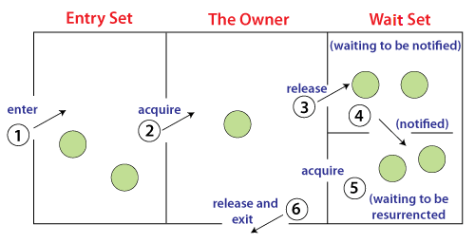
The point to point explanation of the above diagram is as follows:
- Threads enter to acquire lock.
- Lock is acquired by on thread.
- Now thread goes to waiting state if you call wait() method on the object. Otherwise it releases the lock and exits.
- If you call notify() or notifyAll() method, thread moves to the notified state (runnable state).
- Now thread is available to acquire lock.
- After completion of the task, thread releases the lock and exits the monitor state of the object.

Example of Inter Thread Communication in Java
Let's see the simple example of inter thread communication.
ThreadCommunicationTest.java
class BankClient {
int balAmount = 5000;
synchronized void withdrawMoney(int amount) {
System.out.println("Withdrawing money");
balAmount -= amount;
System.out.println("The balance amount is: " + balAmount);
}
synchronized void depositMoney(int amount) {
System.out.println("Depositing money");
balAmount += amount;
System.out.println("The balance amount is: " + balAmount);
notify();
}
}
public class ThreadCommunicationTest {
public static void main(String args[]) {
final BankClient client = new BankClient();
new Thread() {
public void run() {
client.withdrawMoney(3000);
}
}.start();
new Thread() {
public void run() {
client.depositMoney(2000);
}
}.start();
}
}

Output:
Withdrawing money
The balance amount is: 2000
Depositing money
The balance amount is: 4000

The provided Java program demonstrates thread communication using synchronized methods and the notify() method. It simulates a bank client where two threads perform withdrawal and deposit operations. The withdrawMoney() and depositMoney() methods are synchronized to ensure only one thread can access them at a time, preventing race conditions. After depositing money, the notify() method is called, signaling any waiting threads that they can proceed. While thread safety is ensured, there is no use of wait(), meaning the threads execute sequentially without waiting for conditions to be met.
c) In Java, events are actions generated by user interactions or program-triggered changes. These events are handled through event listeners in Java's event-driven programming. Below are three common events in Java with examples:
1. ActionEvent
An ActionEvent is triggered when an action occurs, such as clicking a button, pressing a key, or selecting a menu item. This event is commonly used in GUI applications.
Example: (ActionEventExample.java)
import java.awt.*;
import java.awt.event.*;
import javax.swing.*;

public class ActionEventExample {
public static void main(String[] args) {
JFrame frame = new JFrame("ActionEvent Example");
JButton button = new JButton("Click Me");

// Adding ActionListener to handle button click event
button.addActionListener(new ActionListener() {
public void actionPerformed(ActionEvent e) {
System.out.println("Button Clicked!");
}
});

frame.add(button);
frame.setSize(300, 200);
frame.setLayout(new FlowLayout());
frame.setDefaultCloseOperation(JFrame.EXIT_ON_CLOSE);
frame.setVisible(true);
}
}

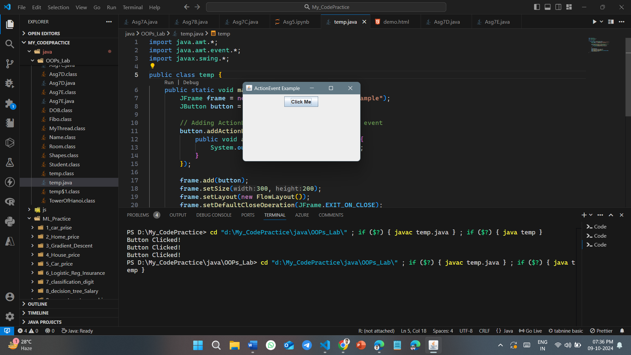
Output :

Explanation: When the button is clicked, an ActionEvent is fired, triggering the actionPerformed() method and printing "Button Clicked!" to the console.

2. KeyEvent
A KeyEvent is triggered when a key is pressed, released, or typed on the keyboard. This event is useful for handling keyboard input.
Example: (KeyEventExample.java)
import java.awt.event.*;
import javax.swing.*;

public class KeyEventExample extends JFrame implements KeyListener {
JLabel label;

public KeyEventExample() {
label = new JLabel();
label.setBounds(20, 50, 200, 20);
add(label);

addKeyListener(this);
setSize(300, 200);
setLayout(null);
setVisible(true);
setDefaultCloseOperation(EXIT_ON_CLOSE);
}

public void keyPressed(KeyEvent e) {
label.setText("Key Pressed: " + e.getKeyChar());
}

public void keyReleased(KeyEvent e) {}
public void keyTyped(KeyEvent e) {}

public static void main(String[] args) {
new KeyEventExample();
}
}

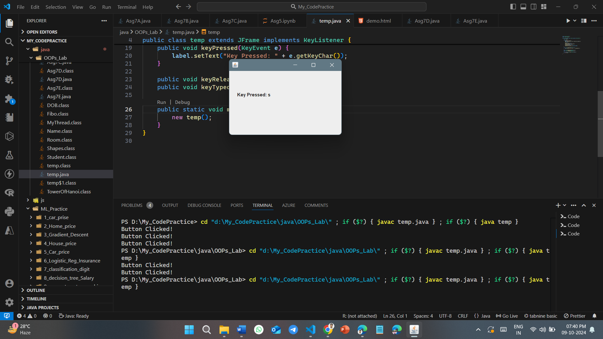
Output :

Explanation: When a key is pressed, a KeyEvent is generated, and the keyPressed() method updates the label to display the pressed key.

3. MouseEvent (MouseEventExample.java)
A MouseEvent is triggered by mouse actions like clicking, entering, exiting, or dragging the mouse. This event is useful for handling mouse interactions.
Example:
import java.awt.*;
import java.awt.event.*;
import javax.swing.*;

public class MouseEventExample extends JFrame implements MouseListener {
JLabel label;

public MouseEventExample() {
label = new JLabel("Click anywhere");
label.setBounds(20, 50, 200, 20);
add(label);

addMouseListener(this);
setSize(300, 200);
setLayout(null);
setVisible(true);
setDefaultCloseOperation(EXIT_ON_CLOSE);
}

public void mouseClicked(MouseEvent e) {
label.setText("Mouse Clicked at X: " + e.getX() + " Y: " + e.getY());
}

public void mousePressed(MouseEvent e) {}
public void mouseReleased(MouseEvent e) {}
public void mouseEntered(MouseEvent e) {}
public void mouseExited(MouseEvent e) {}

public static void main(String[] args) {
new MouseEventExample();
}
}

Output :
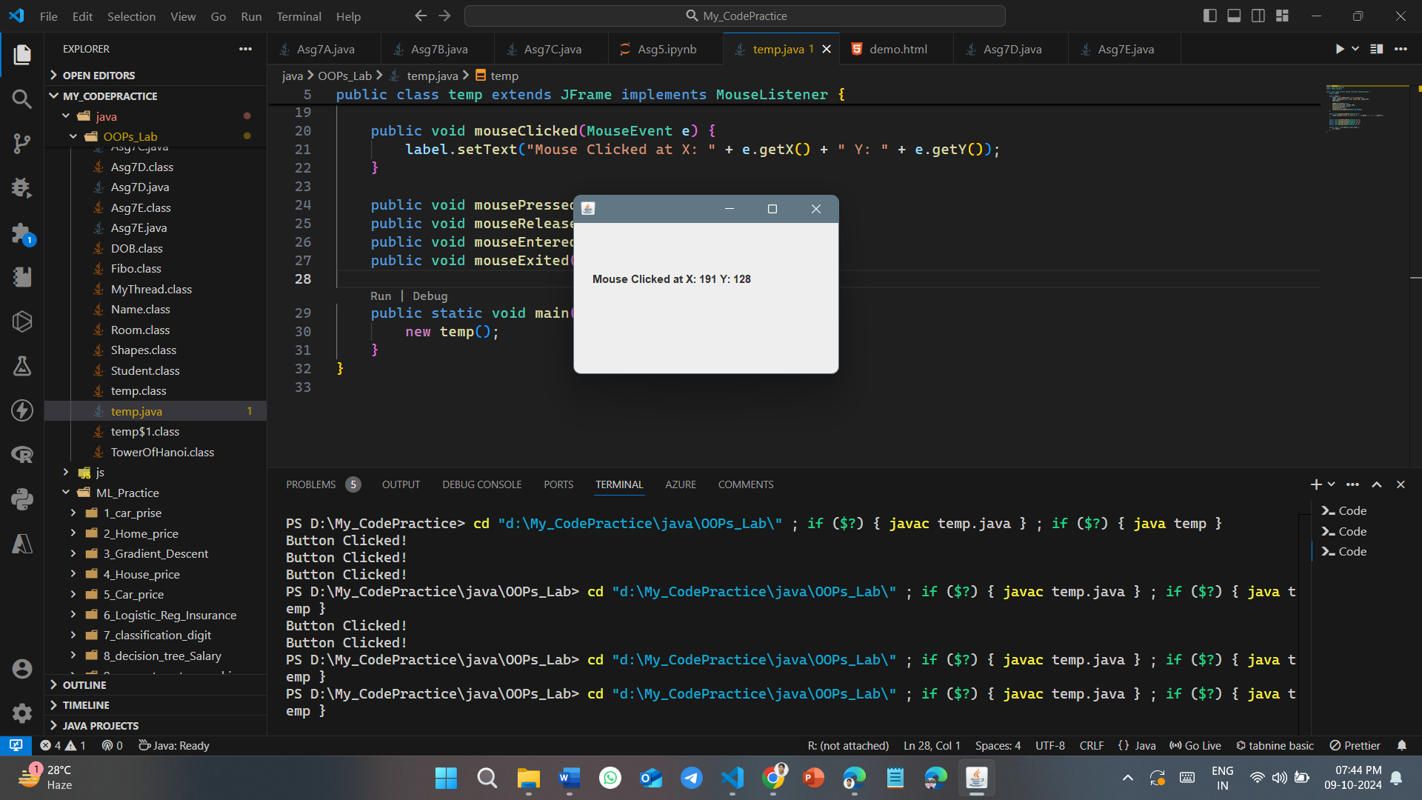

Explanation: When the mouse is clicked within the frame, a MouseEvent is generated, and the mouseClicked() method displays the coordinates of the click in the label.
Each of these events (ActionEvent, KeyEvent, MouseEvent) allows the program to respond to user inputs, creating interactive applications.

38. a) Write a program running a main thread and a child thread simultaneously. b) List various attributes of Applet tag used in HTML. c) Write a Java program that uses the draw polygon ( ) method of Graphics class to draw a triangle with end points (25, 30), (75, 80) and (50, 50). (6+3+6)
Ans. a) In Java, you can run a main thread and a child thread simultaneously by creating a new thread using either the Thread class or by implementing the Runnable interface. Here's a simple example where the main thread and a child thread run simultaneously:
Example: Running Main Thread and Child Thread Simultaneously
class ChildThread extends Thread {
public void run() {
for (int i = 1; i <= 5; i++) {
System.out.println("Child Thread: " + i);
try {
Thread.sleep(500); // Pauses the thread for 500ms
} catch (InterruptedException e) {
System.out.println(e);
}
}
}
}

public class MainThreadExample {
public static void main(String[] args) {
// Creating a child thread
ChildThread childThread = new ChildThread();
childThread.start(); // Starting the child thread

// Main thread work
for (int i = 1; i <= 5; i++) {
System.out.println("Main Thread: " + i);
try {
Thread.sleep(500); // Pauses the thread for 500ms
} catch (InterruptedException e) {
System.out.println(e);
}
}
}
}

Output:
The output will show both the main thread and the child thread running concurrently, with alternating prints from each thread:
Main Thread: 1
Child Thread: 1
Main Thread: 2
Child Thread: 2
Main Thread: 3
Child Thread: 3
Main Thread: 4
Child Thread: 4
Main Thread: 5
Child Thread: 5
Explanation:
- The main thread (inside main()) starts and prints values from 1 to 5, with a pause of 500 milliseconds between each print.
- Simultaneously, the child thread (from ChildThread.run()) does the same, printing its own values from 1 to 5, also with a 500-millisecond pause.
- Both threads run concurrently, and the actual order of output may vary slightly depending on the system's thread scheduling.
b) HTML <applet> tag specifies an applet. It is used for embedding a Java applet within an HTML document.
Syntax
<applet code="URL" height="200" width="100">
...
</applet>

attributes:
Attribute Values | Description
align | Specifies the alignment of an applet.
alt | Specifies an alternate text for an applet.
archive | Specifies the location of an archive file.
border | Specifies the border around the applet panel.
codebase | Specifies a relative base URL for applets specified in the code attribute.
height | Specifies the height of an applet.
hspace | Defines the horizontal spacing around an applet.
mayscript | Indicates whether the Java applet is allowed to access the scripting objects of the web page.
name | Defines the name for an applet (to use in scripts).
vspace | Defines the vertical spacing around an applet.
width | Specifies the width of an applet.

c) Here’s a complete Java program that uses the drawPolygon() method of the Graphics class to draw a triangle with the specified endpoints (25, 30), (75, 80), and (50, 50).
import javax.swing.*;
import java.awt.*;

public class TriangleDrawing extends JPanel {
@Override
protected void paintComponent(Graphics g) {
super.paintComponent(g);

// Define the x and y coordinates of the triangle's vertices
int[] xPoints = {25, 75, 50}; // X coordinates
int[] yPoints = {30, 80, 50}; // Y coordinates

// Draw the triangle using drawPolygon method
g.drawPolygon(xPoints, yPoints, 3); // 3 is the number of points (a triangle)
}

public static void main(String[] args) {
// Create a JFrame window
JFrame frame = new JFrame("Triangle Drawing Example");
frame.setDefaultCloseOperation(JFrame.EXIT_ON_CLOSE);
frame.setSize(200, 200);

// Add the TriangleDrawing component (JPanel)
frame.add(new TriangleDrawing());

// Make the window visible
frame.setVisible(true);
}
}
Explanation:
- TriangleDrawing class: This class extends JPanel and overrides the paintComponent() method to perform custom drawing.
- paintComponent(Graphics g): This method is called whenever the panel needs to be redrawn. Inside this method, we define two arrays for the x and y coordinates of the triangle's vertices.
- g.drawPolygon(xPoints, yPoints, 3): This method draws the triangle using the specified coordinates. The last parameter, 3, indicates the number of points in the polygon.
- main method: This is the entry point of the program. It creates a JFrame, sets its default close operation, size, and adds an instance of TriangleDrawing to the frame.
Output:
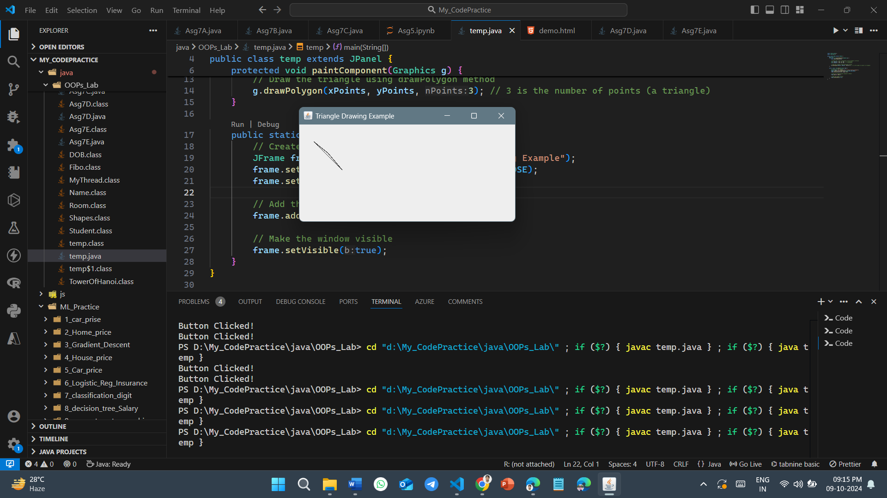

39. a) Why does Java have two ways to create child threads (by extending thread or implementing Runnable) and which approach is better? b) Define an exception called “Not Equal Exception” that is thrown when a float value is not equal to 3.14. Write a program that uses that user defined exception. c) Write a multithread program to generate the square roots to the first 30 natural numbers using Runnable interface. d) What do you mean by Synchronization? Why do we need it?
Ans. a) Java provides two ways to create child threads—by extending the Thread class or implementing the Runnable interface—for flexibility and design considerations. Here’s why there are two approaches and which one is typically preferred:
1. Extending the Thread class: We create a new class that extends Thread and override its run() method. This method contains the code that the thread will execute.
Example:
class MyThread extends Thread {
public void run() {
System.out.println("Thread is running");
}
}

public class Main {
public static void main(String[] args) {
MyThread t1 = new MyThread();
t1.start();
}
}

Output:
Thread is running
When to use: This method might be suitable when we want to directly modify or enhance the behavior of the Thread class itself.
Limitations: Java only allows single inheritance, so if we extend the Thread class, we cannot extend any other class. This restricts the flexibility of our class design.

2. Implementing the Runnable interface:
- How it works: You implement the Runnable interface in your class and define the run() method. You then pass an instance of this class to a Thread object.
Example:
class MyRunnable implements Runnable {
public void run() {
System.out.println("Runnable is running");
}
}

public class Main {
public static void main(String[] args) {
Thread t1 = new Thread(new MyRunnable());
t1.start();
}
}

Output:
Runnable is running
When to use: This method is preferred when your class needs to extend another class (since Java doesn't support multiple inheritance). It also separates the task of defining the work (Runnable) from the mechanism of running it (Thread).
Advantages:
Better flexibility: Allows your class to extend another class and implement multiple interfaces.
Clear separation of concerns: The Runnable interface only defines the task, while the Thread class handles the thread's execution.

In most cases, implementing the Runnable interface is considered the better approach because:
- Flexibility: It allows your class to extend another class if needed.
- Separation of logic: Runnable provides a clean separation of the task to be performed from the threading mechanism.
- Compatibility with thread pools and executors: In modern Java, it's common to use thread pools (ExecutorService), where tasks are submitted as Runnable objects. This makes Runnable the more versatile option.
b) Here's a Java program that defines a custom exception called NotEqualException, which is thrown when a float value is not equal to 3.14.

import java.util.Scanner;

// Custom exception class
class NotEqualException extends Exception {
public NotEqualException(String message) {
super(message);
}
}
public class Main {
// Method to check if the float value is equal to 3.14
public static void checkValue(float value) throws NotEqualException {
if (value != 3.14f) {
throw new NotEqualException("The value " + value + " is not equal to
3.14");
} else {
System.out.println("The value is equal to 3.14");
}
}
public static void main(String[] args) {
// Taking input from user
Scanner sc = new Scanner(System.in);
System.out.print("Enter a float value: ");
float input = sc.nextFloat(); // Read user input

// Try-catch block to handle the custom exception
try {
checkValue(input); // Check the input value
} catch (NotEqualException e) {
System.out.println("Exception caught: " + e.getMessage());
}
sc.close();
}
}

Output:
Enter a float value: 2.5
Exception caught: The value 2.5 is not equal to 3.14

Enter a float value: 3.14
The value is equal to 3.14

c) Here's a Java program that generates the square roots of the first 30 natural numbers using multithreading with the Runnable interface. The number of threads (for parallel execution) is taken from the user as input.
import java.util.Scanner;

class SquareRootTask implements Runnable {
private int number;
public SquareRootTask(int number) {
this.number = number;
}
@Override
public void run() {
System.out.println("Square root of " + number + " is " + Math.sqrt(number));
}
}

public class Main {
public static void main(String[] args) {
Scanner sc = new Scanner(System.in);
System.out.print("Enter the number of threads: ");
int numThreads = sc.nextInt();
for (int i = 1; i <= 30; i++) {
Thread t = new Thread(new SquareRootTask(i));
t.start();
if (i % numThreads == 0) {
try {
t.join();
} catch (InterruptedException e) {
e.printStackTrace();
}
}
}
sc.close();
}
}

Output :
Enter the number of threads: 30
Square root of 21 is 4.58257569495584
Square root of 3 is 1.7320508075688772
Square root of 5 is 2.23606797749979
Square root of 6 is 2.449489742783178
Square root of 1 is 1.0
Square root of 28 is 5.291502622129181
Square root of 26 is 5.0990195135927845
Square root of 23 is 4.795831523312719
Square root of 7 is 2.6457513110645907
Square root of 19 is 4.358898943540674
Square root of 30 is 5.477225575051661
Square root of 9 is 3.0
Square root of 25 is 5.0
Square root of 14 is 3.7416573867739413
Square root of 20 is 4.47213595499958
Square root of 16 is 4.0
Square root of 8 is 2.8284271247461903
Square root of 17 is 4.123105625617661
Square root of 29 is 5.385164807134504
Square root of 10 is 3.1622776601683795
Square root of 18 is 4.242640687119285
Square root of 13 is 3.605551275463989
Square root of 15 is 3.872983346207417
Square root of 22 is 4.69041575982343
Square root of 12 is 3.4641016151377544
Square root of 24 is 4.898979485566356
Square root of 4 is 2.0
Square root of 11 is 3.3166247903554
Square root of 27 is 5.196152422706632
Square root of 2 is 1.4142135623730951

d) Synchronization in Java is the capability to control the access of multiple threads to any shared resource.
Java Synchronization is better option where we want to allow only one thread to access the shared resource.

Why use Java Synchronization?
Java Synchronization is used to make sure by some synchronization method that only one thread can access the resource at a given point in time.
The synchronization is mainly used to
- To prevent thread interference.
- To prevent consistency problem.
There are two types of synchronization
- Process Synchronization
- Thread Synchronization

