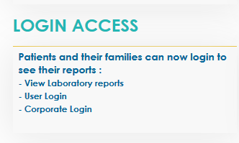

Below are the links :

**-** [**View Laboratory reports**](https://jaslokwebserver.jaslokhospital.net/jaslokwebreports/default.aspx)

**Link: https://** ja**slokwebserver.jaslokhospital.net/jaslokwebreports/default.aspx**

**-** [**User Login**](https://jaslokwebserver.jaslokhospital.net/jaslok_bill/User_Login.aspx)

**Link: https://jaslokwebserver.jaslokhospital.net/jaslok_bill/User_Login.aspx**

**-** [**Corporate Login**](https://jaslokwebserver.jaslokhospital.net/jaslok_bill/Corporate_login.aspx)

**Link: https://** **jaslokwebserver.jaslokhospital.net/jaslok_bill/Corporate_login.aspx**

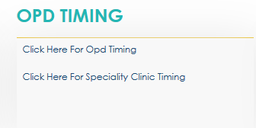

**Below are the links :**

**-Click Here For Opd Timing**

**Links : https:// jaslokhospital.net/Specialitywise-OPD**

**-**