**Assignment: Basic Calculator Script**

This assignment focuses on creating a JavaScript script that performs basic arithmetic operations on two numbers. You will build a calculator that computes addition, subtraction, multiplication, and division, logs the results to the console, and answer related questions. The task emphasizes variables, arithmetic operations, error handling, and string formatting.

**Objectives**

* Practice variable declaration and arithmetic operations in JavaScript.
* Implement basic error handling for division by zero.
* Use string concatenation or template literals for formatted output.
* Understand type coercion in JavaScript.

**Task**

Write a JavaScript code that:

1. Declares two number variables:
   * num1 (number): The first number (e.g., 10).
   * num2 (number): The second number (e.g., 2).
2. Performs the following operations:
   * Addition (num1 + num2)
   * Subtraction (num1 - num2)
   * Multiplication (num1 * num2)
   * Division (num1 / num2, with error handling for division by zero)
3. Uses console.log to output a formatted sentence in the format:
4. Addition: 12, Subtraction: 8, Multiplication: 20, Division: 5 or, if division by zero occurs: Addition: 10, Subtraction: 10, Multiplication: 0, Division: Cannot divide by zero
5. Tests the script with at least two sets of numbers (e.g., positive, negative, or decimal).
6. Includes clear comments, with one explaining type coercion (e.g., numbers to strings in output).

**Output Example**

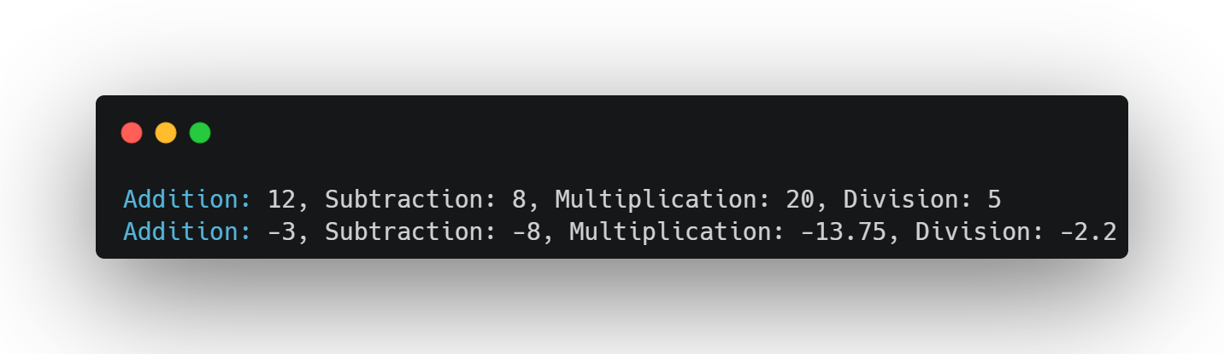

**Questions**

1. Explain the difference between let, const, and var for variable declaration in JavaScript.
2. What happens if you try to divide by zero without error handling? Provide an example of the output.
3. How does type coercion affect the output when combining numbers with strings in the log message?

**Submission Instructions**

* Save your script as calculator.js and your answers to the questions in a file named answers.txt.
* Email your submissions to [tech@skillyards.com](mailto:tech@skillyards.com) by default deadline:   
  **26 June** **11PM.**
* Upload your code to the GitHub repository:  
  <https://github.com/Skill-yards/Assignment-Submission.git>
* Ensure your code runs without errors in a JavaScript environment (e.g., Node.js or browser console).

*Course: Introduction to JavaScript | Instructor: Mrigesh Deshpande | Date: June 26, 2025*