**Assignment: Traffic Light Simulator Script**

You will use a variable to store a traffic light color (red, yellow, or green) and log the corresponding action (stop, wait, or go) to the console. The task emphasizes variable declaration, conditional statements, and string formatting, encouraging you to apply basic JavaScript concepts.

**Objectives**

* Practice variable declaration and string manipulation in JavaScript.
* Use conditional statements (e.g., if, switch) to determine outcomes.
* Apply string concatenation or template literals for formatted output.
* Understand basic control flow in JavaScript.

**Task**

Write a JavaScript script that:

1. Declares a variable:
   * color (string): The traffic light color (e.g., "red", "yellow", or "green").
2. Uses conditional logic to determine the action based on the color:
   * "red" → "Stop"
   * "yellow" → "Wait"
   * "green" → "Go"
   * Any other input → "Invalid color"
3. Uses console.log to output a formatted sentence in the format:
4. The traffic light is red: Stop
5. Tests the script with at least three different inputs (e.g., "red", "green", and an invalid color like "blue").
6. Includes clear comments, with one explaining how strings are used or handled in the script (e.g., string comparison or formatting).

**Output Example**

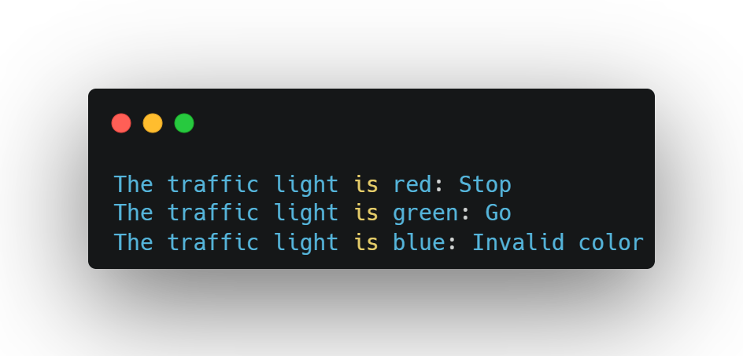

**Questions**

1. Explain the difference between if, else if, and switch statements for handling conditional logic in JavaScript.
2. How would you modify the script to use string concatenation instead of template literals (or vice versa) for the output?
3. What happens if you compare the color variable without considering case sensitivity (e.g., "Red" vs. "red")? Provide an example.
4. How could you modify the script to accept user input for the color using prompt() in a browser environment?

**Submission Instructions**

* Save your script as trafficLight.js and your answers to the questions in a file named answers.txt.
* Email your submissions to [tech@skillyards.com](mailto:tech@skillyards.com) by default deadline: 27-06-2025 11PM.
* Upload your code to the GitHub repository:   
  <https://github.com/Skill-yards/Assignment-Submission.git>
* Ensure your code runs without errors in a JavaScript environment (e.g., Node.js or browser console).

*Course: Introduction to JavaScript | Instructor: Mrigesh Deshpande | Date: June 27, 2025*