**Assignment: Triangle Star Pattern Script**

In this assignment, you’ll write a JavaScript script to create a triangle pattern made of stars, starting with 1 star in the first row, 2 stars in the second, and up to 5 stars in the fifth row. You’ll use nested loops to build the pattern and display it in the console. This task helps you practice loop, and printing output while learning how to control the flow of your code.

**Objectives**

* Practice using nested loops to create patterns.
* Apply string manipulation to build and display output.
* Use console.log for formatted pattern display.
* Understand iteration and string concatenation in JavaScript.

**Task**

Write a JavaScript script that:

1. Uses nested loops to generate a triangle star pattern with 5 rows:
   * Row 1: 1 star (*)
   * Row 2: 2 stars (**)
   * Row 3: 3 stars (***)
   * Row 4: 4 stars (****)
   * Row 5: 5 stars (*****)
2. Uses console.log to output each row of the pattern.
3. Tests the script to ensure the pattern displays correctly.

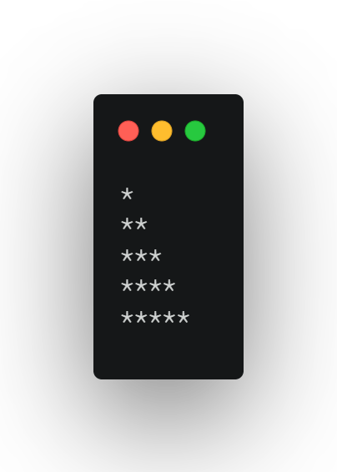

**Questions**

1. Explain the difference between a for loop and a while loop in JavaScript, and why you chose one for this task.
2. How would you modify the script to generate a reverse triangle pattern (e.g., 5 stars down to 1 star)?
3. How could you modify the script to allow the user to specify the number of rows (e.g., using prompt() in a browser)?

**Submission Instructions**

* Save your script as triangleStar.js and your answers to the questions in a file named answers.txt.
* Email your submissions to [tech@skillyards.com](mailto:tech@skillyards.com) by default deadline: 30-06-2025 11PM.
* Upload your code to the GitHub repository: <https://github.com/Skill-yards/Assignment-Submission.git>
* Ensure your code runs without errors in a JavaScript environment (e.g., Node.js or browser console).

*Course: Introduction to JavaScript | Instructor: Mrigesh Deshpande | Date: June 30, 2025*