**Assignment: Playlist App Script**

In this assignment, you’ll write a JavaScript script to create a simple playlist app. You’ll use an array to store song names, add and remove songs, and display the playlist in the console. This task helps you practice working with arrays, array methods, and printing output while learning how to manage data in JavaScript.

**Objectives**

* Learn to create and manipulate arrays in JavaScript.
* Practice using array methods like push and splice to add and remove items.
* Use console.log to display the playlist clearly.
* Understand how to work with strings and arrays together.

**Task**

Write a JavaScript script that:

1. Creates an array of at least three song names (strings), e.g.,   
   ["Song A", "Song B", "Song C"].
2. Adds a new song to the end of the playlist using an array method.
3. Removes a song from the playlist (e.g., the second song) using an array method.
4. Uses console.log to output the playlist in a formatted way, e.g.:
5. Playlist: Song A, Song B, Song C
6. Tests the script by showing the playlist before and after adding/removing songs.
7. Includes clear comments, with one explaining how arrays or strings are manipulated (e.g., how songs are added or joined for display).

**Output Example**

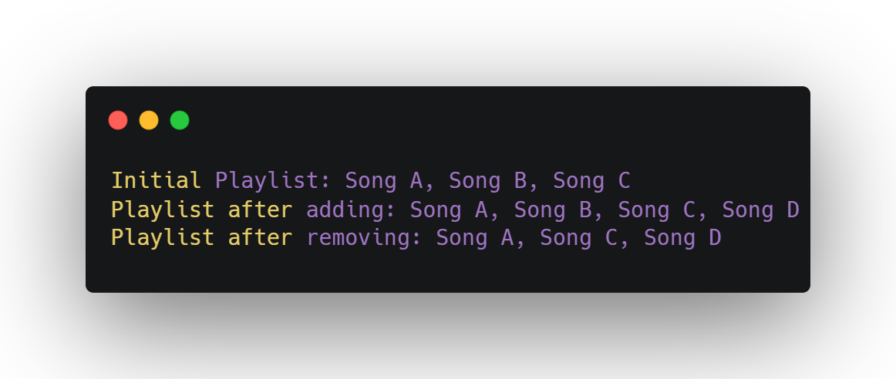

**Questions**

1. Explain the difference between push and unshift for adding elements to an array in JavaScript.
2. What happens if you try to remove a song at an invalid index (e.g., index 10 in a 3-song array)? Provide an example of the result.
3. How could you modify the script to allow the user to input a song name to add using prompt() in a browser?

**Submission Instructions**

* Save your script as playlistApp.js and your answers to the questions in a file named answers.txt.
* Email your submissions to [tech@skillyards.com](mailto:tech@skillyards.com) by default deadline: 25-06-2025 11PM.
* Upload your code to the GitHub repository:   
  <https://github.com/Skill-yards/Assignment-Submission.git>
* Ensure your code runs without errors in a JavaScript environment (e.g., Node.js or browser console).

*Course: Introduction to JavaScript | Instructor: Mrigesh Deshpande | Date: June 30, 2025*