**Assignment: Tip Calculator**

In this assignment, you’ll write a JavaScript script to create a tip calculator function. The function will take a bill amount and a tip percentage (defaulting to 15%) as inputs, calculate the tip, and log both the tip amount and the total bill (bill + tip) in Indian Rupees (₹) to the console. This task helps you practice creating functions, handling parameters, performing calculations, and formatting output in JavaScript.

**Objectives**

* Learn to create and use functions with default parameters.
* Practice basic arithmetic operations for calculations.
* Use console.log to display formatted results in Rupees.
* Understand how to work with numbers and string formatting.

**Task**

Write a JavaScript script that:

1. Defines a function called calculateTip that accepts:
   * billAmount (number): The total bill amount in Rupees (e.g., 500).
   * tipPercentage (number, optional): The tip percentage (e.g., 15 for 15%, defaults to 15 if not provided).
2. Calculates:
   * The tip amount (billAmount * tipPercentage / 100).
   * The total amount (billAmount + tip).
3. Uses console.log to output a formatted message, e.g.:
4. Bill: ₹500, Tip (15%): ₹75, Total: ₹575
5. Tests the function with at least three cases:
   * A bill with the default tip percentage.
   * A bill with a custom tip percentage.
   * A bill with a different amount and custom tip percentage.
6. Includes clear comments, with one explaining how numbers are formatted or manipulated (e.g., using toFixed for decimal places or string formatting).

**Output Example**

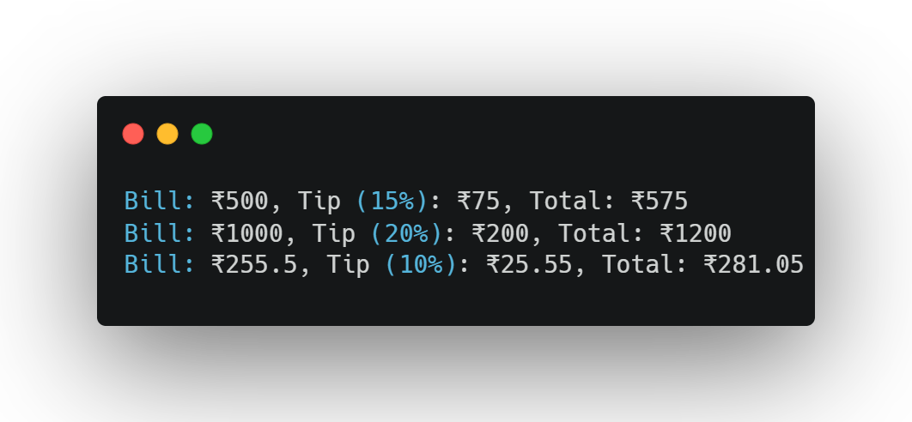

**Questions**

1. Explain the purpose of default parameters in JavaScript functions and how they are used in this script.
2. How would you modify the script to use string concatenation instead of template literals (or vice versa) for the output?
3. What happens if a negative bill amount or tip percentage is passed to the function? Provide an example of the output.

**Submission Instructions**

* Save your script as tipCalculator.js and your answers to the questions in a file named answers.txt.
* Email your submissions to [tech@skillyards.com](mailto:tech@skillyards.com) by default deadline: 25-06-2025 11PM.
* Upload your code to the GitHub repository: <https://github.com/Skill-yards/Assignment-Submission.git>
* Ensure your code runs without errors in a JavaScript environment (e.g., Node.js or browser console).

*Course: Introduction to JavaScript | Instructor: Mrigesh Deshpande | Date: June 30, 2025*