35.What is the difference between synchronous and asynchronous mode of communication in control flow architecture?
Synchronous Transmission | Asynchronous Transmission
In Synchronous transmission, data is sent in form of blocks or frames. | In Asynchronous transmission, data is sent in form of bytes or characters.
Synchronous transmission is fast. | Asynchronous transmission is slow.
Synchronous transmission is costly. | Asynchronous transmission is economical.
n Synchronous transmission, the time interval of transmission is constant. | In Asynchronous transmission, the time interval of transmission is not constant, it is random.
In this transmission, users have to wait till the transmission is complete before getting a response back from the server. | Here, users do not have to wait for the completion of transmission in order to get a response from the server.
In Synchronous transmission, there is no gap present between data. | In Asynchronous transmission, there is a gap present between data.
36.Write a VHDL code to implement Full Adder
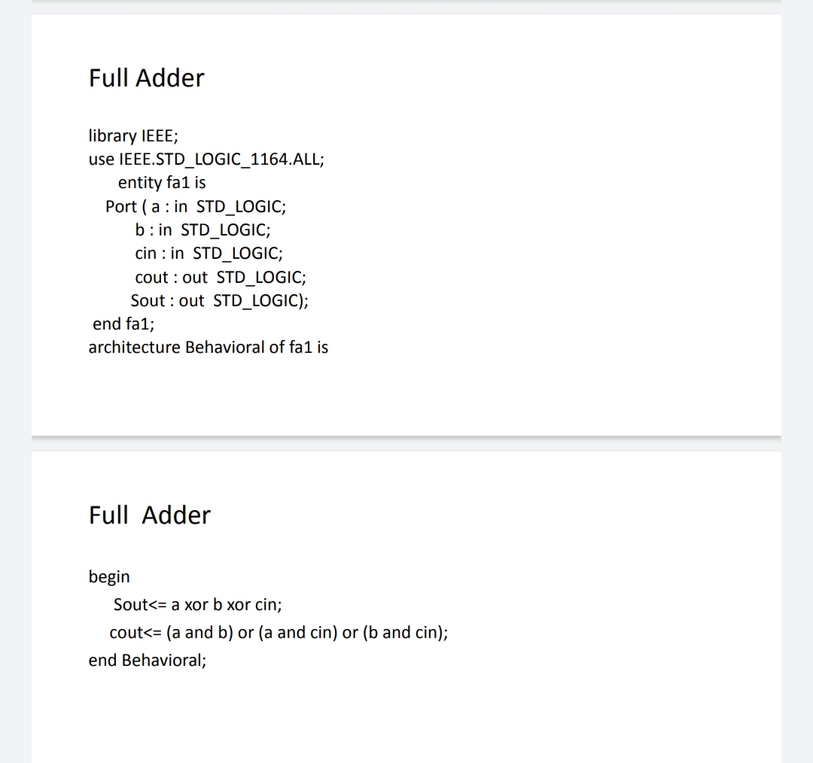
37.Write a VHDL code to implement Half Adder
