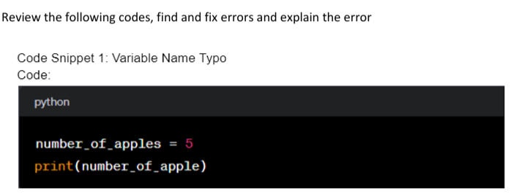

Error:
NameError: name 'number_of_apple' is not defined.
Corrected Code
number_of_apples=5
print(number_of_apples)
Error Explanation
This error has occurred as the variable name was ‘number_of_apples’ and we have used the variable name as number_of_apple while printing. So, the ‘number_of_apple’ is not priorly defined hence it gives an error.


Error
IndexError: list index out of range
Corrected Code
fruits=["apple","banana","cherry"]
print(fruits[2])

Error Explanation
We know that array indexing starts from 0 in python so if there are three elements then array indexes of those elements must be 2. An index 3 will lead to an index error.

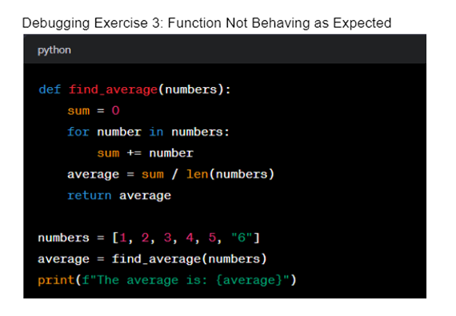

Error
TypeError: unsupported operand type(s) for +=: 'int' and 'str'
Corrected Code
def find_average(numbers):
sum=0
for number in numbers:
sum+=int(number)
average=sum/len(numbers)
return average
numbers=[1,2,3,4,5,”6”]
average=find_average(numbers)
print(f"The average is: {average}")
OUTPUT
The average is: 3.5
Error Explanation
In this code we are calculating the average of numbers. So, we are passing 1,2,3,4,5,6 as parameters. But when we were passing 1,2,3,4,5 and “6”, the “6” value was of type ‘str’ and not ‘int’. So, it is not possible to calculate the average of integer values along with a string. So, it provided a type error. So we are first converting all the values passed into integers.
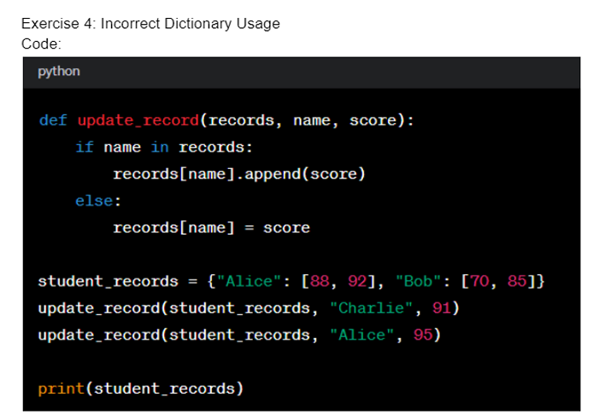

Error
Attribute Error
Corrected Code
def update_record(records, name, score):
if name in records:
records [name].append(score)
else:
records [name] = [score]
student_records = {"Alice" : [88, 92], "Bob": [70,85]}
update_record(student_records, "Charlie", 91)
update_record(student_records, "Alice", 95)
print(student_records)
Error Explanation
The new element of dictionary when created it should have keys as list
So, to use append function new key for value must be created as a list otherwise it shall show an attribute error.

