Name-Mrigangana Sarkar
Email-mriganganasarkar@gmail.com
Domain-Python Programming
Number-9093649825

GitHub link-https://github.com/Mrigangana-Sarkar/VaultOfCodesAssignment2

LinkedIn Post Link-https://www.linkedin.com/posts/mrigangana-sarkar-71a877280_github-mrigangana-sarkarvaultofcodesassignment2-activity-7249302090257182720-z7EE?utm_source=share&utm_medium=member_android

Implementation Code
# Secret Code Generator: Encode and Decode Messages using a Caesar Cipher

# Function to encode a message
def encode_message(message, shift):
encoded_message = ""
for char in message:
# Check if it's an uppercase letter
if char.isupper():
# Shift character and handle wrap-around using modulo 26
encoded_message += chr(((ord(char) - 65 + shift) % 26) + 65)
# Check if it's a lowercase letter
elif char.islower():
# Shift character and handle wrap-around using modulo 26
encoded_message += chr(((ord(char) - 97 + shift) % 26) + 97)
else:
# If it's not a letter, add it as is
encoded_message += char
return encoded_message

# Function to decode a message
def decode_message(encoded_message, shift):
decoded_message = ""
for char in encoded_message:
# Check if it's an uppercase letter
if char.isupper():
# Reverse shift and handle wrap-around using modulo 26
decoded_message += chr(((ord(char) - 65 - shift) % 26) + 65)
# Check if it's a lowercase letter
elif char.islower():
# Reverse shift and handle wrap-around using modulo 26
decoded_message += chr(((ord(char) - 97 - shift) % 26) + 97)
else:
# If it's not a letter, add it as is
decoded_message += char
return decoded_message

# Function to handle user input and menu choices
def secret_code_generator():
while True:
print("\nSecret Code Generator Menu")
print("1: Encode a message")
print("2: Decode a message")
print("3: Exit")

choice = input("Choose an option (1/2/3): ")

if choice == '1':
# Encoding
message = input("Enter the message to encode: ")
try:
shift = int(input("Enter the shift number: "))
encoded_message = encode_message(message, shift)
print(f"Encoded Message: {encoded_message}")
except ValueError:
print("Invalid shift number. Please enter a valid integer.")

elif choice == '2':
# Decoding
encoded_message = input("Enter the message to decode: ")
try:
shift = int(input("Enter the shift number: "))
decoded_message = decode_message(encoded_message, shift)
print(f"Decoded Message: {decoded_message}")
except ValueError:
print("Invalid shift number. Please enter a valid integer.")

elif choice == '3':
# Exit
print("Exiting the program. Goodbye!")
break
else:
print("Invalid choice. Please select 1, 2, or 3.")

# Call the main menu function to run the program
if __name__ == "__main__":
secret_code_generator()

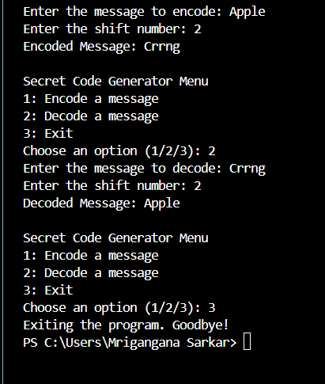
OUTPUT SCREENSHOTS

