OUTPUT
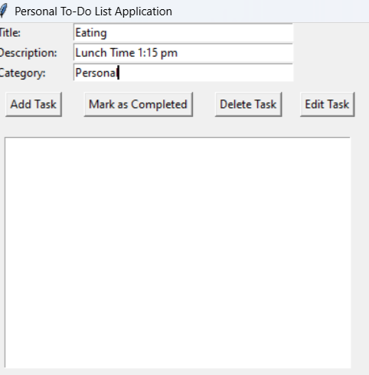
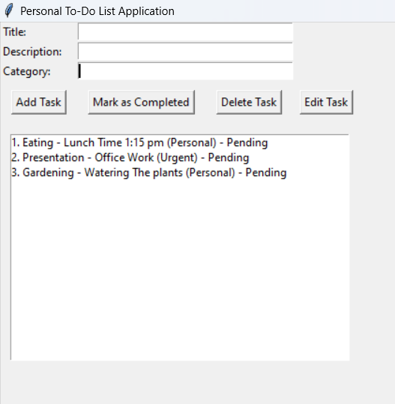
ADD TASK

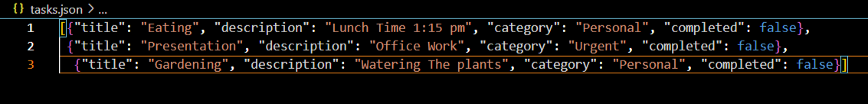
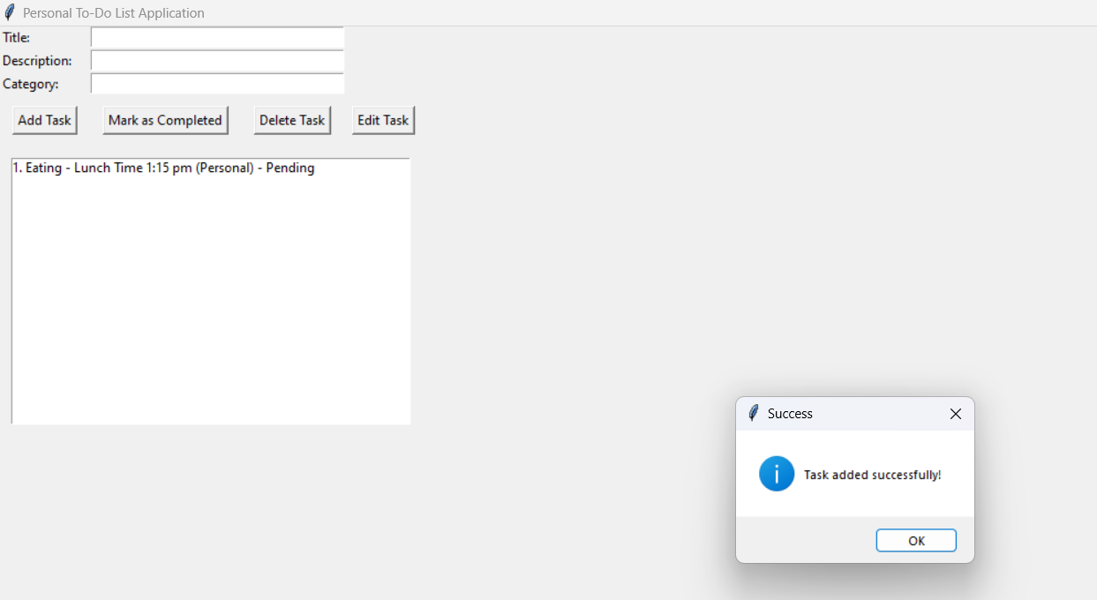
After clicking Add Task Button

tasks.json

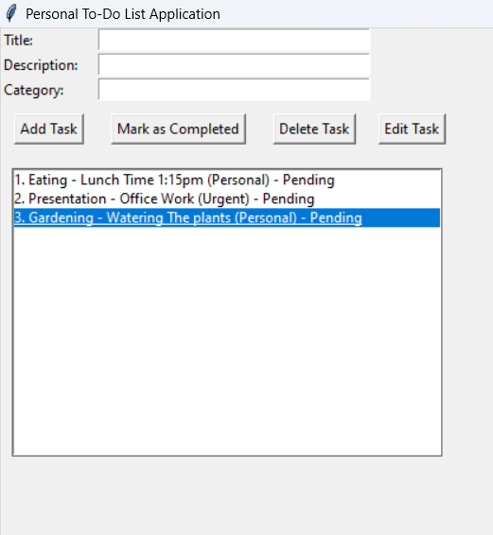
Mark as Completed-Selecting the task to be marked as completed

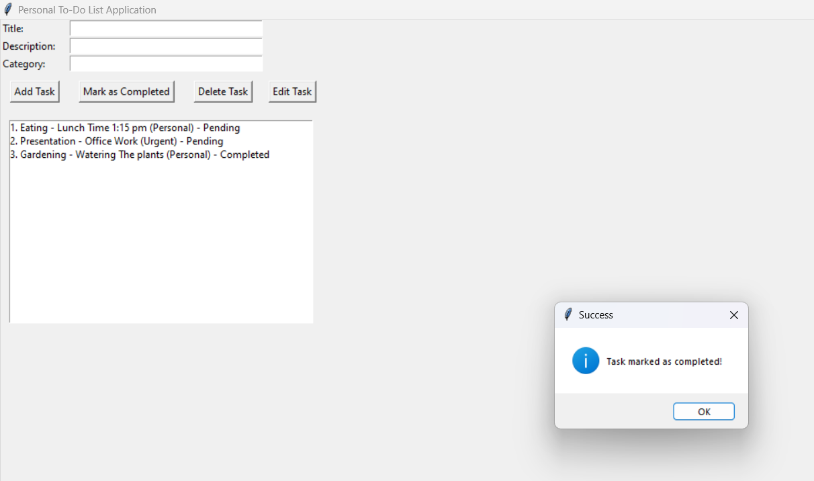
After clicking Mark as Completed Button

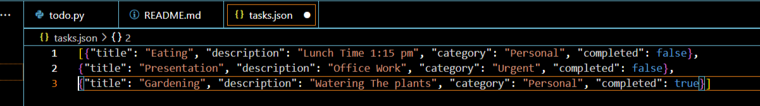
tasks.json

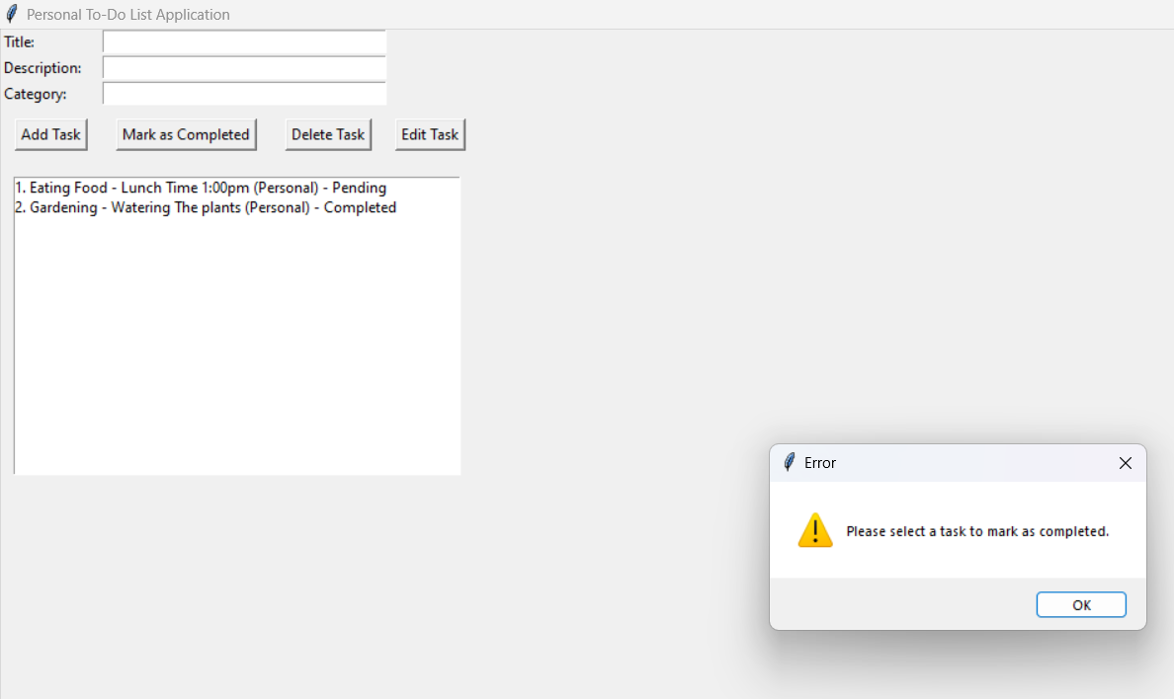
If Mark as Completed button is pressed without selecting the task

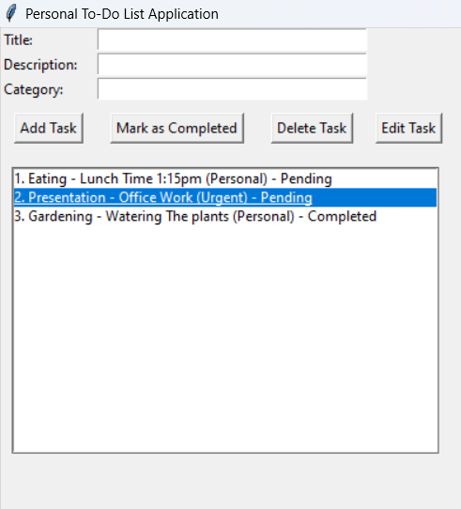
Delete Task- Selecting the task to be deleted

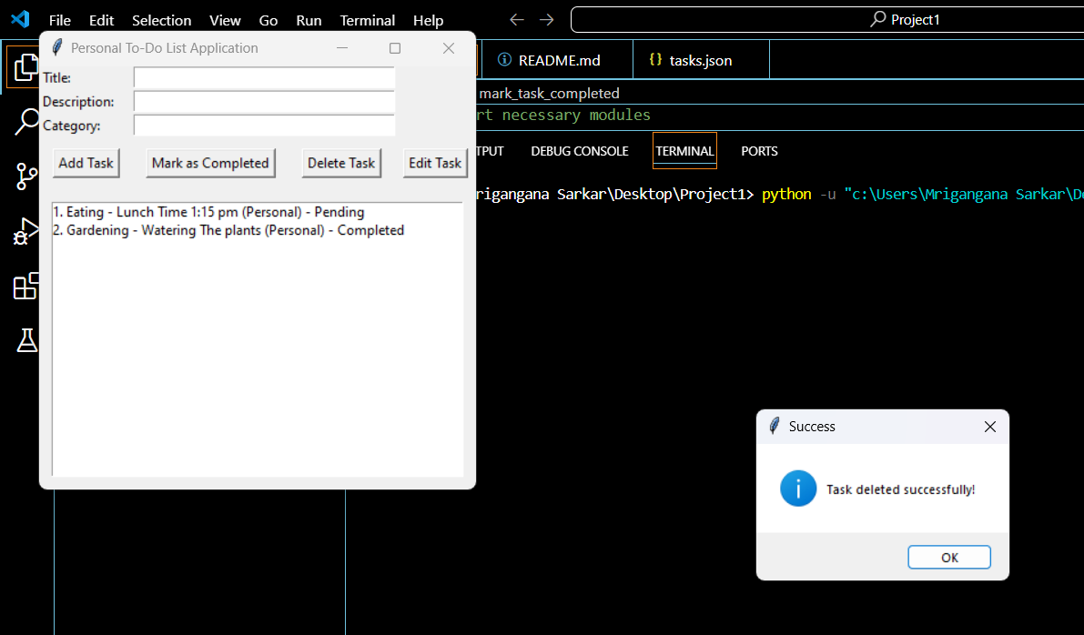
After clicking Delete Task Button

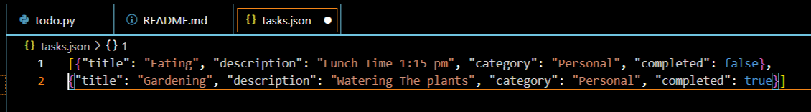
tasks.json

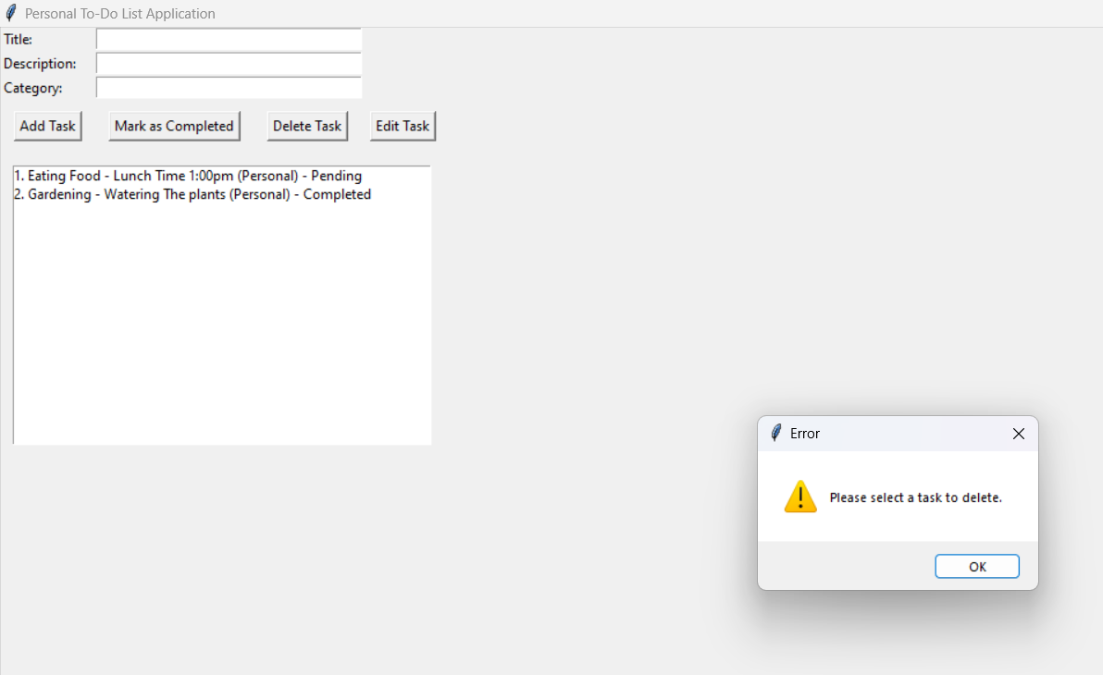
If Delete task button is pressed without selecting the task

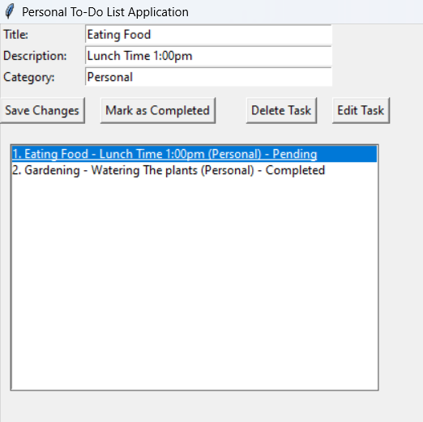
Edit Task-Selecting the task to be edited and also editing the task

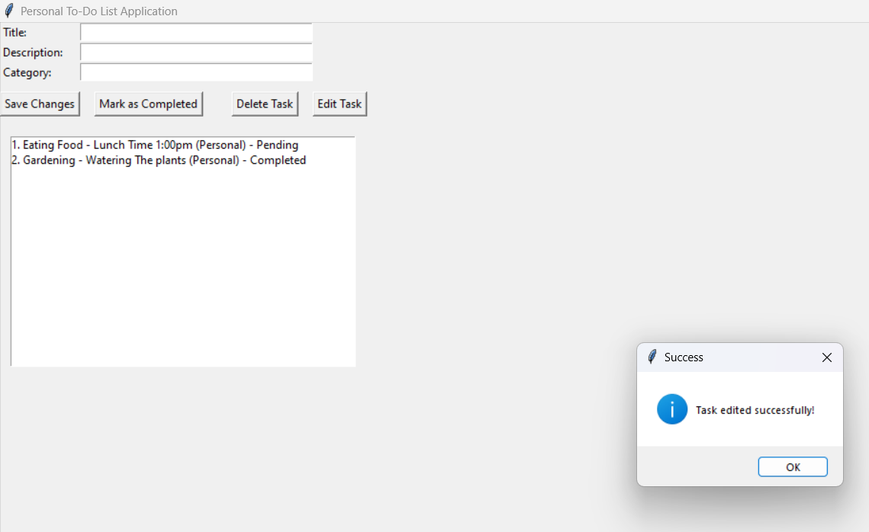
After clicking on Save Changes button

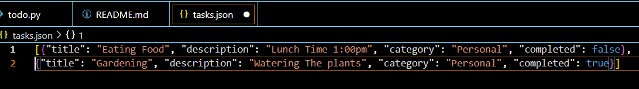
tasks.json

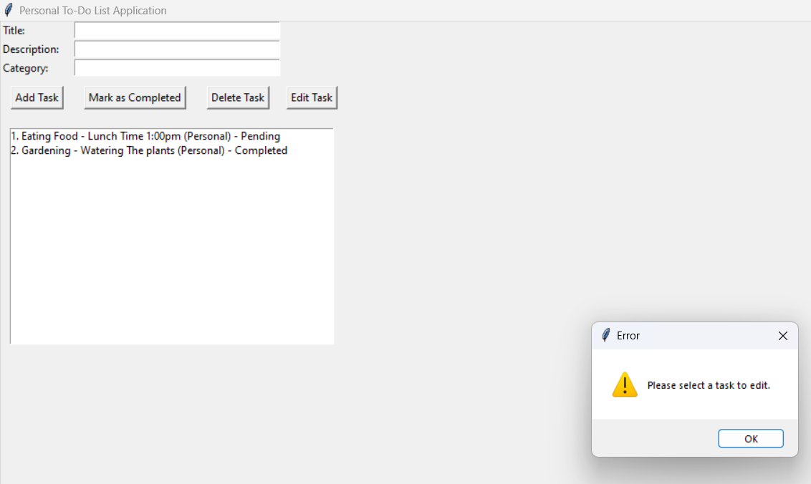
If Edit task button is pressed without selecting the task

