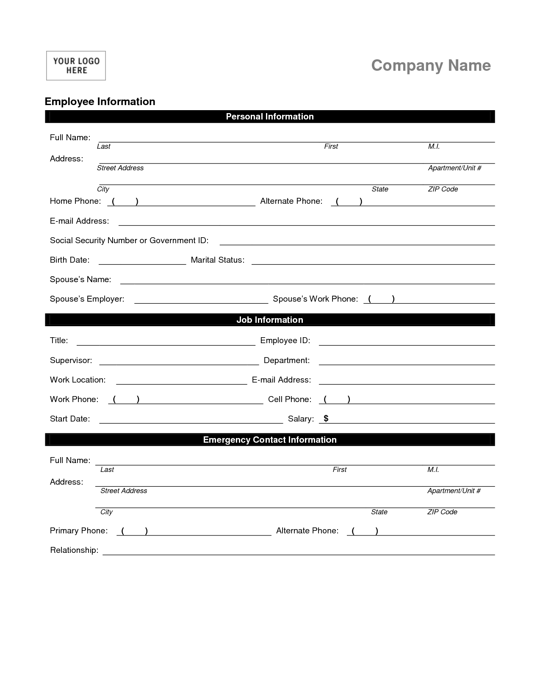

**Scene description:**

Imagine that you work for some IT company as a new assistant of an HR Manager. You are standing in a crowded room where are waiting a lot of people for job interviews. Potential employees got stressed and that makes them impatient and at all costs (za wszelką cenę) we want to avoid a bad first impression. In IT industry more often a potential employee is more important than a company and this is what (I to właśnie) companies fight for a good programmer, analyst, tester or other IT specialist. Your job is to collect all fulfilled necessary forms like the one above as fast as you can. Don’t forget about being polite and making a great impression of your company.

**The first Scene:** Task delegation.

HR Manager: Hi, here you have got a form of personal data. Please walk to everybody in this room and ask them for personal data. When they are giving you data you will check these (data) with their ID cards.

Me: Ok, no problem I can handle it very well. But I have one question or rather a suggestion. Maybe I´ll ask each person to that table to separate him to feel that his personal data is and will be fully confidential.

HR Manager: Yeah, it’s a great idea, but don’t bother me, because that’s why I chose you for this job. Handle it perfect and I have my own duties so for now, that’s all. Oh, wait when you finish this task, write the time down to your daily schedule and then take a break. After that, come to my office I have many tasks for you today.

[https://etutor-images-common.s3.eu-central-1.amazonaws.com/en/transcriptions/audience.png](https://www.diki.pl/podrecznik-angielski/wymowa-angielska/alfabet-fonetyczny)Me: Ok, back to work.

**The second scene:** Announce to the audience.

Me: Hi everyone to improve the application process I would like to ask each of you to fill personal data form. Let´s organize it that way: I will sit at that desk and call one person at a time. Please before prepare your ID card. If someone doesn´t know yet, you can ask Maria (points her) for drinks: water or juice. Ok, let´s get started.

(walk to the desk and sit)

Please come and then the next person from this side of the room to the end.

Hi, please your form and a pencil. And don’t worry about the fact that I´ll look over your shoulder because I will only check the correctness of your data compared to the ID card.

Please write in capital letters.

**The third scene:** Complete the form for someone who has trouble.

Me: Please fill out the form with your data in capital letters the I will check the correctness compared to your ID card.

Sbd: Excuse me I´m not sure what should I put here.

Me: