Computer Vision Assignment 10

import cv2

import numpy as np

import matplotlib.pyplot as plt

from google.colab.patches import cv2_imshow img1 = cv2.imread('messi.jfif')

G = img1.copy() gpimg = [G]

**for** i **in** range(6): G = cv2.pyrDown(G) gpimg.append(G)

cv2_imshow(gpimg[i])

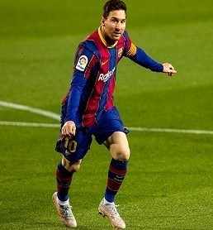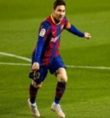

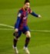



lpimg = [gpimg[5]] cv2_imshow(lpimg[0]) **for** i **in** range(6,0,-1):

GE = cv2.pyrUp(gpimg[i])

GE = cv2.resize(GE, gpimg[i -1].shape[-2::-1]) L = cv2.subtract(gpimg[i-1],GE) lpimg.append(L)

**for** i **in** range(6,0,-1): cv2_imshow(lpimg[i])

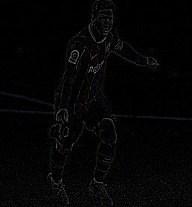

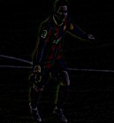

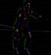

import cv2

import numpy as np

import matplotlib.pyplot as plt

from google.colab.patches import cv2_imshow A = cv2.imread('apple.jfif')

B = cv2.imread('orange.jpg') *# generate Gaussian pyramid* G = A.copy()

gpA = [G]

**for** i **in** range(6): G= cv2.pyrDown(G) gpA.append(G)

*# generate Gaussian Pyramid B*

G = B.copy() gpB = [G]

**for** i **in** range(6): G = cv2.pyrDown(G) gpB.append(G)

lpA = [gpA[5]]

**for** i **in** range(6,0,-1): GE = cv2.pyrUp(gpA[i])

GE = cv2.resize(GE,gpA[i -1].shape[-2::-1]) L = cv2.subtract(gpA[i-1],GE)

lpA.append(L) lpB = [gpB[5]]

**for** i **in** range(6,0,-1): GE = cv2.pyrUp(gpB[i])

GE = cv2.resize(GE,gpB[i -1].shape[-2::-1]) L = cv2.subtract(gpB[i-1],GE)

lpB.append(L)

*# now add left and right halves of image in each level*

LS = []

lpAc = []

**for** i **in** range(len(lpA)):

b = cv2.resize(lpA[i],lpB[i].shape[-2::-1]) lpAc.append(b)

j=0

**for** i **in** zip(lpAc,lpB): la,lb = i

rows,cols,dpt = la.shape

ls = np.hstack((la[:,0:cols//2],lb[:,cols//2:])) j=j+1

LS.append(ls) ls_ = LS[0]

**for** i **in** range(1,6): ls_= cv2.pyrUp(ls_)

ls_ = cv2.resize(ls_,LS[i].shape[-2::-1]) ls_ = cv2.add(ls_,LS[i])

*# image direct connected each half*

B = cv2.resize(B,A.shape[-2::-1])

real = np.hstack((A[:,:cols//2],B[:,cols//2:])) cv2.imwrite('Pyramaid_blending2.jpg',ls_) cv2.imwrite('Blending.jpg',real) cv2_imshow(ls_)

cv2_imshow(real)

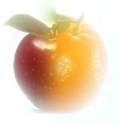

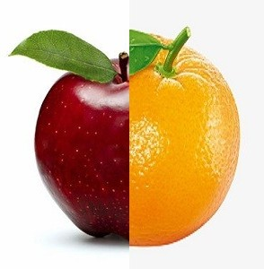

import cv2

import numpy as np

import matplotlib.pyplot as plt

from google.colab.patches import cv2_imshow im = cv2.imread('blob1.jpg')

gray = cv2.cvtColor(im, cv2.COLOR_BGR2GRAY) cv2_imshow(im)

params = cv2.SimpleBlobDetector_Params() detector = cv2.SimpleBlobDetector_create(params) keypoints = detector.detect(gray)

im_with_keypoints = cv2.drawKeypoints(gray,keypoints, np.array([]), (0,0,255),cv2.DRAW_MATCHES_FLAGS_DRAW_RICH_KEYPOINTS)

cv2_imshow(im_with_keypoints)

