**Patent Analytics**

Major Project Report

Submitted in Partial Fulfillment of the Requirements for

the Award of Degree of

**Bachelor in Information Technology**



# 

Submitted by:

MRINAL BHASKAR(1406654) IT- F

Department of Information Technology

Chandigarh Engineering College

**Patent Analytics**

Major Project Report

Submitted in Partial Fulfillment of the Requirements for

the Award of Degree of

**Bachelor in Information Technology**



# 

Submitted by:

MRINAL BHASKAR(1406654) IT- F

Department of Information Technology

Chandigarh Engineering College

CERTIFICATE

This is to certify that the work presented in the thesis entitled “Patent Analytics” is a bonafide record of the work done during the period from Jan, 2018 to July, 2018 at Evalueserve, Gurugram, Haryana, by **MrinalBhaskar (1406654)**.

The project work is an authentic record of my own work and is carried out under the supervision and guidance of **Mr Vijay Khatri, Manager**. The matter presented in the report has not been submitted elsewhere, wholly or in part, for the award of any other degree or diploma.

MrinalBhaskar(1406654)

 This is to certify that the above statement made by the candidate is correct to the best of my knowledge.

**Ms Astha Gupta**

Designation

Department of Information & Technology

**Dr. Shashi Bhushan**

Professor and Head

Department of Information & Technology

ChandigarhEngineeringCollege, Landran, Mohali, PUNJAB

ACKNOWLEDGEMENT

I take this opportunity to express my sincere gratitude to the Entire team of IPRD Department of Evalueserve for providing this opportunity to carry out the present thesis work.

The constant guidance and encouragement received from **Mr Vijay Khatri, Manager**, IPRD-02, Evalueserve, has been of great help in carrying our present work and helped us in completing this project with success.

I would like to express a deep sense of gratitude to my Project Advisor**Mr Karan Chadha**, for his guidance and support in defining the design problem and towards the completion of my project work. Without his wise counsel and able guidance, it would have been impossible to complete the project in this manner.

I am also thankful to all the faculty and staff members of Department of Information Technology, Chandigarh Engineering College, Landran for their intellectual support throughout the course of this work.

Mrinal Bhaskar (1406654)

**Table of contents**

**Abstract**………………................................................................................................................ 1-2

**Cerificate...**...................................................................................................................................... 3

**Acknowledgement** ......................................................................................................................... 4

**Table of contents** ........................................................................................................................... 5

**List of figures** ................................................................................................................................. 6

**List of tables**................................................................................................................................... .7

1. **Company Profile** ........................................................................................................................ 9

1.1. History....................................................................................................................................... 9

1.2. Services Offered by Company ............................................................................................... 10

2. **Technology** ............................................................................................................................... **11**

1.1. Intellectual Property Right...................................................................................................... 11

1.2. Patent Deatiled Description .................................................................................................... 13

1.3. Patent Terminology................................................................................................................. 17

1.4. Patent Research and Patent Analysis ...................................................................................... 22

1.5. Prior Art in Patent Industry..................................................................................................... 24

1.6. Product Search......................................................................................................................... 30

1.8. Patent Prosecution.................................................................................................................. 36

1.9. Patent Classification............................................................................................................... 42

1.10. Patent Drafting..................................................................................................................... 50

3. **References** ............................................................................................................................... 52

**List of Figures**

|  |  |  |  |
| --- | --- | --- | --- |
| **Sr. No.** | **Figure** | **Description** | **Page No.** |
| 1 | Figure 1 |  | 11 |
| 2 | Figure 2 |  | 13 |
| 3 | Figure 3 |  | 21 |
| 4 | Figure 4 |  | 23 |
| 5 | Figure 5 |  | 29 |
| 6 | Figure 6 |  | 32 |
| 7 | Figure 7 |  | 49 |
| 8 | Figure 3.3 |  | 14 |
| 9 | Figure 3.4 |  | 15 |
|  |  |  |  |
|  |  |  |  |
|  |  |  |  |
|  |  |  |  |
|  |  |  |  |

**List of Tables**

|  |  |  |  |
| --- | --- | --- | --- |
| **Sr. No.** | **Table** | **Description** | **Page No.** |
| 1 | Table 4.1 |  | 21 |

**COMPANY PROFILE:**

**EVALUESERVE** is a global market [research company](https://de.wikipedia.org/wiki/Marktforschung) with around 3,200 employees. The company is headquartered in Switzerland. Its largest office is in India, others in [China](https://de.wikipedia.org/wiki/Volksrepublik_China) , [Chile](https://de.wikipedia.org/wiki/Chile) and [Romania,](https://de.wikipedia.org/wiki/Rum%C3%A4nien) and is represented worldwide by client executives.

## COMPANY HISTORY

Evalueserve was founded in 2000 by former [McKinsey](https://de.wikipedia.org/wiki/McKinsey) partner [Marc Vollenweider](https://de.wikipedia.org/w/index.php?title=Marc_Vollenweider&action=edit&redlink=1) and [IBM](https://de.wikipedia.org/wiki/IBM) research manager [Alok Aggarwal](https://de.wikipedia.org/w/index.php?title=Alok_Aggarwal&action=edit&redlink=1) . Since 2005, the company has a research center in [Shanghai](https://de.wikipedia.org/wiki/Shanghai) , China, since December [2006](https://de.wikipedia.org/wiki/2006) in [Valparaíso](https://de.wikipedia.org/wiki/Valpara%C3%ADso) , Chile and since August 2008 in Cluj, Romania. Clients include 100 of the [*Fortune 1,000*](https://de.wikipedia.org/wiki/Fortune_(Zeitschrift)) companies, many global [business consultancies](https://de.wikipedia.org/wiki/Unternehmensberatung) and some of the largest [investment banks](https://de.wikipedia.org/wiki/Investmentbank) . Since August 2014 Beyond Data GmbH is based in Rheinbach, part of the Evalueserve Group. In May 2015, Evalueserve announced the acquisition of the Dutch software company Treparel

In January 2015, the company introduces the term 'powered by mind + machine' into its positioning. Mind + machine describes the connection of specialized analysts with the latest information technology.  Evalueserve supports this repositioning through selected partnerships such as: For example, since April 2015 Evalueserve with Software AG, which will support Evalueserve with data analysis.

## SERVICES

About 15% of the studies are in Asian markets, about 80% in Europe and America. The company is able to offer research services in over 50 languages. The employees are all academics from different disciplines, so a specialist can be used in almost every industry and region.

The offers are divided into different areas:

**BUSINESS RESEARCH**

For strategy or [marketing](https://de.wikipedia.org/wiki/Marketing) departments, Evalueserve researches market trends, monitors competitors (Competitive Intelligence) and conducts benchmarking. New markets are identified, production locations assessed and potential cooperation partners sought. Evalueserve supports purchasing departments worldwide in global sourcing, in the identification of new suppliers and informs about industry novelties. A dedicated team also generates leads for customer sales departments and supports entry into global markets.

**MARKET RESEARCH**

Evalueserve carries out worldwide [market research](https://de.wikipedia.org/wiki/Marktforschung) studies on customer satisfaction, brand awareness or employee surveys.

**INVESTMENT RESEARCH**

Not only for [investment banks](https://de.wikipedia.org/wiki/Investmentbank) but also for [private equity](https://de.wikipedia.org/wiki/Private_Equity) , [venture capital](https://de.wikipedia.org/wiki/Venture_Capital) and [hedge funds](https://de.wikipedia.org/wiki/Hedgefonds) , researchers analyze markets, sectors and individual stocks. In M & A, Evalueserve provides support at every stage of the ownership cycle (eg [Initial Target Screening](https://de.wikipedia.org/w/index.php?title=Initial_Target_Screening&action=edit&redlink=1) , [Commercial Due Diligence](https://de.wikipedia.org/w/index.php?title=Commercial_Due_Diligence&action=edit&redlink=1) , Valuation).

[**PATENT SEARCHES**](https://de.wikipedia.org/wiki/Patent)**/ PATENT ANALYZES / PATENT APPLICATIONS**

With over 200 patent specialists, Evalueserve is one of the world's largest providers. Evalueserve supports patent departments and patent attorneys with research, analysis (patent & technology landscapes, [monitoring](https://de.wikipedia.org/wiki/Monitoring) , [valuation](https://de.wikipedia.org/w/index.php?title=Valuation&action=edit&redlink=1) ) and novel, tailor-made support for patent filing.

**DATA ANALYTICS**

In addition to the analysis of customer databases (eg for segmentation or measurement of sales or marketing efficiency), complete reporting, controlling or even management information systems are created and managed. The maintenance of databases is also part of Evalueserve's offerings.

**INTELLECTUEL PROPERY- AN INTRODUCTION**

Intellectual Property (IP) is the name given to patents, trademarks, copyrights, industrial designs and other types of intangible property that arise from creations of the mind and in their broadest sense have no physical form.

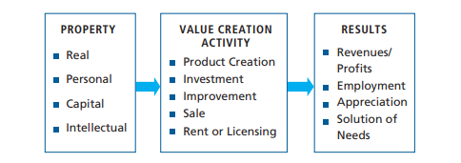

Figure

Like all types of property, IP is owned and can generate income. For this reason IP is considered an asset. It is often the result of investment and should generate a return of one sort or another. IP differs from other types of property because it has no physical form and comes into being because of human intelligence, creativity and imagination.

There are different types of IP each with its own unique laws. IP is sometimes divided into two general categories, “industrial property” and “copyright.” Industrial property refers to assets created primarily for the advancement of technology, industry and trade such as patents (inventions), industrial designs, trademarks, service marks, trade secrets and geographic indications of origin.1 The most common forms of IP are:

* **PATENTS**: A patent is a legal document granting its holder the exclusive right to control the use of an invention, as set forth in the patent’s claims, within a limited area and time by stopping others from, among other things, making, using or selling the invention without authorization. For example, patents could be granted for a battery that efficiently stores solar energy indefinitely and without loss, a vaccine to protect against malaria or a new compound for transforming fish bones into agricultural fertilizer.
* **INDUSTRIAL DESIGNS**: Industrial design protection allows its owner to control the exploitation of the ornamental shapes associated with products such as the stylish shape of a new sports car, the distinctive plastic casing of a certain type of computer or the shape of a soft drink bottle.
* **TRADEMARKS:** A trademark allows its owner to confirm the origin of his goods to the public. Examples of trademarks include the distinctive names of products such as Nando’s® or Coca Cola® or a logo such as the Mercedes Benz® triad symbol.
* **SERVICE MARKS:** A service mark is a form of trademark that allows its owner to verify the origin of a service to the public such as “Cheques for Two®.”
* **COPYRIGHT:** A copyright refers to original expressions and “works of authorship.” The person who creates a copyrighted work is called an author. Examples of copyrighted works include: paintings, photography, music, dances, poems, novels etc. In addition, copyright applies to some technical things that have an element of originality such as computer software, technical specifications and related documentation. One difference between copyrights and industrial property is that generally copyrights do not require registration with a government authority as a condition for protection against unauthorized use. Industrial property rights, on the other hand, must be expressly granted by, and registered with, a government authority before they can be recognized and enforced. In theory, anyone can draft a patent or a trademark application but in practice, professionals including lawyers (patent attorneys) and technical professionals called “patent agents” or “patent engineers” write patent applications and file them with government authorities because these applications can be technically and procedurally complex.

**PATENT- DETAILED DESCRIPTION**

A **patent** is a set of [exclusive rights](https://en.wikipedia.org/wiki/Exclusive_right) granted by a [sovereign state](https://en.wikipedia.org/wiki/Sovereign_state) or [intergovernmental organization](https://en.wikipedia.org/wiki/Intergovernmental_organization) to an inventor or assignee for a limited period of time in exchange for detailed public disclosure of an [invention](https://en.wikipedia.org/wiki/Invention). An invention is a solution to a specific technological problem and is a product or a process. Patents are a form of [intellectual property](https://en.wikipedia.org/wiki/Intellectual_property).

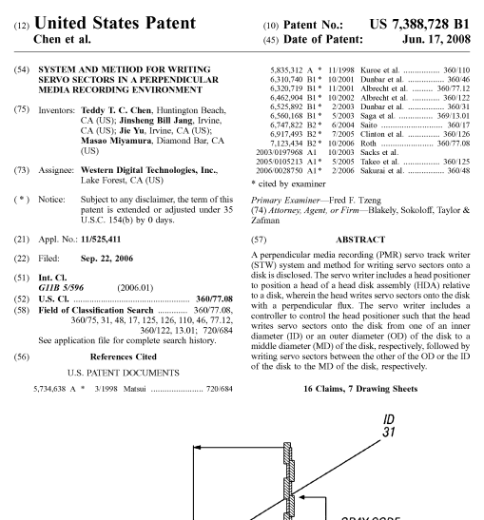

Figure

Patents may be granted to protect inventions that are new, involve an inventive step and are capable of industrial application.2 The patent has to be for an invention that works, or as it is put in some countries, the invention must be capable of being “reduced to practice.” Thus, a clever notion that cannot presently work (e.g. a time machine) cannot be patented. Different countries have different ways of expressing the criteria for patents. For example, patents must generally be technical in nature but not all jurisdictions have the same definitions for what is “technical” and what is not technical. A patent may include many claims, each of which defines a specific property right. These claims must meet relevant [patentability](https://en.wikipedia.org/wiki/Patentability) requirements, such as [novelty](https://en.wikipedia.org/wiki/Novelty_(patent)), [usefulness](https://en.wikipedia.org/wiki/Utility_(patent)), and [non-obviousness](https://en.wikipedia.org/wiki/Inventive_step_and_non-obviousness). The exclusive right granted to a patentee in most countries is the right to prevent others, or at least to try to prevent others, from commercially making, using, selling, importing, or distributing a patented invention without permission.

The term of a patent is generally twenty years from the filing date of the patent application. A patent gives its owner the right to exclude others from making, using, offering for sale or selling the invention or importing the patented invention into the country where the patent has been granted. In other words, a patent provides a property right that allows the owner to say who cannot use the invention protected by the patent. Anyone who is not the patent owner or who is not licensed by the patent owner and who manufactures, uses, imports, offers for sale or sells the patented invention is called an “infringer.” An infringer can be sued in court to force him to stop the infringement and to pay the owner damages.

Patents are “territorial;” they have effect only in countries where they have been applied for and granted. Each country has the sovereign right to grant or refuse to grant patent applications. In a few instances such as the European Patent Office (EPO), groups of nations have agreed by treaty to provide for common examination of patent applications. Some countries have also agreed by treaty to accept patents granted by other nations.3 For example, some former British colonies will accept patents approved by the UK Patent Office and/or the EPO when the UK is a designated country in the EPO application.

Under the [World Trade Organization](https://en.wikipedia.org/wiki/World_Trade_Organization)'s (WTO) [TRIPS Agreement](https://en.wikipedia.org/wiki/TRIPS_Agreement), patents should be available in WTO member states for any invention, in all fields of technology, provided they are new, involve an inventive step, and are capable of industrial application.Nevertheless, there are variations on what is [patentable subject matter](https://en.wikipedia.org/wiki/Patentable_subject_matter) from country to country, also among WTO member states. TRIPS also provides that the [term of protection](https://en.wikipedia.org/wiki/Term_of_patent) available should be a minimum of twenty years.

## BENEFITS

Primary incentives embodied in the patent system include incentives to invent in the first place; to disclose the invention once made; to invest the sums necessary to experiment, produce and market the invention; and to [design around](https://en.wikipedia.org/wiki/Design_around) and improve upon earlier patents.

1. Patents provide incentives for economically efficient [research and development](https://en.wikipedia.org/wiki/Research_and_development) (R&D). A study conducted annually by the IPTS shows that the 2,000 largest global companies invested more than 430 billion euros in 2008 in their R&D departments. If the investments can be considered as inputs of R&D, real products and patents are the outputs. Based on these groups, a project named Corporate Invention Board, had measured and analyzed the patent portfolios to produce an original pictureof their technological profiles. Supporters of patents argue that without patent protection, R&D spending would be significantly less or eliminated altogether, limiting the possibility of technological advances or breakthroughs. Corporations would be much more conservative about the R&D investments they made, as third parties would be [free to exploit](https://en.wikipedia.org/wiki/Free-rider_problem) any developments.
2. In accordance with the original definition of the term "patent", patents are intended to facilitate and encourage disclosure of [innovations](https://en.wikipedia.org/wiki/Innovation) into the [public domain](https://en.wikipedia.org/wiki/Public_domain) for the [common good](https://en.wikipedia.org/wiki/Common_good). Thus patenting can be viewed as contributing to [open hardware](https://en.wikipedia.org/wiki/Open-source_hardware) after an embargo period (usually of 20 years). If [inventors](https://en.wikipedia.org/wiki/Inventor_(patent)) did not have the legal protection of patents, in many cases, they might prefer or tend to keep their inventions secret (e.g. keep [trade secrets](https://en.wikipedia.org/wiki/Trade_secret)). Awarding patents generally makes the details of new technology publicly available, for exploitation by anyone after the patent expires, or for further improvement by other inventors. Furthermore, when a [patent's term](https://en.wikipedia.org/wiki/Term_of_patent) has expired, the public record ensures that the patentee's invention is not lost to humanity.
3. In many industries (especially those with high [fixed costs](https://en.wikipedia.org/wiki/Fixed_cost) and either low [marginal costs](https://en.wikipedia.org/wiki/Marginal_cost) or low reverse engineering costs — computer processors, and pharmaceuticals for example), once an invention exists, the cost of commercialization (testing, tooling up a factory, developing a market, etc.) is far more than the initial conception cost.

One effect of modern patent usage is that a small-time inventor, who can afford both the patenting process and the defense of the patent,can use the exclusive right status to become a licensor. This allows the inventor to accumulate capital from licensing the invention and may allow innovation to occur because he or she may choose not to manage a manufacturing buildup for the invention. Thus the inventor's time and energy can be spent on pure innovation, allowing others to concentrate on manufacturability.[48]

Another effect of modern patent usage is to both enable and incentivize competitors to design around (or to "[invent around](https://en.wikipedia.org/wiki/Design_around)" according to [R S Praveen Raj](https://en.wikipedia.org/w/index.php?title=R_S_Praveen_Raj&action=edit&redlink=1)) the patented invention.This may promote healthy competition among manufacturers, resulting in gradual improvements of the technology base. This may help augment national economies and confer better living standards to the citizens. The [1970 Indian Patent Act](https://en.wikipedia.org/w/index.php?title=1970_Indian_Patent_Act&action=edit&redlink=1) allowed the Indian pharmaceutical industry to develop local technological capabilities in this industry. This act coincided with the transformation of India from a bulk importer of pharmaceutical drugs to a leading exporter. The rapid evolution of Indian pharmaceutical industry since the mid-1970s highlights the fact that the design of the patent act was instrumental in building local capabilities even in a developing country like India.

**PATENT TERMINOLOGY**

Applicant: The person or company that applies for the patent and intends to “work” the invention (i.e. to manufacture or licence the technology). In most countries the inventor(s) does not necessarily have to be the applicant. In the United States, applicants must be the inventor(s), except in a few exceptional circumstances (e.g. legal representatives of a deceased inventor may make a patent application).

Application for a patent To obtain a patent, an application must be filed with the authorised body (Patent Office) with all the necessary documents and fees. The patent office will conduct an examination to decide whether to grant or reject the application.

Application date The patent application date is the date on which the patent office received the patent application.

Citations Citations may be made by the examiner or the applicant/inventor. They comprise a list of references that are believed to be relevant prior art and which may have contributed to the "narrowing" of the original application. The examiner can also cite references from technical journals, textbooks, handbooks and sources. The citations practices of the EPO differ substantially from the USPTO. Applicants to USPTO are legally required to include a full list of prior art known or believed to be relevant (“duty of candor”). At EPO, no such requirement exists for applicants.

Claim(s) These define the invention that the applicant wishes to protect. A main claim will define the invention in its broadest form, by including its essential technical features. Further "dependant" claims can then relate to additional features of the invention.

Disclosure The first public disclosure of details of an invention. This may be deliberately revealed outside the patent system to make the invention unpatentable, or what is described in a patent application. In return for a patent (monopoly rights for a limited time period), the applicant must make a full disclosure of the invention for which protection is sought.

European Patent Convention (EPC) The Convention on the Grant of European Patents (European Patent Convention, EPC) was signed in Munich 1973 and entered into force in 1977. As a result of the EPC, the European Patent Office (EPO) was created to grant European patents. Currently, there are 31 EPC member countries (as at December 2005). In addition, extension agreements exist with five countries, which allow the possibility of extending European patents to those countries upon request. EPC member countries are Austria, Belgium, Bulgaria, Cyprus, the Czech Republic, Denmark, Estonia, Finland, France, Germany, Greece, Hungary, Iceland, Ireland, Italy, Latvia, Liechtenstein, Lithuania, Luxembourg, Monaco, the Netherlands, Poland, Portugal, Romania, the Slovak Republic, Slovenia, Spain, Sweden, Switzerland, Turkey and the United Kingdom. EPC extension countries are Albania, Bosnia and Herzegovina, Croatia, the Former Yugoslav Republic of Macedonia, and Serbia and Montenegro.

European Patent Office (EPO) The European Patent Office (a regional patents office) was created by the EPC to grant European patents, based on a centralised examination procedure. By filing a single European patent application in one of the three official languages (English, French and German), it is possible to obtain patent rights in all the EPC member and extension countries by designating the countries in the EPO application. The EPO is not an institution of the European Union.

Expiry date The date when a patent has run its full term in a country and is no longer valid.

First to file A patent system in which the first inventor to file a patent application for a specific invention is entitled to the patent. This law is increasingly becoming the standard for countries adhering to the so-called Trade-Related aspects of Intellectual Property (TRIPs) guidelines. At the EPO and JPO, patents are awarded on the first to file basis, whereas at the USPTO, patents are awarded on the first to invent basis.

**GRANT**: A temporary right given by the authorised body for a limited time period (normally 20 years) to prevent unauthorised use of the technology outlined in the patent. A patent application does not automatically give the applicant a temporary right against infringement. A patent has to be granted for it to be effective and enforceable against infringement.

Grant date The date when the patent office issues a patent to the applicant. On average it takes three years for a patent to be granted at the USPTO and five years at the EPO.

**INFRINGEMENT UNAUTHORISED USE OF A PATENTED INVENTION.**

International Patent Classification (IPC) The International Patent Classification, which is commonly referred to as the IPC, is based on an international multilateral treaty administered by WIPO. The IPC is an internationally recognised patent classification system, which provides a common classification for patents according to technology groups. The IPC is a hierarchical system in which the whole area of technology is divided into a range of sections, classes, subclasses and groups. There are eight sections that are broken down into classes and subclasses. IPC is periodically revised in order to improve the system and to take account of technical development. The current (eighth) edition of the IPC entered into force on 1 January 2006.

Licence The means by which the owner of a patent gives permission to another person to carry out an action which, without such permission, would infringe on the patent. A licence can thus allow another person to legitimately manufacture, use or sell an invention protected by a patent. In return, the patent owner will usually receive royalty payments. A license, which can be exclusive or non-exclusive, does not transfer the ownership of the invention to the licensee. In certain countries, patent law contains rules on compulsory licenses. The law empowers the courts to decide if a compulsory license should be issued and what should be the terms and conditions.

Novelty If an application for a patent is to be successful, the invention must be novel (new). The invention must never have been made public in any way, anywhere, before the date on which the application for a patent is filed (or before the priority date).

Pending application In this case, an application is with the patent office. No decision has been made on whether to grant or reject the patent application (e.g. application is still waiting for search and examination). In 2004, the total number of pending applications at JPO and USPTO amounted to around 610 000 and 756 000, respectively. The number of total pending applications is expected to increase in the coming years.

Prior art Previously used or published technology that may be referred to in a patent application or examination report, i.e. (a) in a broad sense, technology that is relevant to an invention and was publicly available (e.g. described in a publication or offered for sale) at the time an invention was made; or (b) in a narrow sense, any such technology which would invalidate a patent or limit its scope. The process of prosecuting a patent or interpreting its claims largely consists of identifying relevant prior art and distinguishing the claimed invention from that prior art. The objective of the search process is to identify patent and non-patent documents constituting the relevant prior art in order to determine whether the invention is novel and includes an inventive step.

Priority date The priority date is the first date of filing of a patent application, anywhere in the world (normally in the applicant’s domestic patent office), to protect an invention. The priority date is used to determine the novelty of the invention, which implies that it is an important concept in patent procedures. For statistical purposes, the priority date is the closest date to the date of invention.

Publication In most countries, a patent application is published 18 months after the priority date. For example, all pending EPO and JPO patent applications are published 18 months after the priority date. Prior to a change in rules under the American Inventors Protection Act of 1999, USPTO patent applications were held in confidence until a patent was granted. Patent applications filed at the USPTO on or after 29 November 2000 are required to be published 18 months after the priority date. However, there are certain exceptions for the publication of pending patents. For example, an applicant can ask (upon filing) for the patent not to be published by certifying that the invention disclosed in the application has not and will not be the subject of an application filed in another country.

Renewal fees Once a patent is granted, annual renewal fees are payable to patent offices to keep the patent in force. In the USPTO these payments are referred to as maintenance fees. For example, all USPTO granted (utility) patents are subjected to maintenance fees which are due after three and half years, seven and half years, and eleven and half years following the date of the original patent grant.

United States Patent and Trademark Office (USPTO) The USPTO administers the examination and granting of patent rights in the United States. It falls under the jurisdiction of the U.S. Department of Commerce.

World Intellectual Property Organization (WIPO) An intergovernmental organisation responsible for the negotiation and administration of various multilateral treaties dealing with the legal and administrative aspects of intellectual property. In the patent area, the WIPO is notably in charge of administering the Patent Cooperation Treaty (PCT) and the International Patent Classification system (IPC).

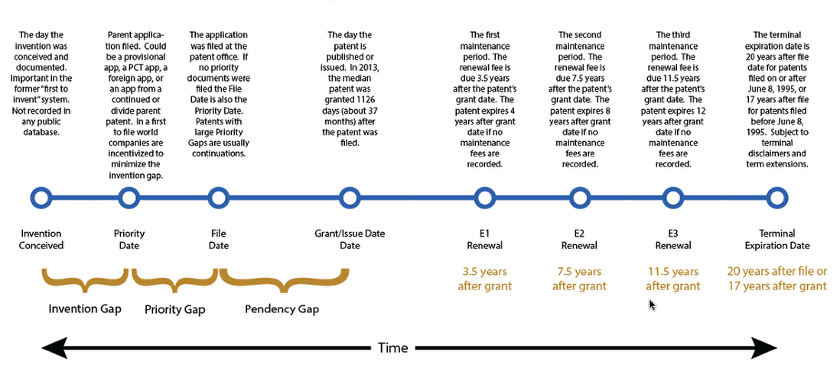

Figure

**PATENT ANALYSIS/ PATENT RESEARCH**

**Patent analysis** is a family of techniques and tools for studying the information present within and attached to [patents](https://en.wikipedia.org/wiki/Patents), a major form of [intellectual property](https://en.wikipedia.org/wiki/Intellectual_property). Although this has traditionally been done using spreadsheet-based [data analysis](https://en.wikipedia.org/wiki/Data_analysis) methods, the field of intellectual property has witnessed a surge in the availability of software-based patent analysis tools

Advanced Analysis is the only full lifecycle patent research and patent analysis software designed for both IP power and business users. Drill as deep as you like into the data or generate point and click reports. Either way, you get the industry’s most comprehensive data analytics with insights that would otherwise take weeks or months to derive.

**MAJOR TECHNIQUES ARE:**

* **Portfolio Management:**Get a more comprehensive view of your portfolio and your competitors’ byintegrating public data and internal information to expose richer insights and make more informed decisions about your IP portfolio.
* **Patent Licensing:**Patents can represent up to 85% of a company’s value.  Use Innography for patent research to monetize your assets, identify new candidates for out-licensing, or cross-licensing. Find suppliers for in-licensing and open innovation. Isolate relevant adjacent markets for strengthening your IP in noncompeting industries.
* **Patent Litigation:** Respond to assertion letters from a position of strength by using Innography to locate patents that may invalidate prior art. Understand the litigation trends in your market and predict threats against your portfolio. Use Innography to locate infringers and develop assertion strategies.
* **M&A Due Diligence:** Chain-of-title issues can render patents invalid. Determine if the assets you are buying are worth the price and easily identify hidden litigation risk they may carry. Determine if acquired patents provide adequate gap coverage.
* **Competitive Intelligence:** Understand competitors’ portfolio strength, strongest patents, trademarks and filing trends. Innography helps you examine the white space in your industry.
* **Risk Management:** Understand non-practicing entities in your space, litigation trends, and gaps in your portfolio.
* **Innovation & Patentability:** Conduct patent research, explore technology landscapes, mine for connections and adjacencies, and uncover market development opportunities.
* **IP Strategies:**Track and monitor IP investments, view market landscapes, determine positioning, and portfolio companies.

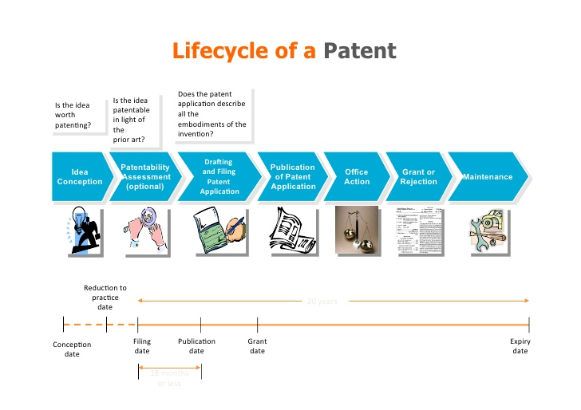

Figure

**PRIOR ART IN PATENT INDUSTRY:**

**Prior art**, in most systems of [patent](https://en.wikipedia.org/wiki/Patent) law, is constituted by all [information](https://en.wikipedia.org/wiki/Information) that has been made available to the public in any form before a given date that might be relevant to a patent's claims of originality. If an [invention](https://en.wikipedia.org/wiki/Invention) has been described in the prior art or would have been [obvious](https://en.wikipedia.org/wiki/Inventive_step_and_non-obviousness) over what has been described in the prior art, a patent on that invention is not valid.

Prior art is **any** evidence that your invention is already known Prior art does not need to exist physically or be commercially available. It is enough that someone, somewhere, sometime previously has described or shown or made something that contains a use of technology that is very similar to your invention.

An existing product is the most obvious form of prior art. This can lead many inventors to make a common mistake: just because they cannot find a product containing their invention for sale in any shops, they assume that their invention must be novel. Information kept secret, for instance, as a [trade secret](https://en.wikipedia.org/wiki/Trade_secret), is not usually prior art, provided that employees and others with access to the information are under a non-disclosure obligation. With such an obligation, the information is typically not regarded as prior art. Therefore, a patent may be granted on an invention, even though someone else already knew of the invention. A person who used an invention in secret may in some jurisdictions be able to claim "prior user rights" and thereby gain the right to continue using the invention. As a special exception, earlier-filed and unpublished [patent applications](https://en.wikipedia.org/wiki/Patent_application) do qualify as prior art as of their filing date in certain circumstances.

To anticipate the subject-matter of a [patent claim](https://en.wikipedia.org/wiki/Claim_(patent)), prior art is generally expected to provide a description sufficient to inform an average worker in the field (or the [*person skilled in the art*](https://en.wikipedia.org/wiki/Person_skilled_in_the_art)) of some subject matter falling within the scope of the claim. Prior art must be available in some way to the public, and in many countries, the information needs to be recorded in a fixed form somehow. Prior art generally does not include unpublished work or mere conversations (though according to the [European Patent Convention](https://en.wikipedia.org/wiki/European_Patent_Convention), oral disclosures also form prior art. It is disputed whether [traditional knowledge](https://en.wikipedia.org/wiki/Traditional_knowledge) (*e.g.,* of [medical](https://en.wikipedia.org/wiki/Medical) properties of a certain plant) constitutes prior art.

Patents disclose to society how an invention is practiced, in return for the right (during a limited term) to exclude others from manufacturing, selling, offering for sale or using the patented invention without the patentee's permission. Patent offices deal with prior art searches in the context of the patent granting procedure.

## EFFECTIVE DATE OF PATENTS AND PATENT APPLICATIONS AS PRIOR ART

It is typical for a patent office to treat its own patents and published patent applications as prior art as of their filing dates, although under the [European Patent Convention](https://en.wikipedia.org/wiki/European_Patent_Convention), this applies only to novelty rather than inventive step.However, [United States patent law](https://en.wikipedia.org/wiki/United_States_patent_law) before the [Leahy-Smith America Invents Act](https://en.wikipedia.org/wiki/Leahy-Smith_America_Invents_Act) (AIA) included the Hilmer doctrine, under which United States patents and patent application publications were prior art only as of their earliest effective United States filing dates, i.e., disregarding any foreign priority claimed in those patents and patent application publications. The AIA has abolished the Hilmer doctrine and makes United States patents and patent application publications that name another inventor prior art as of when they were "effectively filed."

## USAGE IN LITIGATION

Arguments claiming prior art are used in defending and attacking patent validity. In one U.S. case on the issue, the court said:

"One attacking the validity of a patent must present clear and convincing evidence establishing facts that lead to the legal conclusion of invalidity. 35 U.S.C. § 282. To establish invalidity under 35 U.S.C. § 103, certain factual predicates are required before the legal conclusion of obviousness or nonobviousness can be reached. The underlying factual determinations to be made are

(1) the scope and content of the prior art;

(2) the differences between the claimed invention and the prior art;

(3) the level of ordinary skill in the art; and

(4) objective evidence of non-obviousness, such as commercial success, long-felt but unsolved need, failure of others, copying, and unexpected results."

## TYPES OF PRIOR ART SEARCHES

### **NOVELTY**

A "novelty search" is a prior art search that is often conducted by [patent attorneys, patent agents](https://en.wikipedia.org/wiki/Patent_attorney) or professional patent searchers before an inventor files a [patent application](https://en.wikipedia.org/wiki/Patent_application). A novelty search helps an inventor to determine if the invention is novel before the inventor commits the resources necessary to obtain a patent. The search may include searching in databases of patents, patent applications and other documents such as [utility models](https://en.wikipedia.org/wiki/Utility_model) and in the [scientific literature](https://en.wikipedia.org/wiki/Scientific_literature). Novelty searches can also be used to help an inventor determine what is unique about his/her invention. Anything not found in the prior art can be potentially patentable. [Thomas Edison](https://en.wikipedia.org/wiki/Thomas_Edison), for example, did not get a patent on the basic concept of the light bulb. It was already patented and therefore in the prior art. Instead, Edison got a patent on his improvements to the light bulb. These improvements included a very thin filament and a reliable technique for joining the white hot filament to the room temperature lead wires.Novelty is requirement for a [patent claim](https://en.wikipedia.org/wiki/Claim_(patent)) to be [patentable](https://en.wikipedia.org/wiki/Patentability). In contrast, if an invention was known to the public before filing a [patent application](https://en.wikipedia.org/wiki/Patent_application), or before its date of [priority](https://en.wikipedia.org/wiki/Priority_right), if the priority of an earlier patent application is claimed, the invention is not considered new and therefore not patentable.To assess the novelty of an invention, a search through what is called the [prior art](https://en.wikipedia.org/wiki/Prior_art) is usually performed, the term "art" referring to the relevant technical field. A prior art search is generally performed with a view to proving that the invention is "not new" or old. No search can possibly cover every single publication or use on earth, and therefore cannot prove that an invention is "new". A prior art search may for instance be performed using a keyword search of large patent databases, scientific papers and publications, and on any web search engine. However, it is impossible to guarantee the novelty of an invention, even once a patent has been granted, since some obscure little known publication may have disclosed the claimed invention. Because a patent gives a person the legal right to an invention, patent protection is necessary for an inventor. Without patent protection, competitors can take the idea and make it their own. When this happens, there's no legal action an inventor can take. There are still some loopholes when meeting the novelty standard, and each case is reviewed by the U.S. Patent Office. Before applying for a patent, find out if there's prior art similar to your invention. If so, be prepared to explain how your invention is new and different enough for a patent. Inventors may also consider a provisional patent, which is a quick and fairly inexpensive way to start the patent process, making it easier for the inventor to file ahead of competitors. Closely related to the novelty is obviousness. To receive a patent, an invention cannot be obvious to either a professional in the industry or non-experts. Obviousness isn't always easily figured, and many inventors unknowingly void their idea. Printed hints and suggestions that allow others to easily reach the same idea can make the invention obvious. For instance, an article may explain a specific problem and propose, in general terms, a solution. If your invention fits that description, it will be considered obvious — especially if the publication is one that others in your field are likely to read.

### **VALIDITY**

A "validity search" is a prior art search done after a patent issues. The purpose of a validity (or invalidity) search is to find prior art that the patent examiner overlooked so that a patent can be declared invalid. This might be done by an entity [infringing, or potentially infringing, the patent](https://en.wikipedia.org/wiki/Patent_infringement), or it might be done by a patent owner or other entity that has a financial stake in a patent to confirm the validity of a patent. [Crowdsourcing](https://en.wikipedia.org/wiki/Crowdsourcing), where a large number of interested people search for prior art, may be effective where references would otherwise be difficult to find.

### **CLEARANCE**

A [clearance search](https://en.wikipedia.org/wiki/Clearance_search_and_opinion) is a search of issued patents to see if a given product or process violates someone else's existing patent. If so, then a validity search may be done to try to find prior art that would invalidate the patent. A clearance search is a search targeting patents being in force and may be limited to a particular country and group of countries, or a specific market. A clearance search, also called freedom-to-operate (FTO) search or infringement search, is a search done on issued patents or on pending [patent applications](https://en.wikipedia.org/wiki/Patent_application) to determine if a product or process infringes any of the [claims](https://en.wikipedia.org/wiki/Claim_(patent)) of the issued patents or pending patent applications. A clearance search may also include expired art that acts as a 'safe harbor' permitting the product or process to be used based on patents in the public domain. These searches are often performed by one or more professional patent searchers who are under the direction of one or more [patent attorneys](https://en.wikipedia.org/wiki/Patent_attorney). A clearance search can be followed by a *clearance opinion*, i.e. a legal opinion provided by one or more patent attorneys as to whether a given product or process infringes the claims of one or more issued patents or pending patent applications. Clearance opinions may be done in combination with a "validity and enforceability" opinion. A validity and enforceability opinion is a legal opinion as to whether a given patent is valid and/or enforceable. In other words, a *validity opinion* is a legal opinion or letter in which a patent attorney or patent agent analyzes an issued patent and provides an opinion on how a court might rule on its validity or enforceability. Validity opinions are often sought before litigation related to a patent. The average cost of a validity opinion (according to one 2007 survey) is over $15,000, with an infringement analysis adding $13,000. The cost of these opinions for U.S. patents can run from tens to hundreds of thousands of dollars (or more) depending upon the particular patent, the number of defenses and prior art references, the length of the prosecution file history, and the complexity of the technology in question.

## DUTY OF DISCLOSURE

In the United States, inventors and their patent agents or attorneys are required by law to submit any references they are aware of to the [United States Patent and Trademark Office](https://en.wikipedia.org/wiki/United_States_Patent_and_Trademark_Office) that may be material to the patentability of the claims in a patent application they have filed. The [patent examiner](https://en.wikipedia.org/wiki/Patent_examiner) will then determine if the references qualify as "prior art" and may then take them into account when examining the patent application. If a person having a duty to disclose, acting with [deceptive](https://en.wikipedia.org/wiki/Deception) [intent](https://en.wikipedia.org/wiki/Intent), fails to properly disclose the [material](https://en.wikipedia.org/wiki/Materiality_(law)) references of which they are aware, then a patent can be found unenforceable for [inequitable conduct](https://en.wikipedia.org/wiki/Inequitable_conduct).

[Japan](https://en.wikipedia.org/wiki/Japan) also has a duty of disclosure.

[Australia](https://en.wikipedia.org/wiki/Australia) has abolished its duty of disclosure with regard to the results of documentary searches by, or on behalf of, foreign patent offices, except where:

(a) normal exam was requested before April 22, 2007,

(b) the foreign patent office search issued before April 22, 2007, and

(c) acceptance (allowance) was officially advertised before July 22, 2007.

## PUBLIC PARTICIPATION IN PATENT EXAMINATION

With the advent of the [Internet](https://en.wikipedia.org/wiki/Internet), a number of initiatives have been undertaken to create a forum where the public at large can participate in prior art searches. These forums have been related to both issued patents and pending patent applications.More recently, different attempts to employ open Internet-based discussions for encouraging public participation commenting on pending U.S. applications have been started. These may take the form of a [wiki](https://en.wikipedia.org/wiki/Wiki):

* [Peer-to-patent online system for open, community patent review](http://www.peertopatent.org/).
* [Wikipatents. Public patent clarity: the public can add prior art references for a given patent](http://wikipatents.org/).
* [patents@stackexchange. A Q&A site for people interested in improving and participating in the patent system.](http://patents.stackexchange.com/)

Patent examiners often use the online encyclopedia [Wikipedia](https://en.wikipedia.org/wiki/Wikipedia) as a reference to get an overall feel for a given subject.Citations of Wikipedia as actual prior art can be problematic, however, due to the fluid and open nature of its editing, and Patents Commissioner Doll said the agency used Wikipedia entries as background and not as a basis for accepting or rejecting an application.

## NOTABLE PRIOR ART DATABASES

* [**ESPACENET**](https://en.wikipedia.org/wiki/Espacenet)—[European Patent Office](https://en.wikipedia.org/wiki/European_Patent_Organisation) public patent literature database, with patents from many patent offices.**Espacenet** (formerly often written as *esp@cenet*) is a free [online](https://en.wikipedia.org/wiki/Internet) service for searching patents and [patent applications](https://en.wikipedia.org/wiki/Patent_application). Espacenet was developed by the [European Patent Office](https://en.wikipedia.org/wiki/European_Patent_Organisation) (EPO) together with the member states of the [European Patent Organisation](https://en.wikipedia.org/wiki/European_Patent_Organisation). Most member states have an Espacenet service in their national [language](https://en.wikipedia.org/wiki/Language), and access to the EPO's worldwide [database](https://en.wikipedia.org/wiki/Database), most of which is in English. In 2015, the Espacenet worldwide service claimed to have records on more than 90 million patent publications. By launching Espacenet in 1998, the EPO is said to have "revolutionized public access to international patent information, releasing patent data from its paper prisons and changing forever how patents are disseminated, organized, searched, and retrieved."In 2004, i.e. in the early years of Espacenet, Nancy Lambert considered that, although free, Espacenet, like the [United States Patent and Trademark Office](https://en.wikipedia.org/wiki/United_States_Patent_and_Trademark_Office) (USPTO) database of US patents, "still tend[ed] to have primitive search engines and in some cases rather cumbersome mechanisms to download patents."She reported it as being deliberate, on the part of the USPTO and EPO, "who have said they do not wish to compete unfairly with commercial vendors".
* [**GOOGLE PATENTS**](https://en.wikipedia.org/wiki/Google_Patents)—public search engine from [Google](https://en.wikipedia.org/wiki/Google) that indexes patents from the [United States Patent and Trademark Office](https://en.wikipedia.org/wiki/United_States_Patent_and_Trademark_Office) (USPTO) and other international patent offices, and machine-[CPC](https://en.wikipedia.org/wiki/Cooperative_Patent_Classification)-classified non-patent literature from [Google Scholar](https://en.wikipedia.org/wiki/Google_Scholar). Google Patent is a [search engine](https://en.wikipedia.org/wiki/Search_engine) from [Google](https://en.wikipedia.org/wiki/Google) that indexes more than 87 million [patents](https://en.wikipedia.org/wiki/Patent) and patent applications with full text from 17 [patent offices](https://en.wikipedia.org/wiki/Patent_office). The service was launched on December 14, 2006. Google says it uses "the same technology as that underlying [Google Books](https://en.wikipedia.org/wiki/Google_Books)",allowing scrolling through pages, and zooming in on areas.The images are saveable as [PNG](https://en.wikipedia.org/wiki/Portable_Network_Graphics). Google Patents was updated in 2012 with coverage of the [European Patent Office](https://en.wikipedia.org/wiki/European_Patent_Office) (EPO) and the Prior Art Finder tool. In 2013, it was expanded to cover [World Intellectual Property Organization](https://en.wikipedia.org/wiki/World_Intellectual_Property_Organization) (WIPO), [German Patent Office](https://en.wikipedia.org/wiki/German_Patent_Office) ([German](https://en.wikipedia.org/wiki/German_language): *Deutsches Patent- und Markenamt*, DPMA), [Canadian Intellectual Property Office](https://en.wikipedia.org/wiki/Canadian_Intellectual_Property_Office) (CIPO), and China's [State Intellectual Property Office](https://en.wikipedia.org/wiki/State_Intellectual_Property_Office) (SIPO). All foreign patents were also translated to English and made searchable.[[7]](https://en.wikipedia.org/wiki/Google_Patents#cite_note-7)In 2015, a new version was introduced at patents.google.com with a new UI, integration of [Google Scholar](https://en.wikipedia.org/wiki/Google_Scholar) with machine-classified with [Cooperative Patent Classifications](https://en.wikipedia.org/wiki/Cooperative_Patent_Classification) (CPCs), and search result clustering into CPCs. In 2016, coverage of 11 additional patent offices was announced.[[9]](https://en.wikipedia.org/wiki/Google_Patents#cite_note-9) Support for the USPTO and EPO boolean search syntax (proximity, wildcards, title/abstract/claims fields) was introduced, as well as visual graphs of inventors, assignees and CPCs by date, a thumbnail grid view of search results and downloadable result sets as CSV.

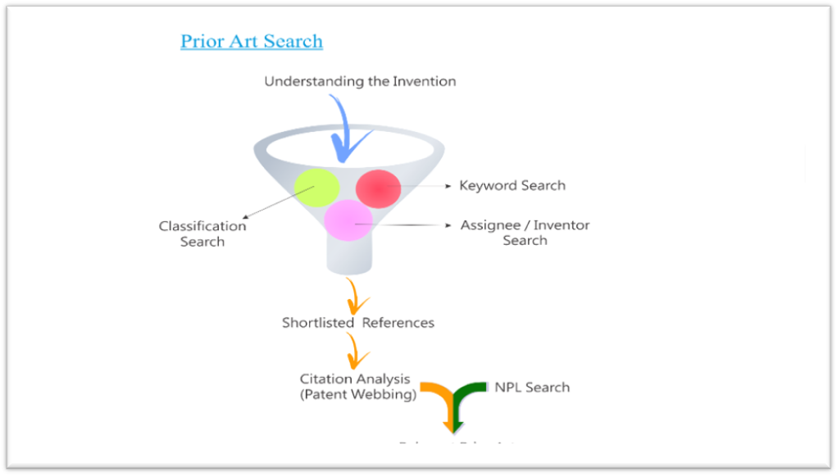

Figure

**PRODUCT SEARCHING**

Innovative companies quickly come up against intellectual property rights belonging to others. In a Derwent survey, 70% of the companies surveyed admitted that they had spent money on R&D, only to find that the product or technology in development was already protected by a competitor’s patent. We can work with you at any point during your product life cycle to get your product protected and cleared for marketing.

A Product Clearance Search Focuses on In-Force Patent Claims

A Product Clearance Search, sometimes called a Patent Infringement Search or simply just a Clearance Search, seeks to determine whether your proposed product infringes any in-force patent claims. If infringement exists, you will be aware of it and can make the appropriate business decision. That business decision may be to commission a [Patent Invalidity Search](http://www.priorartsearch.com/validity.htm) on the patent in question, to initiate design-around activities, or to consider licensing the technology at issue.

A Product Clearance Search is generally much more complex than patentability searches because the claim scope of every relevant patent must be determined. A Product Clearance Search often precedes the drafting of a legal opinion, which will assess the risks relating to infringement of patents and potential infringement of pending patent applications. In the U.S., only a patent attorney can provide such an opinion. At PriorArtSearch.com, we can provide both the search and the opinion.

Product Clearance Search Distinguished from Freedom to Operate Search

Because a Product Clearance Search is only directed at infringement, only the claims of in-force patents are relevant. Thus, searching for expired patents or non-patent literature is unnecessary. Note that a similar, more expansive search, known as a [Freedom to Operate Search](http://www.priorartsearch.com/freedomtooperate.htm), also considers expired patents and publicly available documents in addition to in-force patents.

In-Force Claims May be very Broad and Not Include all Features of the Proposed Product

Note that the in-force claims may be very broad and not include all features of the proposed product or invention. For example, the new product may include features A + B + C + D. That combination will infringe an earlier and broader claim that only recites A + B.

Conducting a Product Clearance Search Requires In-Depth Knowledge of Claim Interpretation

An understanding of patent law, particularly claim interpretation, is important in conducting a Product Clearance Search. The patent searcher must interpret hundreds or thousands of patent claims of potentially relevant in-force patents. It follows that searchers make critical judgments based on claim interpretation when they determine which references to give to clients and which to delete.

This leaves a patent holder with two choices-

* Be updated on every product rolled in the marketplace to discover patent infringement by any of them. (more on it below) OR
* Hire a patent consulting firm or law firm that can help you find the products that use your technology.

It’s really simple and you too can do it provided you are ready to put in the hard work. Let’s take an example of e-cigarettes domain to find out how you can uncover products infringing on your patents.

The first step is to[create a taxonomy](https://www.greyb.com/lets-make-patent-landscapes-great/?utm_source=cur-gap) which is a hierarchical representation of various aspects related to a technology domain. Consider the below taxonomy for the e-cigarettes industry. For a quick understanding, the Taxonomy has been prepared based on device type, size, and usage type and activation methods.

The taxonomy tries to cover aspects like manual/automatic battery, a soft/hard tip, etc.

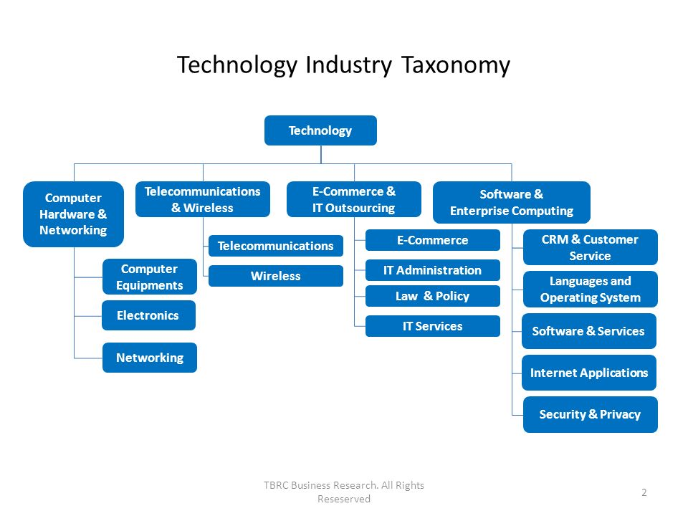

Figure

In the second step of the infringement discovery process**, a patent feature mapping**is done. This step is about finding all the patents in the domain and figuring out which patents map onto which features.

For instance, consider the example of [US patent 8511318](http://www.google.co.in/patents/US8511318) which is essentially an e-cigarette patent. The description of the patent indicates that based on components, a liquid component used is nicotine hence the patent is marked in the nicotine-based features. Further, the activation type is automatic hence the patent is marked in the automatic activation feature.

In this manner, all the patents are read and differentiated based on features.

* Understand whether or how much to prune your portfolio because you could tie it more directly to your balance sheet
* Gain insight into new licensing opportunities
* Determine how to direct future R&D investments
* Enhance your existing capability to manage protect and exploit your patents

That said, mapping a given product to one or more patents can be a daunting task. In fact, the short answer is that there is no real way to demonstrate a true one-to-one mapping of patents to products. It is possible, however, to do the next best thing, which can provide a very close approximation: trademarks.

Process uses semantic mapping between trademark descriptions and the language used on patents. There are many more examples, but these associations provide a very unique insight into a process that hasn't been possible before. This capability is an industry first that has the potential to change the way people think about both their patents and their trademarks. It establishes an intrinsic link between the technologies they own and brands/products they have created and brought to market.

An understanding of how products are related to patented technologies can help you protect, defend and exploit a much greater segment of your intellectual property. We’re no longer talking about only patents, which is the current mindset in the industry. I personally believe this represents a change in how people view their IP – that it will foster a more integrated view of IP and its business value.

This sort of holistic approach has not only been lacking in the industry, it hasn't even been on the radar until now. It’s my hope that other industry leaders will embrace this enhanced perspective of how customers can and should be truly managing their IP.]

**PROSECUTION**

Patent prosecution is the legal right to protect your [intellectual property](https://www.upcounsel.com/intellectual-property). In a legal sense, the phrase "patent prosecution" typically refers to the plaintiff's side of a patent-related lawsuit. But when looking at [patent law](https://www.upcounsel.com/patent-law) as a whole, patent prosecution usually refers to the process of obtaining [patent protection](https://www.upcounsel.com/patent-protection) on an idea, invention, design, or plant. If a patent holder is looking to take legal action against someone who infringed on his patent, he would seek a litigator who specializes in patent law. But when going through the process of patent prosecution, or applying for a patent, you would want to look for a patent lawyer.

Patent prosecution includes several steps:

* Developing a strategy for intellectual property protection.
* Developing claims that define your invention.
* Preparing [patent applications](https://www.upcounsel.com/patent-application) to submit to the United States Patent and [Trademark](https://www.upcounsel.com/trademarks) Office (USPTO).
* Creating drawings and images to the USPTO specifications of the design or invention.
* Filing patent applications with the USPTO.
* Arguing your claims that your invention or design is eligible for patent protection.

Many inventors make a mistake of abandoning the patent application after receiving the office action without any significant response back to the examiner.  They cut the examination process short too soon without giving the attorney a chance to advocate their position before the examiner. An office action is simply a written document prepared by an examiner that indicates the reasons they are rejecting the patent application.

A majority of patent applications are initially rejected.  A part of the reason is, in my opinion, due to the employment structure of Patent Office.  Another reason is that patent applications are usually designed to be on the broader side.  When we receive the rejection, the claims are then narrowed to get around the prior art and hopefully convince the examiner that the claims are allowable.  Lastly, even if you conducted a novelty search, the search is not a guarantee and not all prior art references are discovered during a novelty search.

Common reasons for rejection of a patent application

The most common reasons for rejecting a patent application are novelty (Section 102) and non-obviousness (Section 103).  Novelty simply refers to whether the claimed invention is new.  Non-obviousness simply requires that the claimed invention not be an obvious variant of what is already known.

Another reason may be that the invention is not eligible for patent protection under Section 101 or that there is an issue with the written description of the patent application under Section 112.  Section 101 rejections are very difficult to overcome.  With respect to Section 112 rejections, the difficulty of overcoming these rejections depends on the strength of the examiner’s arguments.

Other rejections may be for reasons of formalities.  These are technically referred to as objections, not rejections.  They have to do with the form of the patent application.  For examples, do the drawings have a sufficient border?  Are their lines clear and dark?  Do all of the figures have corresponding figure descriptions?  The Office of Initial Patent Examination should have identified these types of objections right after the nonprovisional patent application was filed.  Sometimes, they miss it.  These are generally easy to fix.

### **TYPES OF ISSUES: FORMALITIES VERSUS SUBSTANTIVE ISSUES VERSUS AN ACTION ON THE MERITS**

#### Identifying issues related to formalities

Issues dealing with the form of the patent application refer to the formalities of submitting a patent application.  Examples of these include:

* Restriction requirement: i.e., more than one invention is being claimed
* Drawing objections: e.g, if figures have light lines that cannot be reproduced
* Claim objections: e.g., a term in the claims do not have the proper antecedent basis support
* Specification objections: e.g., the patent specification may be missing a description to one or more of the drawings

The issues dealing with the form of the patent application are generally easy to overcome. They may be time consuming to fix but fixing the formalities is generally straightforward.

#### Identifying issues related to substantive issues

Issues related to the substance of the invention refer to:

* Section 101: Patent eligible subject matter (exceptions and double-patenting rejections)
* Section 102: Novelty
* Section 103: Obviousness
* Section 112: Written Description, Enablement, Definiteness

**PATENT CLASSIFICATION**

A Patent Classification is a system for [examiners](https://en.wikipedia.org/wiki/Patent_examiner) of [patent offices](https://en.wikipedia.org/wiki/Patent_office) or other people to categorize (code) documents, such as published [patent applications](https://en.wikipedia.org/wiki/Patent_application), according to the technical features of their content. Patent classifications make it feasible to search quickly for documents about earlier disclosures similar to or related to the invention for which a [patent](https://en.wikipedia.org/wiki/Patent) is applied for, and to track technological trends in patent applications.

Searches based on patent classifications can identify documents of different languages by using the codes (classes) of the system, rather than words. Patent classification systems were originally developed for sorting paper documents, but are nowadays used for searching patent databases.

The [International Patent Classification](https://en.wikipedia.org/wiki/International_Patent_Classification) (IPC) is agreed internationally. The [United States Patent Classification](https://en.wikipedia.org/wiki/United_States_Patent_Classification) (USPC) is fixed by the [United States Patent and Trademark Office](https://en.wikipedia.org/wiki/United_States_Patent_and_Trademark_Office) (USPTO). The [Derwent classification system](https://en.wikipedia.org/wiki/Derwent_World_Patents_Index) is fixed by an enterprise. The [German Patent Classification](https://en.wikipedia.org/wiki/German_Patent_Classification) (DPK) was fixed by the [German Patent Office](https://en.wikipedia.org/wiki/German_Patent_Office).

In October 2010, the [European Patent Office](https://en.wikipedia.org/wiki/European_Patent_Office) (EPO) and USPTO launched a joint project to create the [Cooperative Patent Classification](https://en.wikipedia.org/wiki/Cooperative_Patent_Classification) (CPC) in order to harmonise the patent classifications systems between the two offices. CPC from 2013 replaces the [European Classification](https://en.wikipedia.org/wiki/European_Classification) (ECLA), which was based on the IPC but adapted by the EPO.

## CLASSIFICATION

Patent publications from all of the Contracting States (and also most others) are each assigned at least one classification symbol indicating the subject to which the invention relates and may also be assigned further classification symbols and indexing codes to give further details of the contents.

Each classification symbol is of the form A01B 1/00 (which represents "hand tools"). The first letter represents the "section" consisting of a letter from A ("Human Necessities") to H ("Electricity"). Combined with a two digit number, it represents the "class" (class A01 represents "Agriculture; forestry; animal husbandry; trapping; fishing"). The final letter makes up the "subclass" (subclass A01B represents "Soil working in agriculture or forestry; parts, details, or accessories of agricultural machines or implements, in general"). The subclass is followed by a one-to-three-digit "group" number, an oblique stroke and a number of at least two digits representing a "main group" or "subgroup". A [patent examiner](https://en.wikipedia.org/wiki/Patent_examiner) assigns classification symbols to patent application or other document in accordance with classification rules, and generally at the most detailed level which is applicable to its content.

A: Human Necessities

B: Performing Operations, Transporting

C: Chemistry, Metallurgy

D: Textiles, Paper

E: Fixed Constructions

F: Mechanical Engineering, Lighting, Heating, Weapons

G: Physics

H: Electricity

The origin of the International Patent Classification is the "International Classification" created under the [European Convention on the International Classification of Patents for Invention](https://en.wikipedia.org/wiki/European_Convention_on_the_International_Classification_of_Patents_for_Invention). The first edition of the International Classification became effective on September 1, 1968. It consisted of eight sections, 103 classes, and 594 subclasses, as compared with the IPC eighth edition consisting of eight sections, 129 classes, 639 subclasses, 7,314 main groups, and 61,397 subgroups.

International comparisons in economic studies are generally based on sector classifications, for instance, comparisons of production, employment, research and development or foreign trade. Sectors are defined by typical products, but many enterprises produce a broad variety of different products, so that in the real world sectors describe the main economic activities of enterprises. The production and function of products are based on technologies, and most products use a variety of technologies. In consequence, the notions of “sector” and “technology” describe different aspects of products and must be analysed separately. Patents are oriented towards the legal protection of technologies and therefore the classification of patents is based on technologies or products which use specific technologies. In many cases, the patent classification is quite similar to sector classifications, but they are never identical. The present study aims to draw up a technology classification for country comparisons.

This approach is relevant, as in today's world, a substantial share of economic activity refers to research- and knowledge-intensive goods and services, where technology is a major factor of competitiveness. Technological competence is the basis for engaging in specific product areas and sectors. The analysis of technologies is a first step in describing and understanding the economic activities and performance of countries. The next step – not yet realised in this report – is to establish a concordance between technologies and sectors in order to show how technological competence is transferred into economic performance.

Various technology classifications have been used by different institutions for many years. These classifications generally follow the systematic of specific patent classifications, either the International Patent Classification or the US Patent Classification. An appropriate technology classification has to take this change into account. To summarize, there are various reasons to draw up a revised technology classification based on IPC codes adapted to the changed framework. 2.

**BASIC REQUIREMENTS**

A technology classification for country comparisons should fulfil various requirements which cannot be perfectly achieved, but which should be realized as far as possible.

1. The classification should cover all technology fields, i.e. all codes of the International Patent Classification.
2. The size of the fields should be balanced, i.e. very large fields and very small fields, in terms of the number of patent applications involved, should be avoided. The problem with too large fields is that they cover too many technologies and are too heterogeneous. The disadvantage of too small fields is that the number of patent applications concerned is too small for meaningful statistical analysis, particularly in the case of smaller countries.
3. +The classification should be based exclusivelely on codes of the IPC, for many data sources do not provide useful text elements for more advanced analyses. However, individuals and institutions without detailed knowledge of database searches should be able to utilize the classification.
4. The level of differentiation should be appropriate. On the one hand, the classification should allow crude analysis based on about 5 groups, on the other hand, a more detailed analysis with about 20 fields should be feasible. This more detailed level is necessary for a better analysis of country structures. However, the number of classes should be below 40 fields, as too many details tend to blur the general structures. Furthermore, it should be possible to present the result for a 4 country in one bar chart with readable letters. This is a very pragmatic argument, but it has proved to be relevant in the context of country studies.
5. The content of the fields should be quite distinct from each other. The overlap of technologies cannot be avoided completely. In particular, the new 8th version of the IPC does not differentiate clearly between the main and secondary classifications of patent documents.3 This implies a relevant overlap of fields in patent searches. However, this overlap should not be too extensive otherwise merging fields is more appropriate than artificially separating them.

Due to these simple requirements, it has to be accepted that a certain heterogeneity within the fields is inevitable. However, in most cases a core area dominates quantitatively, so that the factual heterogeneity is much smaller than assumed. Experience with the former versions of the ISI-OST-INPI classification has shown that the definition of specific fields of special topical interest is not useful, as key words prove to be necessary for more precise descriptions and the absolute number of applications is often too small for meaningful interpretation. In other cases, the topicality of some fields proved to be quite short and they were displaced by other fields. In consequence, the classification should map relevant areas of present technology, but the necessary higher level of aggregation will imply their longer relevance. The area of information technology is broken down into more fields and thus differentiated at a finer level. Furthermore, the general area of process engineering is completely abandoned, as the fields covered had unclear references to mechanical engineering or chemistry. For the present version, new fields with a definite relation either to mechanical engineering or chemistry were introduced. In order to illustrate the quantitative implications of the new definitions

Due to the multiple classifications of documents they are sometimes associated with more than one technical field, but the effect is limited. The overlap or the double counting rate is at a level of 20 percent. To avoid such double counting, it is possible to use the first classification codes exclusively which are equivalent to the former main classification at many patent offices. However, the relative distribution of the applications to fields on the basis of the first code is largely equivalent to that with the inclusion of all codes. The content of each field and the reasons for their specific definition are explained in the following:

1. **Electrical machinery, apparatus, energy**: the field primarily covers the non-electronic part of electrical engineering, for instance, the generation, conversion and distribution of electric power, electric machines but also basic electric elements such as resistors, magnets, capacitors, lamps or cables. This field is often associated with “traditional” electrical engineering, but the high patent activity shows that technological innovation is still very important.

2. **Audio-visual technology**: audio-visual technology is largely equivalent to consumer electronics. The relevant IPC codes primarily refer to technologies and only sometimes products are directly addressed (H04R Loudspeakers …, H04S Stereophonic systems)

3. **Telecommunications:** telecommunications is a very broad field covering a variety of techniques and products. The IPC codes are often quite technology-oriented, so that it is difficult to separate relevant product/applications areas such as mobile communication in a clear-cut field. 4 See footnote 3. 8 With almost 6 percent of all applications in 2005, telecommunications is one of the largest fields of the suggested classification. 4. Digital communication: in the ISI-OST-INPI classification, this field was part of telecommunications. At present, it is a self-contained technology at the border between telecommunications and computer technology. A core application of this technology is the internet.

5. **Basic communication processes**: in the ISI-OST-INPI classification, this field was part of telecommunications. It covers very basic technologies such oscillation, modulation, resonant circuits, impulse technique, coding/decoding. These techniques are used in telecommunications, computer technology, measurement, control. However, the explicit link to these fields by multiple classification is moderate, in the case of telecommunications 2.4 percent. So the definition as a separate field is justified. However, with 0.9 percent of all applications in 2005, it is the smallest fields of the present version of the classification.

6. **Computer technology**: this field is the largest of the proposed classification with 6.4 percent of all applications in 2005. Its size is already reduced by extracting field 7. The core area of C06F (Electrical digital processing) is defined in a very technical way (Arrangement for programme control, methods and arrangements for data conversion …), so that a further break-down is difficult. It may be possible to separate specific application fields such as image data processing, recognition of data or speech analysis, but then these special fields may become too small.

7. **It methods for management**: a major improvement of IPC8 is the introduction of the subclass G06Q “Data processing methods, specially adapted for administrative, commercial, financial, managerial, supervisory or forecasting purposes”. This field represents software for these special purposes. In most countries, business methods are not patentable, but if they are admitted, they are registered in this sub-class. In any case, the size of this field is relevant with 1.2 percent of all applications in 2005. A combination of the fields 3 to 7 represents information technology in general. As the overlap is limited, this can be done by simple addition. The correct way is to combine the fields without double counting (unit)

8. **Semiconductors:** the field comprises semiconductors including methods for their production. Integrated circuits or photovoltaic elements belong to this field. The field includes microstructural technology (B81), as the number of applications in this sub-field is too small for a separate field.

9. **Optics**: this field covers all parts of traditional optical elements and apparatus, but also laser beam sources. In recent years new optical technologies such as optical switching have become more relevant. 9 Table 2: New concept of technology classification, update: May 2010. Measurement: this field covers a broad variety of different techniques and applications. It would be possible to differentiate special sub-fields such as measuring of mechanical properties (length, oscillation, speed …), but these sub-fields are generally too small.

11. **Analysis of biological materials**: this is the largest sub-field of “measurement” and was defined as a separate field. It primarily refers to the analysis of blood for medical purposes. In many cases, biotechnological methods are addressed.

12. **Control:** In the ISI-OST-INPI classification, this field was part of measuring & control. In recent years the part of control has become quantitatively more important, so that an independent field is justified. The field covers elements for controlling and regulating electrical and nonelectrical systems and referring test arrangements, traffic control or signalling systems etc.

13. **Medical technology**: Medical technology is generally associated with high technology. However, a large part of the class A61 refers to less sophisticated products and technologies such as operating tables, massage devices, bandages etc. These less complex sub-fields represent a large number of patent applications, and the total field is the second largest of the suggested classification with 6.3 percent of all applications in 2005.

14. **Organic fine chemistry**: without further limitations, the applications in organic chemistry primarily refer to pharmaceuticals. More than 40 percent of the applications have an additional code in pharmaceuticals. As such a large overlap of fields is less appropriate for a classification system, all documents with co-classification in A61K were excluded. The major exception is the group A61K-008, which refers to cosmetics.

15. **Biotechnology:** biotechnology is defined as a separate field, although it is linked to a variety of different applications. Like organic chemistry or computer technology, it is a crosscutting or generic technology. However, the overlap with pharmaceuticals is too large, with a share of nearly 30 percent. Therefore, as in organic chemistry, applications with explicit co-classification in A61K are excluded.

16. **Pharmaceuticals**: this field refers to an area of application, not a technology. However, the key sub-class A61K is primarily organized by technologies (e.g., medicinal preparations containing inorganic active ingredients …). Cosmetics are explicitly excluded from the field; these represent about 10 percent of all applications classified in A61K.

17. **Macromolecular chemistry**, polymers: this field contains the chemical aspects of polymers. Machines for producing articles from plastics are classified in B29 and not included.

18. **Food chemistry**: this field represents 1.3 percent of the applications in 2005 and is one of the smallest fields in this classification. However, the growth of this field is remarkable, so that a 14 higher weight can be assumed for the next years. Machines for food production are not included, but classified as part of field 28 (other special machines).

19. **Basic materials chemistry**: This field primarily covers typical mass chemicals such as herbicides, fertilisers, paints, petroleum, gas, detergents etc.

20. **Materials, metallurgy**: This field covers all types of metals, ceramics, glass or processes for the manufacture of steel.

21 **Surface technology, coating**: The coating of metals, generally with advanced methods represents the core of this field (C23). Furthermore it covers electrolytic processes, crystal growth and apparatus for applying liquids to surfaces. This field may be qualified as the high-tech part of field 20.

22 **Micro-structure and nano-technology**: This field covers micro-structural devices or systems, including at least one essential element or formation characterised by its very small size. It includes nano-structures having specialised features directly related to their size.

23. **Chemical engineering**: This field covers technologies at the borderline of chemistry and engineering. It refers to apparatus and processes for the industrial production of chemicals. Some of these processes may be classified as physical ones.

24. **Environmental technology**: This field covers a variety of different technologies and applications, in particular filters, waste disposal, water cleaning (a quite large area), gas-flow silencers and exhaust apparatus, waste combustion or noise absorption walls. However, it is not possible to define measuring of environmental pollution by IPC codes in a clear cut way.

25. **Handling**: This field comprises elevators, cranes or robots, but also packaging devices. So in terms of research intensity, the field is quite heterogeneous.

26. **Machine tools**: The field is dominated by patent applications referring to turning, boring, grinding, soldering or cutting with a focus on metals.

27**. Engines, pumps, turbines**: This field covers non-electrical engines for all types of applications. In quantitative terms, applications for automobiles dominate.

28**. Textile and paper machines**: The fields 27 and 28 cover machines for specific production purposes. Textile and food machines represent the most relevant part of these machines and are classified separately.

29. **Other special machines**: see field 26.

30. **Thermal processes and apparatus**: The field covers applications such as steam generation, combustion, heating, refrigeration, cooling or heat exchange. 15

31. **Mechanical elements**: The field covers fluid-circuit elements, joints, shafts, couplings, valves, pipe-line systems or mechanical control devices. The focus is on engineering elements of machines such as joints or couplings.

32. **Transport:** the field covers all types of transport technology and applications with dominance of automotive technology. In principle, a separation of rail traffic and air traffic would be feasible, but the associated fields would be too small. In both cases, this is due to a low propensity to patent. The samples are quite small and not representative of the total technological activities in these sub-fields.

33. **Furniture, games**: this field represents the main parts of consumer goods in terms of the number of patent applications. The other consumer goods are a mix of many different technologies, all of them with low quantitative weight. Therefore a further differentiation is not useful. Even furniture and games combined comprise not more than 2.3 percent of all applications in 2005.

34. **Other consumer goods**: this field primarily represents less research-intensive sub-fields. 35. Civil engineering: the field covers construction of roads and buildings as well as elements of buildings such as locks, plumbing installations or strongrooms for valuables. A special part refers to mining which may be important for some countries. In general, the importance of mining is so low that the definition of a separate field is not justified.

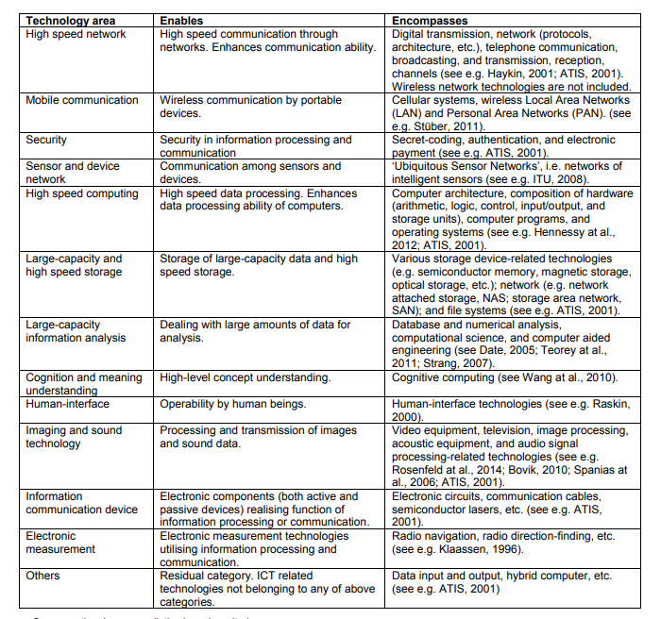

Figure

## PATENT DRAFTING

Patent drafting is a part of [how to patent an idea](https://www.upcounsel.com/how-to-patent-an-idea) and is the process of writing the patent description and claims. It is at the core of every patent application. When the patent is issued or allowed, the draft serves as the specification part of the document.

Often an inventor wants to complete the patent drafting process by providing an essay or a business plan that outlines the invention. Unfortunately, documents like these are of limited use.

Journal articles usually state that the invention is consistent with accepted science. This goes against the grain of what patenting accomplishes. In this case, the goal is to point out that the work is not an apparent continuation of current accepted wisdom.

A business plan is also the wrong for a patent application. A project or business plan focuses on what will be done. It may describe the results the company hopes to achieve with the invention. This future-oriented way of presenting the invention is not helpful. When drafting a successful patent application, the focus is on what has already been established.

The technical aspects required of a patent draft also make a business plan or journal article unusable. The detail necessary for a patent draft would be overkill for either of the two documents discussed. Finally, drawings and illustrations in a journal article and a business plan, generally do not meet the criteria for a patent draft.

Collaboration between an attorney and the inventors is an essential part of the patent drafting process. It is imperative that the attorneys understand the invention in detail, all of its claims of usefulness, as well as what distinguishes it from similar existing products or processes. Failure in this area increases the chances of the application being denied by the United States Patent and Trademark Office (USPTO).

According to the USPTO, in one nine-year period, [fewer than 60 percent](https://www.uspto.gov/ip/officechiefecon/OCE_WP_2013-2.pdf) of U.S. patent applications were recommended for issuance. Of those that were issued, only about 20 percent were ever commercialized. This statistic emphasizes the importance of having an experienced patent attorney with whom you have good regular communication.

CONCLUSION

From a proper analysis of the positive points and constraints on the component, it can be safely concluded that the product is a highly efficient GUI based component. This component can be easily being plugged in many other systems.

Also the component is highly user friendly. Generally the search and updating in stores are done by non-technical people. So it is in the best interest of the organization to use such software which their employees can handle easily. This software comes with just that solution. Being mostly GUI based, this component can be used very easily. With very little training, users can learn the usage of the product. Also the search results are presented in numerous forms like report format, graphical format etc which makes it versatile. Again the GUI based system is certainly more eye-catching and attractive. Nowadays most of the companies are going global .So their business has also become distributed and diverse.

References

[1] W. B. Gu, C. Y. Wang, S. M. Li, M. M. Geng, and B. Y. Liaw, “Modeling discharge and charge characteristics of nickel-metal hybrid batteries,” *ElectrochimicaActa,* vol. 44, pp. 4525-4541, 1999.

[2] A. P. Chandrakasan, and R. W. Broderson, “Low Power Digital CMOS Design,” Norwell, MA: Kulwer, 1995.

[3] J. M. Rabaey, and M. Pedram (Eds), “*Low Power Design Methodologies*,”Norwell, MA: Kulwer, 1996.

[4] A. Bellaur, and M. I. Elmasry, “*Low Power Digital CMOS Design: Circuits and Systems*.” Norwell, MA: Kluwer, 1996.