* A list of the top 25 oldest board games (in AD) from the board game dataset:

Query-

select Name, Year_Published from `board_games.details`

where Year_Published is not null and Year_Published>0

order by Year_Published

limit 25;

Output:

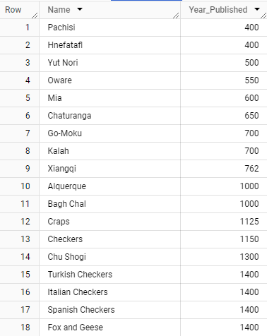

* Top 5 games released every year based on the number of user ratings, along with their avg ratings, min and max players, and play time from 2010 to 2022

Query-

select Name, Year_Published, Users_Rated,Rating_Average,Min_Players,Max_Players,Play_Time

from( select  Name, Year_Published, Users_Rated,

dense_rank()over(partition by Year_Published order by Users_Rated desc) as top,

Rating_Average,Min_Players,Max_Players,Play_Time

from `board_games.details`)t

where top<=5 and Year_Published >=2010

order by Year_Published, Users_Rated desc;

Output:

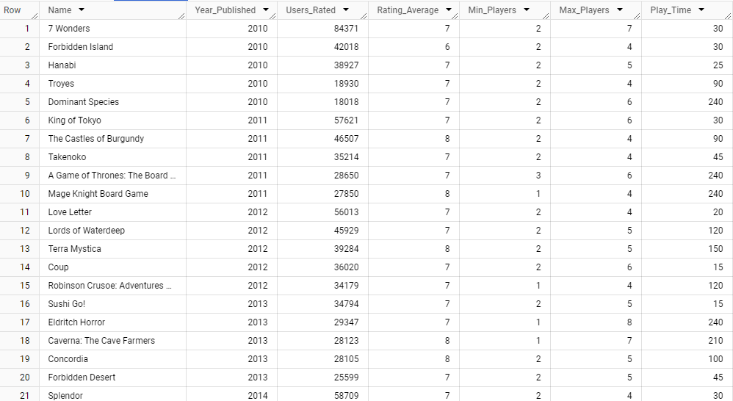

* Games with the highest number of user ratings in 2010-2022:

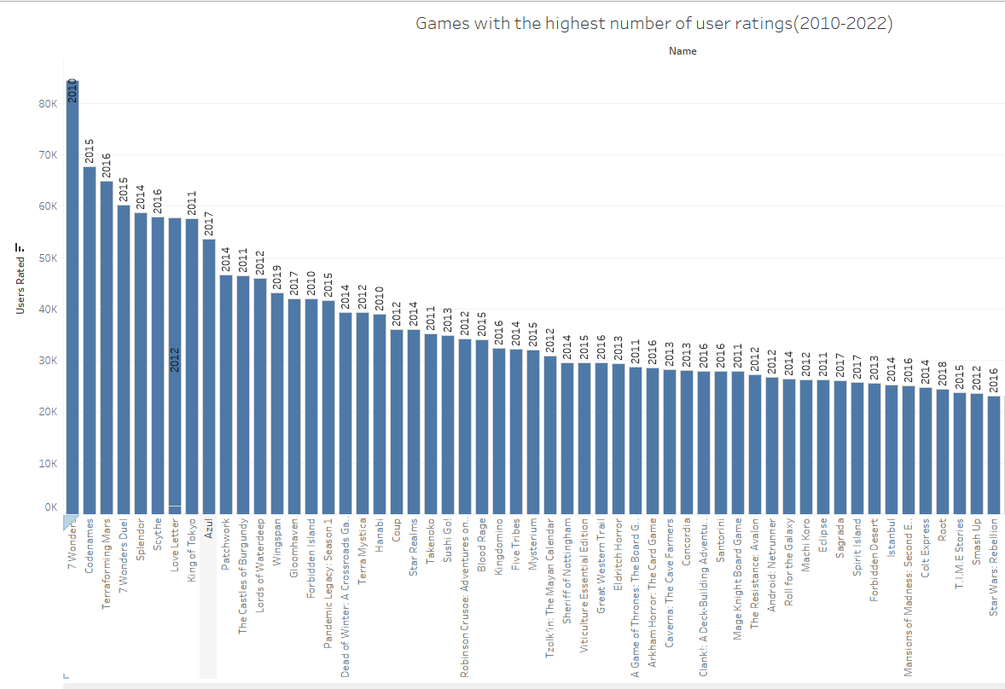

* Top 10 most rated games of all time along with their avg rating, min and max players

Query-

select Name, Users_Rated, Year_Published, Rating_Average,Min_Players,Max_Players from(

select Name, Users_Rated,Year_Published,Rating_Average, Min_Players,Max_Players from `board_games.details`

group by Users_Rated, Name,Year_Published, Rating_Average,Min_Players,Max_Players)t

order by Users_Rated desc

limit 10;

Output-

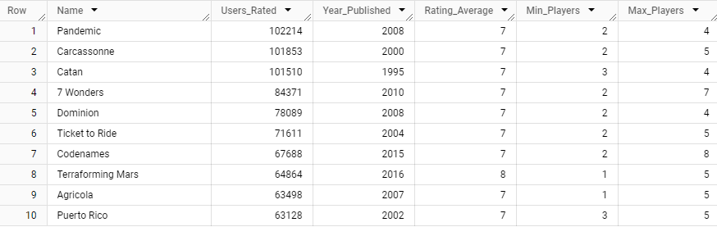

* Top 25 Board games with min number of players = 2

Query-

select Name,Users_Rated,Rating_Average,Min_Players,Max_Players,Play_Time

from `board_games.details`

where Min_Players =2

Order by Users_Rated desc

limit 25;

Output-

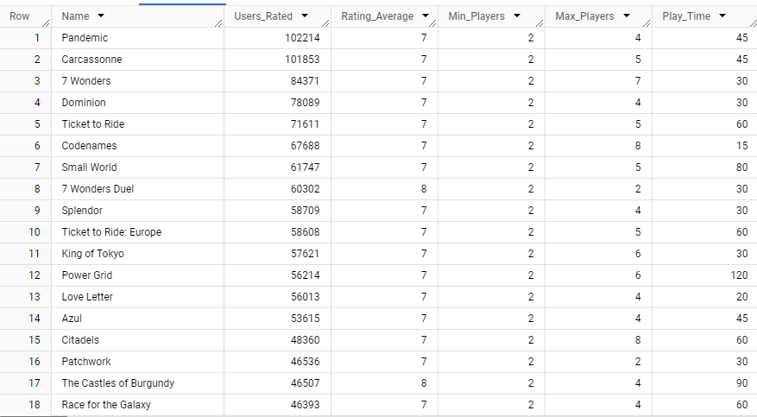

Top 10 user-rated games and the minimum number of players:

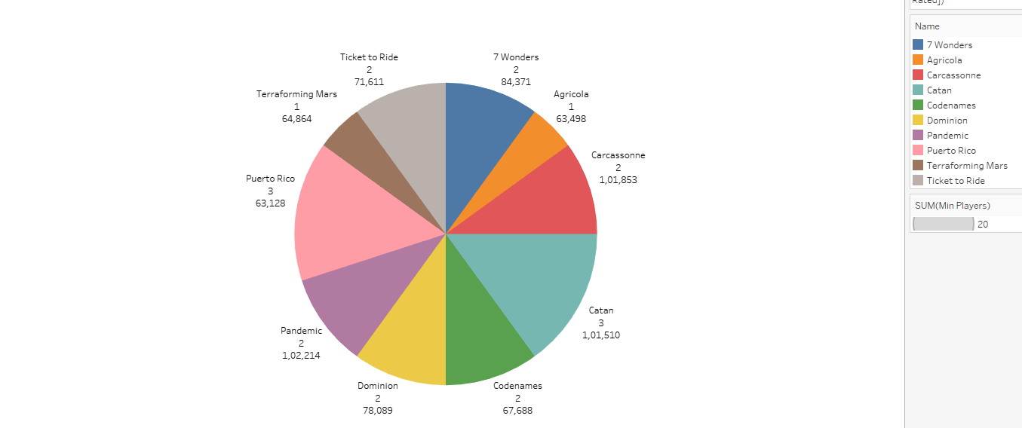

* Highest rated games and the minimum age:

