**Wound Image Classification Using Deep**

**Learning**

**ABSTRACT: -**

Wounds pose significant challenges to both physical and mental health, alongside imposing substantial medical costs. Compounding this, areas experiencing physician shortages face additional hurdles in wound diagnosis due to unreliable clinical examinations. Thus, the accurate analysis of wounds is crucial for effective diagnosis, treatment, and care. With the rapid advancement of deep learning in computer vision and medical imaging, it has emerged as a prominent tool in wound image analysis. This paper explores current research on deep learning techniques for wound image classification. The study begins with a comprehensive review of publicly available datasets and preprocessing methods used in wound image analysis. Subsequently, various deep learning models employed in classification tasks are examined, with a focus on their applications in different types of wounds such as burns, diabetic foot ulcers, and pressure ulcers. Additionally, a novel approach leveraging the VGG19 architecture is proposed for enhanced wound classification accuracy and feature extraction. Finally, the paper delves into the challenges inherent in wound image classification using deep learning methodologies. It discusses issues such as dataset scarcity, class imbalance, and the interpretability of deep learning models in medical contexts. Furthermore, the paper provides insights into the future directions and potential advancements in the field of wound image classification, highlighting avenues for continued research and development. This study aims to contribute to the ongoing efforts in leveraging deep learning for improved wound analysis, ultimately enhancing diagnostic accuracy, treatment efficacy, and patient outcomes.

|  |  |
| --- | --- |
| **EXSISTING SYSTEM** | **PROPOSED SYSTEM** |
| * Convolutional Neural Networks (CNNs) are a class of deep learning algorithms widely used in image recognition, computer vision, and other visual tasks. CNNs are inspired by the structure and function of the human visual cortex, where neurons in different layers respond to different-sized receptive fields in the visual field. * CNNs have revolutionized the field of artificial intelligence, achieving state-of-the-art performance in various tasks such as image classification, object detection, and segmentation. | * VGG19 is a convolutional neural network architecture proposed by the Visual Geometry Group (VGG) at the University of Oxford. It is an extension of the original VGG16 architecture and is named after the number of weight layers it comprises. * VGG19 is widely used in various computer vision tasks, including image classification, object detection, and segmentation, due to its simplicity, effectiveness, and transferability of learned features. |
| **EXISTING ALGORITHM**   * CNN | **PROPOSED ALGORITHM: -**   * VGG19 |
| * Convolutional Neural Networks (CNNs) are a type of artificial neural network designed to process structured grid-like data, such as images. CNNs consist of multiple layers, including convolutional layers, pooling layers, and fully connected layers. * Convolutional layers apply convolution operations to the input data, extracting features through learnable filters. Pooling layers down sample the feature maps, reducing computational complexity and controlling overfitting. Fully connected layers combine the extracted features to produce the final output, such as class probabilities in image classification tasks. | **ALGORITHM DEFINITION: -**   * VGG19 is a deep convolutional neural network architecture composed of 19 layers, including 16 convolutional layers and 3 fully connected layers.   The network architecture follows a simple and uniform design principle, where convolutional layers have small 3x3 filters with a stride of 1 and max-pooling layers with 2x2 filters and a stride of 2. VGG19 achieves deep representation learning by stacking multiple convolutional layers, enabling the extraction of increasingly abstract features from input images.   * Pre-trained VGG19 models, trained on large-scale image datasets such as ImageNet, can be readily used as feature extractors or fine-tuned for specific tasks with relatively small datasets. This facilitates transfer learning and accelerates model development for new applications. |
| **DRAWBACKS: -**   * CNN architectures can be complex and difficult to design, requiring careful tuning of hyperparameters and network architectures to achieve optimal performance. * Despite their success, CNNs lack interpretability, making it challenging to understand how they arrive at their predictions. | **ADVANTAGES: -**   * VGG19's architecture is straightforward and easy to understand, making it accessible for both researchers and practitioners in the field of deep learning. * The uniform design of VGG19, with small 3x3 convolutional filters and max-pooling layers, allows for efficient learning of hierarchical features across multiple scales. |

**SYSTEM ARCHITECTURE:**

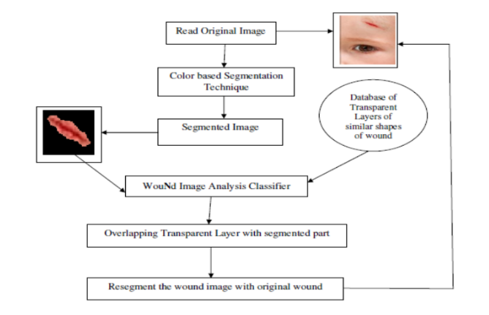

Fig:- proposed model

**MINIMUMSYSTEM REQUIREMENTS**

**HARDWARE REQUIREMENTS**

* PROCESSOR : Pentium i3 Processor
* RAM : 2GB DD RAM
* HARD DISK : 250 GB

**SOFTWARE REQUIREMENTS**

* BACK END : PYTHON
* OPERATING SYSTEM : WINDOWS 7
* IDE : Spyder3