**Assignment 7: Implement Forward Chaining Algorithm**

**Name -** Mrinmayee Jayant Deshpande

**Roll No -** 381014

**PRN -** 22210087

**Batch -** A1

**Problem Statement**

The goal of this assignment is to implement the Forward Chaining algorithm, which is used to infer new facts from a given set of known facts within a knowledge base. This technique is essential for rule-based systems where knowledge needs to be derived dynamically.

**Objectives**

* Understand the principles of rule-based reasoning.
* Implement the Forward Chaining algorithm for knowledge inference.

**Theory**

**What is Forward Chaining?**

Forward Chaining is a method of reasoning in which inference rules are applied to known facts to derive new facts. It works in a data-driven manner, continually adding new facts until no more can be inferred.

**Methodology**

1. **Start with an Initial Set of Known Facts**:
   * Initialize your knowledge base with a set of known facts that can be used as starting points for inference.
2. **Apply Rules to Infer New Facts**:
   * Each rule in the knowledge base typically has a premise (the condition) and a conclusion (the fact to be inferred). If the premises of a rule are satisfied by the known facts, then the conclusion of that rule can be added to the set of known facts.
3. **Repeat Until No More Facts Can Be Inferred**:
   * Continue applying the rules iteratively, adding new facts to the knowledge base, until no additional inferences can be made.

**Working Principle / Algorithm**

Here’s a simple outline of the Forward Chaining algorithm:

1. **Initialize the Knowledge Base**:
   * Represent known facts and inference rules. For example:
     + **Facts**: F1,F2,…,FnF_1, F_2, \ldots, F_nF1​,F2​,…,Fn​
     + **Rules**: If AAA and BBB, then CCC.
2. **Create a Loop for Inference**:
   * While there are new facts that can be inferred:
     + For each rule in the knowledge base:
       - Check if the premises of the rule are satisfied by the known facts.
       - If satisfied, add the conclusion of the rule to the known facts.
3. **Output the Inferred Facts**:
   * Once no more facts can be inferred, output the final set of known facts.

**Advantages**

* **Dynamic Inference**: Forward chaining is efficient for systems where new facts are added regularly, as it allows for continuous reasoning.
* **Simplicity**: The algorithm is straightforward to implement and easy to understand.

**Disadvantages / Limitations**

* **Unnecessary Inferences**: If not carefully managed, forward chaining can infer facts that are not required for the problem at hand, potentially leading to irrelevant conclusions.
* **Computationally Intensive**: For large knowledge bases, repeated rule applications can become computationally expensive.

**Diagram**

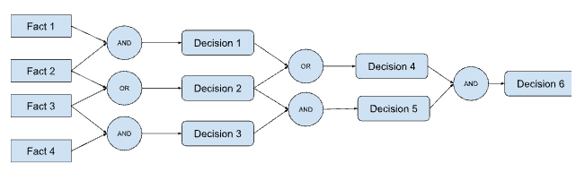

**Conclusion**

Forward chaining is an effective method for reasoning in rule-based systems, allowing systems to infer new knowledge dynamically. Its ability to generate conclusions from a set of premises makes it a powerful tool for applications in artificial intelligence and expert systems.