Mdhumne_hm03

Mrinmayee Dhumne

4/1/2022

****Use this dataset to estimate the volatility of the efficient security price.

library(xts)

## Loading required package: zoo

##   
## Attaching package: 'zoo'

## The following objects are masked from 'package:base':  
##   
## as.Date, as.Date.numeric

library(highfrequency)  
Sys.setenv(TZ = "GMT") # work in East Coast Time Zone  
options(digits.secs=3)  
load("sampleTQdata.RData")  
  
tqdata<- tqdata  
head(tqdata)

## SYMBOL EX BID BIDSIZ OFR OFRSIZ MODE PRICE   
## 2008-01-04 09:30:27 "XXX" "N" "193.340" "4.5" "193.890" "11.5" "12" "193.710"  
## 2008-01-04 09:30:28 "XXX" "N" "193.340" "4.5" "193.890" "11.5" "12" "193.590"  
## 2008-01-04 09:30:29 "XXX" "N" "193.250" "12.5" "193.810" "8.5" "12" "193.445"  
## 2008-01-04 09:30:30 "XXX" "N" "193.470" "0.5" "193.630" "0.5" "12" "193.380"  
## 2008-01-04 09:30:31 "XXX" "N" "193.470" "0.5" "193.630" "0.5" "12" "193.340"  
## 2008-01-04 09:30:33 "XXX" "N" "193.300" "2.5" "193.640" "0.5" "12" "193.520"  
## SIZE   
## 2008-01-04 09:30:27 "9100"  
## 2008-01-04 09:30:28 "200"   
## 2008-01-04 09:30:29 "200"   
## 2008-01-04 09:30:30 "250"   
## 2008-01-04 09:30:31 "300"   
## 2008-01-04 09:30:33 "400"

tail(tqdata)

## SYMBOL EX BID BIDSIZ OFR OFRSIZ MODE PRICE   
## 2008-01-04 15:59:52 "XXX" "N" "191.600" "60.5" "191.670" "3.5" "12" "191.695"  
## 2008-01-04 15:59:55 "XXX" "N" "191.620" "0.5" "191.790" "1.5" "12" "191.620"  
## 2008-01-04 15:59:57 "XXX" "N" "191.600" "180" "191.690" "27.5" "12" "191.690"  
## 2008-01-04 15:59:58 "XXX" "N" "191.600" "180" "191.690" "27.5" "12" "191.650"  
## 2008-01-04 15:59:59 "XXX" "N" "191.600" "180" "191.690" "27.5" "12" "191.620"  
## 2008-01-04 16:00:00 "XXX" "N" "191.600" "180" "191.690" "27.5" "12" "191.670"  
## SIZE   
## 2008-01-04 15:59:52 "550"   
## 2008-01-04 15:59:55 "1600"  
## 2008-01-04 15:59:57 "350"   
## 2008-01-04 15:59:58 "150"   
## 2008-01-04 15:59:59 "50"   
## 2008-01-04 16:00:00 "50"

length(tqdata$SIZE) #8153 trades

## [1] 8153

# Plot prices   
  
asks <- as.numeric(tqdata$OFR)  
bids <- as.numeric(tqdata$BID)  
mids <- 0.5*bids + 0.5*asks  
  
qspread <- asks - bids  
  
pmin = min(as.numeric(tqdata$PRICE))  
pmax = max(as.numeric(tqdata$PRICE))  
plot(as.numeric(tqdata$PRICE),col="red", type="l", ylab="Trade price",   
 xlab="Trade #", main="Trade price ", ylim=c(pmin-0.1,pmax+0.1))  
lines(mids, type="l", col="blue")

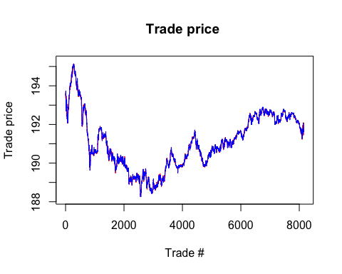

plot(as.numeric(tqdata$SIZE),col="pink", type="l",   
 ylab="Trade size",   
 xlab="Trade #", main="Trade volume", ylim=c(0,10000))

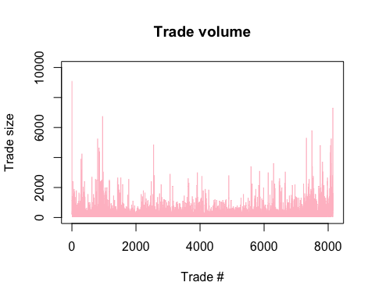

Problem 1. Calibrate the Roll model on the time series of trade prices pt, and estimate the Roll model parameters c,σu. What is the estimated bid-ask spread 2c?

#calibrate the Roll model on the real data  
pt <- as.numeric(tqdata$PRICE)  
dpt <- diff(pt) # price change  
  
head(dpt)

## [1] -0.120 -0.145 -0.065 -0.040 0.180 0.060

covpt <- acf(dpt, lag.max=20, type="covariance",   
 main="covariance of price changes")

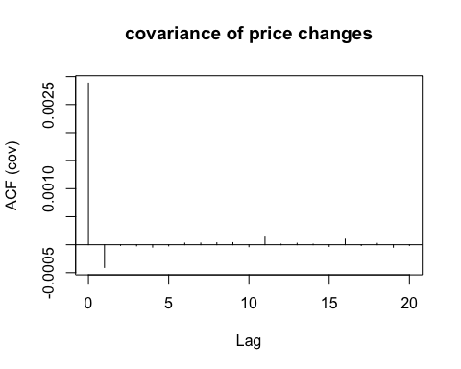

# Roll model estimate of bid-ask spread  
gamma0 <- covpt$acf[1]  
print(gamma0)

## [1] 0.002884046

gamma1 <- covpt$acf[2]  
print(gamma1)

## [1] -0.0004072397

Gamma 0 = 0.002884046

Gamma 1 = -0.0004072397

#the Roll model parameters c,σu  
c_param <- sqrt(-covpt$acf[2])  
print(c_param) # c = 0.02018018

## [1] 0.02018018

# Calculating Sigma u  
Sig2u <- gamma0 +2*gamma1 #σu2  
Sigu <- sqrt(Sig2u) # σu  
print(Sigu) # σu = 0.04549248

## [1] 0.04549248

n.trades <- length(pt)  
sigann <- sqrt(252*n.trades)*Sigu  
print(sigann) #65.20767

## [1] 65.20767

sav <-mean(pt)  
sigannln <- sigann/sav  
print(sigannln) #0.3412752

## [1] 0.3412752

c = 0.02018018

σu = 0.04549248

Problem2.Repeat the calibration, using this time the time series of the log-trade prices log pt. What are the parameters?

pt <- as.numeric(tqdata$PRICE)  
log_pt <- log(pt)  
log_dpt <- diff(log_pt)  
log_acpt <- acf(log_dpt, lag.max =20, type= "correlation", plot =TRUE, main="Autocorrelation")

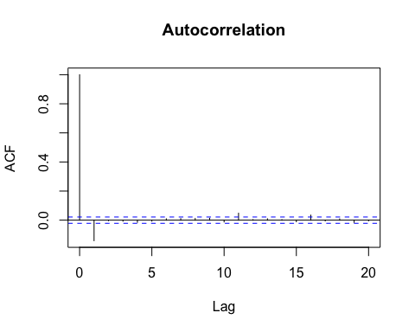

covpt <- acf(log_dpt, lag.max=20, type="covariance",   
 main="covariance of price changes")

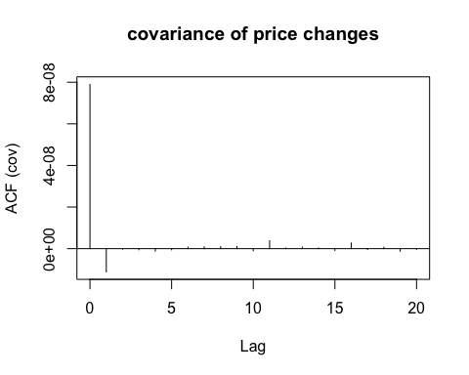

#Roll model estimate of bid-ask spread  
  
log_gamma0 <- sd(dpt)^2  
print(log_gamma0)

## [1] 0.002884399

log_gamma1 <- covpt$acf[2]  
print(gamma1) #-1.116191e-08

## [1] -0.0004072397

#Parameter C of the roll model  
c_param <- sqrt(-covpt$acf[2])  
print(c_param) # c = 0.0001056499

## [1] 0.0001056499

# Calculating Sigma u  
Sig2u <- gamma0 +2*gamma1 #sigma square  
Sigu <- sqrt(Sig2u) # sigma u  
print(Sigu) # sigma u = 0.0002380327

## [1] 0.04549248

n.trades <- length(pt)  
sigann <- sqrt(252*n.trades)*Sigu  
print(sigann) #0.341189

## [1] 65.20767

sav <-mean(pt)  
sigannln <- sigann/sav  
print(sigannln) #0.00178567

## [1] 0.3412752

Gamma 0 = 7.89737e-08

Gamma 1 = -1.116191e-08

c = 0.0001056499

σu = 0.0002380327

Problem 3.1. Compute the signature plot showing σ2 (q) for lags q = 1 : 100. Recall day that σday(q) is the daily price volatility measured by keeping only every q-th trade price. For this part use the function realizedVar(q) as define.

realizedVar <- function(q){  
 pr<- as.numeric(tqdata$PRICE)  
 rCov(diff(pr, lag=q, differences=1)/q)}  
# compute the signature plot sigma.day(q) = sqrt(RV(q))  
sig_data <- NULL  
for(q in 1:100){  
 sig_data <- c(sig_data, sqrt(realizedVar(q)))  
}  
plot(sig_data, type ="l", main="Signature plot")  
abline(h= sqrt(realizedVar(50)), col= "purple")

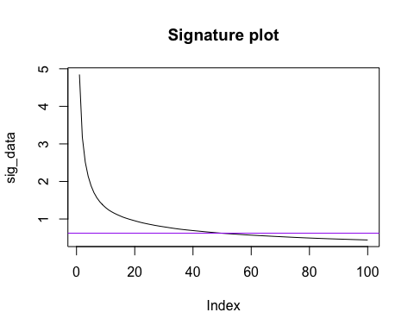

Problem 3.2.Comment on the shape of the signature plot. What do we learn from it?

The volatility signature plot gives us a useful insigt abut bias of realised variance estimate is manifesting itself in an upward sloping pattern as the samppling interval or lag becomes shoter that is bias increases with assumed availability of high frequency price here sampling interval is time period divided by assumed available high frequency.

Problem 4.Compare the daily volatility obtained from point 1. σ2 = ntradesσu2 day,Roll with the daily volatility obtained in point 3 with a lag q5min corresponding to a 5 minute interval between trades, assuming that the rate of trading is constant during the day. First determine the lag q5min = ntrades 5 and then compute the volatility.

n.trades <- length(tqdata$PRICE)  
  
sig_p2_daily <- n.trades * Sig2u  
sig_p_daily <- sqrt(sig_p2_daily)  
sig_p_daily #0.02149108

## [1] 4.107697

q5mins <- (n.trades*5)/390  
rv5 = realizedVar(q5mins)  
rv5 ##0.1850623

## [1] 0.1850623

sig5min_daily =sqrt(rv5)  
sig5min_daily #0.43018

## [1] 0.4301887

The daily volatality from roll model = 0.02149108

Daily volatility from lag q5min= 0.1850623

The daily volatility calculated using q5mins is higher than the daily volatality calculated using roll model. Since, Roll model assumes uncorrelated trade indicatores and its more accurate.