Week 5 Report
Deep Learning Application in Data Science
Handwritten Digit Classification using PyTorch
Dataset: MNIST | Model: Fully Connected Neural Network (MLP)
Yuvaintern Machine Learning Internship

1. Introduction
The objective of Week 5 is to apply deep learning fundamentals to a practical data science problem. A neural network was implemented using PyTorch to classify handwritten digit images from the MNIST dataset.
The task was formulated as supervised multi-class classification. The complete workflow includes dataset preparation, neural network design, model training, evaluation using multiple metrics, visualization, and analysis of incorrect predictions.

2. Problem Statement
Given a 28 × 28 grayscale image of a handwritten digit, the model must predict the correct digit class from 0 to 9. The problem contains ten output classes and is therefore treated as a multi-class classification problem.

3. Dataset Description

Dataset Name
MNIST (Modified National Institute of Standards and Technology)

Description
Property | Description
Training samples | 60,000
Testing samples | 10,000
Image size | 28 × 28 pixels
Image type | Grayscale
Number of classes | 10
Labels | Digits 0–9
Task | Multi-class classification

Why This Dataset Was Used
MNIST is a standard public dataset for handwritten digit recognition and provides a clear problem for demonstrating neural-network fundamentals. In the submitted notebook, torchvision automatically downloaded and loaded the dataset.

4. Data Preparation
The images were converted to tensors using ToTensor(). Normalization was then applied using mean 0.5 and standard deviation 0.5 for the grayscale channel. DataLoaders were created with a batch size of 64.
transform = transforms.Compose([
transforms.ToTensor(),
transforms.Normalize((0.5,), (0.5,))
])
batch_size = 64
train_loader = DataLoader(train_dataset, batch_size=batch_size, shuffle=True)
test_loader = DataLoader(test_dataset, batch_size=batch_size, shuffle=False)
The submitted run used CPU execution. The notebook automatically selects CUDA when available; in the recorded run, PyTorch 2.6.0+cpu reported that the CPU was used.

5. Neural Network Architecture
A fully connected feed-forward neural network, or Multi-Layer Perceptron (MLP), was implemented.
Layer | Configuration | Purpose
Input | 28 × 28 pixels | Image input
Flatten | 784 values | Converts image to vector
Linear | 784 → 128 | First hidden representation
ReLU | Activation | Adds non-linearity
Dropout | 0.2 | Regularization
Linear | 128 → 64 | Second hidden representation
ReLU | Activation | Adds non-linearity
Output | 64 → 10 | Ten digit classes
Architecture:
28 × 28 → Flatten(784) → Linear(128) → ReLU → Dropout(0.2) → Linear(64) → ReLU → Linear(10)
class NeuralNetwork(nn.Module):
def __init__(self):
super().__init__()
self.network = nn.Sequential(
nn.Flatten(),
nn.Linear(28 * 28, 128),
nn.ReLU(),
nn.Dropout(0.2),
nn.Linear(128, 64),
nn.ReLU(),
nn.Linear(64, 10)
)
def forward(self, x):
return self.network(x)
A Softmax layer was not explicitly added because CrossEntropyLoss is designed to operate on the raw output logits.

6. Training Configuration
Parameter | Value
Framework | PyTorch
Model | Neural Network / MLP
Epochs | 10
Batch size | 64
Optimizer | Adam
Learning rate | 0.001
Loss function | Cross-Entropy Loss
Execution device | CPU
The model was trained for ten epochs. During each batch, the network performed a forward pass, calculated the loss, computed gradients using backpropagation, and updated the parameters using Adam.
criterion = nn.CrossEntropyLoss()
optimizer = optim.Adam(model.parameters(), lr=0.001)
loss.backward()
optimizer.step()

7. Training Performance
The recorded training run showed a steady reduction in training loss and an increase in training accuracy.
Epoch | Loss | Accuracy
1 | 0.4258 | 0.8698
2 | 0.2228 | 0.9323
3 | 0.1820 | 0.9443
4 | 0.1597 | 0.9501
5 | 0.1430 | 0.9554
6 | 0.1304 | 0.9593
7 | 0.1230 | 0.9610
8 | 0.1161 | 0.9633
9 | 0.1101 | 0.9648
10 | 0.1059 | 0.9657
Training loss decreased from 0.4258 in the first epoch to 0.1059 in the tenth epoch, while training accuracy increased from 86.98% to 96.57%.
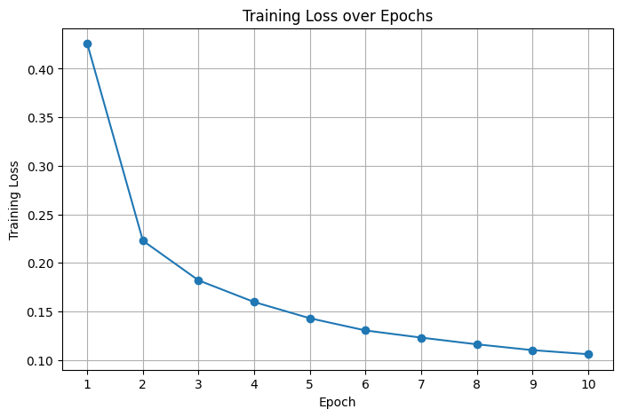
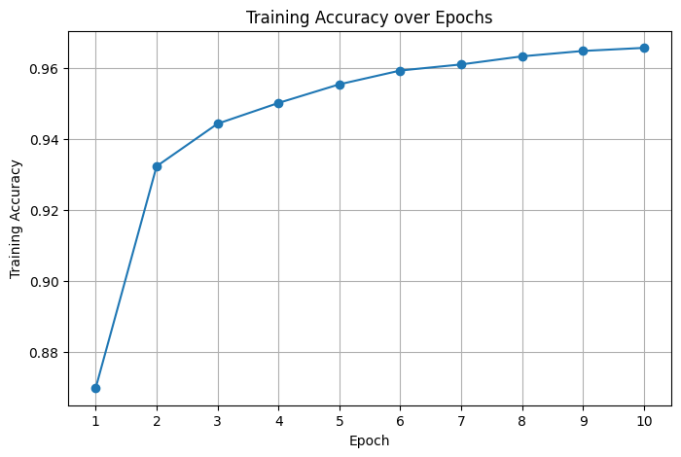

8. Model Evaluation
The trained model was evaluated on the 10,000-image test dataset. The recorded test loss was 0.0894 and the test accuracy was 0.9706, equivalent to 97.06%.
Metric | Result
Test Loss | 0.0894
Test Accuracy | 97.06%
Correct Predictions | 9,706
Incorrect Predictions | 294
The model correctly classified 9,706 of the 10,000 test images and misclassified 294 images.

9. Classification Report
Precision, recall, and F1-score were calculated separately for each digit class.
Digit | Precision | Recall | F1-score | Support
0 | 0.9786 | 0.9806 | 0.9796 | 980
1 | 0.9791 | 0.9885 | 0.9838 | 1135
2 | 0.9692 | 0.9767 | 0.9730 | 1032
3 | 0.9626 | 0.9673 | 0.9649 | 1010
4 | 0.9742 | 0.9613 | 0.9677 | 982
5 | 0.9532 | 0.9821 | 0.9674 | 892
6 | 0.9761 | 0.9791 | 0.9776 | 958
7 | 0.9743 | 0.9591 | 0.9667 | 1028
8 | 0.9621 | 0.9641 | 0.9631 | 974
9 | 0.9745 | 0.9465 | 0.9603 | 1009
The classification report provides class-level performance rather than relying only on overall accuracy. The submitted run shows high precision, recall, and F1-scores across all ten digit classes.

10. Confusion Matrix
A confusion matrix was generated to compare actual digit labels with predicted labels. Diagonal entries represent correct predictions, while off-diagonal entries represent misclassifications.
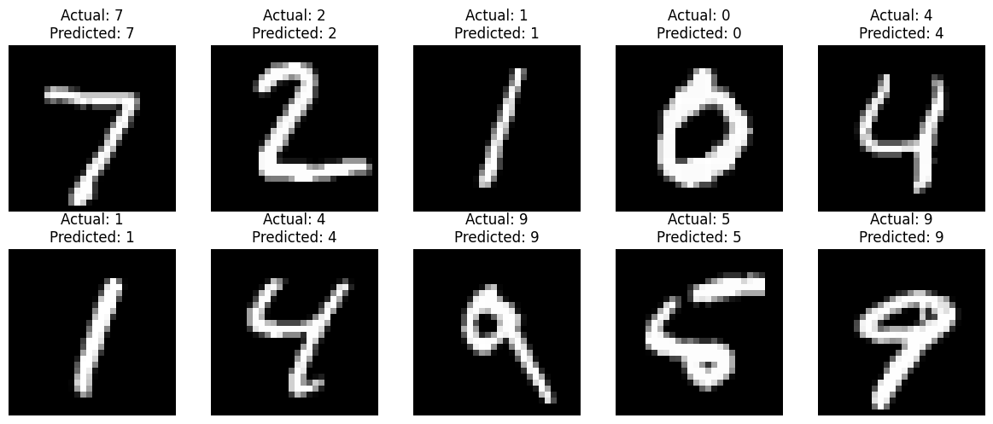

11. Actual vs Predicted Analysis
Sample test images were displayed with both actual and predicted labels. This provides a direct visual check of the model's classification behavior.

12. Incorrect Prediction Analysis
The notebook identified 294 incorrect predictions. The first ten incorrect samples were visualized together with their actual and predicted labels. Such cases are useful for understanding where visually similar handwritten digits can cause classification errors.

13. Challenges
Challenge | Approach Used
Overfitting | Dropout with probability 0.2 was included.
Computational resources | The notebook automatically checks for CUDA; the recorded run used CPU.
Image representation | The 28 × 28 image is flattened into 784 inputs for the MLP.
Class confusion | Confusion matrix and incorrect-prediction visualization were used.
Multi-class prediction | Ten output logits were trained using Cross-Entropy Loss.

14. Critical Analysis
The MLP achieved 97.06% test accuracy in the recorded run, showing that a relatively small fully connected network can learn the MNIST classification task effectively. Training accuracy also increased consistently over the ten epochs, while training loss decreased.
However, the architecture does not explicitly preserve the spatial structure of the image because the pixels are flattened before the linear layers. A CNN would be a more specialized choice for image data because convolutional layers can learn local spatial patterns.
The current notebook does not use a separate validation split or early stopping. Therefore, a stronger experimental setup would monitor validation loss and validation accuracy during training and select the best model based on validation performance.

15. Strengths
- Simple and reproducible PyTorch implementation.
- Automatic MNIST download through torchvision.
- Normalization and mini-batch training are included.
- Dropout is used as a regularization technique.
- Multiple evaluation metrics are calculated.
- Confusion matrix and incorrect predictions are visualized.
- GPU support is included when CUDA is available.

16. Limitations
- The model is an MLP rather than a CNN.
- No separate validation dataset is used.
- Only one main architecture and hyperparameter configuration is evaluated.
- Training uses a fixed ten epochs without early stopping.
- No data augmentation is applied.

17. Possible Improvements
- Create a train-validation-test split.
- Add early stopping and save the best validation model.
- Tune learning rate, batch size, hidden-layer sizes, and dropout.
- Implement a CNN and compare it with the MLP.
- Use suitable image data augmentation.
- Compare multiple deep learning architectures.
- Track validation loss and validation accuracy during training.

18. Learning Outcomes
- Understood the workflow of a deep learning classification task.
- Implemented a neural network using PyTorch.
- Learned image tensor conversion and normalization using torchvision.
- Applied Cross-Entropy Loss and Adam optimization.
- Understood the role of backpropagation in neural-network training.
- Evaluated a multi-class model using accuracy, precision, recall, F1-score, and confusion matrix.
- Analyzed incorrect predictions and identified possible improvements.

19. Final Model Performance
Measure | Recorded Result
Model | PyTorch Neural Network (MLP)
Test Loss | 0.0894
Test Accuracy | 0.9706 (97.06%)
Correct Predictions | 9,706
Incorrect Predictions | 294
The recorded model performance demonstrates strong classification results on the MNIST test set. These results are specific to the submitted notebook run using the stated architecture and training configuration.

20. Conclusion
A deep learning model was successfully implemented using PyTorch to classify handwritten digits from the MNIST dataset. The workflow included dataset loading, normalization, DataLoader creation, neural network design, model training, test evaluation, classification reporting, confusion-matrix analysis, and inspection of incorrect predictions.
The final recorded model achieved a test accuracy of 97.06% with a test loss of 0.0894, correctly classifying 9,706 out of 10,000 test images. The project provided practical understanding of neural-network architecture, optimization, evaluation, regularization, and error analysis. Future work can extend the implementation with a validation set, early stopping, hyperparameter tuning, and a CNN-based architecture.

