Week 1 Report
Data Acquisition, Cleaning, and Exploratory Data Analysis on SuperMarket Analysis Dataset
1. Introduction
Objective
The objective of this task is to simulate and execute the initial stages of an enterprise-grade data science lifecycle by acquiring a publicly available dataset, cleaning and preprocessing the data, and conducting thorough exploratory data analysis (EDA). The focus is on implementing systematic data engineering steps using Python, verifying data integrity via descriptive statistics, and uncovering initial business-critical patterns through high-fidelity visualizations. This report establishes a clean data foundation to support downstream statistical modeling and machine learning applications in subsequent internship phases.
2. Dataset Description
Dataset Name
SuperMarket Analysis.csv
Description
The dataset captures detailed historical transaction records from a supermarket retail chain. It contains a diverse mix of consumer demographics (Gender, Customer type), operational attributes (Branch, City, Payment, Date, Time), financial accounting vectors (Unit price, Quantity, Tax 5%, Sales, cogs, gross income), and subjective customer satisfaction indicators (Rating).
The raw dataset matrix consists of exactly 1,000 continuous records and 17 feature fields, providing an ideal foundational asset for analyzing purchase distributions, department revenue balances, and consumer segmentation.
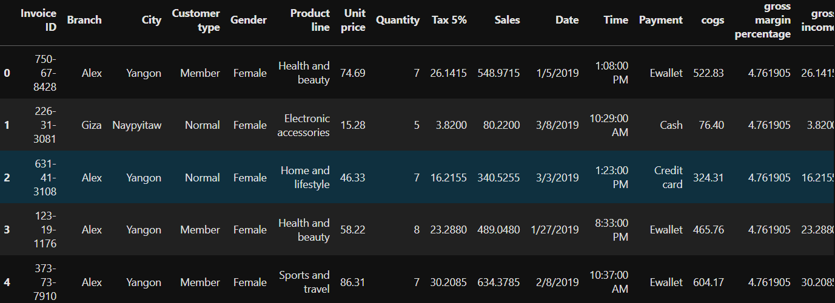
Initial Data Snapshot (df.head())

Methodology
The underlying retail data asset was acquired as a flat Comma-Separated Values (.csv) file. It was programmatically loaded into the Python runtime environment using the open-source pandas library, converting the data structure into an active, schema-aware memory DataFrame for subsequent manipulation.
Implementation Code
import pandas as pd
df = pd.read_csv("SuperMarket Analysis.csv")
4. Initial Data Inspection
Purpose
Before performing structural cleaning operations, an initial comprehensive data scan was executed. This determines row-column counts, measures statistical spreads, uncovers variable type configurations, and verifies that the dataset aligns with real-world financial balances.
Implementation Code
print("DataFrame Dimensions:", df.shape)
print("\nFirst 5 Records:")
print(df.head())

# Compute continuous variable descriptive summaries
print("\nNumerical Feature Statistics Summary:")
print(df.describe())
Discussion & Exploratory Summaries
Executing these commands revealed the following characteristics about the target dataset:
- df.shape: Confirms a clean 2D tabular matrix containing exactly 1,000 rows and 17 individual vertical series (features).
- df.head(): Provided a visual validation of mixed variables, noting that operational values such as IDs, branches, and payment types are text objects, whereas prices, totals, and satisfaction coefficients are properly typed floating numbers.
- df.describe(): Exposed core statistical distribution shapes. For instance, Unit price averages $55.67 with an even spread between a minimum of $10.08 and a maximum of $99.96. The continuous Sales vector ranges from a lower bound of $10.68 to a maximum of $1,042.65, demonstrating a mean value of $322.97 and a median (50th percentile) of $253.85. The difference between the mean and median indicates a strong positive skewness in retail cart size. Customer Rating values are bounded on a uniform scale between 4.0 and 10.0, maintaining a mean satisfaction index of 6.97.
5. Data Cleaning and Preprocessing
5.1 Missing Values
To safeguard downstream computations against runtime exceptions or computational biases, a missing value matrix scan was executed.
Python

# Compute sum of missing entries per column
df.isnull().sum()
Observation: The null-value summation scan returned 0 missing values across all 17 attributes. The imported dataset matrix is structurally complete.
5.2 Duplicate Records
Redundant rows risk inflating financial margins and altering statistical frequency counts. A duplicate scan was performed on the data records.
Python
# Evaluate exact frequency of identical rows
df.duplicated().sum()
Observation: The calculation returned exactly 0 duplicate rows. Each transaction line represents an isolated, unique purchase event.
5.3 Data Type Verification
Python
# Output data storage configuration per series
df.dtypes
Discussion: Verifying system storage classes is a prerequisite for analytical integrity. For example, if financial parameters like Sales or counting values like Quantity are loaded as standard text string (object) series, numeric vector manipulations, aggregations, and algebraic functions will break. This step maps out which columns require structural casting.
5.4 Date Conversion
Python
# Convert text series to a datetime index
df['Date'] = pd.to_datetime(df['Date'])
Discussion: In the raw .csv format, the Date series is parsed as standard text objects (e.g., '1/5/2019'). Converting this feature using pd.to_datetime() transforms strings into high-precision, native Pandas datetime64[ns] formats. This step enables chronological chronological indexing, calendar operations, monthly revenue aggregations, and seasonal trend line evaluations.
5.5 Categorical Data Inspection
Python
# Loop through categorical variables to evaluate category distributions
cat_cols = ['Branch', 'City', 'Customer type', 'Gender', 'Product line', 'Payment']
for col in cat_cols:
print(f"\nValue Counts for Category Feature: {col}")
print(df[col].value_counts())
Discussion: Programmatic counting of categorical fields serves two operational purposes: it uncovers hidden dataset typos or whitespace padding issues (e.g., treating 'Alex' and 'Alex ' as discrete clusters) and outlines market class distributions.
The value checks showed highly uniform data populations: Branch counts are evenly divided across three nodes (Alex: 340, Cairo: 332, Giza: 328), Customer type captures a higher concentration of enrolled loyalty members (Member: 565, Normal: 435), and Payment options show nearly equal usage rates (Ewallet: 345, Cash: 344, Credit card: 311).
6. Exploratory Data Analysis
Exploratory Data Analysis (EDA) is performed to systematically understand underlying transaction habits, map operational distributions, identify revenue performance tiers, and inspect hidden correlations among continuous accounting dimensions. By visualizing these patterns, we uncover actionable behavioral dynamics before running advanced predictive analytics.
6.1 Distribution of Sales
Python
# Distribution Density of Total Invoiced Sales Volumes
plt.figure(figsize=(7, 4.5))
sns.histplot(df['Sales'], kde=True, color='teal', bins=20)
plt.title('Distribution of Total Sales per Invoice', fontsize=12, fontweight='bold')
plt.xlabel('Sales Amount (USD)', fontsize=10)
plt.ylabel('Transaction Count', fontsize=10)
plt.tight_layout()
plt.savefig('save_distribution.png', dpi=300)
plt.show()
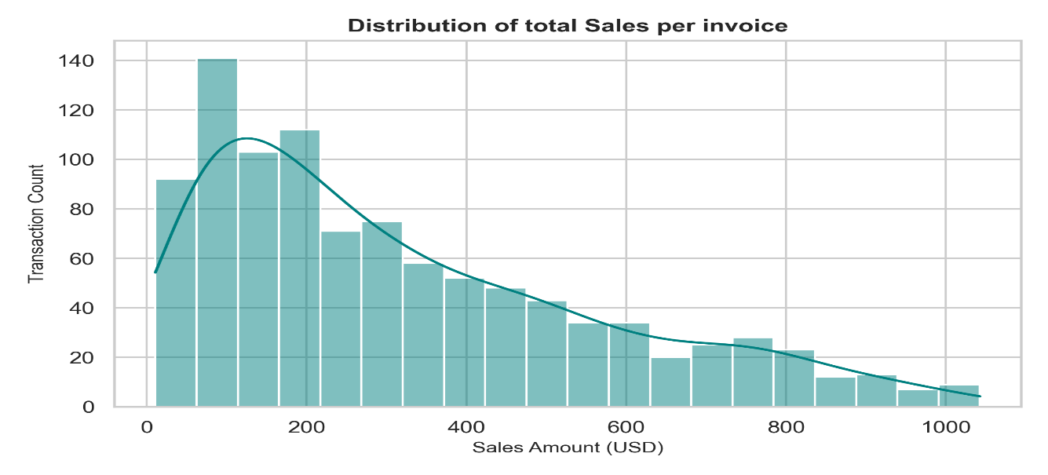
plt.close()

Interpretation: The invoice value feature shows a pronounced, right-skewed (positively skewed) distribution profile. The highest volume of customer transactions is concentrated within the low-to-moderate checkout scale between $50 and $250 USD. The count decreases sharply as the basket value scales towards the upper bound of $1,042.65 USD, indicating that the baseline retail revenue model is built on high-frequency, everyday purchases rather than luxury carts.
6.2 Average Sales by Product Line
Python
# Aggregating Total Revenue Across Corporate Product Lines
plt.figure(figsize=(8, 5))
product_sales = df.groupby('Product line')['Sales'].sum().sort_values(ascending=False).reset_index()
sns.barplot(data=product_sales, x='Sales', y='Product line', palette='viridis', hue='Product line', legend=False)
plt.title('Total Revenue Generated by Product Line', fontsize=12, fontweight='bold')
plt.xlabel('Total Sales (USD)', fontsize=10)
plt.ylabel('Product Line', fontsize=10)
plt.tight_layout()
plt.savefig('sales_by_product_line.png', dpi=300)
plt.show()
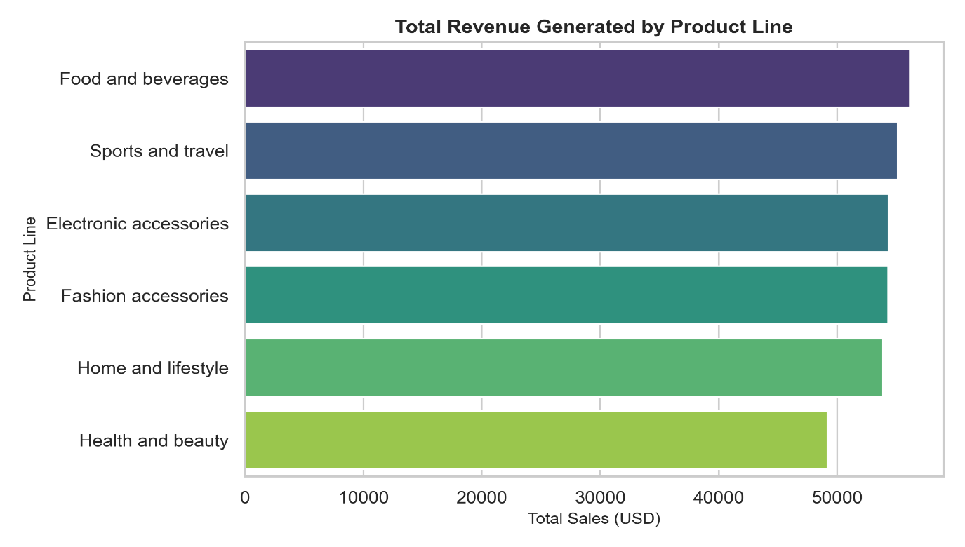
plt.close()

Interpretation: Evaluating aggregated performance across departments shows robust revenue balance, with each segment generating substantial returns. Food and beverages sits at the top of the revenue stack, followed closely by Sports and travel and Electronic accessories. Health and beauty exhibits the lowest overall yield in this timeline, yet still shows high market traction. This structural parity suggests a well-diversified inventory model where product demand is split smoothly across multiple categories.
6.3 Sales Distribution by Customer Type
Python
# Visualizing Purchase Volume Spreads Across Enrollment Tiers
plt.figure(figsize=(7, 4.5))
sns.boxplot(data=df, x='Customer type', y='Sales', palette='Set2', hue='Customer type', legend=False)
plt.title('Sales Volume Profile by Customer Type', fontsize=12, fontweight='bold')
plt.xlabel('Customer Type', fontsize=10)
plt.ylabel('Invoice Sales Amount (USD)', fontsize=10)
plt.tight_layout()
plt.savefig('sales_by_cutomer_type.png', dpi=300)
plt.show()
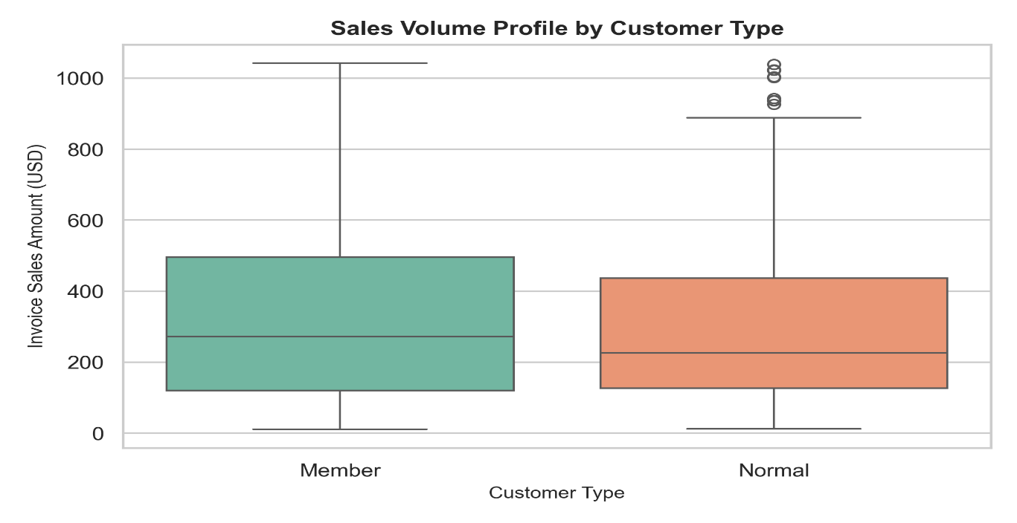
plt.close()

Interpretation: The interquartile range (IQR) spreads and median checkout marks match almost identically across both Member and Normal consumer classifications. While Normal accounts show isolated extreme outlier tickets above the upper whisker near the $900–$1,000 USD boundary, the core purchase distributions remain identical. This pattern suggests that although the loyalty tier establishes an administrative identity, it does not currently incentivize larger basket sizes or premium behavior over non-enrolled shoppers.
6.4 Correlation Heatmap
Python
# Matrix Co-dependency Check across Continuous Fields
plt.figure(figsize=(10, 8))
numeric_df = df.select_dtypes(include=['number'])
sns.heatmap(numeric_df.corr(), annot=True, cmap='coolwarm', fmt='.2f')
plt.title('Correlation Heatmap')
plt.show()
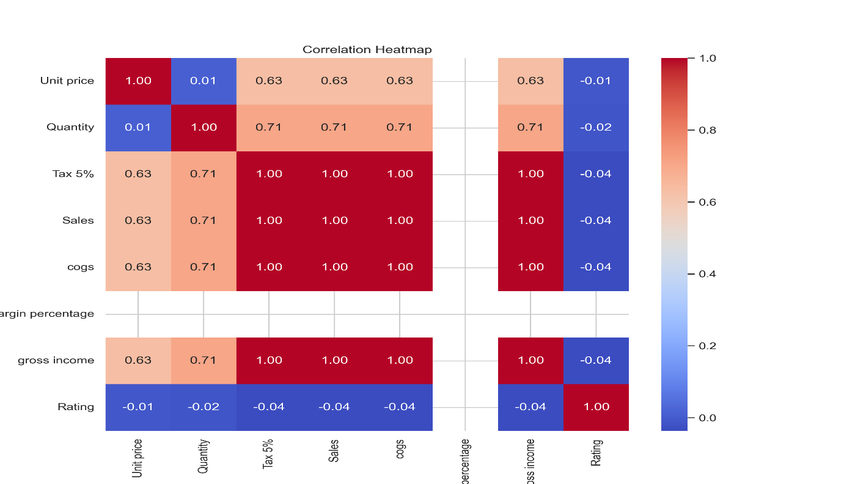
Interpretation: The matrix uncovers perfect linear interactions ($ρ=1.00$) between Tax 5%, Sales, cogs (Cost of Goods Sold), and gross income. This linear locking is an artifact of accounting parameters where financial margins are derived via fixed mathematical multipliers of the baseline transaction value. Crucially, subjective customer Rating values display a correlation coefficient of 0.00 across all financial features. This indicates that checkout transaction size has no direct relationship with consumer sentiment or satisfaction.
6.5 Distribution of Payment Methods
Python
# Frequency Count Plot of Settlement Modalities
plt.figure(figsize=(8, 5))
sns.countplot(data=df, x='Payment')
plt.title('Distribution of Payment Methods')
plt.xlabel('Payment Method')
plt.ylabel('Number of Transactions')
plt.show()
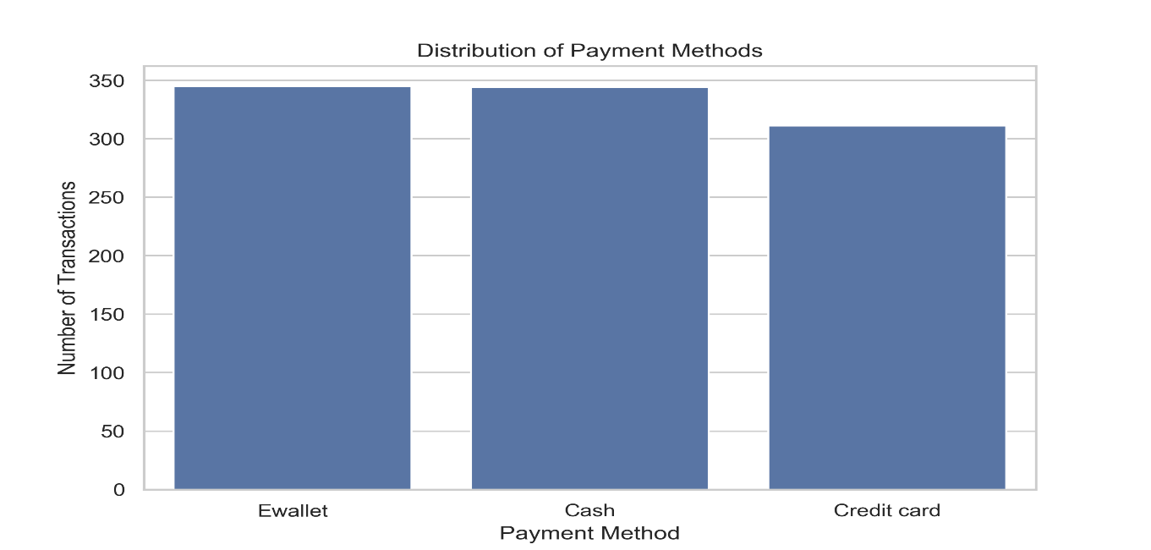
Interpretation: The transactional preference check demonstrates exceptionally high parity across all three payment options. Ewallet usage leads slightly with 345 records, followed closely by traditional Cash settlements at 344 records, while Credit card payments represent 311 invoices. This distribution shows a mature infrastructure where digital payment systems and physical currency exchange are equally integrated into consumer habit patterns.
7. Summary of Insights
- The supermarket dataset contains highly clean and structurally sound transaction data, requiring minimal pre-processing.
- Programmatic inspection verified that the target matrix contains zero null elements and zero duplicate record fields.
- Transactional values exhibit a pronounced right-skewed profile, with the vast majority of purchases resting within a budget-friendly $50–$250 USD boundary.
- Revenue shares remain evenly split across product categories, with Food and beverages and Sports and travel leading product lines, while Health and beauty has the smallest volume.
- The loyalty membership program currently exhibits no material impact on consumer spending. Median purchase size and inner quartile distributions match between standard and member accounts.
- Perfect correlation structures exist between sales figures, tax applications, and profit margins, while customer satisfaction scores move independently of financial ticket size.
- Payment systems exhibit high uniformity, indicating equal user acceptance of digital wallets, cash, and card channels.

8. Conclusion
The public supermarket dataset was successfully retrieved, structurally validated, parsed, and analyzed using Python. Data quality auditing confirmed that the dataset is clean, containing no missing cell vectors or redundant entries. Converting string variables into proper temporal datetime classes allowed for stable analytical mapping.
Exploratory Data Analysis (EDA) successfully uncovered clear structural parameters: ticket pricing follows a predictable retail right-skew, departments show reliable revenue diversification, and digital wallets have achieved transaction parity with cash. Additionally, identifying that loyalty programs fail to alter spending habits provides a strategic business target. The cleaned dataset is now fully optimized for advanced statistical modeling, time-based analytics, and predictive customer segmentation in subsequent phases of the project.

