Week 2 Report
Exploratory Data Analysis and Visualization on SuperMarket Analysis Dataset
1. Introduction
Objective
The objective of this task is to explore the SuperMarket Analysis dataset using Python and understand the main patterns in the sales data. The analysis focuses on basic statistics, data cleaning, grouping, and different visualizations. The main purpose is to understand the data before using it for any further machine learning or business analysis.
Pandas is used for reading and preparing the dataset, while Matplotlib and Seaborn can be used for visualization. Each graph is followed by a short explanation so that the result is easy to understand.
2. Dataset Description
Dataset Name
SuperMarket Analysis.csv
Description
The dataset contains 1,000 supermarket transactions and 17 original columns. It includes information about branches, cities, customer type, gender, product line, unit price, quantity, sales, payment method, gross income, and customer ratings.
Each row represents one transaction. This makes the dataset useful for studying customer purchases, product performance, payment preferences, and sales patterns.
Initial Data Snapshot (df.head())
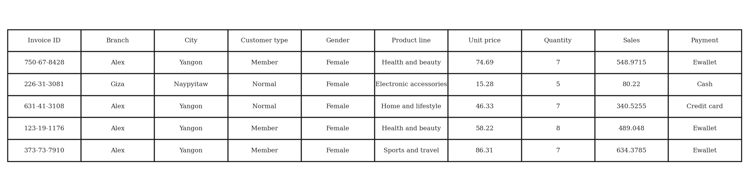
Methodology
The CSV file was loaded into a Pandas DataFrame. After loading it, the first few rows, shape, data types, missing values, and summary statistics were checked. The Date and Time columns were also converted so that they could be used for time-based analysis.
Implementation Code
import pandas as pd

df = pd.read_csv("SuperMarket Analysis.csv")
print(df.head())
3. Initial Data Inspection
Purpose
Before making any changes, the dataset was checked to understand its size, column types, and numerical values. This gives us a basic idea of what is inside the dataset and helps us find possible data-quality problems.
Implementation Code
print("DataFrame Dimensions:", df.shape)
print("\nFirst 5 Records:")
print(df.head())

print("\nNumerical Feature Statistics:")
print(df.describe())
Discussion & Exploratory Summaries
• df.shape shows that the dataset has 1000 rows and 17 original columns.
• df.head() shows the first five transactions and confirms that both text and numerical columns are present.
• Sales has an average value of 322.97, while the median is 253.85. The higher mean suggests that some larger transactions increase the average.
• Quantity has an average of 5.51 items per transaction, and the average customer rating is 6.97.
4. Data Cleaning and Preprocessing
4.1 Missing Values
# Check the number of missing values in each column
df.isnull().sum()
The result shows 0 missing values in all 17 original columns. Therefore, there was no need to remove rows or fill missing values. This means the dataset is complete for the variables used in this analysis.
4.2 Duplicate Records
# Check for completely duplicated rows
df.duplicated().sum()
The result is 0, which means that no completely identical rows were found. This is useful because duplicate transactions could otherwise affect totals and statistical calculations.
4.3 Data Type Verification
# Check the data type of every column
df.dtypes
Most categorical fields such as Branch, City, Gender, Product line, and Payment are stored as text. Fields such as Unit price, Quantity, Sales, and Rating are stored as numbers, so they can be used directly for calculations and plots.
4.4 Date and Time Conversion
df["Date"] = pd.to_datetime(df["Date"])
df["Time"] = pd.to_datetime(df["Time"])
df["Month"] = df["Date"].dt.month_name()
df["Day"] = df["Date"].dt.day_name()
df["Hour"] = df["Time"].dt.hour
The Date and Time columns were originally read as text. They were converted into datetime values so that we can easily extract the month, day, and hour for further analysis.
5. Exploratory Data Analysis
EDA helps us understand the dataset through statistics and graphs. In this section, different plots are used to look at sales distribution, product performance, customer type, correlations, payment methods, quantity, city-wise sales, and monthly sales.
5.1 Distribution of Sales
Python
plt.figure(figsize=(7, 4.5))
sns.histplot(df["Sales"], kde=True, bins=20)
plt.title("Distribution of Total Sales per Transaction")
plt.xlabel("Sales Amount")
plt.ylabel("Transaction Count")
plt.tight_layout()
plt.show()
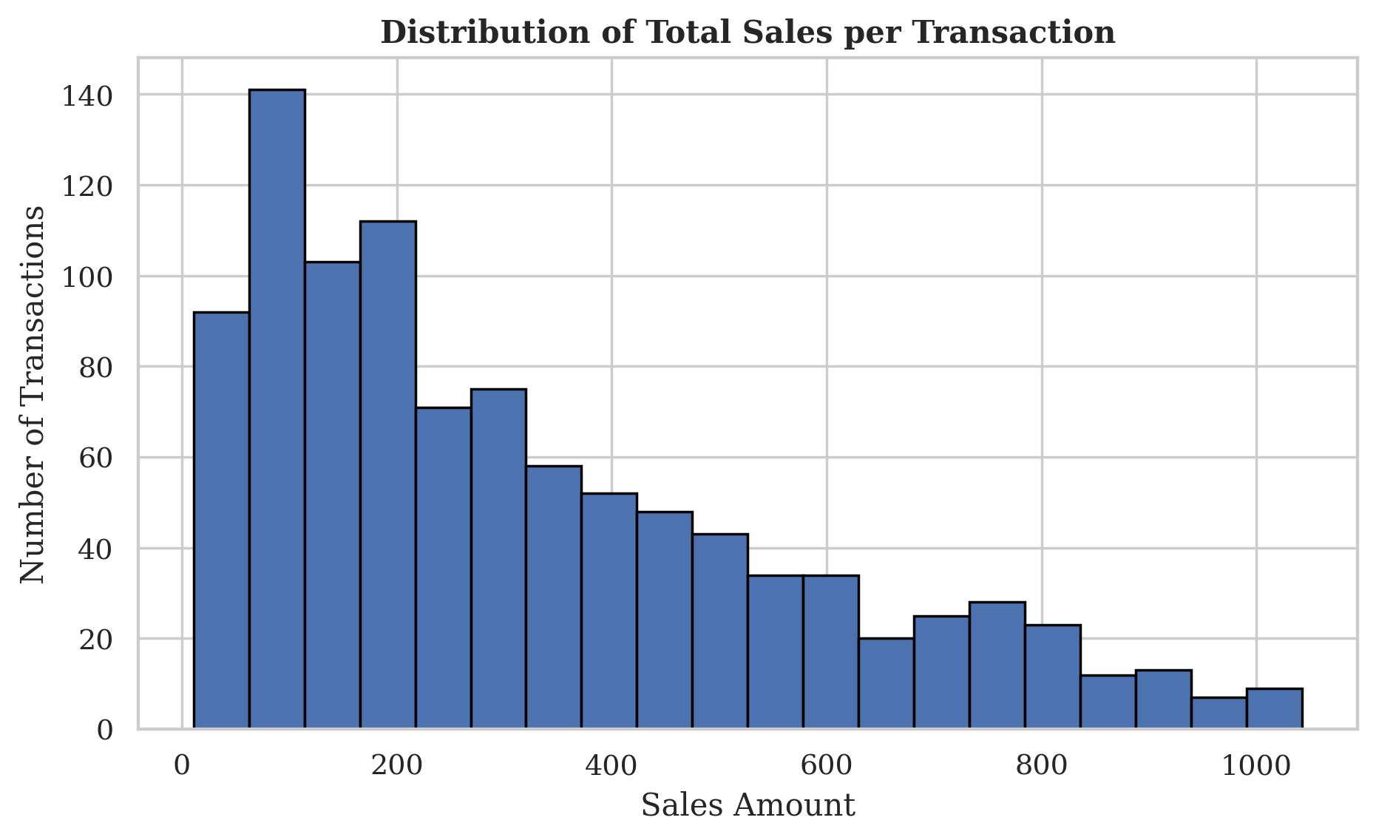
Interpretation: Most transactions are in the lower and middle sales range, while fewer transactions have very high values. The mean sales value is 322.97, which is higher than the median of 253.85. This happens because a few large purchases pull the average upward.
5.2 Total Sales by Product Line
Python
product_sales = (
df.groupby("Product line")["Sales"]
.sum()
.sort_values(ascending=False)
)

sns.barplot(x=product_sales.values, y=product_sales.index)
plt.title("Total Sales by Product Line")
plt.xlabel("Total Sales")
plt.ylabel("Product Line")
plt.show()
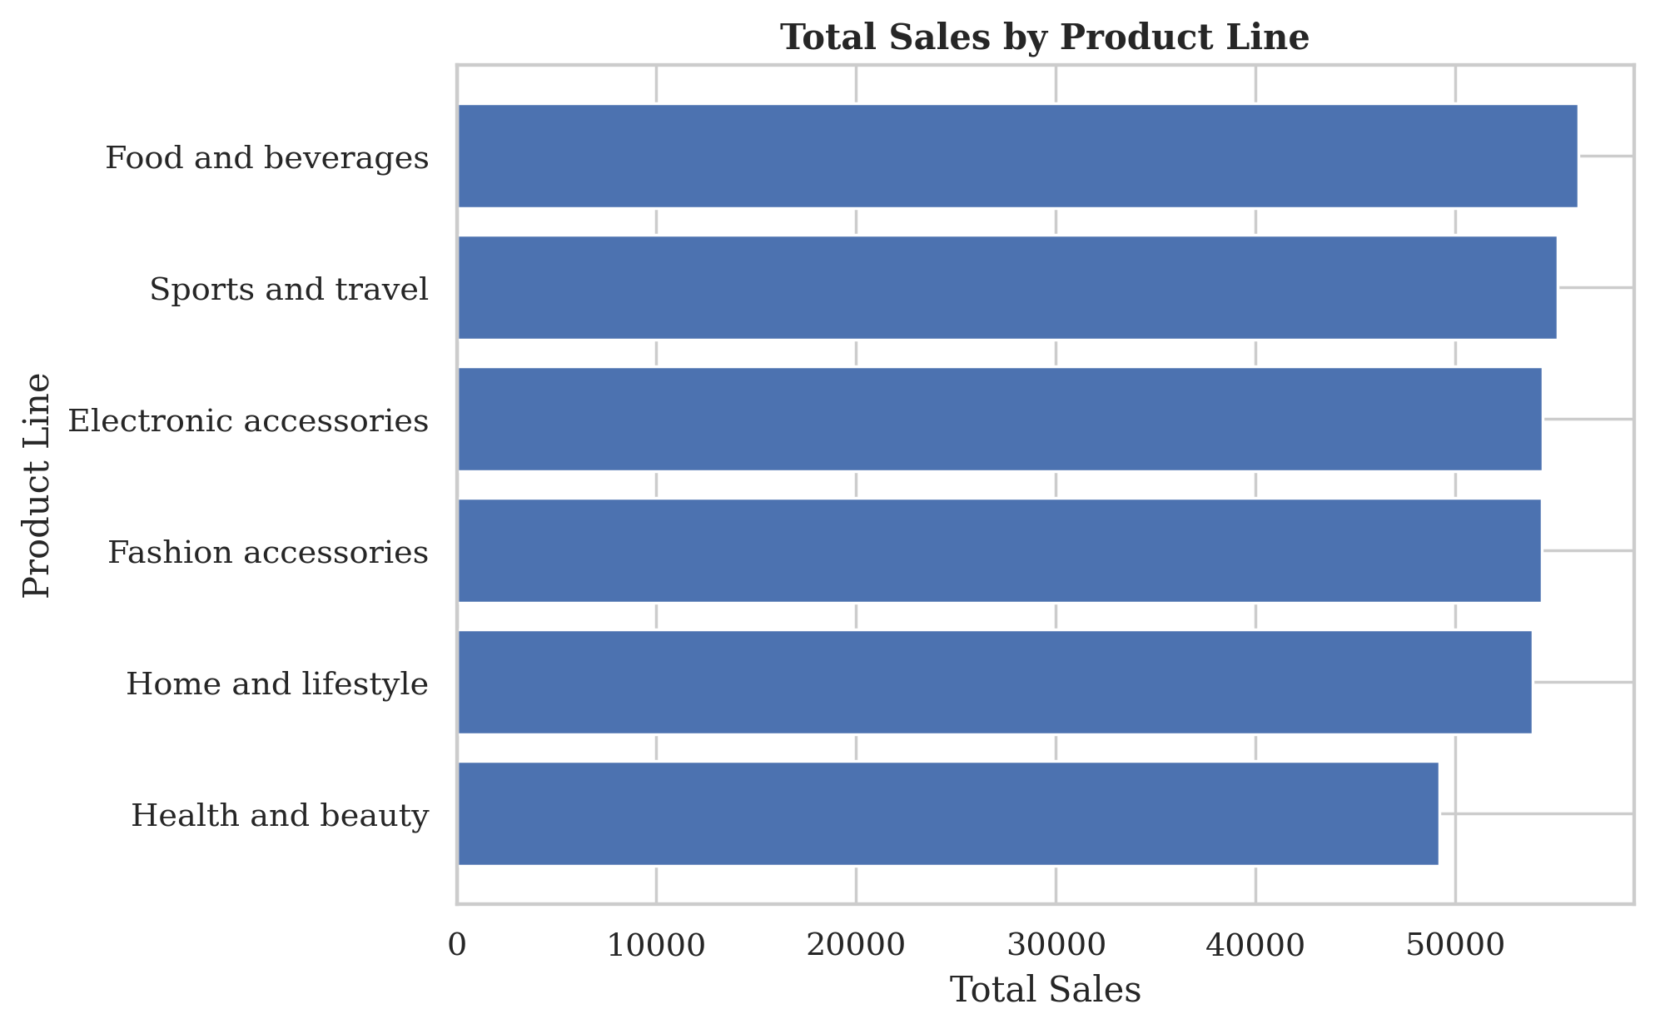
Interpretation: Food and beverages has the highest total sales, while Health and beauty has the lowest. The difference can be caused by the number of transactions in each category and the prices of the products. A category with more purchases can have higher total sales even if its individual items are not very expensive.
5.3 Sales Distribution by Customer Type
Python
sns.boxplot(data=df, x="Customer type", y="Sales")
plt.title("Sales Distribution by Customer Type")
plt.xlabel("Customer Type")
plt.ylabel("Sales Amount")
plt.show()
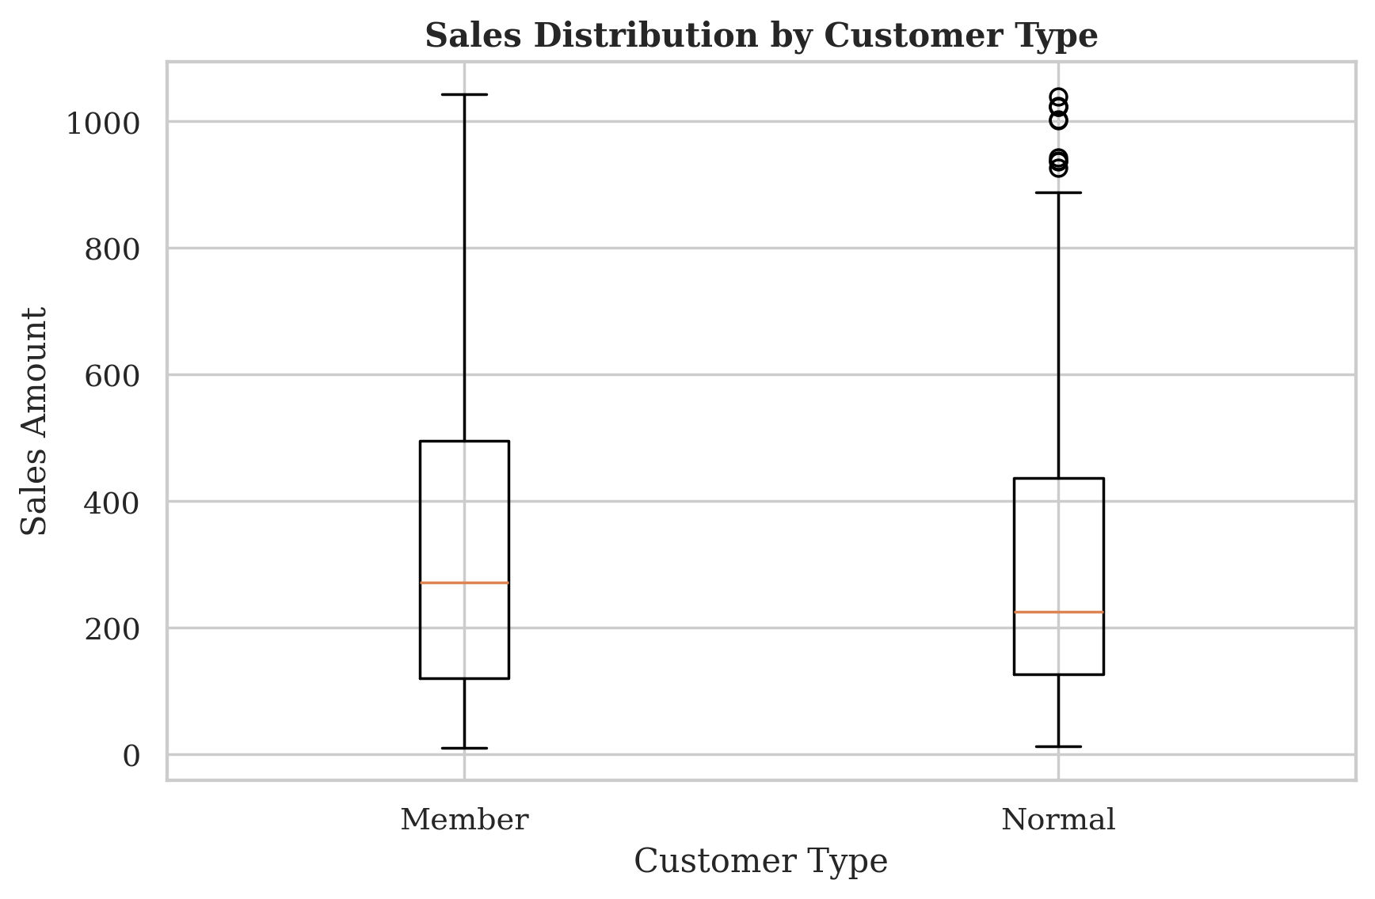
Interpretation: The two groups have fairly similar sales ranges. This suggests that being a Member does not automatically make a customer spend more in a single transaction. There are also some high-value transactions, especially among Normal customers.
5.4 Correlation Heatmap
Python
numeric_df = df.select_dtypes(include=["number"])

sns.heatmap(
numeric_df.corr(),
annot=True,
cmap="coolwarm",
fmt=".2f"
)
plt.title("Correlation Heatmap")
plt.show()
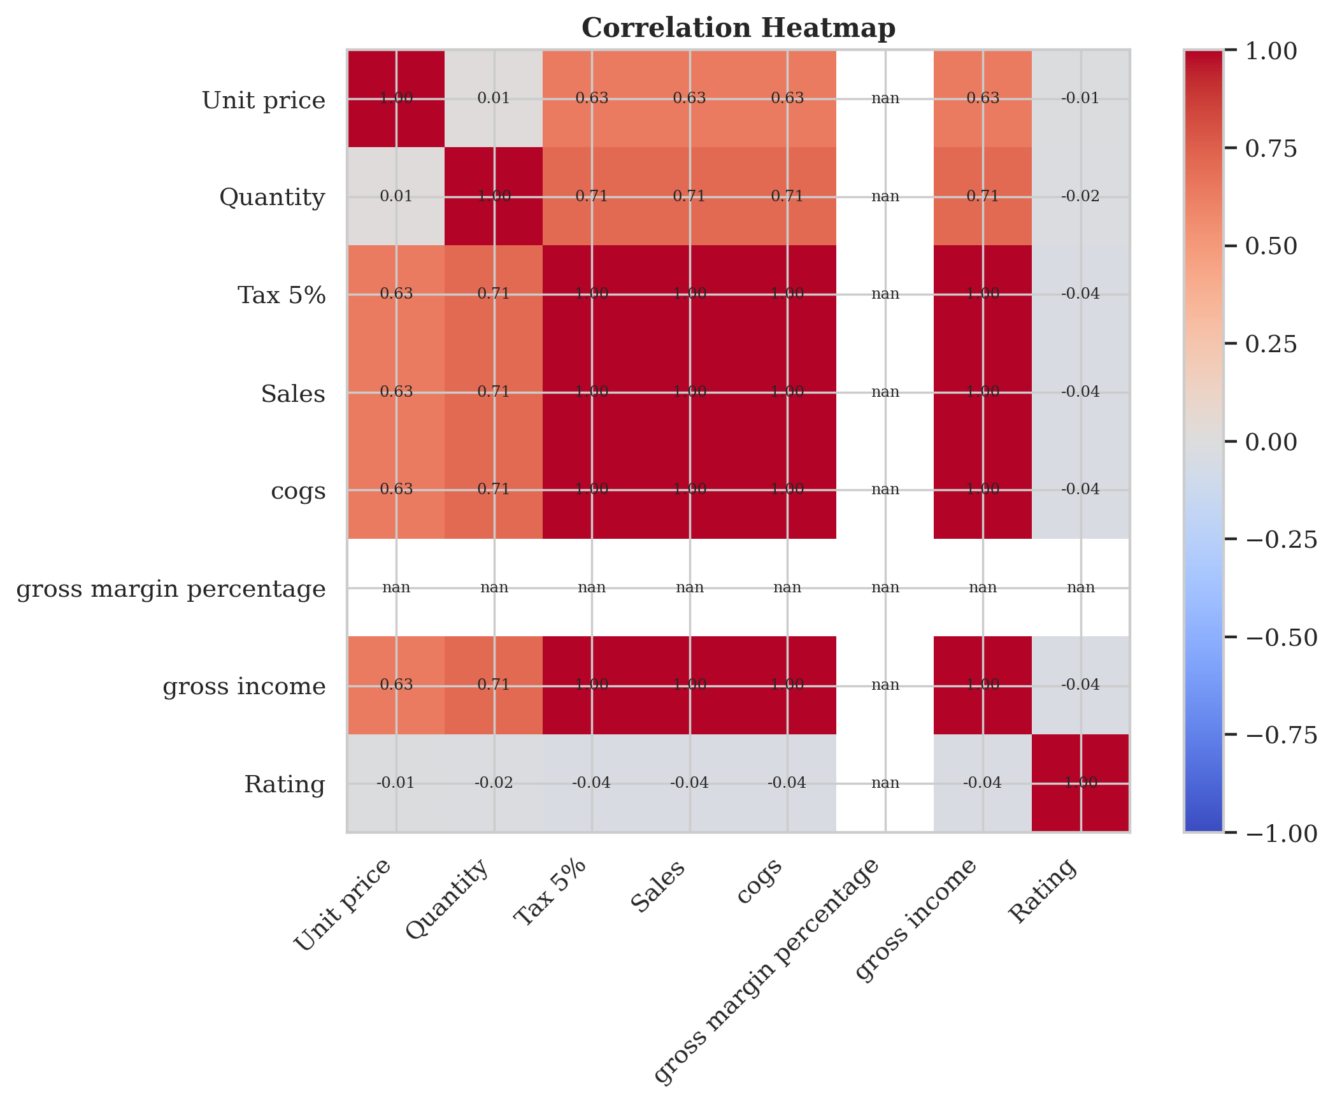
Interpretation: Sales, Tax 5%, cogs, and gross income have very strong correlations because these values are directly related to the same transaction. Quantity also has a positive relationship with Sales. Rating has very weak correlations with the financial columns, so customer satisfaction does not appear to depend strongly on transaction size.
5.5 Distribution of Payment Methods
Python
sns.countplot(data=df, x="Payment")
plt.title("Distribution of Payment Methods")
plt.xlabel("Payment Method")
plt.ylabel("Number of Transactions")
plt.show()
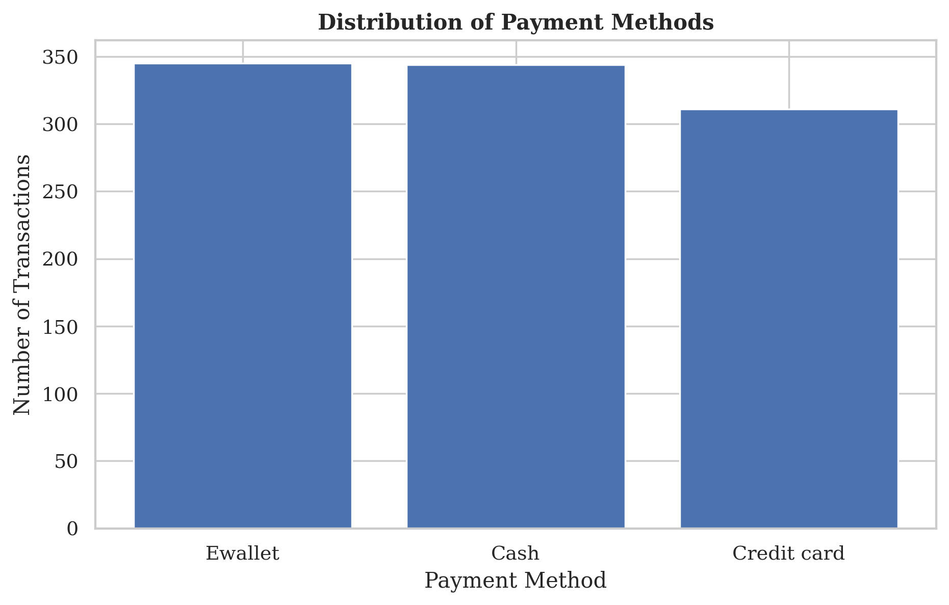
Interpretation: Ewallet is used the most with 345 transactions, followed very closely by Cash with 344. Credit card has 311. The three methods are fairly close, so no single payment method completely dominates the dataset.
5.6 Quantity vs Sales
Python
sns.scatterplot(data=df, x="Quantity", y="Sales")
plt.title("Quantity vs Sales")
plt.xlabel("Quantity")
plt.ylabel("Sales")
plt.show()
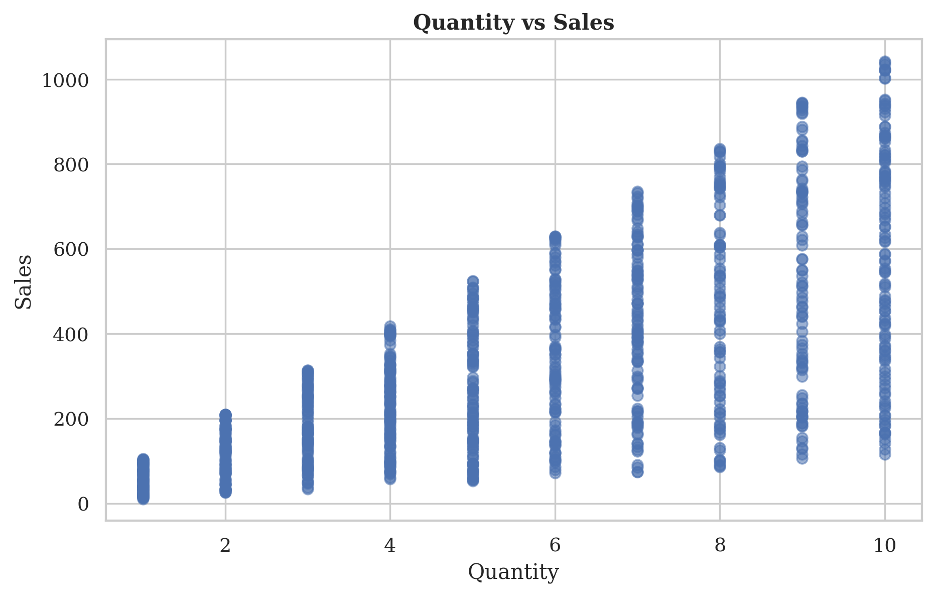
Interpretation: The points generally move upward as Quantity increases. The correlation is 0.71, showing a positive relationship. This is expected because buying more items usually increases the total sales amount. However, the exact sales value also depends on the unit price.
5.7 Total Sales by City
Python
city_sales = df.groupby("City")["Sales"].sum().sort_values(ascending=False)

city_sales.plot(kind="bar")
plt.title("Total Sales by City")
plt.xlabel("City")
plt.ylabel("Total Sales")
plt.show()
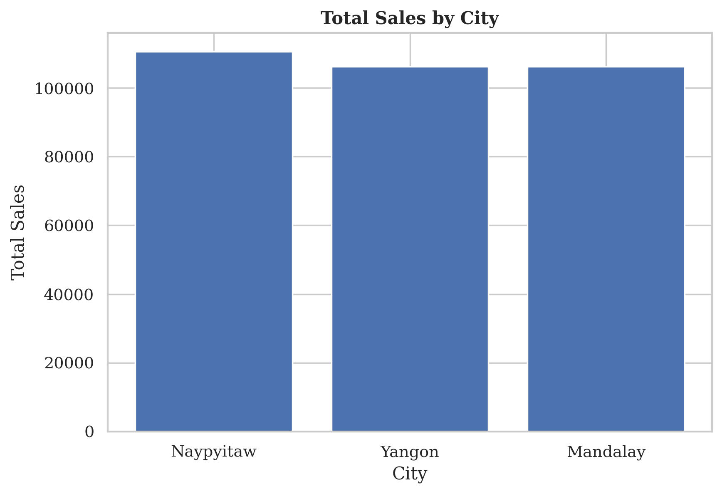
Interpretation: Naypyitaw has the highest total sales among the three cities. Differences between cities may come from customer behavior, product choices, or the number of transactions. City-wise analysis can therefore help compare the performance of different locations.
5.8 Monthly Sales Trend
Python
monthly_sales = df.groupby(df["Date"].dt.month)["Sales"].sum()

plt.plot(monthly_sales.index, monthly_sales.values, marker="o")
plt.title("Monthly Sales Trend")
plt.xlabel("Month")
plt.ylabel("Total Sales")
plt.show()
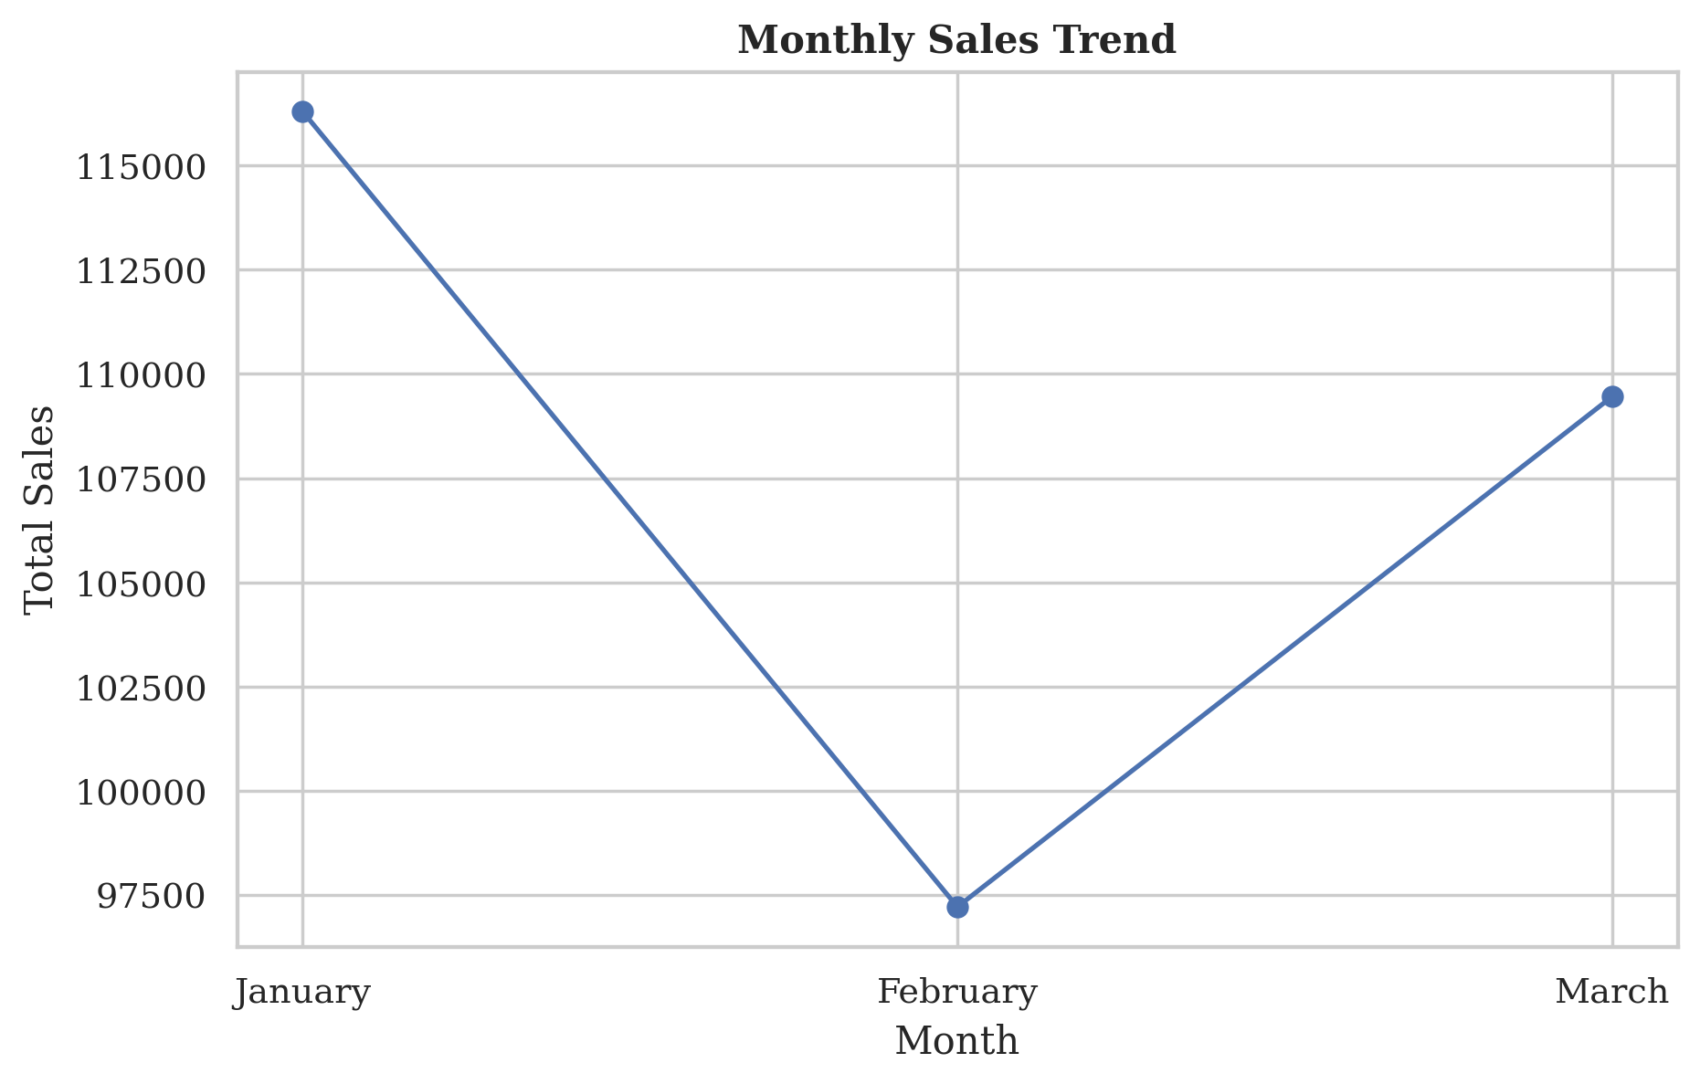
Interpretation: The monthly plot compares sales for January, February, and March. Changes from one month to another may be related to customer demand, promotions, holidays, or normal variation. Since the dataset only covers three months, it is not enough to make a strong conclusion about yearly seasonality.
6. Summary of Insights
• The dataset contains 1,000 transactions and 17 original columns.
• There are no missing values and no completely duplicated rows.
• Sales are right-skewed: most transactions are smaller, while a smaller number of transactions have much higher values.
• Food and beverages has the highest total sales among the product lines, while Health and beauty has the lowest.
• Member and Normal customers have similar transaction-value distributions, so membership alone does not appear to strongly affect one-time spending.
• Sales, tax, cost, and gross income are strongly correlated because these financial values are calculated from the same transaction.
• Ewallet and Cash are the two most common payment methods, and the difference between payment methods is relatively small.
• Quantity and Sales have a positive relationship, which is expected because buying more items generally increases the bill.
7. Conclusion
The supermarket dataset was successfully loaded, checked, cleaned, and explored using Python. The data is complete, with no missing values or duplicate rows found. Date and time values were also converted so that they can be used for further analysis.
The visualizations helped us understand the main sales patterns. Most transactions are in the lower and middle sales ranges, product categories have fairly close total sales, and payment methods are used at similar rates. The analysis also shows a clear relationship between quantity and sales.
Overall, this EDA gives a good understanding of the dataset and provides a clean starting point for future work such as customer segmentation, sales prediction, product analysis, or other machine-learning tasks.
8. Main EDA Code Used
import pandas as pd
import matplotlib.pyplot as plt
import seaborn as sns

df = pd.read_csv("SuperMarket Analysis.csv")

print(df.shape)
print(df.head())
print(df.describe())
print(df.isnull().sum())
print(df.duplicated().sum())
print(df.dtypes)

df["Date"] = pd.to_datetime(df["Date"])

sns.histplot(df["Sales"], kde=True)
sns.boxplot(data=df, x="Customer type", y="Sales")
sns.scatterplot(data=df, x="Quantity", y="Sales")
sns.heatmap(df.select_dtypes("number").corr(), annot=True)

