Week 3 Report
Unsupervised Learning and Clustering Analysis on SuperMarket Analysis Dataset
1. Introduction
Objective
The objective of Week 3 is to apply an unsupervised machine learning technique to the SuperMarket Analysis dataset and identify groups of similar transactions. Unlike supervised learning, clustering does not use a target variable. Instead, the algorithm finds groups based on similarities between selected features. K-Means clustering was used in this project to create transaction segments and study the characteristics of each group.
2. Dataset Description
Dataset Name
SuperMarket Analysis.csv
Description
The dataset contains 1,000 supermarket transaction records with 17 original columns. It includes customer information, product information, transaction values, payment methods, dates, and ratings. The dataset was also used in Week 1 and Week 2, so its basic structure and data quality were already checked.
Why This Dataset Was Used
The dataset contains numerical variables that describe purchasing behavior. Unit price, quantity, sales, and rating can be used to compare transactions and find groups with similar characteristics.
3. Data Preparation
Data Quality Check
The earlier analysis found no missing values and no duplicate rows in the 1,000 records. For this clustering task, numerical variables that directly describe each transaction were selected.
Implementation Code
df = pd.read_csv("SuperMarket Analysis.csv")

features = ["Unit price", "Quantity", "Sales", "Rating"]

X = df[features].copy()
4. Feature Selection
Four features were selected for clustering. Unit price shows the price of the items, Quantity shows how many items were purchased, Sales represents the total transaction value, and Rating represents the customer's rating. Invoice ID, date, payment method, and product line were not directly included in this K-Means model because they are identifiers, categorical values, or time-related information.
5. Feature Scaling
The selected features have different ranges. For example, Sales can be much larger numerically than Rating. StandardScaler was therefore used to put all selected features on a comparable scale before calculating distances between transactions.
Implementation Code
from sklearn.preprocessing import StandardScaler

scaler = StandardScaler()
X_scaled = scaler.fit_transform(X)
6. K-Means Clustering
K-Means is an unsupervised learning algorithm that divides observations into a chosen number of groups. It assigns each observation to the nearest cluster center and repeatedly updates the centers until the groups become stable. The main parameter that needs to be selected is the number of clusters, K.
Implementation Code
from sklearn.cluster import KMeans

kmeans = KMeans(
n_clusters=4,
random_state=42,
n_init=10
)

df["Cluster"] = kmeans.fit_predict(X_scaled)
7. Choosing the Number of Clusters
Elbow Method
The Elbow Method compares the inertia for different values of K. Inertia becomes smaller when more clusters are used. The aim is to find a point where adding another cluster gives a smaller improvement. The curve suggests that values around 4 provide a useful level of segmentation.
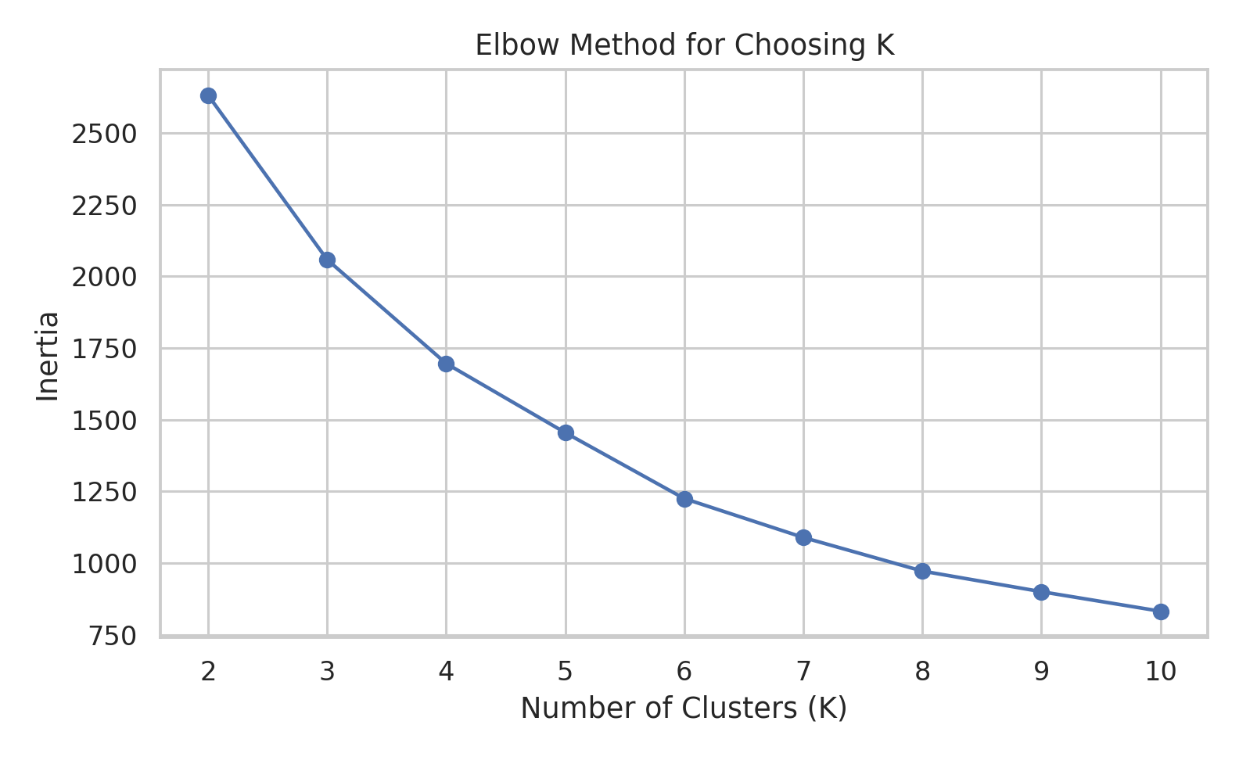
Silhouette Score
The Silhouette Score was also calculated for K values from 2 to 10. K = 2 produced the highest score of 0.311, while K = 4 produced a score of 0.281. Although K = 2 gives stronger separation according to this metric, K = 4 was selected because it provides four reasonably balanced groups and gives a more detailed view of transaction behavior. This choice is therefore a practical trade-off between separation and useful segmentation.
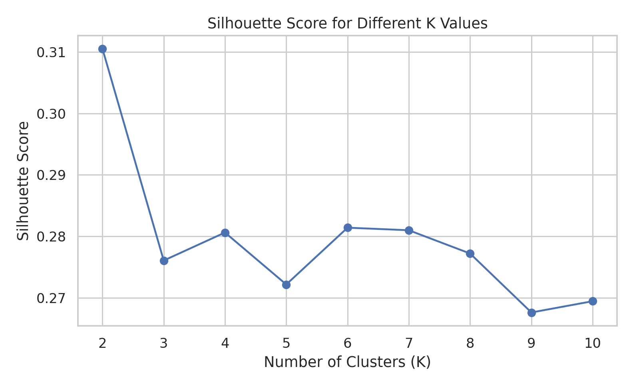
Implementation Code
from sklearn.metrics import silhouette_score

for k in range(2, 11):
kmeans = KMeans(
n_clusters=k,
random_state=42,
n_init=10
)

labels = kmeans.fit_predict(X_scaled)
score = silhouette_score(X_scaled, labels)

print(k, score)
8. Final Clustering Results
After selecting K = 4, the final model assigned every transaction to one of four clusters. The cluster sizes are 250, 231, 268, and 251 transactions. The groups are fairly balanced, which makes the resulting segmentation easier to compare.
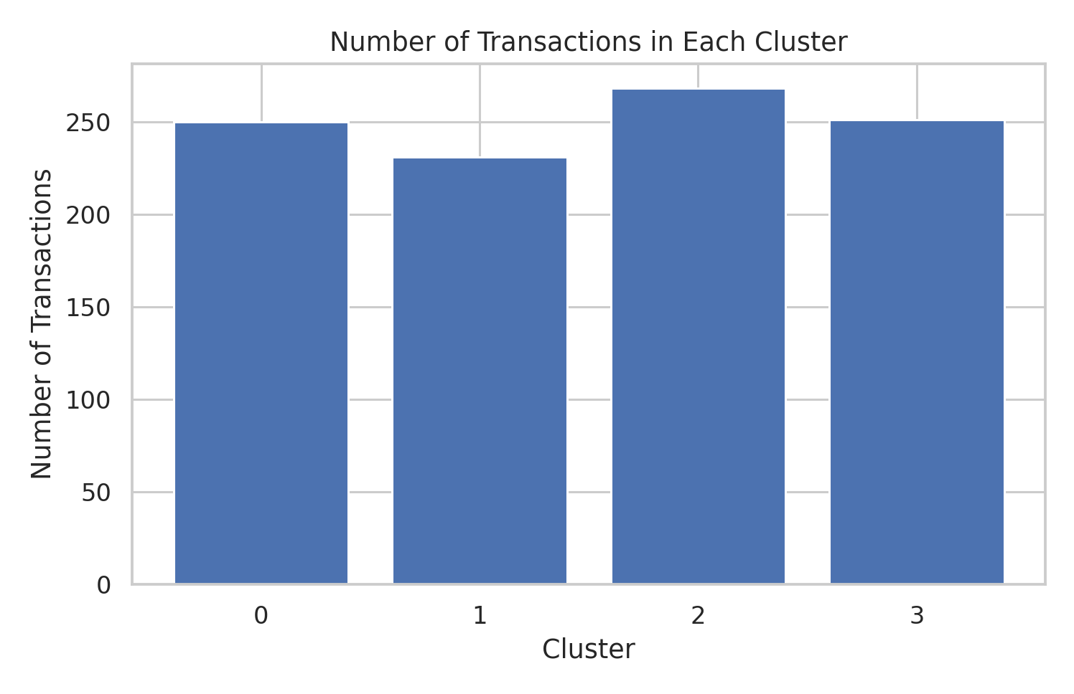
Cluster Sizes
Cluster | Number of Transactions
0 | 250
1 | 231
2 | 268
3 | 251

9. Cluster Characteristics
The following table shows the average values of the four features used by the model. These values are used to understand what makes each cluster different.
Cluster | Unit price | Quantity | Sales | Rating
0 | 35.17 | 3.02 | 107.98 | 6.02
1 | 76.93 | 2.95 | 236.62 | 7.66
2 | 34.06 | 7.59 | 268.86 | 7.71
3 | 79.60 | 8.12 | 674.33 | 6.50

10. Interpretation of Each Cluster
Cluster 0 — Lower-Value Transactions
This group has the lowest average sales at 107.98. Its average quantity is 3.02 and average unit price is 35.17. This indicates smaller transactions with relatively lower-priced purchases. The average rating is 6.02.
Cluster 1 — Higher-Price, Smaller-Quantity Transactions
This cluster has an average unit price of 76.93 but a relatively small average quantity of 2.95. Its average sales are 236.62. The pattern suggests purchases involving fewer items but comparatively higher-priced items. The average rating is 7.66.
Cluster 2 — Lower-Price, Larger-Quantity Transactions
This cluster has a lower average unit price of 34.06 and a larger average quantity of 7.59. Its average sales are 268.86. This suggests transactions where customers purchase more items at lower individual prices. The average rating is 7.71.
Cluster 3 — High-Value Transactions
This group has the highest average sales at 674.33. It also has the highest average quantity at 8.12 and a high average unit price of 79.60. These transactions represent the largest purchase values in the dataset. The average rating is 6.50.
11. Quantity vs Sales Visualization
The scatter plot compares quantity and sales while showing the cluster assignment. The plot helps visualize the relationship between the number of items purchased and the final transaction value. Higher quantities generally lead to higher sales, but unit price also affects the final value.
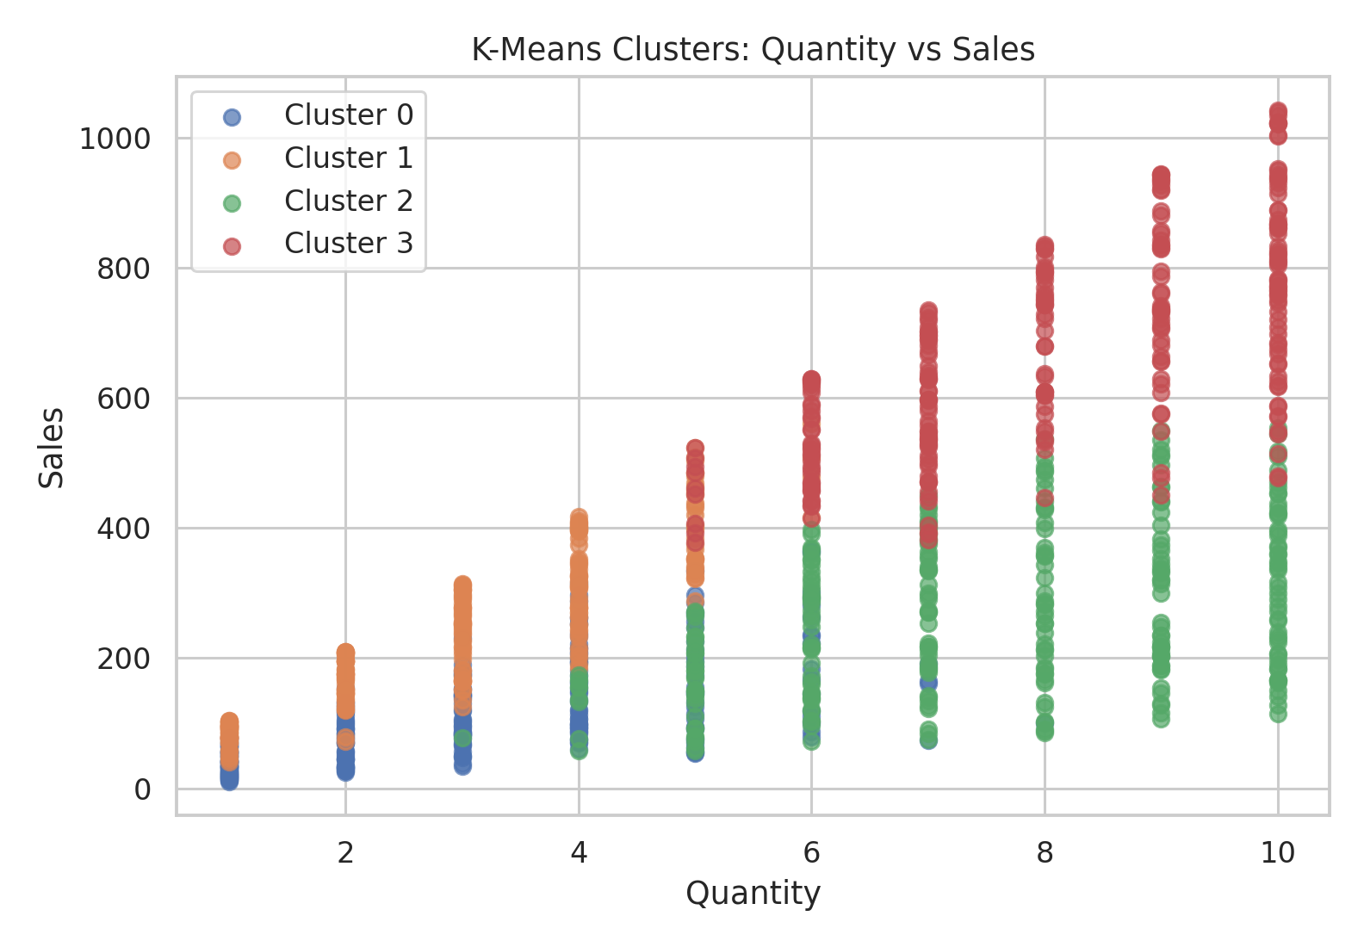

12. PCA Visualization
The clustering model uses four features, so the original data cannot be shown in a simple two-dimensional plot. PCA was used to reduce the standardized data to two components for visualization. The first two components explain approximately 73.9% of the total variance. The graph provides a simpler view of the positions of the four clusters.
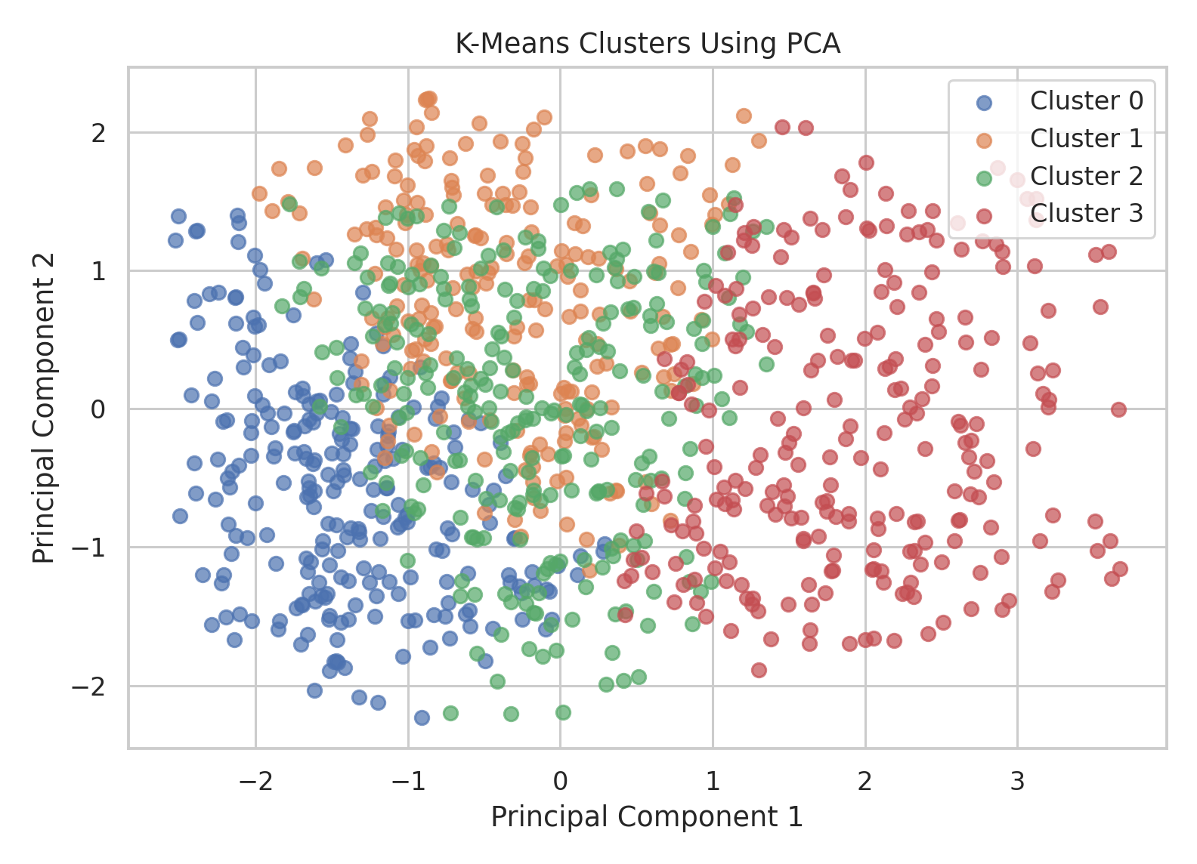
Implementation Code
from sklearn.decomposition import PCA

pca = PCA(n_components=2)
X_pca = pca.fit_transform(X_scaled)

pca_df = pd.DataFrame(
X_pca,
columns=["PC1", "PC2"]
)

pca_df["Cluster"] = df["Cluster"]
13. Cluster Comparison
The following chart compares the average values of the selected features across the four clusters. It helps highlight the different purchasing patterns identified by K-Means.
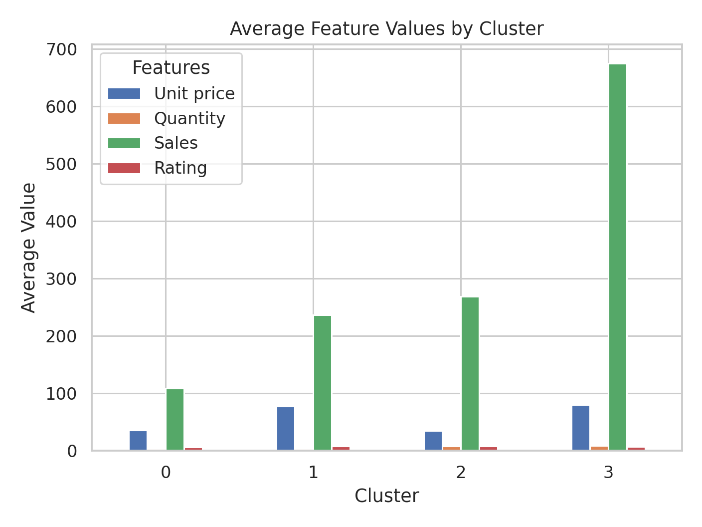
Implementation Code
cluster_means = df.groupby("Cluster")[features].mean()

cluster_means.plot(
kind="bar",
figsize=(10, 6)
)

plt.title("Average Feature Values by Cluster")
plt.xlabel("Cluster")
plt.ylabel("Average Value")
plt.show()
14. Cluster Centers
The K-Means cluster centers below are expressed in standardized units. Positive values indicate that the cluster is above the overall standardized average for a feature, while negative values indicate that it is below the average.
Cluster | Unit price | Quantity | Sales | Rating
0 | -0.77 | -0.85 | -0.87 | -0.55
1 | 0.80 | -0.88 | -0.35 | 0.40
2 | -0.82 | 0.71 | -0.22 | 0.43
3 | 0.90 | 0.89 | 1.43 | -0.28

Implementation Code
centers = pd.DataFrame(
kmeans.cluster_centers_,
columns=features
)

centers
15. Business Implications
The clusters can help a supermarket understand different types of transaction behavior. High-value transactions can be studied to identify purchasing patterns associated with larger bills. Lower-value transactions may provide opportunities for promotions or product combinations that encourage larger baskets. The middle clusters also show that a similar sales value can be produced in different ways, such as buying fewer higher-priced items or more lower-priced items.
16. Limitations
This analysis groups individual transactions rather than long-term individual customers. The dataset does not provide a stable customer identifier that can be used to build reliable customer purchase histories. Therefore, the groups should be called transaction segments rather than permanent customer segments. Also, K-Means is distance-based, so the result depends on the selected features and scaling method.
17. Conclusion
K-Means clustering was applied to the SuperMarket Analysis dataset using Unit price, Quantity, Sales, and Rating. The features were standardized before clustering. The Elbow Method and Silhouette Score were used to compare different numbers of clusters. K = 4 was selected because it produced four reasonably balanced and interpretable transaction groups, while the higher Silhouette Score for K = 2 was also considered. The final clusters showed clear differences in transaction value, quantity, and unit price. Overall, this analysis demonstrates how unsupervised learning can discover useful groups in data without using a predefined target variable.

