Mrinmoy Chaku  B.Tech Computer Science Student | Aspiring Web Developer  Hooghly, West Bengal, India 712408  +91 6297698886 | mrinmoychaku@gmail.com | 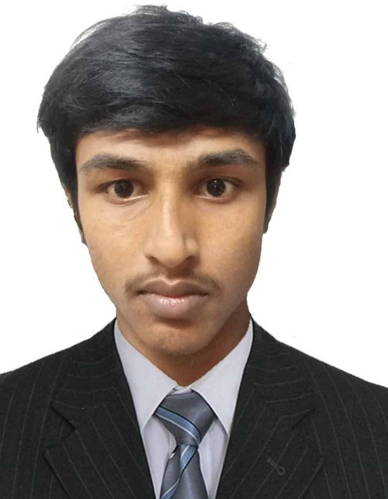
PROFESSIONAL SUMMARY
Motivated B.Tech Computer Science student with hands-on experience in web development and database-driven applications. Skilled in Python, HTML, CSS, and JavaScript, with a working knowledge of relational databases, and has contributed to a real-time yoga competition scoring platform. Experienced in building clean, maintainable code, debugging runtime issues, and delivering features that meet user requirements. A fast learner with strong problem-solving skills and a genuine passion for building responsive, user-friendly web applications.
TECHNICAL SKILLS
- Programming Languages: Python, JavaScript
- Web Technologies: HTML5, CSS3, Responsive Web Design, REST APIs
- Databases: MySQL, PostgreSQL
- Concepts: Object-Oriented Programming, Debugging and Testing, Front-end and Back-end Development
PROJECTS
Yoga Scoring System (YSS) – Real-Time Web-Based Judging and Scoring Platform
- Worked on a web-based platform for yoga competitions that collects marks from judges in real time through their smartphones.
- Contributed to the scoring logic that removes the highest and lowest marks for each asana and totals the rest automatically.
- Supported live on-screen score display, judge login accounts, and result sheets, so participants and audiences can see marks instantly.
- Used Python, HTML, CSS, JavaScript, and a database to build, test, and debug features for stable, reliable performance.
WORK EXPERIENCE
Junior Developer – Kolkata, India | June 2024 – Present
- Developed clean, maintainable code for assigned application features.
- Debugged runtime issues and resolved defects across development environments.
- Tested software functionality to verify performance and stability.
- Collaborated with team members to implement user requirements accurately.
EDUCATION
Bachelor of Technology (B.Tech) in Computer Science – Currently Enrolled
Dr. Sudhir Chandra Sur Institute of Technology & Sports Complex (SurTech), Kolkata, India
High School Diploma (H.S.) – Guti Uday Chand Vidyamandir (H.S), Hooghly, India
LANGUAGES
English | Bengali | Hindi

