**大 连 海 事 大 学**

**____________ 实 验 报 告**

**.NET体系及编程实验**

|  |
| --- |
| 专业班号____________________ 姓名________________ 学号________________  实验日期____________________ 指导教师____________________  **2023.12.7** |
| 实验（应用系统）名称 ______________________________  智能教务信息管理系统 |

**目录**

一、实验目的 1

二、实验内容 1

2.1系统设计 1

2.1.1功能模块图 1

2.1.2权限图 1

2.2数据库设计 2

2.2.1需求分析 2

2.2.2业务流程图 2

2.2.3数据流图(DFD) 2

2.2.4数据库概念模型设计 4

2.2.5数据库逻辑模型设计 5

2.2.6数据库物理模型设计 6

2.3主要代码和截图 7

2.3.1主界面 7

2.3.2人员管理 15

2.3.3成绩管理 21

2.3.4事务管理 25

2.3.5使用说明 25

三、实验体会 26

3.1总结 26

3.2问题和解决方案 26

# 一、实验目的

1. 熟练运用ASP.NET服务器控件、ASP.NET内置对象以及ADO.NET数据库访问技术；

2. 掌握使用ASP.NET开发Web应用程序的基本方法和基本技能；

3. 综合运用“.Net体系及编程”课程所学知识，设计并实现一个完整的ASP.NET Web应用系统。

# 二、实验内容

## 2.1系统设计

### 2.1.1功能模块图

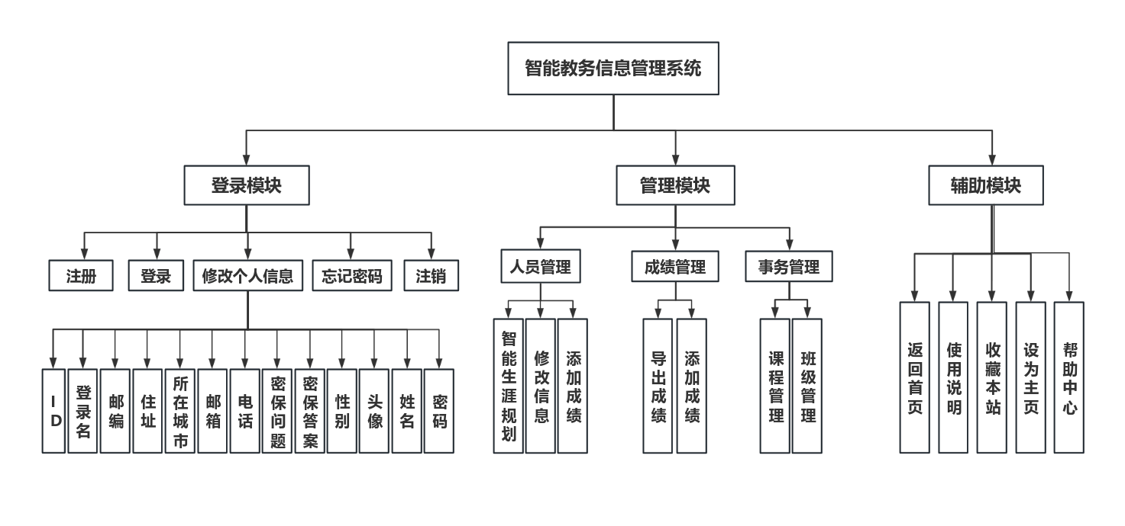

图 1功能模块图

### 2.1.2权限图

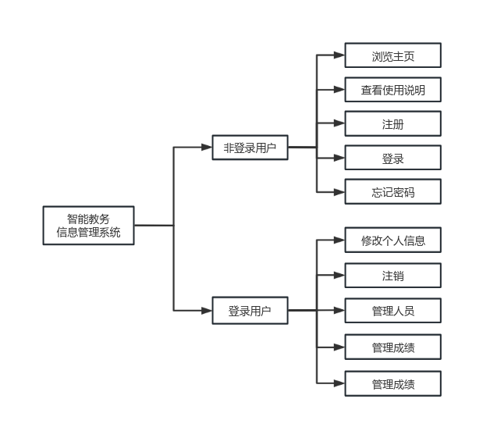

图 2权限一览

## 2.2数据库设计

### 2.2.1需求分析

智能教务信息管理系统数据库主要需要学生信息、课程、选课（含成绩）、员工信息，辅助需要用户登录信息，从而使得用户可以登录获得权限，并对数据库进行有限的操作。

### 2.2.2业务流程图

以数据库操作流程为例：

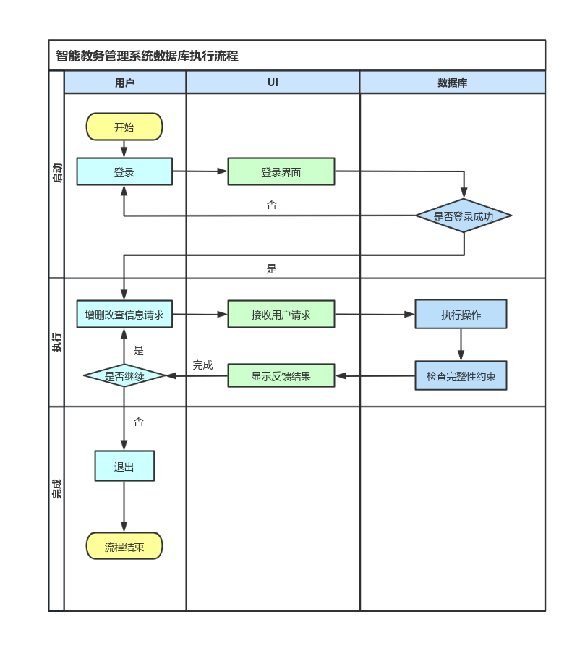

图 3登录业务流程图

### 2.2.3数据流图(DFD)

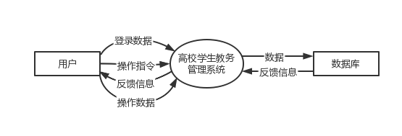

图 4顶层数据流图

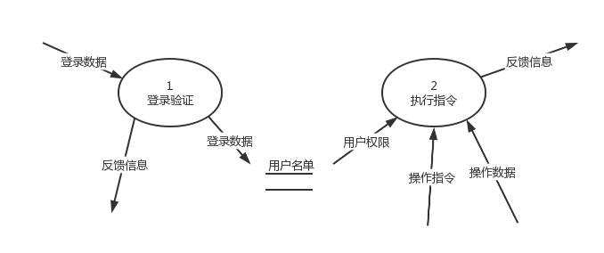

图 5第1层数据流图

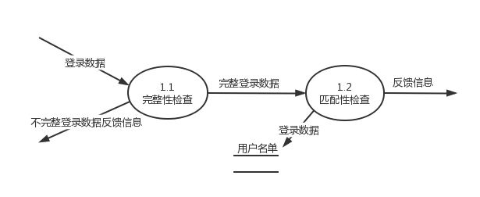

图 6第2层数据流图(1)

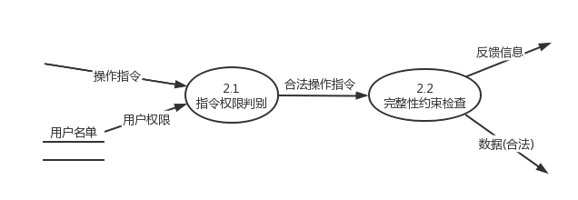

图 7第2层数据流图(2)

### 2.2.4数据库概念模型设计

一个专业存在于一个学院，一个学院拥有多个专业；

一个学生属于一个专业，一个民族的自然属性；一个专业包含若干学生，一个民族在本校包括若干学生；

职工分为教师和导员，导员包含了教师的职能，教师没有导员的职能。

一名导员可以在多个班级指导学生，一个班级只能有一个导员；

一个学生归属一个班级，一个班级包括多名学生，有一位班长；

一个院系可以开设多门课程，每门课程只能在一个院系开设；

一个学生可以在一个学年/学期选修多门课程，可以在多个学年不断重修同一门课，一门课程可以被多个学生选修；

一门课程在一个学年/学期可以由多个任课教师讲授，一个任课教师也可以讲授多门课程，学生在某个时间选修一位老师讲授的一门课程就对应有一个成绩；

一位职工隶属于一个学院，一个学院有多位职工。

主要实体和属性：

学生：学号，姓名，性别，生日，民族，身份证号，年级，班级序号，专业代码，电话，家庭住址；

职工：职工代码，姓名，性别，类别(教师，导员)，生日，职称代码，介绍，电话；

院系：院系代码，名称，描述，当前可用否；

专业：专业代码，名称，描述，所在院系；

班级：专业，年级，班级序号，导员代码，班长代码；

课程：课程代码，名称，学时，学分，考试方式，授课院系，备注；

民族：民族代码，名称；

职称：职称代码，名称；

性别：性别码，名称；

选课：学号，课程代码，职工代码，学年，学期，成绩。

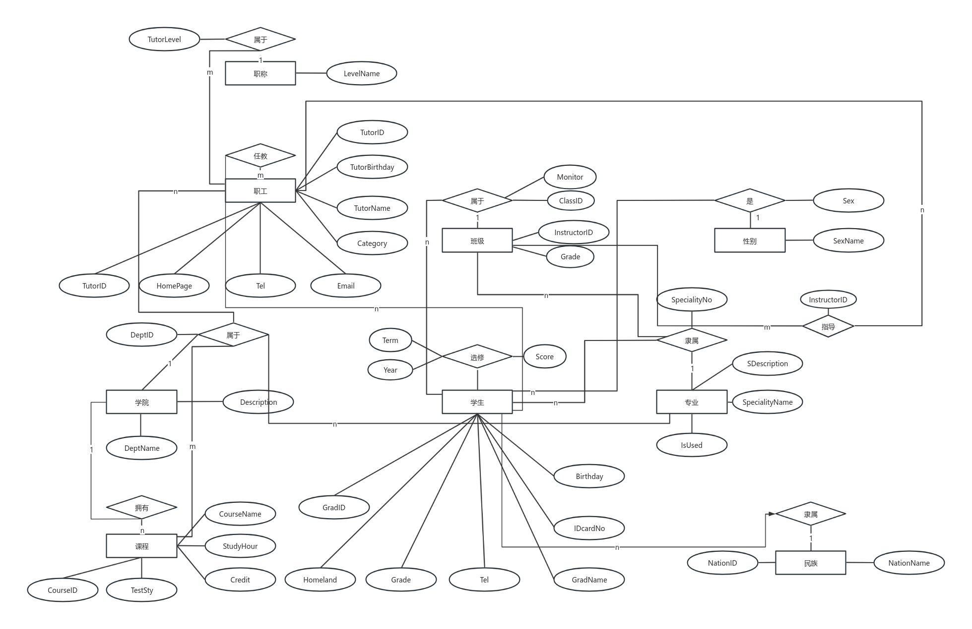

图 8数据库E-R图

### 2.2.5数据库逻辑模型设计

关系模式满足3NF，以学生关系为例，学号是主码，学号能决定后面各属性，任何非主属性都不传递依赖于码，也不能部分依赖于码。

TC_Nation(NationID,NationName)

TC_Tutorlevel(TutorLevel,LevelName)

TC_Sex(Sex,SexName)

TB_Dept_Info(DeptID,DeptName,Description)

TB_Speciality_Info(SpecialityNo,SpecialityName,SDescription,DeptID)

TB_Course_info(CourseID,CourseName,StudyHour,Credit,TestSty,DeptID,Notes)

TB_Tutor_Info(TutorID,TutorName,Sex,Category,TutorBirthday,TutorLevel,TutorDescript,DeptID,Email,Tel)

TC_Class(SpecialityNo,Grade,ClassID,InstructorID varchar(10),MonitorID)

TB_Student_Info(GradID,GradName,Sex,Birthday,NationID,IDcardNo,Grade,ClassID,SpecialityNo,Tel,Homeland)

TB_Select_Course(GradID,CourseID,TutorID,Year,Term,Score)

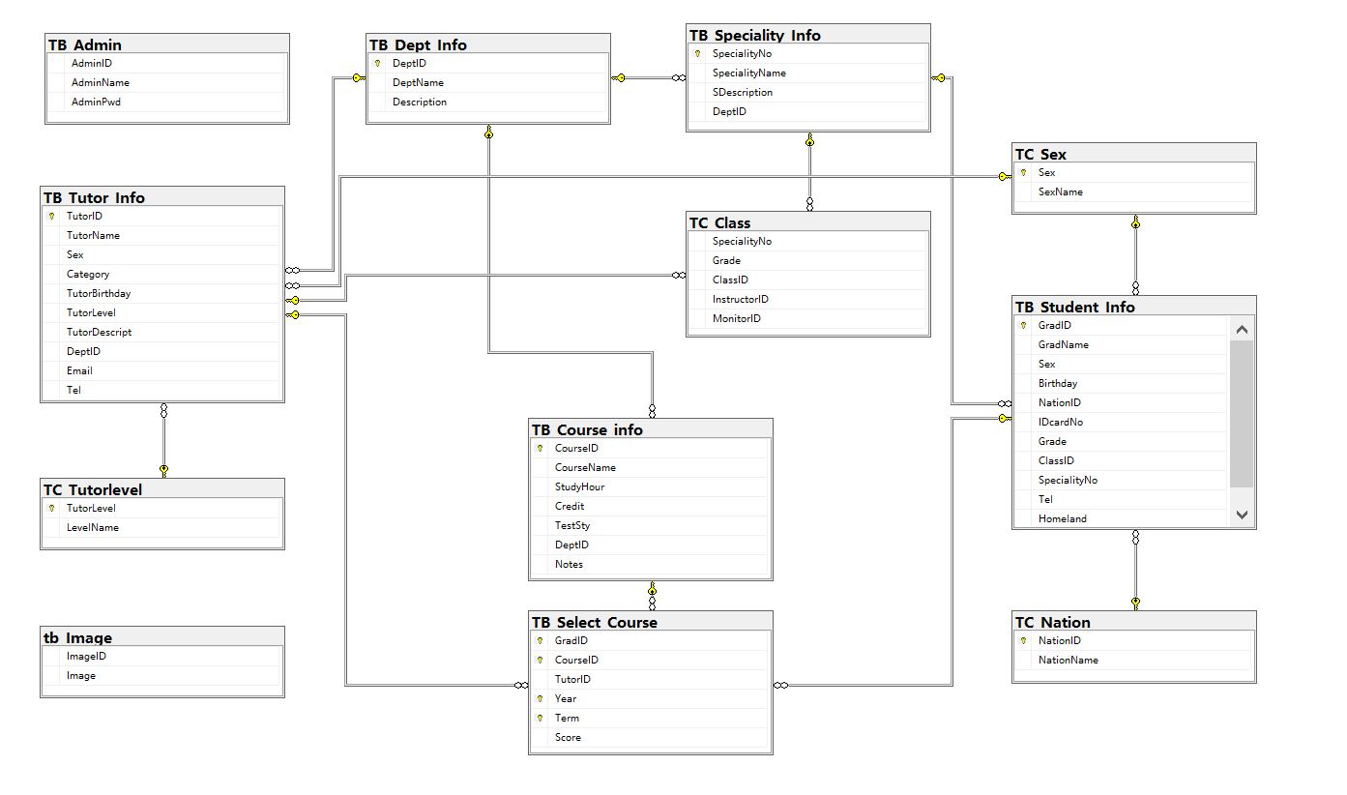

图 9数据库一览

### 2.2.6数据库物理模型设计

CREATE TABLE TC_Nation(NationID varchar(2) PRIMARY KEY,NationName nvarchar(20))

CREATE TABLE TC_Tutorlevel(TutorLevel varchar(3) PRIMARY KEY,LevelName nvarchar(20))

CREATE TABLE TC_Sex(Sex varchar(2) PRIMARY KEY,SexName nvarchar(10))

CREATE TABLE TB_Dept_Info(DeptID varchar(10) PRIMARY KEY,DeptName nvarchar(50),Description nvarchar(500))

CREATE TABLE TB_Speciality_Info(SpecialityNo varchar(8) PRIMARY KEY,SpecialityName nvarchar(50),SDescription nvarchar(400),DeptID varchar(10),FOREIGN KEY (DeptID) REFERENCES TB_Dept_Info(DeptID))

CREATE TABLE TB_Course_info(CourseID varchar(10) PRIMARY KEY,CourseName nvarchar(50),StudyHour Smallint NOT NULL,Credit Numeric(9,1) NOT NULL,TestSty nvarchar(4) CHECK (TestSty='考试' OR TestSty='考查') DEFAULT '考试',DeptID varchar(10),Notes nvarchar(50),FOREIGN KEY (DeptID) REFERENCES TB_Dept_Info(DeptID))

CREATE TABLE TB_Tutor_Info(TutorID varchar(10) PRIMARY KEY,TutorName nvarchar(20),Sex varchar(2) FOREIGN KEY REFERENCES TC_Sex(Sex),Category nvarchar(5) check (Category='教师' OR Category='导员') DEFAULT '教师',TutorBirthday smalldatetime,TutorLevel varchar(3),TutorDescript nvarchar(MAX),DeptID varchar(10),Email varchar(40),Tel varchar(20),FOREIGN KEY (TutorLevel) REFERENCES TC_Tutorlevel(TutorLevel),FOREIGN KEY (DeptID) REFERENCES TB_Dept_Info(DeptID))

CREATE TABLE TC_Class(SpecialityNo varchar(8),Grade nvarchar(4),ClassID varchar(10),InstructorID varchar(10) ,MonitorID varchar(10),FOREIGN KEY (InstructorID) REFERENCES TB_Tutor_Info(TutorID))

CREATE TABLE TB_Student_Info(GradID varchar(10) PRIMARY KEY,GradName nvarchar(20),Sex varchar(2),Birthday SMALLDATETIME,NationID varchar(2),IDcardNo varchar(18),Grade nvarchar(4),ClassID varchar(10),SpecialityNo varchar(8),Tel nvarchar(20),Homeland nvarchar(50),FOREIGN KEY (Sex) REFERENCES TC_Sex(Sex),FOREIGN KEY (NationID) REFERENCES TC_Nation(NationID),FOREIGN KEY (SpecialityNo) REFERENCES TB_Speciality_Info(SpecialityNo))

CREATE TABLE TB_Select_Course(GradID varchar(10),CourseID varchar(10),TutorID varchar(10),Year varchar(20),Term varchar(10),Score INT,PRIMARY KEY(GradID,CourseID,Year,Term),FOREIGN KEY (GradID) REFERENCES TB_Student_Info(GradID),FOREIGN KEY (CourseID) REFERENCES TB_Course_info(CourseID),FOREIGN KEY (TutorID) REFERENCES TB_Tutor_Info(TutorID))

## 2.3主要代码和截图

### 2.3.1主界面

导航栏：

<td colspan="3" style="font-size: 9pt; text-align: right;">

<br />

<a href="javascript:window.external.AddFavorite('https://github.com/Mriris', '燕庭轩的github')" style="text-decoration: none; color: black;">『收藏本站』</a>

<span onclick="var strHref=window.location.href;this.style.behavior='url(#default#homepage)';this.setHomePage('https://github.com/Mriris');" style="cursor: hand; color: white;">『设置主页』</span>

<a href="2647381485@qq.com" style="text-decoration: none; color: white;">『联系我们』</a>

<a href="https://chat.openai.com/?model=gpt-4" style="font-size: 9pt; text-decoration: none; color: black;">『帮助中心』</a>

</td>

功能栏：

<tr>

<td style="height: 45px" colspan="2" align="center">

<br />

<asp:ImageButton ID="ibtnGName" runat="server" Height="115px" Width="129px" ImageUrl="~/Image/例图/人员管理.jpg" OnClick="PersonM" Visible="false" />

<br />

<asp:Label ID="Label1" runat="server" Text="人员管理"></asp:Label>

<br />

<br />

</td>

</tr>

<tr>

<td style="height: 45px" colspan="2" align="center" class="auto-style1" rowspan="1">

<br />

<asp:ImageButton ID="gradeManage" runat="server" Height="115px" Width="129px" ImageUrl="~/Image/例图/链接图片3.jpg" OnClick="GradeM" Visible="false" />

<br />

<asp:Label ID="Label3" runat="server" Text="成绩管理"></asp:Label>

<br />

<br />

<br />

</td>

</tr>

<tr>

<td style="text-align: center; width: 201px;">

<asp:ImageButton ID="ibtnGoods2" runat="server" Height="115px" Width="130px" ImageUrl="~/Image/例图/事务管理.jpg" OnClick="MetterM" Visible="false" />

<br />

<asp:Label ID="Label2" runat="server" Text="事务管理"></asp:Label>

<br />

<table style="width: 200px;" cellpadding="0" cellspacing="0">

<tr>

<td style="text-align: right; height: 17px;">&nbsp;

</td>

</tr>

</table>

</td>

</tr>

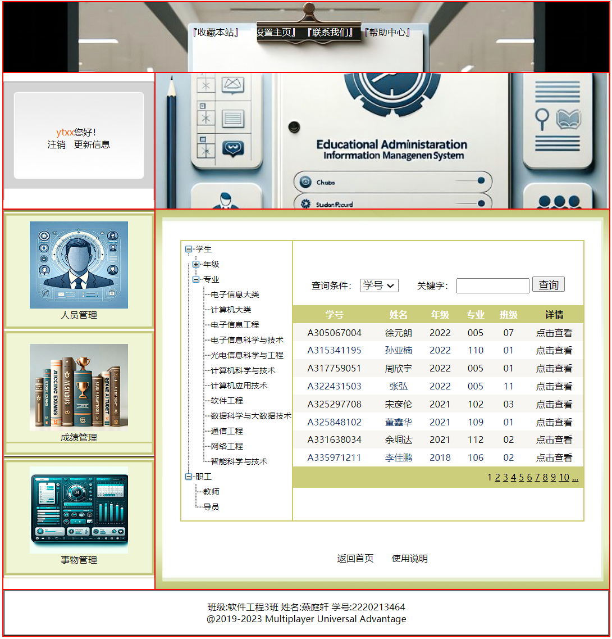

图 10主界面

#### 2.3.1.1注册

SqlOperate sqloperate = new SqlOperate();

SqlConnection sqlconn = new SqlConnection(ConfigurationManager.AppSettings["ConnectionString"]);

protected void Page_Load(object sender, EventArgs e)

{

UnobtrusiveValidationMode = UnobtrusiveValidationMode.None;

if (!IsPostBack)

{

sqlconn.Open();

string sqlstr = "select * from tb_Image";

SqlDataAdapter myda = new SqlDataAdapter(sqlstr, sqlconn);

DataSet myds = new DataSet();

myda.Fill(myds, "tb_Image");

ddlPhoto.DataSource = myds.Tables["tb_Image"];

ddlPhoto.DataTextField = "Image";

ddlPhoto.DataBind();

imgPhoto.ImageUrl = ddlPhoto.SelectedValue;

sqlconn.Close();

}

}

protected void btnRegister_Click(object sender, EventArgs e)

{

string sqltest = "select * from tb_Member where MemberName='" + this.txtLoginName.Text + "'";

sqlconn.Open();

SqlCommand sqlcom = new SqlCommand(sqltest, sqlconn);

SqlDataReader read = sqlcom.ExecuteReader();

read.Read();

if (read.HasRows)

{

if (this.txtLoginName.Text.Trim() == read["MemberName"].ToString().Trim())

{

Response.Write("<script language='javascript'>alert('该会员已经注册过');localtion='Register.aspx'</script>");

return;

}

}

string sqlstr = "insert into tb_Member "

+ "(MemberName,MemberSex,MemberPWD,MemberTName,"

+ "MemberQue,MemberAns,MemberPhone,MemberEmail,MemberCity,MemberAddress,MemberPostCode,MemberPhoto)"

+ "values('" + txtLoginName.Text + "','" + ddlSex.SelectedValue

+ "','" + txtPwd.Text + "','" + txtTName.Text + "','" + txtQuePwd.Text

+ "','" + txtAnsPwd.Text + "','" + txtTel.Text + "','" + txtEmail.Text

+ "','" + ddlCity.SelectedValue + "','" + txtAddress.Text + "','" + txtPostCode.Text + "','" + ddlPhoto.Text + "')";

sqloperate.DataCom(sqlstr);

sqlconn.Close();

Session["regName"] = txtLoginName.Text.Trim();

Response.Redirect("SuccReg.aspx");

}

protected void btnCancel_Click(object sender, EventArgs e)

{

txtLoginName.Text = "";

txtPwd.Text = "";

txtTName.Text = "";

txtQuePwd.Text = "";

txtAnsPwd.Text = "";

txtTel.Text = "";

txtEmail.Text = "";

txtAddress.Text = "";

txtPostCode.Text = "";

txtLoginName.Focus();

}

protected void btnTest_Click(object sender, EventArgs e)

{

if (txtLoginName.Text == "")

{

Response.Write("<script language='javascript'>alert('会员登录名不能为空！');localtion='Register.aspx'</script>");

}

else

{

string sqlstr = "select * from tb_Member where MemberName='" + this.txtLoginName.Text + "'";

sqlconn.Open();

SqlCommand sqlcom = new SqlCommand(sqlstr, sqlconn);

SqlDataReader read = sqlcom.ExecuteReader();

read.Read();

if (read.HasRows)

{

if (this.txtLoginName.Text.Trim() == read["MemberName"].ToString().Trim())

{

Response.Write("<script language='javascript'>alert('该会员已经注册过');localtion='Register.aspx'</script>");

return;

}

}

else

{

Response.Write("<script language='javascript'>alert('您可以进行正常注册');localtion='Register.aspx'</script>");

}

read.Close();

sqlconn.Close();

}

}

protected void ddlPhoto_SelectedIndexChanged(object sender, EventArgs e)

{

imgPhoto.ImageUrl = ddlPhoto.SelectedValue;

}

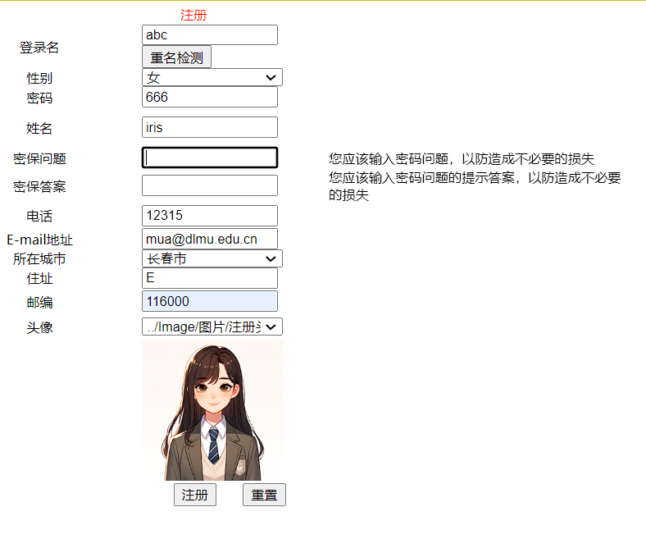

图 11注册内容不全时反馈

#### 2.3.1.2登录

SqlConnection sqlconn = new SqlConnection(ConfigurationManager.AppSettings["ConnectionString"]);

protected void Page_Load(object sender, EventArgs e)

{

if (!IsPostBack)

{

if (Session["MName"] != null)

{

Panel1.Visible = true;

Panel2.Visible = false;

MName.Text = Session["MName"].ToString();

}

}

}

protected void btnLogin_Click(object sender, EventArgs e)

{

sqlconn.Open();

SqlCommand sqlcom = new SqlCommand("proMemberInfo", sqlconn);

sqlcom.CommandType = CommandType.StoredProcedure;

sqlcom.Parameters.Add("@MemberName", SqlDbType.VarChar, 20).Value = txtMName.Text.Trim();

sqlcom.Parameters.Add("@MemberPwd", SqlDbType.VarChar, 20).Value = txtMPwd.Text.Trim();

SqlDataReader read = sqlcom.ExecuteReader();

if (read.Read())

{

Panel1.Visible = true;

Panel2.Visible = false;

MName.Text = txtMName.Text;

Session["MName"] = txtMName.Text.Trim();

Response.Redirect(Request.Url.AbsoluteUri);

}

else

{

Response.Write("<script>alert('您输入的用户名或密码错误，请重新输入！');location='javascript:history.go(-1)';</script>");

}

}

protected void lbtnLogout_Click(object sender, EventArgs e)

{

Panel1.Visible = false;

Panel2.Visible = true;

txtMName.Text = "";

txtMPwd.Text = "";

Session.Clear();

Session.Abandon();

Response.Redirect(Request.Url.AbsoluteUri);

}

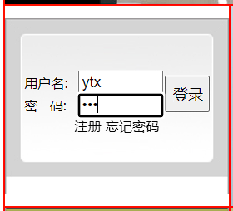

图 12登录模块

#### 2.3.1.3修改个人信息

SqlOperate sqloperate = new SqlOperate();

SqlConnection sqlconn = new SqlConnection(ConfigurationManager.AppSettings["ConnectionString"]);

protected void Page_Load(object sender, EventArgs e)

{

if (!IsPostBack)

{

if (Session["MName"] != null)

{

sqlconn.Open();

string sqlstr = "Select * from tb_Member where MemberName='" + Session["MName"].ToString() + "'";

SqlDataAdapter myApter = new SqlDataAdapter(sqlstr, sqlconn);

DataSet myDS = new DataSet();

myApter.Fill(myDS, "tb_Member");

DataRowView rowView = myDS.Tables["tb_Member"].DefaultView[0];

txtUserID.Text = Convert.ToString(rowView["MemberID"]);

txtLoginName.Text = Convert.ToString(rowView["MemberName"]);

txtPwd.Text = Convert.ToString(rowView["MemberPWD"]);

txtTName.Text = Convert.ToString(rowView["MemberTName"]);

txtQuePwd.Text = Convert.ToString(rowView["MemberQue"]);

txtAnsPwd.Text = Convert.ToString(rowView["MemberAns"]);

txtTel.Text = Convert.ToString(rowView["MemberPhone"]);

txtEmail.Text = Convert.ToString(rowView["MemberEmail"]);

ddlCity.SelectedValue = Convert.ToString(rowView["MemberCity"]);

txtAddress.Text = Convert.ToString(rowView["MemberAddress"]);

txtPostCode.Text = Convert.ToString(rowView["MemberPostCode"]);

//txtMoney.Text = Convert.ToString(rowView["MemberMoney"]);

string sqlstrbind = "select * from tb_Image";

SqlDataAdapter mydabind = new SqlDataAdapter(sqlstrbind, sqlconn);

DataSet mydsbind = new DataSet();

mydabind.Fill(mydsbind, "tb_Image");

ddlPhoto.DataSource = mydsbind.Tables["tb_Image"];

ddlPhoto.DataTextField = "Image";

ddlPhoto.DataBind();

iGPhoto.ImageUrl = Convert.ToString(rowView["MemberPhoto"]);

if (Convert.ToString(rowView["MemberSex"]).Trim() == "男")

{

ddlSex.SelectedIndex = 0;

}

if (Convert.ToString(rowView["MemberSex"]).Trim() == "女")

{

ddlSex.SelectedIndex = 1;

}

sqlconn.Close();

}

else

Response.Write("<script>alert('您还没有登录，请登录后再使用，谢谢！');</script>");

}

}

protected void btnModify_Click(object sender, EventArgs e)

{

string sqlstr = "update tb_Member set MemberName='" + txtLoginName.Text

+ "',MemberSex='" + ddlSex.Text + "',MemberPWD='" + txtPwd.Text

+ "',MemberTName='" + txtTName.Text + "',MemberQue='" + txtQuePwd.Text

+ "',MemberAns='" + txtAnsPwd.Text + "',MemberPhone='" + txtTel.Text

+ "',MemberEmail= '" + txtEmail.Text + "',MemberCity = '" + ddlCity.SelectedValue

+ "',MemberAddress= '" + txtAddress.Text + "',MemberPostCode='"

+ txtPostCode.Text + "',MemberPhoto='" + ddlPhoto.SelectedValue

+ "',MemberMoney='" + "0" + "' where MemberID = '" + txtUserID.Text + "'";

sqloperate.DataCom(sqlstr);

Response.Write("<script lanuage=javascript>alert('修改成功');location='javascript:history.go(-1)'</script>");

}

protected void btnCancel_Click(object sender, EventArgs e)

{

Response.Redirect("..//index.aspx");

}

protected void ddlPhoto_SelectedIndexChanged(object sender, EventArgs e)

{

iGPhoto.ImageUrl = ddlPhoto.SelectedValue;

}

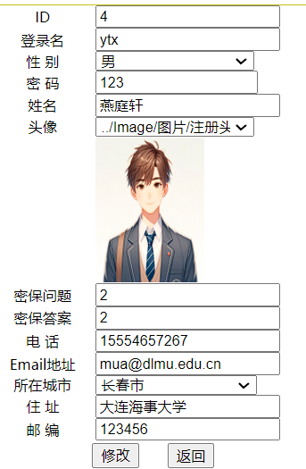

图 13个人信息修改界面

#### 2.3.1.4忘记密码

SqlConnection sqlconn = new SqlConnection(ConfigurationManager.AppSettings["ConnectionString"]);

protected void Page_Load(object sender, EventArgs e)

{

sqlconn.Open();

SqlCommand sqlcom = new SqlCommand("select MemberQue from tb_Member where MemberID='"

+ Convert.ToString(Session["MemberID"]) + "'", sqlconn);

txtQuePwd.Text = Convert.ToString(sqlcom.ExecuteScalar());

sqlconn.Close();

}

protected void btnSure_Click(object sender, EventArgs e)

{

sqlconn.Open();

SqlCommand sqlcom = new SqlCommand("select count(*) from tb_Member where MemberAns='"

+ txtAnsPwd.Text + "' and MemberID='" + Convert.ToString(Session["MemberID"]) + "'", sqlconn);

int count = Convert.ToInt32(sqlcom.ExecuteScalar());

if (count > 0)

{

Page.Response.Redirect("ShowPwd.aspx");

}

else

{

Response.Write("<script>alert('提示问题答案输入有误！');location='javascript:history.go(-1)'</script>");

return;

}

sqlconn.Close();

}

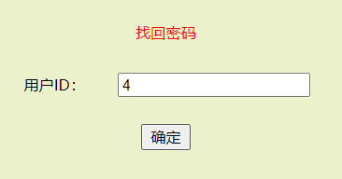

图 14输入用户ID

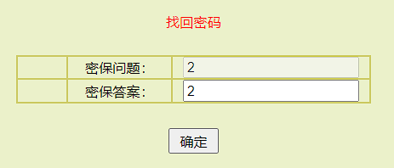

图 15输入密保答案

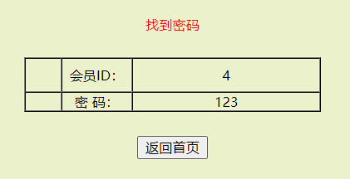

图 16密码找回成功

### 2.3.2人员管理

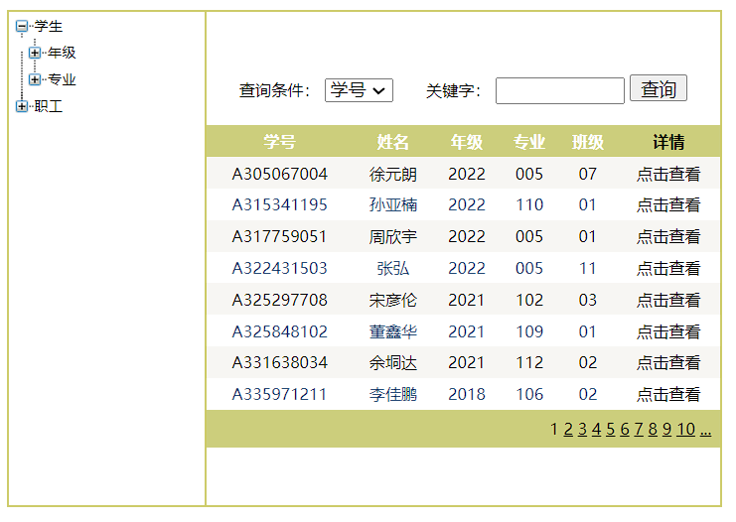

图 17学生管理

public void gvbind()

{

if (txtKey.Text == "")

{

string sqlstr = "select * from TB_Student_Info";

sqloperate.gvDataBind(gvGoodsInfo, sqlstr);

}

else

{

string sqlstr = "select * from TB_Student_Info where "

+ ddlCondition.SelectedValue + " like '%" + txtKey.Text.Trim() + "%'";

sqloperate.gvDataBind(gvGoodsInfo, sqlstr);

}

}

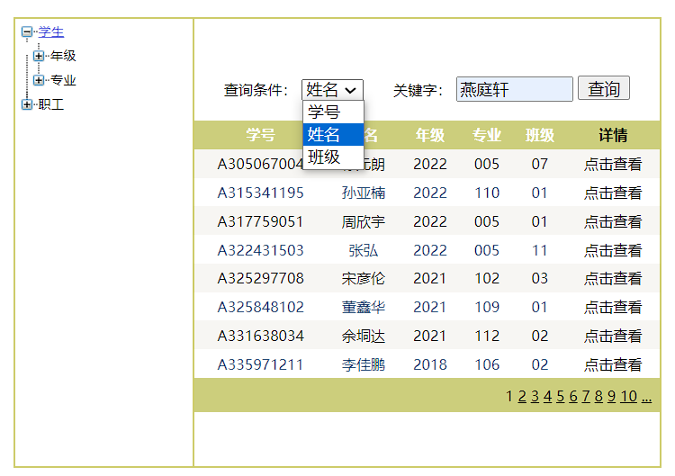

图 18按姓名(燕庭轩)查找学生

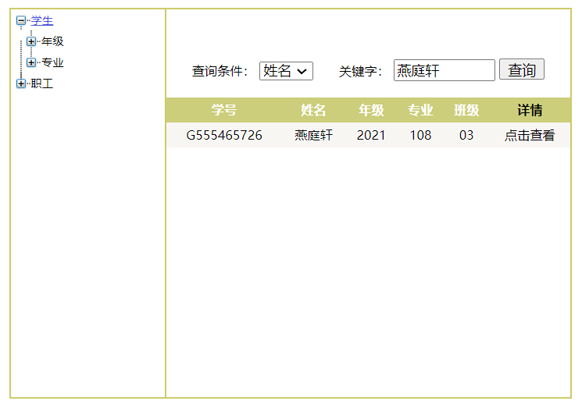

图 19查找成功

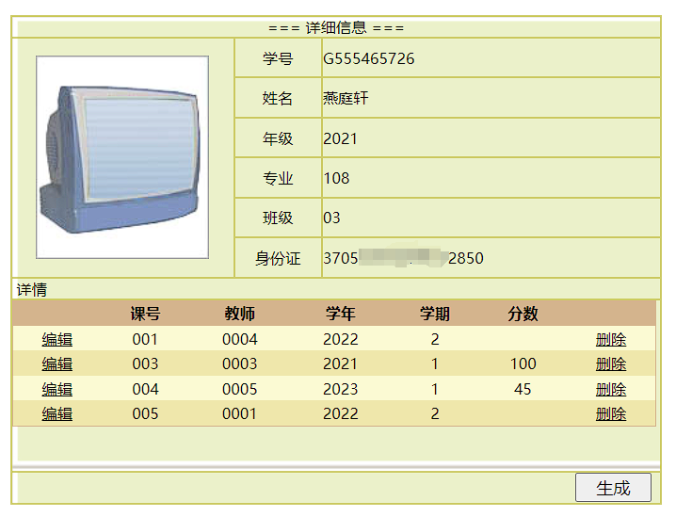

图 20查看该学生详细信息

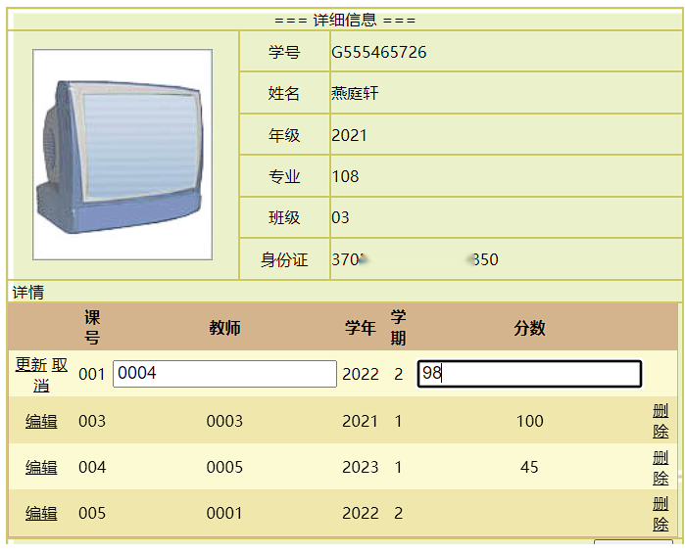

图 21修改成绩信息

private static readonly HttpClient _httpClient = new HttpClient();

public async Task<string> GetGptResponse(string message)

{

// 设置API请求的URL

string apiUrl = "https://api.openai.com/v1/chat/completions";

// 创建请求体

var requestData = new

{

model = "gpt-3.5-turbo",

messages = new[]

{

new { role = "system", content = "你是一个说中文的职业生涯规划分析师" },

new { role = "user", content = message }

},

max_tokens = 500

};

// 序列化请求数据为JSON

string jsonRequest = JsonConvert.SerializeObject(requestData);

HttpContent content = new StringContent(jsonRequest, Encoding.UTF8, "application/json");

// 设置请求头

_httpClient.DefaultRequestHeaders.Authorization = new AuthenticationHeaderValue("Bearer", ConfigurationManager.AppSettings["gpt-key"]);

// 发送请求

var response = await _httpClient.PostAsync(apiUrl, content);

// 处理响应

if (response.IsSuccessStatusCode)

{

var jsonResponse = await response.Content.ReadAsStringAsync();

dynamic responseObject = JsonConvert.DeserializeObject(jsonResponse);

return responseObject.choices[0].message.content;

}

else

{

// 请求失败，可以根据需要进行处理

return $"错误: {response.StatusCode}";

}

}

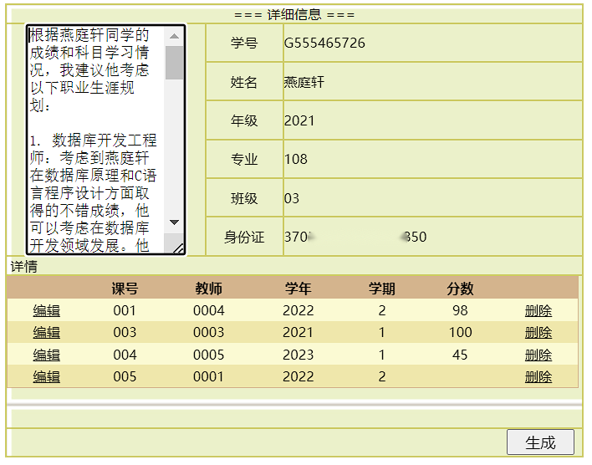

图 22根据成绩智能生成职业生涯规划

protected void tvGType_SelectedNodeChanged(object sender, EventArgs e)

{

string sSeleNodeText = tvGType.SelectedValue.ToString();

if (sSeleNodeText == "worker")

{

Label2.Visible = false;

ddlCondition.Visible = false;

Label1.Visible = false;

txtKey.Visible = false;

btnSel.Visible = false;

gvGoodsInfo.Visible = false;

workerInfo.Visible = true;

string sqlstr = "select * from TB_Tutor_Info";

sqloperate.gvDataBind(workerInfo, sqlstr);

}

else if (sSeleNodeText == "教师" || sSeleNodeText == "导员")

{

Label2.Visible = false;

ddlCondition.Visible = false;

Label1.Visible = false;

txtKey.Visible = false;

btnSel.Visible = false;

gvGoodsInfo.Visible = false;

workerInfo.Visible = true;

string sqlstr = "select * from TB_Tutor_Info where Category='" + sSeleNodeText + "'";

sqloperate.gvDataBind(workerInfo, sqlstr);

}

else

{

Label2.Visible = true;

ddlCondition.Visible = true;

Label1.Visible = true;

txtKey.Visible = true;

btnSel.Visible = true;

gvGoodsInfo.Visible = true;

workerInfo.Visible = false;

string sqlstr;

if (sSeleNodeText == "stu")

{

sqlstr = "select * from TB_Student_Info";

}

else

{

sqlstr = "select * from TB_Student_Info where Grade='" + sSeleNodeText + "' or ClassID='" + sSeleNodeText + "' or SpecialityNo='" + sSeleNodeText + "'";

}

sqloperate.gvDataBind(gvGoodsInfo, sqlstr);

}

}

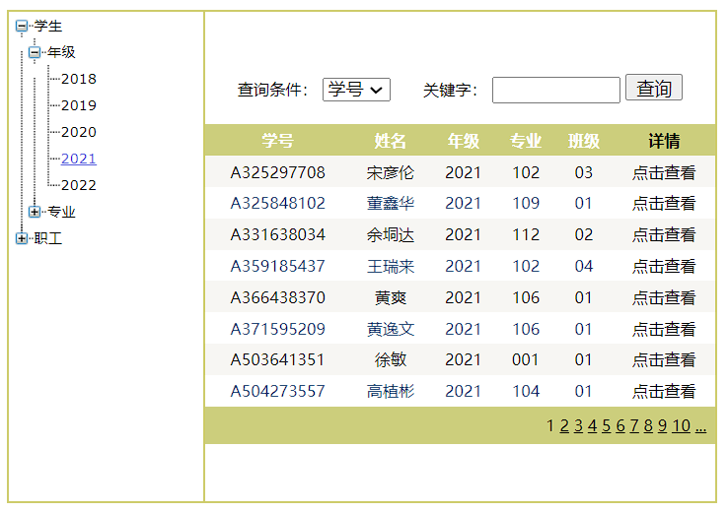

图 23按年级(2021)筛选

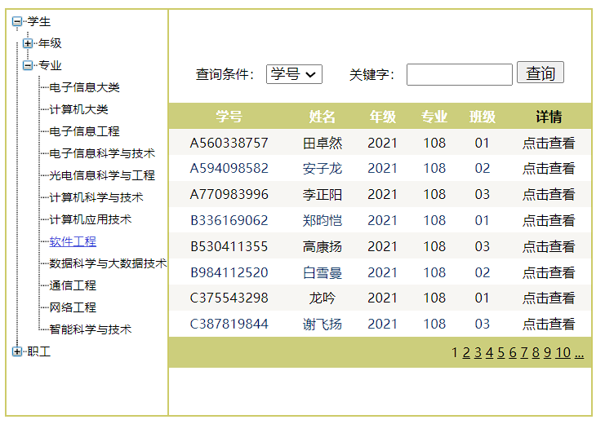

图 24按专业(软件工程)筛选

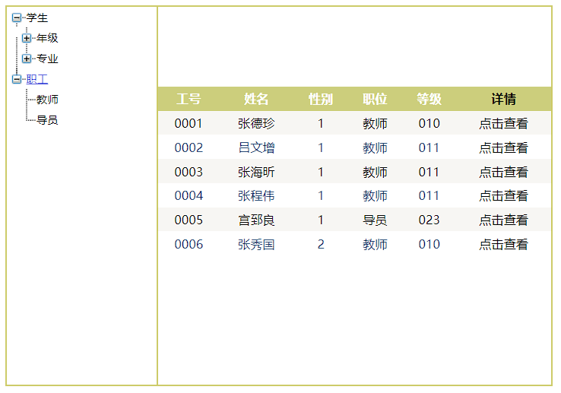

图 25职工管理

### 2.3.3成绩管理

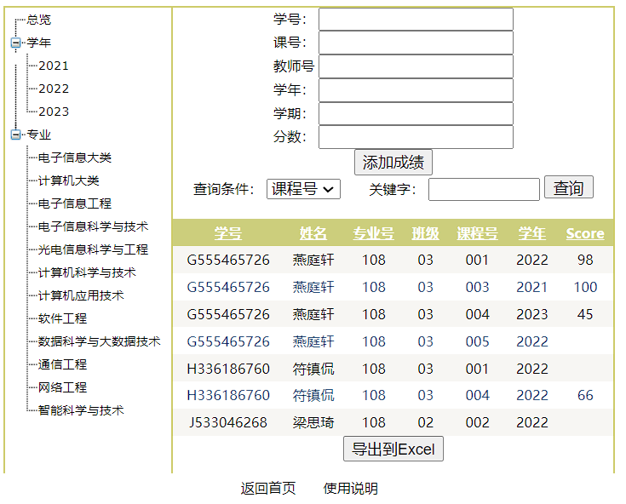

图 26成绩管理

protected void btnAddGrade_Click(object sender, EventArgs e)

{

string GradID = txtGradID.Text.Trim();

string CourseID = txtCourseID.Text.Trim();

string TutorID = txtTutorID.Text.Trim();

string Year = txtYear.Text.Trim();

string Term = txtTerm.Text.Trim();

string Score = txtScore.Text.Trim();

string sqlInsert = "INSERT INTO TB_Select_Course (GradID, CourseID, TutorID, Year, Term, Score) VALUES ('" + GradID + "','" + CourseID + "','" + TutorID + "','" + Year + "','" + Term + "','" + Score + "')";

sqloperate.DataCom(sqlInsert);

gvbind();

}

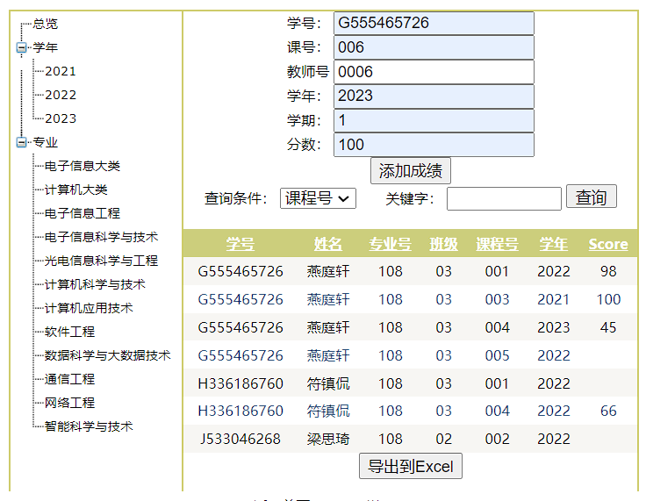

图 27添加成绩

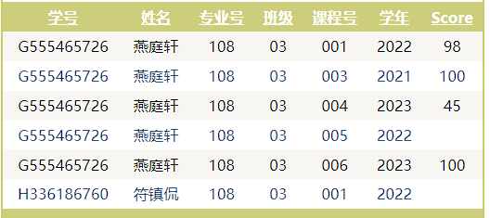

图 28成绩添加成功

protected void btnExportToExcel_Click(object sender, EventArgs e)

{

//HttpContext.Current.Response.SuppressContent = true;

// 设置HttpResponse的Header，指示输出的内容为Excel文件

SqlDataSource3.SelectCommand = Session["sqlstrG"].ToString();

Response.Clear();

Response.Buffer = true;

Response.AddHeader("content-disposition", "attachment;filename=GridViewExport.xls");

Response.Charset = "";

Response.ContentType = "application/vnd.ms-excel";

using (StringWriter sw = new StringWriter())

{

HtmlTextWriter hw = new HtmlTextWriter(sw);

// 为了允许导出到Excel中的样式被包含，需要将GridView的属性设置为False

gradeInfo.AllowPaging = false;

gradeInfo.DataBind();

// 将GridView的HeaderRow和Row样式应用于导出的Excel

gradeInfo.HeaderRow.BackColor = Color.White;

foreach (TableCell cell in gradeInfo.HeaderRow.Cells)

{

cell.BackColor = gradeInfo.HeaderStyle.BackColor;

}

foreach (GridViewRow row in gradeInfo.Rows)

{

row.BackColor = Color.White;

foreach (TableCell cell in row.Cells)

{

if (row.RowIndex % 2 == 0)

{

cell.BackColor = gradeInfo.AlternatingRowStyle.BackColor;

}

else

{

cell.BackColor = gradeInfo.RowStyle.BackColor;

}

cell.CssClass = "textmode";

}

}

gradeInfo.RenderControl(hw);

// 将HTML字符串写入HttpResponse

Response.Output.Write(sw.ToString());

Response.Flush();

Response.End();

gradeInfo.AllowPaging = true;

}

}

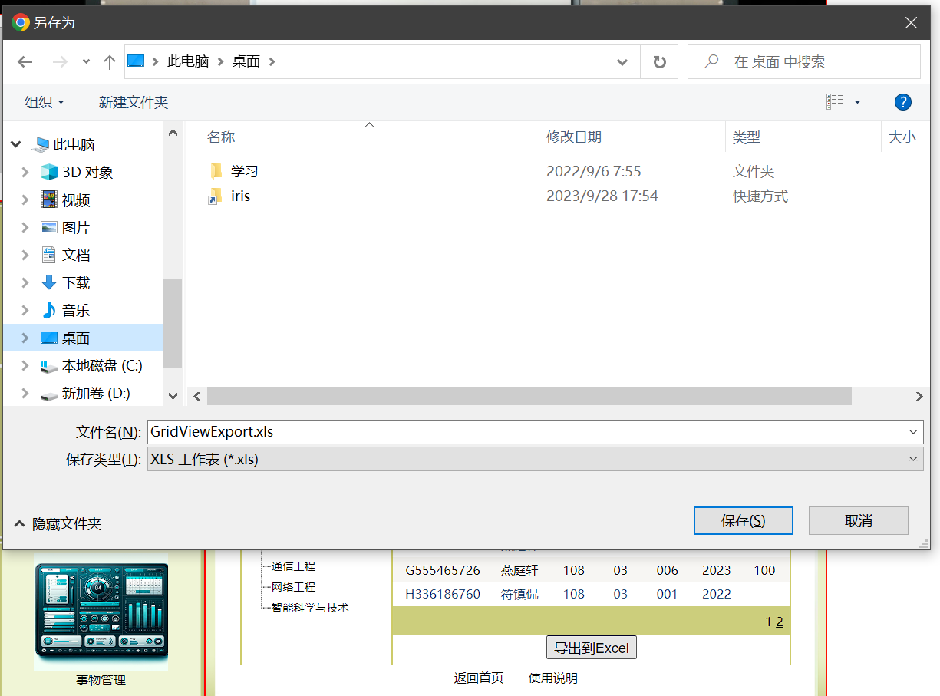

图 29成绩导出到Excel

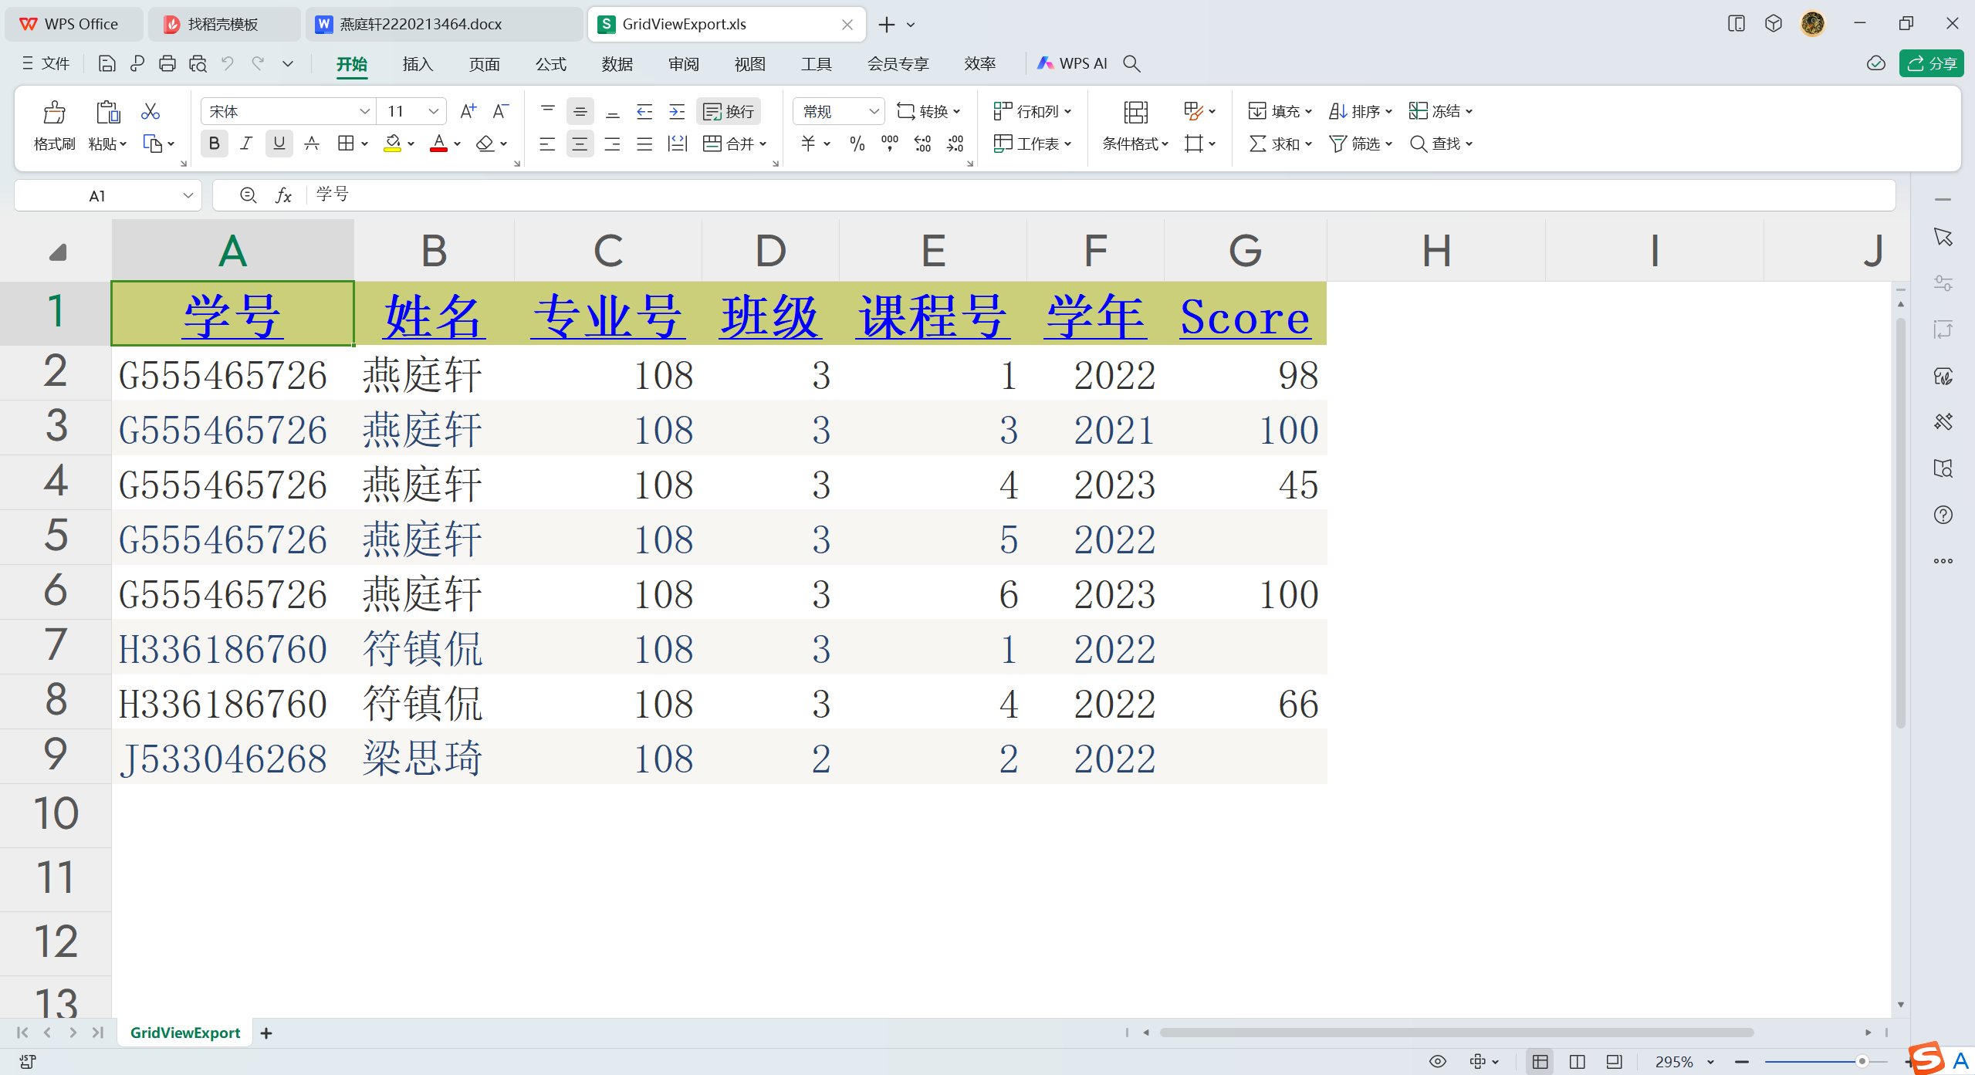

图 30导出结果

### 2.3.4事务管理

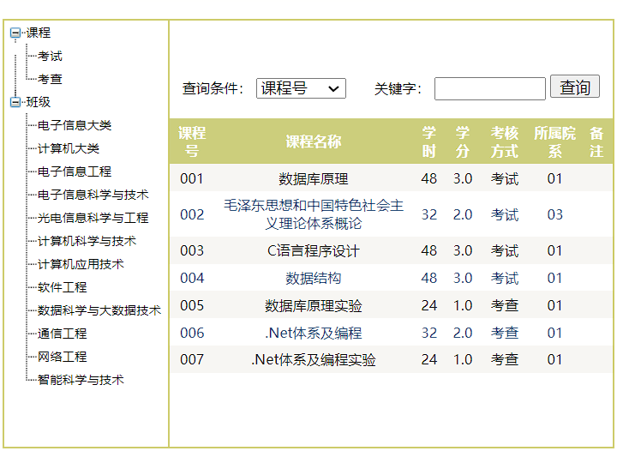

图 31课程一览

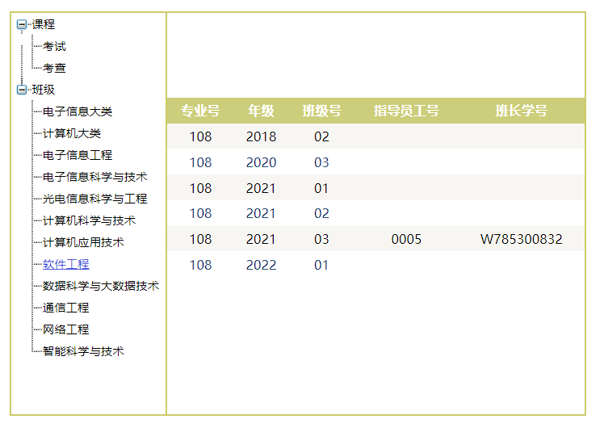

图 32班级筛选(软件工程)

### 2.3.5使用说明

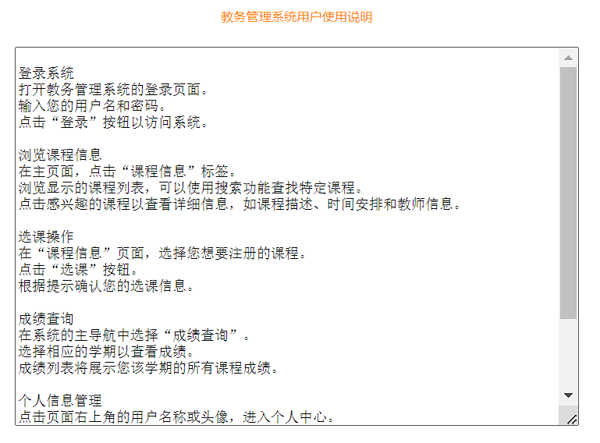

图 33使用说明

# 三、实验体会

## 3.1总结

在这次的ASP.NET实验中，我开发了一个智能教务信息管理系统。这个系统包括了登录认证、课程信息浏览、选课操作、成绩查询等学生、导师、班级信息管理功能。通过这次实验，我不仅学习了ASP.NET的基本框架和操作，加深了我对ASP.NET的理解，提高了我的编程技能和问题解决能力，掌握了如何将理论知识应用于实际的项目开发中。

## 3.2问题和解决方案

3.2.1将GridView的内容导出为Excel异常：只能在执行 Render() 的过程中调用 RegisterForEventValidation

在aspx文件最上方设定属性EnableEventValidation="false"。

3.2.2调用gpt接口时异常：命名空间“System.Net”中不存在类型或命名空间名“Http”

安装NuGet包“Newtonsoft.Json”，并添加对“System.Net.Http”程序集的引用。

3.2.3SQL Server从Excel导入数据时错误：未在本地计算机上注册“Microsoft.Jet.OLEDB.4.0”提供程序

使用SQL Server内置的英文32位导入工具，不能用中文或64位的工具。