
SIM-UOW
CSIT -128
Introduction to Web Design
Assignment 2 Report

Done By: Jahir Hussain Mohamed Risvanudeen
SIM ID: 10212562
PU ID:6743511
Introduction
IGOR(International Geographic ORganization) is an institution set up by the United Nations to capture statistical data of all UN members. With captured data, I am tasked to create a prototype website to contain these captured data and display them in a specified table format upon user’s preference.

Requirements
A requirement for this assignment, would be familiarity with Asynchronus Java Script and XML(AJAX), XML and JSON. Using AJAX, I can create a table based on the data stored in either XML or JSON but for this case, I am tasked to retrieve data from both XML and JSON files.
For the design aspects of the webpage, I am required to make it look professional and simply as our target audience for this prototype webpage would be UN officials, politicians and social science professionals.

Run-through of A3_CtryData_Sample.dtd
- DTD stands for document type definition, it sets the structure , the legal elements and attributes of an XML file , in this case , A3_CtryData_dtd_Sample.xml.
- DTD can also be used to verify that the XML data is valid, and to do that I used this link:https://www.xmlvalidation.com/https://www.xmlvalidation.com/ .

Run-through of A3_CtryData_Sample.xsd
- More or less like DTD , XSD which stands for XML Schema Definition specifies how to formally describe the elements in an XML document for A3_CtryData_xsd_Sample.xml.
- XSD can also be used to verify that the XML is valid and I did this through this website: https://www.freeformatter.com/xml-validator-xsd.html.
- Due to multiple root elements , I had to use the “Salami Slice” design pattern for designing the XML schemas. “Salami Slice” method enables me to use mutliple root elements like “CountryRecord” and “CountryList”.

Run-through of A3_CtryData_dtd_Sample.xml
- In this file , <!DOCTYPE SYSTEM “A3_CtryData_Sample.dtd”> was declared to reference to the .dtd file. This is a specific format that must be there to be able to render the contents correctly.
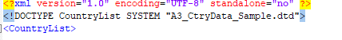
- In this file , I have converted all the data from A3_CtryData_Sample.csv using http://www.convertcsv.com/csv-to-xml.htm , and add in the relevant tagging to synchronize and work with the .dtd file.
- There are 2 type of parent elements here , 1 being the CountryList element and the other being the CountryRecord element
Run-through of A3_CtryData_xsd_Sample.xml
- In this file , the CountryList tagging was declared as such:
<CountryList xmlns:xsi="http://www.w3.org/2001/XMLSchema-instance" xsi:schemaLocation="A3_CtryData_Sample.xsd"> , and this would enable intercommunications between A3_CtryData_xsd_Sample.xml file and the A3_CtryData_Sample.xsd.
- http://www.w3.org/2001/XMLSchema-instance is a namespace used by XSD to define the structures and attributes of the XML file.
- Similar to the .dtd file there are 2 type of parent elements here as well,CountryList element and the CountryRecord element.

Run-through of AA_fmt_1/2.xslt
- The .xslt files are used to give the xml files a design structure and this is done by adding the stylesheet reference: <?xml-stylesheet type="text/xsl" href="region-fmt-1.xsl"?> to the top of the xml file.
- <xsl:template match="/"> Using this element , I am able to define a template for the whole document as “/” defines every attribute in the document.
- These .xslt files were used to implement the table structure and design as well.
Eg.
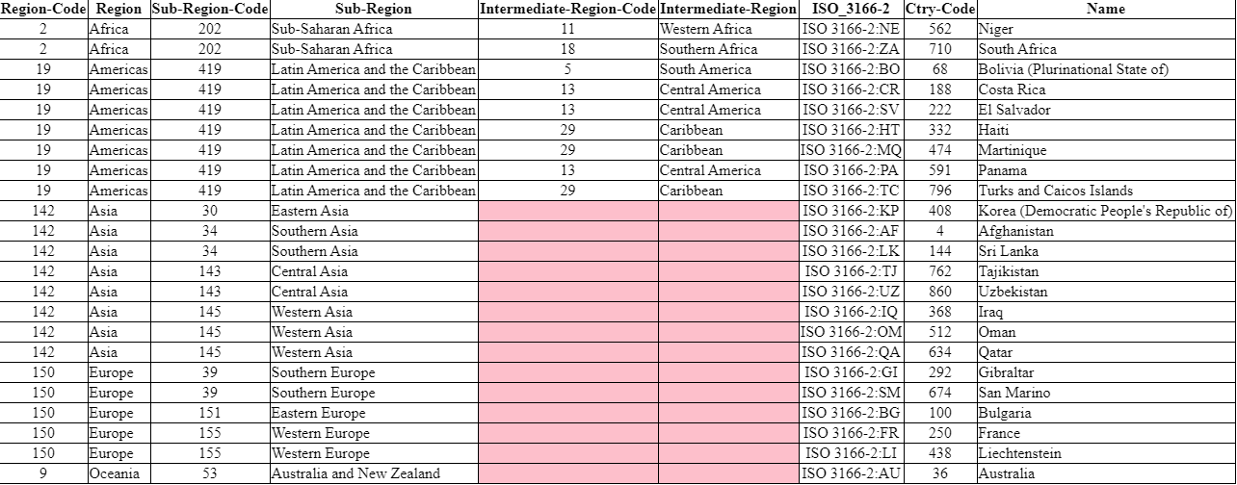

Run-through of A3_CtryData_AJAX-XML.html

- This file uses Asynchronus Javascript and XML to obtain the data “CountryList” stored in A3_CtryData_xsd_Sample.xml.
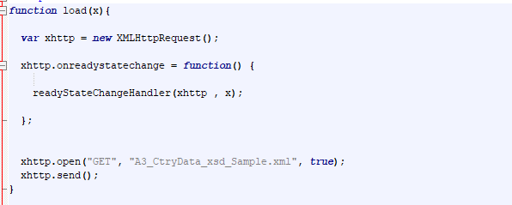
The above function obtains the “x” value from the buttons (eg. x == r1/r2/c1/c2/p1/p2) and also starts a XMLHttpRequest to obtain the datas from the specified URL which is A3_CtryData_xsd_Sample.xml and when async is set to true, it means that the browser do not care of request complete and looks forward other request. The above function is like the load function in A3_CtryData_AJAX-JSON.html as well.

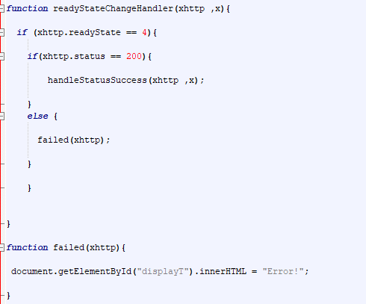
In the function above , it passes on the xhttp variable and the x variable to the handleStatusSuccess function only if the ready state is 4 and the status is 200 which means that the operation is a success .However , if there were to be any hiccups during the process and the operation ceases , function failed(xhttp) would be called upon to display an error message.
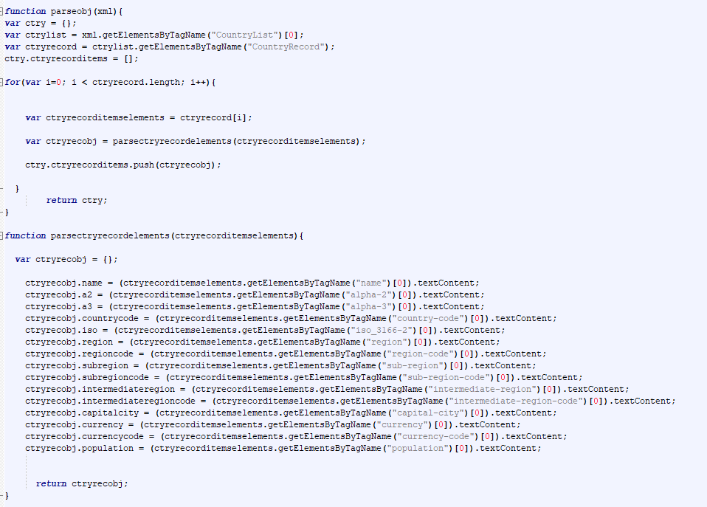
Both functions are used to parse xhttp request response into a JavaScript object .Parseobj(xml) retrieves the xhttp request response.I then parse the 2 parent root elements known as “CountryList” and “CountryRecord” and put it in a for loop to retrieve rest of the data from the XML file. Afterwards we pass the data to the parsectryrecordelements(ctryrecorditemselements) function to parse the remaining data. To retrieve each element from the XML file , I used “ctryrecorditemselements.getElementByTagName(“xx”)[0].textContent;”. All these data are then returned back to the parseobj(html) function which in return would return the data to HandleReadyStatusSuccess function.

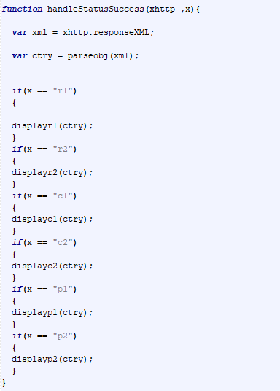

In the above function, we retrieved the JavaScript objects from the previous functions and send it to the function with the user’s preferred format settings(eg. if the user clicks the “Region Info 1(region-fmt-1.xsl)” button , the button sends its id “r1” to the load function as variable “x” and then the once x is passed to this function , it verifies that x = “r1” and sends the data over to displayr1(ctry) function.
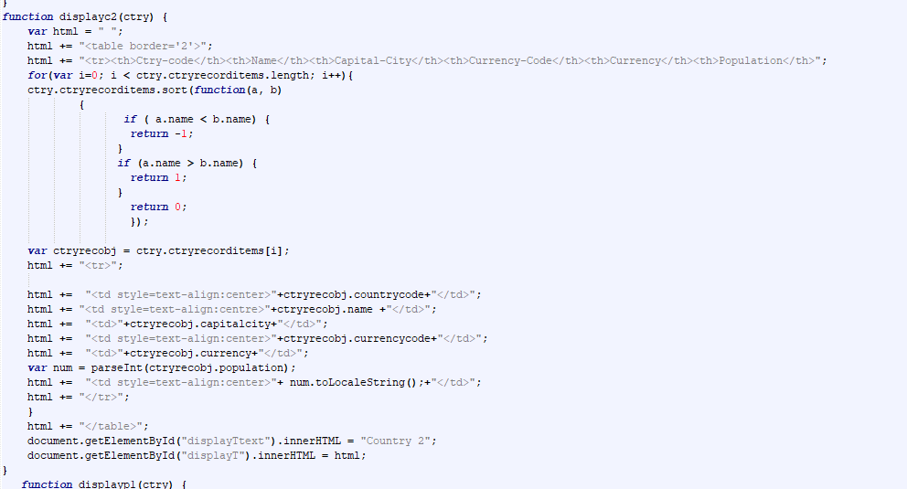
The above function ,displayr1(ctry), displayr2(ctry), displayc1(ctry), displayp1(ctry), displayp2(ctry) are functions that uses parsed javascript objects to create a table based on the elements that the format requires. At the end of the function , all the desired table would be displayed at the “displayT” element, complimented by a display text “displayText”.

Run-through of A3_CtryData_AJAX-JSON.html
- This file uses Asynchronus Javascript and XML to obtain the data “CountryList” stored in A3_CtryData_Sample.json similar to the A3_CtryData_AJAX-XML.html.
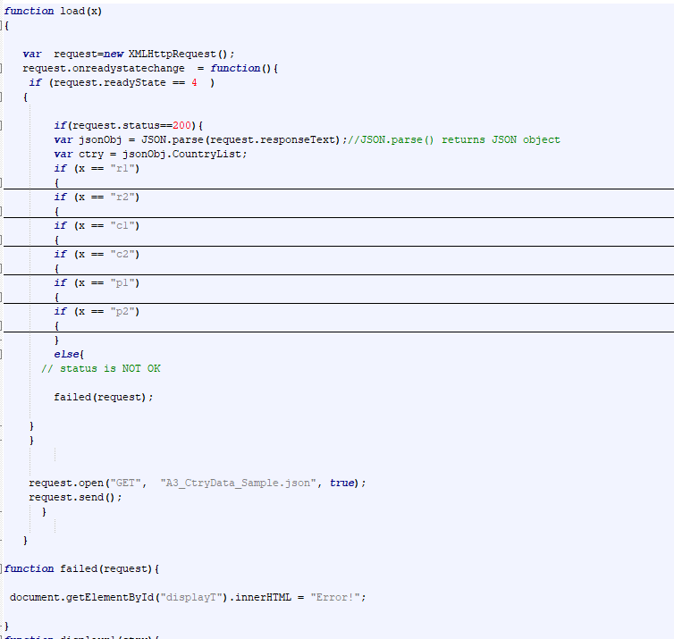
On the function above , similar to A3_CtryData_AJAX-XML.html , I send a query to the URL “A3_CtryData_Sample.json” , retrieve the response(JSON Strings) and parse it into a JavaScript Object using (var jsonObj = JSON.parse(request.responseText) unlike XML whereby we have to parse the response into a JavaScript Object manually . Following the same concept as A3_CtryData_AJAX-XML.html , as soon as the user clicks on one of the buttons , the button would send its id as variable “x” to load(x) function. As for the parsing of JSON string to JavaScript object , its done as soon as the readyState is 4 and the status is 200 , else an error message would be thrown back to the user.
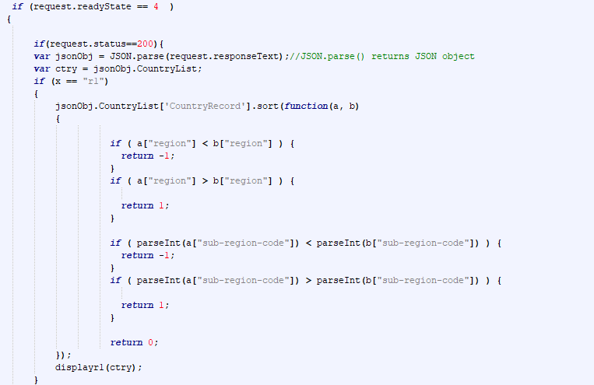
As soon as the x verifies that it is “r1” , it sends its JavaScript Object ctry to the displayr1(ctry) and would furhter process the data there , as for the above if else statements , its used for the sortings of the various table rows depending on the format that is given.
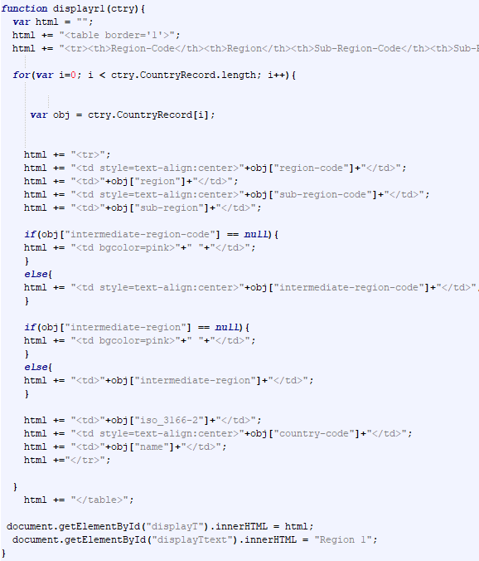
Similar to A3_CtryData_AJAX-XML.html, The above function, displayr1(ctry), displayr2(ctry), displayc1(ctry), displayp1(ctry), displayp2(ctry) are functions that uses parsed JavaScript objects to create a table based on the elements that the format requires. The data is then displayed on the “display” element complimented by a display text “displayTtext”.

Run-through of A3_CtryData_AJAX-XML-EXCEL1.html

Similar to the A3_CtryData_AJAX-XML.html, this file graps the same concept of ajax and xml parsing , however , instead of using buttons to display pre-set formats , I allowed users to choose any or all data that they want to display as shown in the image below.
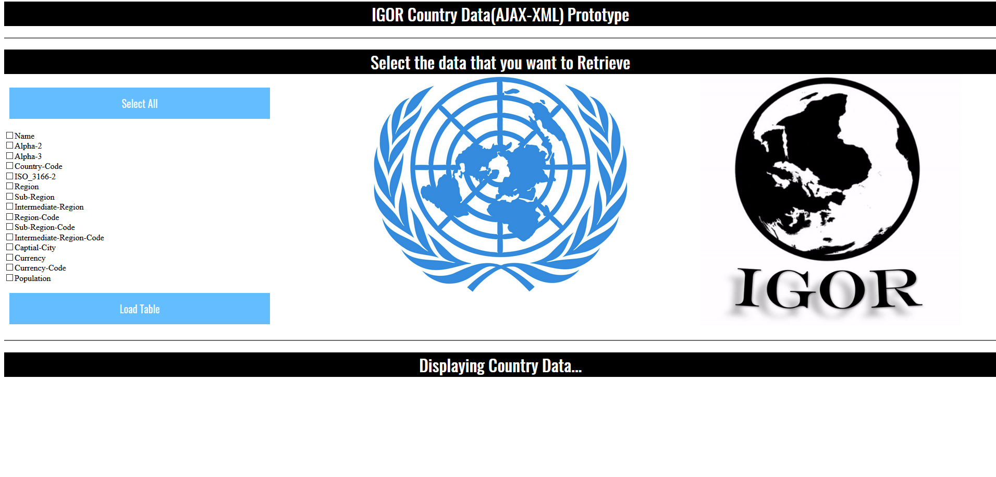
To make this work, I set an if else statement (if the checkbox above is checked) to each and every JavaScript object to verify the data required to be displayed and display it accordingly. I also gave the users a choice to select all the data to enhance user friendliness. The JavaScript is as such as the image below.
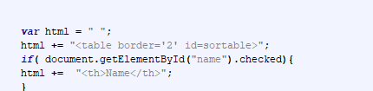

Design Aspects
For the .dtd,.xsd,.xml,.json, there were no designs to it. The .xslt files had some design aspects but it were set by the requirements and no further design features were implemented. However, for the .html files I used the same design for both using a ajaxcss.css file.
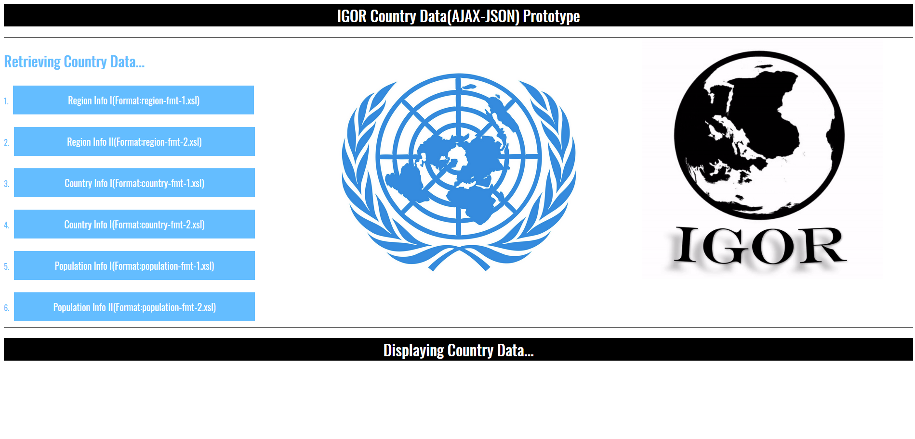
By default , on load , the webpage would look like this , plain and simple incorporated with a little bit of the “UN” theme, also with a personally created “IGOR” gif logo.

