MANISH

+91 (875) 070-2920

[Manishsagar802@gmaiI.com](mailto:Manishsagar802@gmaiI.com)

D — 9 2nd floor harsh dev park budh vihar ph-2 NEW DELHI

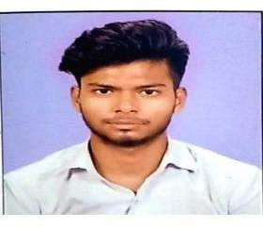**SR. ACCOUNTANT** Employs excellent leadership skills and multi- tasking strengths. Demonstrated ability to improve business operations,

Experience

### ACCOUNTANT

**SK & ASSOCIATES,** New Delhi

* BookKeeping,bank reconcilation
* Book reconciliation from GST portal
* Sale, purchase bills entry In voucher

12/2020 to 04/2023

Highlights

* Results-oriented
* Revenue generation
* Business development
* Organisational capacity
* Operability and commitment
  + Maintain stocks and party ledger and create
  + Bank entry and e-invoicing and e-way bill creation etc.
  + GSTR1 monthly and QTR. Prepare for filling
  + GST 2A and 2B match from portal

12/2020 to 04/2023

### SR. ACCOUNTANT

**SK & ASSOCIATES,** New delhi

* + Answered clients questions and resolved query issues in a timely manner.
  + Diagnosed clients issues by asking probing questions.
  + Knowledge of accounting software are Tally erp, prime and busy
  + Basic excel
* Ability to motivate staff and maintain good relations
* Resistance to stress
* Good manners

# Education

Bachelor of ARTS: HUMANITY - 2022

DELHI UNIVERISITY, ND PERSUING POST GRADUATION DELHI UNIVERSITY

# Hobbies

* Playing chess - great way to unwind, destress, and keep the mind sharp.



## r ty

2nd oor hars

* + Fathers Name Radhey SHYAM
  + Date Of Birth 04 AUG 1998
  + Gender MALE
  + Language Known HINDI, ENGLISH

» Marital Status UN MARRIED

* + Nationality INDIAN

Place: New Delhi Date: