Activity 6
Case Analysis – Avoiding Misleading Proportions

Question 1: Truncated Y-Axis in Sales Growth
Monthly sales data (₹ lakhs): January 95, February 97, March 99, April 101, May 103, June 105. The marketing team's bar chart starts the Y-axis at 90 instead of 0, visually suggesting June sales are almost twice January's.

1. Why the chart is misleading
Sales rose from ₹95 lakhs to ₹105 lakhs — an actual increase of about 10.5%. By starting the Y-axis at 90 rather than 0, the baseline of every bar is cut off, so the small absolute difference between months (2–10 lakhs) occupies almost the entire height of the chart. This makes the June bar appear roughly twice the height of the January bar, when the true growth is only about a tenth. The chart distorts the ratio between categories even though the underlying numbers are accurate.

2. Visualization principle violated
This violates the principle of graphical integrity / the zero-baseline rule for bar charts (closely related to Edward Tufte's "Lie Factor," which states that the visual size of an effect in a chart should match the size of the effect in the data). Because bar length is the visual cue readers use to judge magnitude, bars must start at a true zero baseline; truncating the axis breaks the proportional relationship between bar height and the value it represents.

3. Improved visualization method
Redraw the bar chart with the Y-axis starting at 0, so bar heights are proportional to actual values. If the month-to-month change is the real story, a better option is a line chart (line charts do not require a zero baseline in the same way) with data labels showing the exact values, or an indexed/percentage-change chart that explicitly plots "% growth over January" so the modest growth rate is communicated honestly.
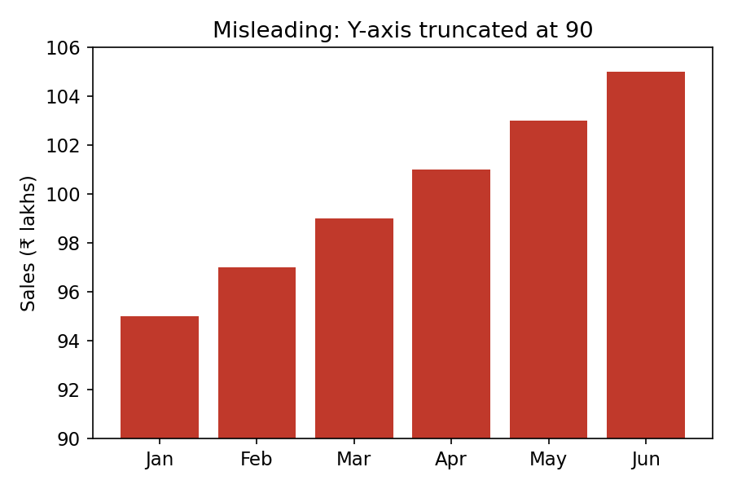
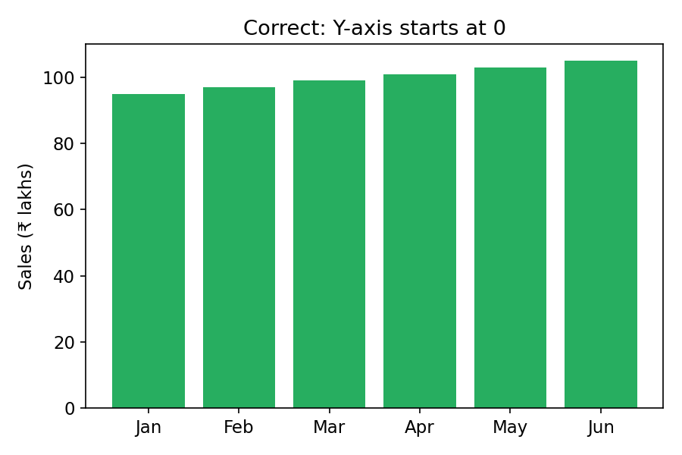
Figure 1: Misleading (Y-axis from 90) vs. Correct (Y-axis from 0) presentation of the same sales data.

4. Influence on business decisions
- Management may overestimate the strength of sales momentum and set unrealistically high targets for the next quarter.
- Investors or the board could be persuaded to approve larger budgets, bonuses, or expansion plans based on an exaggerated growth story.
- Sales teams might become complacent, believing performance is far stronger than it is, delaying corrective action if growth is actually sluggish.
- If the truth later emerges (e.g., during an audit or investor due-diligence), it can damage credibility and trust in the company's reporting.

Question 2: Pie Chart with Incorrect Proportions
Enrollment data — Computer Science: 420, Electronics: 280, Mechanical: 200, Civil: 100 (total 1,000 students). The designer's pie chart shows slices of approximately 50%, 30%, 15%, and 15%.

1. Correct percentage for each department
Department | Students | Correct % | Chart Shows
Computer Science | 420 | 42.0% | ≈50%
Electronics | 280 | 28.0% | ≈30%
Mechanical | 200 | 20.0% | ≈15%
Civil | 100 | 10.0% | ≈15%

2. Why the displayed chart is misleading
The chart overstates Computer Science (50% shown vs. an actual 42%) and Electronics (30% vs. 28%), while understating Mechanical (15% vs. an actual 20%) and misrepresenting Civil (15% shown vs. an actual 10%, more than 1.5 times its true share). Beyond the individual distortions, the four displayed values add up to 110% instead of 100%, meaning the slice angles were not even calculated correctly from the data — a basic proportionality error in a chart type whose entire purpose is to show parts of a whole.
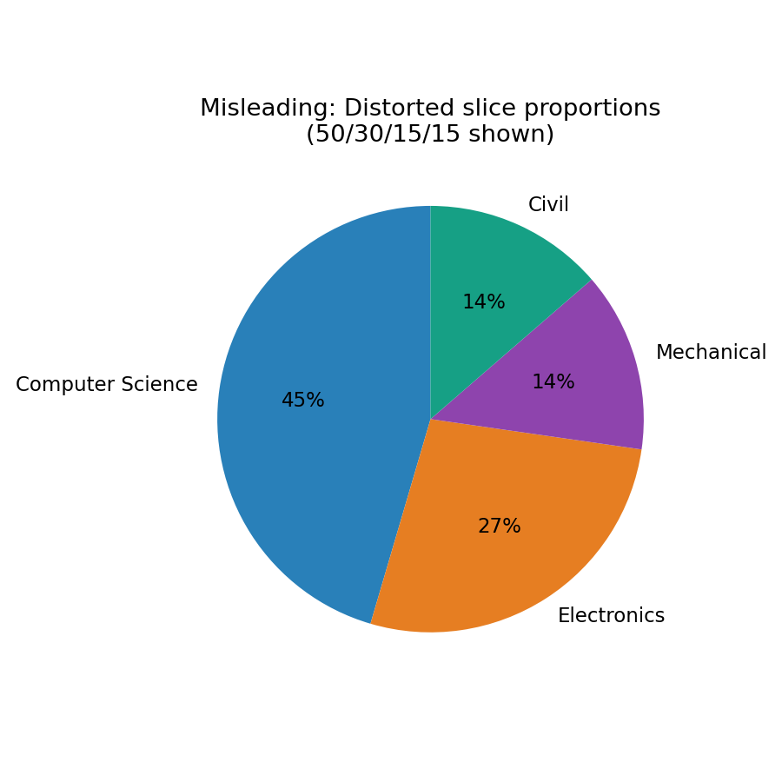
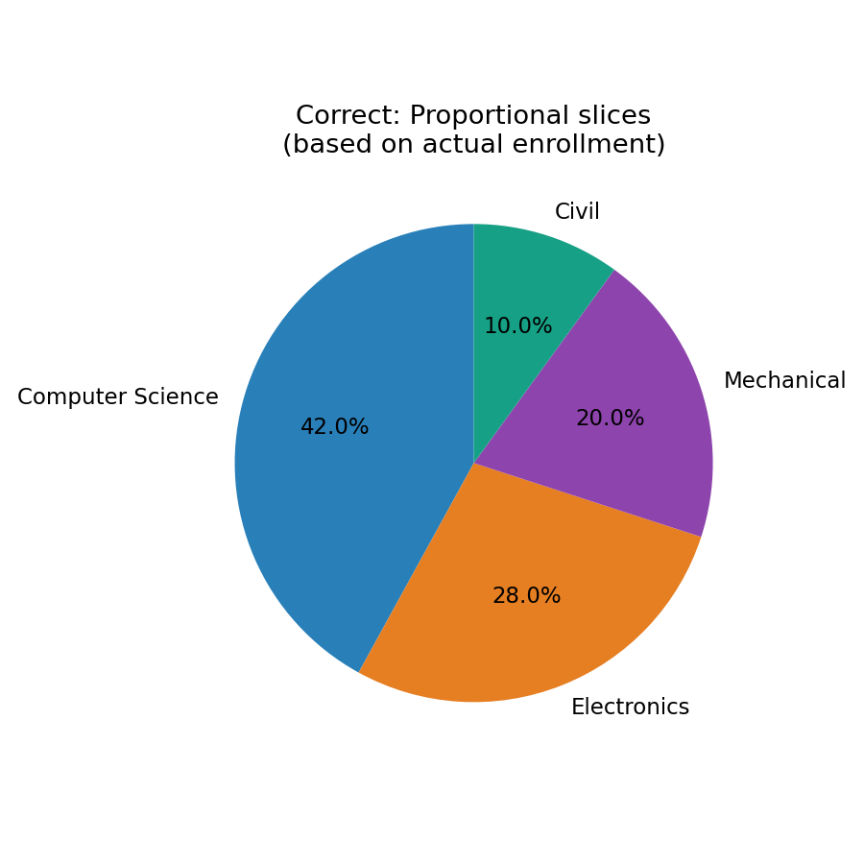
Figure 2: Misleading pie (slices sum to 110%, wrong proportions) vs. Correct pie (accurate 42/28/20/10 split).

3. Alternative chart for improved comparison accuracy
A horizontal or vertical bar chart is generally a safer choice for comparing four categories, because human perception judges bar length far more accurately than pie-slice angle or area. If the "share of total" framing must be retained, a 100% stacked bar chart communicates proportions accurately while avoiding the visual ambiguity of a pie chart.

4. Effect on institutional planning
- Faculty hiring, classroom allocation, and lab infrastructure could be over-provisioned for Computer Science and under-provisioned for Mechanical and Civil engineering.
- Budget committees relying on the chart might approve funding proportions that don't match real student-to-resource ratios, causing overcrowding in under-resourced departments.
- Strategic decisions such as opening new sections, recruiting faculty, or planning placement drives could be misaligned with actual demand.
- Accreditation or regulatory reporting based on the incorrect figures could invite compliance issues once the discrepancy (chart totaling 110%) is noticed.

Question 3: Unequal Bar Widths in Revenue Comparison
Annual revenue (₹ Crores): Product A = 60, B = 75, C = 90, D = 105. Instead of equal-width bars, the designer widens each successive bar, making Product D appear nearly three times larger than Product A even though its revenue is only 1.75 times higher.

1. Graphical error identified
The error is inconsistent bar width — an uncontrolled second visual variable (width) is combined with the intended variable (height) to represent a single data value, which is not a standard or valid encoding for a bar chart.

2. How unequal bar widths distort perception
Viewers perceive the overall area of a bar, not just its height. When both height and width increase together, the perceived area grows multiplicatively (roughly as the product of the two), so a bar that is genuinely only 75% larger in value can appear two-to-three times larger visually. This is exactly what happens here: Product D's revenue is 1.75 times Product A's, but its area on the chart is inflated to look almost 3x, exaggerating the real performance gap between products.
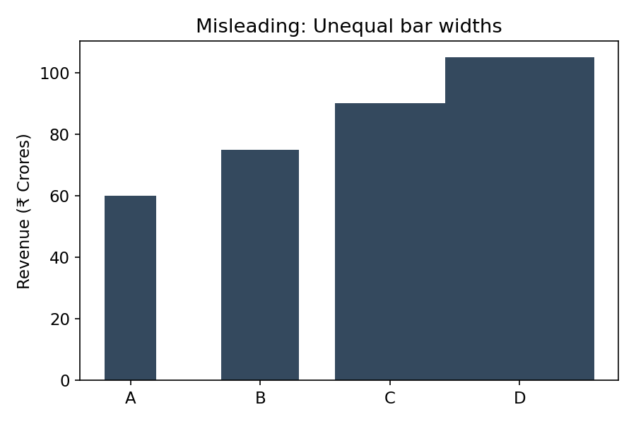
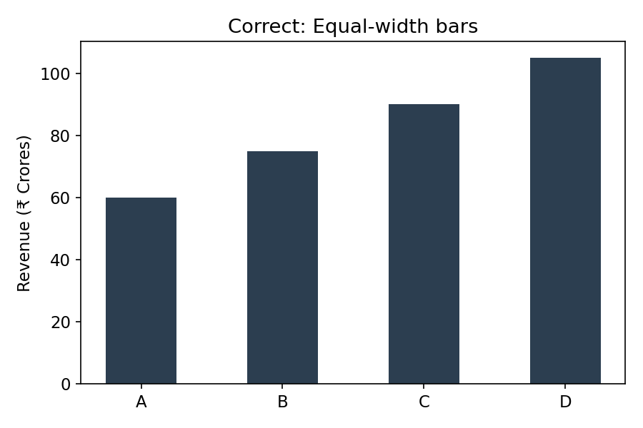
Figure 3: Misleading (widths increase with value) vs. Correct (equal-width bars) revenue comparison.

3. Redesign — correct design principles
- Use equal-width bars for every category — width should never encode data.
- Start the value axis at zero so bar height alone represents magnitude accurately.
- Keep consistent spacing between bars and label each bar with its exact value for clarity.
- Order bars logically (e.g., by product name or by value) rather than by visual emphasis.

4. Consequences if investors rely on this chart
- Investors could overestimate Product D's contribution to overall revenue and underweight the relatively strong performance of Products B and C.
- Capital allocation, marketing spend, or R&D investment could be skewed disproportionately toward Product D based on a visually inflated impression rather than actual financial performance.
- If the distortion is discovered later (e.g., during due diligence), it can raise questions about the company's financial reporting integrity and erode investor trust.

Question 4: 3D Column Chart Distortion
Renewable energy generation (GWh): Solar 450, Wind 500, Hydro 550, Biomass 520. A 3D column chart with perspective effects makes the Hydro bar appear almost 40% larger than Wind, although the actual difference is only 10%.

1. Why 3D charts can create misleading proportions
3D charts introduce depth, perspective, and viewing-angle effects that are irrelevant to the data itself. Columns positioned farther back or at certain angles can appear taller, shorter, or wider purely due to perspective foreshortening, and overlapping or occlusion can hide or exaggerate parts of bars. Because the human eye must mentally "undo" the 3D perspective to judge true height, accuracy is lost — two bars with a small real difference can appear dramatically different depending on camera angle and lighting.

2. Perceived vs. actual difference
Comparison | Actual Difference | Perceived Difference (3D chart)
Hydro (550) vs. Wind (500) | 10.0% | ≈40%

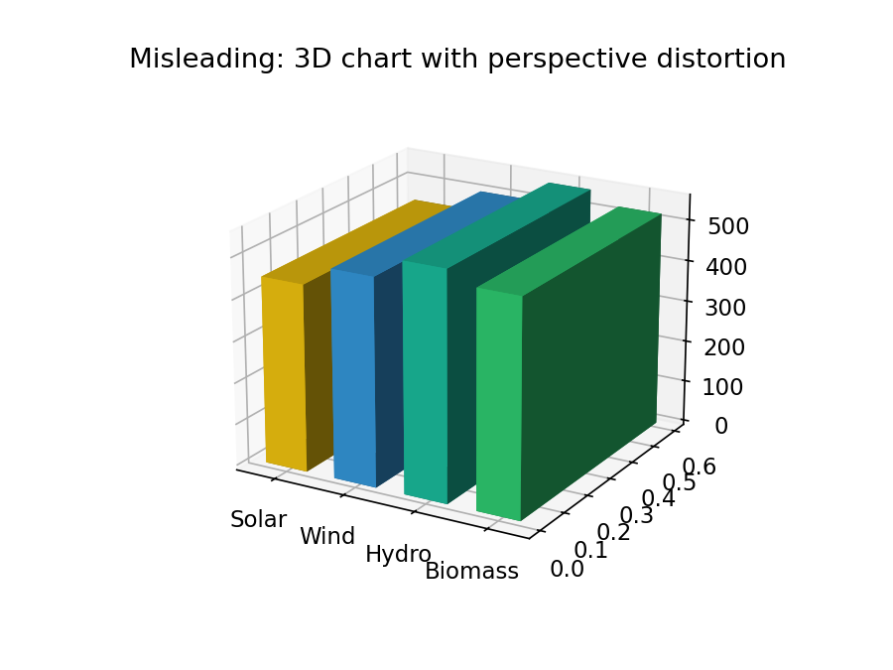
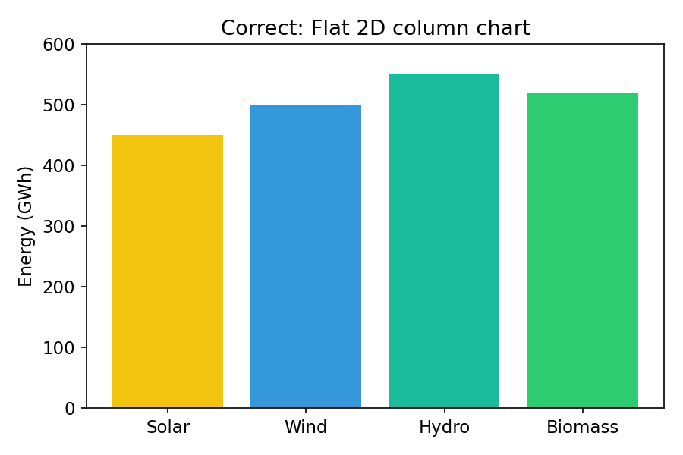
Figure 4: Misleading 3D perspective chart vs. Correct flat 2D column chart for the same energy-generation data.

3. Recommended better visualization
Use a simple flat (2D) column or bar chart viewed straight-on, with the value axis starting at zero and each bar labeled with its exact GWh figure. This removes perspective distortion entirely and lets height be the only, and therefore accurate, visual cue for magnitude.

4. Importance of avoiding visual distortion in sustainability reporting
- Sustainability reports are used by regulators, investors, and the public to judge a company's environmental performance — distorted charts can be seen as a form of "greenwashing" or misrepresentation.
- Accurate visuals build trust with ESG (Environmental, Social, Governance) rating agencies and stakeholders who rely on these reports for investment and policy decisions.
- Misleading proportions could lead to poor energy-mix planning decisions, such as under-investing in Wind because Hydro appeared disproportionately dominant.
- Regulatory bodies increasingly scrutinize sustainability disclosures, and distorted charts could expose the company to compliance or reputational risk.

Question 5: Bubble Chart with Incorrect Scaling
Disease cases by district: A = 150, B = 250, C = 350, D = 450, E = 550. The analyst scales bubble radius directly to the case count rather than scaling bubble area, making District E appear more than ten times larger than District A.

1. Why scaling the radius (instead of area) is misleading
The area of a circle grows with the square of its radius (Area = π × r²). If radius is made directly proportional to the data value, then area — which is what the eye actually perceives as "size" — grows quadratically instead of linearly. District E has about 3.7 times the cases of District A (550 vs. 150), but because radius scales linearly with cases, E's area ends up roughly (3.7)² ≈ 13–14 times larger than A's, matching the described "more than ten times larger" visual impression even though the real difference is much smaller.

2. Correct method for proportional bubble sizing
The bubble's area (not its radius) should be made proportional to the data value, which means the radius must be scaled as the square root of the value: r ∝ √(value). This ensures that a district with twice the cases of another appears with twice the visual area, matching true proportional perception.
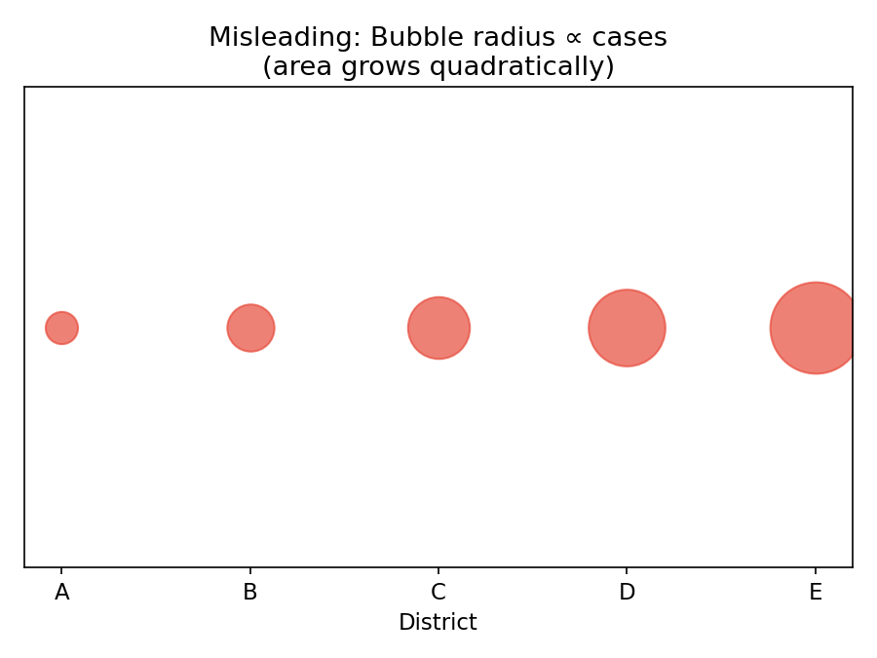
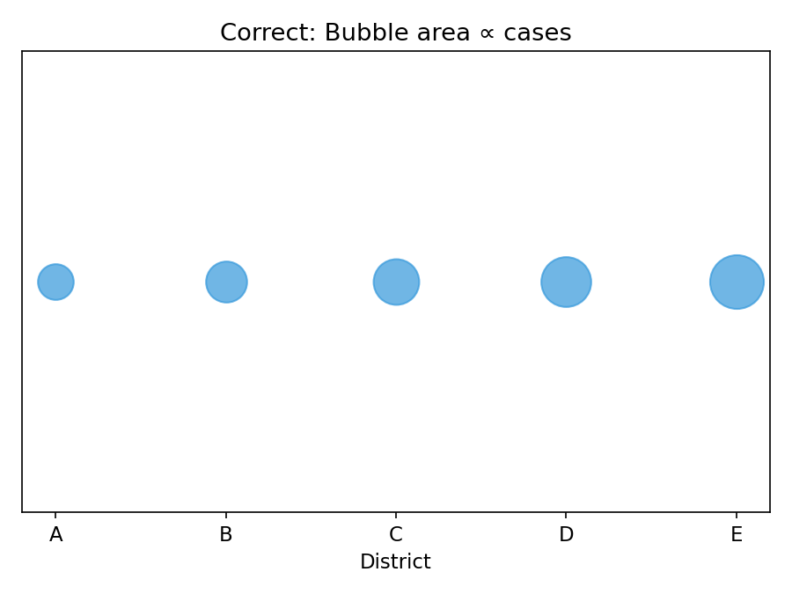
Figure 5: Misleading (radius ∝ cases, area grows quadratically) vs. Correct (area ∝ cases) bubble sizing.

3. Alternative visualization suitable for this dataset
Since the data is a simple one-dimensional comparison across five districts, a bar chart (or a choropleth/heat map if geographic distribution matters) would communicate the differences in case counts more accurately and is easier for readers to interpret precisely than any bubble encoding.

4. Potential impact on public health resource allocation
- Districts like E could receive a disproportionately large share of medical staff, beds, and supplies based on a visually exaggerated sense of severity, while districts like C and D (which are also significant) may be under-resourced by comparison.
- Emergency response planning and budget allocation across districts could become skewed, delaying adequate response in districts whose true case counts are understated visually.
- Public perception and media coverage driven by the misleading chart could create disproportionate alarm about one district while underplaying genuine risk in others.
- Policymakers relying on the chart for long-term infrastructure planning (e.g., new clinics) might build capacity mismatched to actual demand.

Summary: Common Principles Across All Cases
- Always start value axes at zero for bar/column charts unless a break is clearly and prominently marked.
- Ensure the visual encoding (length, area, angle) used in a chart is mathematically proportional to the underlying data — never let a secondary variable (width, depth, 3D perspective) distort the primary encoding.
- Avoid 3D effects for standard comparison charts; use flat, orthogonal 2D views.
- When using area-based encodings (pie slices, bubbles), scale by area, not by radius or a linear dimension.
- Verify that computed proportions and percentages sum correctly and match the source data before publishing any chart.
- Misleading charts — even if unintentional — can distort business, institutional, financial, and public-health decisions, and can damage trust once the discrepancy is discovered.

