Question 1 (Healthcare Analytics)
# Load library
library(ggplot2)
# Create dataset
health <- data.frame(
Patient = c("P1","P2","P3","P4","P5","P6","P7","P8"),
Age = c(24,32,41,48,56,65,38,29),
BMI = c(19.8,24.5,28.1,30.3,33.2,36.5,26.2,22.1),
BloodPressure = c(110,118,132,145,152,168,124,116),
DiseaseSeverity = factor(
c("Low","Medium","High","High","Critical","Critical","Medium","Low"),
levels = c("Low","Medium","High","Critical")
)
)
# Bubble Scatter Plot
ggplot(health,
aes(x = Age,
y = BloodPressure,
color = DiseaseSeverity,
size = BMI)) +

geom_point(alpha = 0.8) +
scale_color_manual(values = c(
"Low" = "green",
"Medium" = "gold",
"High" = "orange",
"Critical" = "red"
)) +
scale_size(range = c(4,10)) +
labs(
title = "Healthcare Analytics: Age vs Blood Pressure",
x = "Age (Years)",
y = "Blood Pressure (mmHg)",
color = "Disease Severity",
size = "BMI"
) +
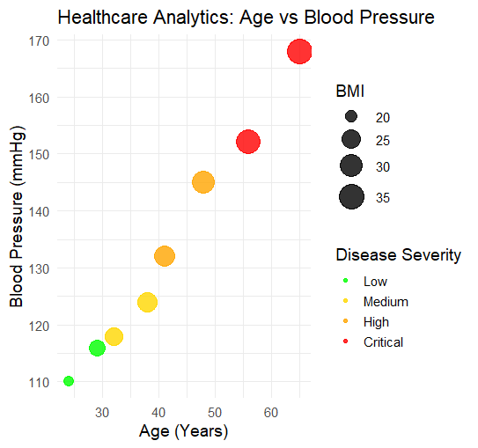
theme_minimal(base_size = 14)

Question 2 (Climate Science)
# Load library
library(ggplot2)
# Create dataset
climate <- data.frame(
Month = factor(c("Jan","Feb","Mar","Apr","May","Jun",
"Jul","Aug","Sep","Oct","Nov","Dec"),
levels = c("Jan","Feb","Mar","Apr","May","Jun",
"Jul","Aug","Sep","Oct","Nov","Dec")),
SolarRadiation = c(180,200,240,280,320,300,260,250,240,220,190,170),
Temperature = c(20,23,29,35,39,36,32,31,30,28,24,21),
Rainfall = c(25,18,12,8,5,65,150,170,120,85,45,30)
)
# Line Chart
ggplot(climate, aes(x = Month, y = Temperature, group = 1)) +
geom_line(color = "blue", linewidth = 1.2) +
geom_point(color = "red", size = 3) +
labs(
title = "Monthly Temperature Variation",
x = "Month",
y = "Temperature (°C)"
) +
theme_minimal(base_size = 14)
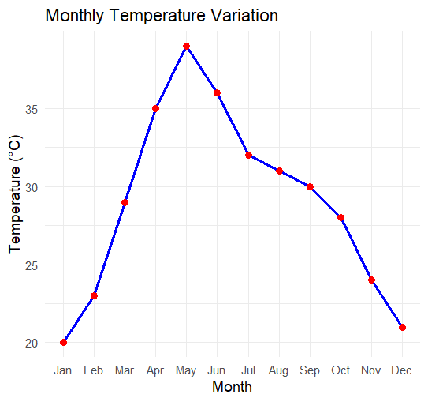

Question 3 (Business Analytics & Marketing)
# Load library
library(ggplot2)
# Create dataset
business <- data.frame(
Product = c("A", "B", "C", "D", "E"),
Sales = c(210, 185, 260, 145, 120),
Profit = c(18, 14, 25, 12, 10),
MarketShare = c(24, 20, 28, 15, 13)
)
# Highlight the product with the highest market share
business$Highlight <- ifelse(
business$MarketShare == max(business$MarketShare),
"Highest Market Share",
"Others"
)
# Bar Chart
ggplot(business, aes(x = Product, y = Sales)) +
geom_col(aes(fill = Profit), color = "black") +
# Highlight highest market share
geom_col(
data = subset(business, Highlight == "Highest Market Share"),
fill = "red",
color = "black"
) +
scale_fill_gradient(
low = "lightyellow",
high = "darkgreen",
name = "Profit (%)"
) +
labs(
title = "Business Analytics: Product Sales and Profit",
x = "Product",
y = "Sales (₹ Lakhs)"
) +
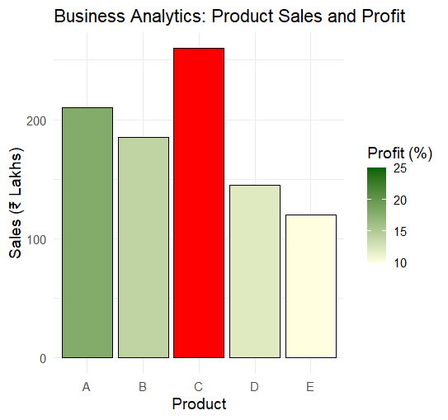
theme_minimal(base_size = 14)

Question 4 (Transportation Engineering)
# Load library
library(ggplot2)
# Create dataset
traffic <- data.frame(
Direction = factor(
c("North", "North-East", "East", "South-East",
"South", "South-West", "West", "North-West"),
levels = c("North", "North-East", "East", "South-East",
"South", "South-West", "West", "North-West")
),
Vehicles = c(980, 760, 1240, 890, 1420, 1130, 860, 720)
)
# Polar Coordinate Chart
ggplot(traffic, aes(x = Direction, y = Vehicles, fill = Vehicles)) +
geom_col(color = "black", width = 1) +
coord_polar() +
scale_fill_gradient(
low = "lightblue",
high = "darkblue",
name = "Vehicles/hour"
) +
labs(
title = "Traffic Flow by Direction (Polar Coordinate Chart)",
x = "Direction",
y = "Vehicles per Hour"
) +
theme_minimal(base_size = 14)
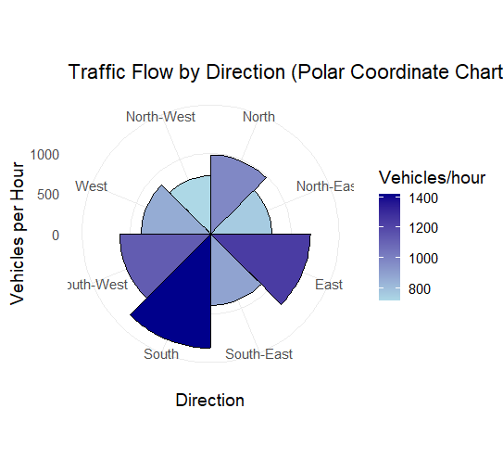

Question 5 (Environmental Sustainability Dashboard)
# Load libraries
library(ggplot2)
library(gridExtra)
# Create dataset
environment <- data.frame(
City = c("A","B","C","D","E","F"),
AQI = c(48,82,135,165,72,95),
GreenCover = c(45,32,21,18,38,30),
CO2 = c(1.8,3.5,5.6,7.4,2.9,4.2),
Population = c(9,15,22,28,12,18)
)

# Create AQI Categories
environment$AQI_Category <- cut(
environment$AQI,
breaks = c(0,50,100,150,200),
labels = c("Good","Moderate","Unhealthy","Very Unhealthy")
)
#-------------------------
# Plot 1: AQI by City
#-------------------------
p1 <- ggplot(environment,
aes(x = City,
y = AQI,
fill = AQI_Category)) +
geom_col(color = "black") +
scale_fill_manual(values = c(
"Good" = "green",
"Moderate" = "yellow",
"Unhealthy" = "orange",
"Very Unhealthy" = "red"
)) +
labs(
title = "Air Quality Index",
x = "City",
y = "AQI"
) +
theme_minimal()
#-------------------------
# Plot 2: Green Cover
#-------------------------
p2 <- ggplot(environment,
aes(x = City,
y = GreenCover,
fill = GreenCover)) +
geom_col(color = "black") +
scale_fill_gradient(
low = "lightgreen",
high = "darkgreen"
) +
labs(
title = "Green Cover (%)",
x = "City",
y = "Green Cover (%)"
) +
theme_minimal()
#-------------------------
# Plot 3: CO2 vs Population
#-------------------------
p3 <- ggplot(environment,
aes(x = Population,
y = CO2,
size = AQI,
color = AQI_Category)) +
geom_point(alpha = 0.8) +
scale_color_manual(values = c(
"Good" = "green",
"Moderate" = "yellow",
"Unhealthy" = "orange",
"Very Unhealthy" = "red"
)) +
labs(
title = "CO2 Emission vs Population",
x = "Population (Lakhs)",
y = "CO2 Emission"
) +
theme_minimal()
#-------------------------
# Dashboard
#-------------------------
grid.arrange(p1, p2, p3, ncol = 2)
