Fundamentals of Data Science - Lab Practice

Dataset: Student Performance
The dataset below (from Day 1) is loaded into a Pandas DataFrame and converted to NumPy arrays wherever the question requires it. This setup block is run before every program.
import pandas as pd
import numpy as np

data = {
"ID": [1,2,3,4,5,6,7,8,9,10],
"Name": ["Arun","Bina","Charu","Dinesh","Esha","Farhan","Gita","Hari","Indu","Jai"],
"Gender": ["M","F","F","M","F","M","F","M","F","M"],
"Study_Hours": [2,4,5,3,6,7,1,8,4,5],
"Attendance": [65,75,80,60,85,90,55,95,70,82],
"Assignment_Marks": [60,70,78,50,88,92,45,95,65,80],
"Final_Marks": [55,68,72,45,82,89,40,91,66,78],
"Result": ["Fail","Pass","Pass","Fail","Pass","Pass","Fail","Pass","Pass","Pass"]
}
df = pd.DataFrame(data)

Question 1
Scenario: You are working on a project that involves analyzing student performance data for a class of 32 students. The data is stored in a NumPy array named student_scores, where each row represents a student and each column represents a different subject (Math, Science, English, History). Your task is to calculate the average score for each subject and identify the subject with the highest average score.
Question: How would you use NumPy arrays to calculate the average score for each subject and determine the subject with the highest average score? Assume a 4x4 matrix that stores marks of each student in the given order.
Mapping to Day 1 dataset: the 4 numeric columns (Study_Hours, Attendance, Assignment_Marks, Final_Marks) act as the four subjects; the first 4 students form the 4x4 matrix.

Code
# 4x4 matrix: first 4 students x 4 numeric columns
# columns: Study_Hours, Attendance, Assignment_Marks, Final_Marks
cols = ["Study_Hours", "Attendance", "Assignment_Marks", "Final_Marks"]
student_scores = df[cols].iloc[:4].to_numpy()

print("student_scores (4x4):")
print(student_scores)

avg_scores = np.mean(student_scores, axis=0) # column-wise average
print("\nAverage of each column:")
for name, avg in zip(cols, avg_scores):
print(f" {name:<17}: {avg:.2f}")

best = np.argmax(avg_scores)
print(f"\nHighest average: {cols[best]} ({avg_scores[best]:.2f})")

Output
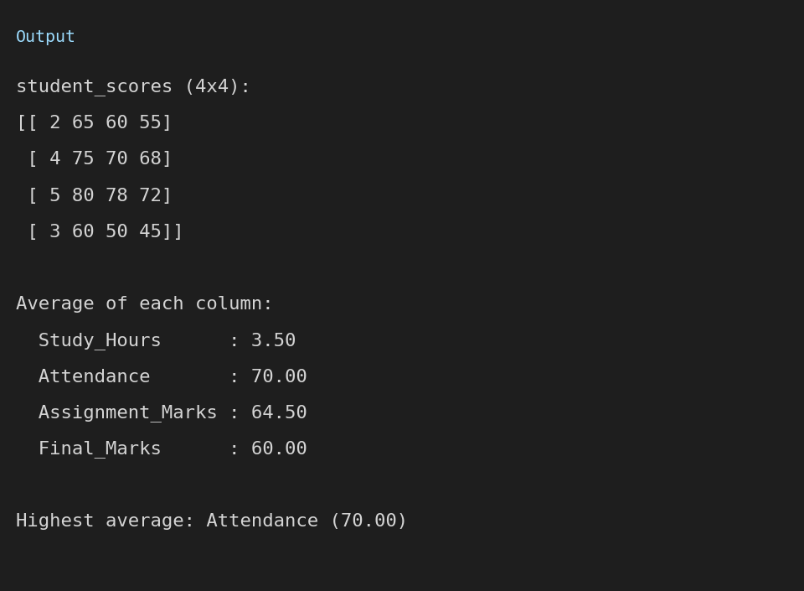

Explanation
- np.mean(..., axis=0) averages down each column, giving one average per subject.
- np.argmax() returns the index of the largest average, which is used to look up the subject name.

Question 2
Scenario: You are a data analyst working for a company that sells products online. You have been tasked with analyzing the sales data for the past month. The data is stored in a NumPy array.
Question: How would you find the average price of all the products sold in the past month? Assume a 3x3 matrix with each row representing the sales for a different product.
Mapping to Day 1 dataset: the first 3 students x (Attendance, Assignment_Marks, Final_Marks) form the 3x3 matrix.

Code
# 3x3 matrix: each row = one item (first 3 students),
# columns = Attendance, Assignment_Marks, Final_Marks
sales = df[["Attendance", "Assignment_Marks", "Final_Marks"]].iloc[:3].to_numpy()

print("Data matrix (3x3):")
print(sales)

print("\nAverage of each row:", np.round(sales.mean(axis=1), 2))
print("Overall average of all values:", round(np.mean(sales), 2))

Output
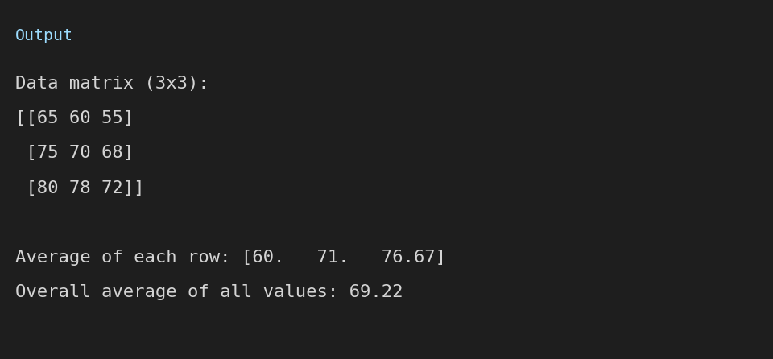

Explanation
- np.mean(matrix) with no axis averages every element of the 3x3 matrix.
- axis=1 gives the average of each row (each product).

Question 3
Scenario: You are working on a project that involves analyzing a dataset containing information about houses in a neighborhood. The dataset is stored in a CSV file, and you have imported it into a NumPy array named house_data. Each row of the array represents a house, and the columns contain various features such as the number of bedrooms, square footage, and sale price.
Question: Using NumPy arrays and operations, how would you find the average sale price of houses with more than four bedrooms in the neighborhood?
Mapping to Day 1 dataset: Study_Hours > 5 replaces "bedrooms > 4", and Final_Marks replaces "sale price".

Code
# house_data analogue: full numeric table of all 10 students
house_data = df[["Study_Hours", "Attendance", "Assignment_Marks", "Final_Marks"]].to_numpy()

# Condition on column 0 (Study_Hours > 5) -> like "bedrooms > 4"
mask = house_data[:, 0] > 5
selected = house_data[mask]

print("Rows with Study_Hours > 5:")
print(selected)

# Average of column 3 (Final_Marks) -> like "sale price"
avg_final = selected[:, 3].mean()
print(f"\nAverage Final_Marks of students who studied > 5 hours: {avg_final:.2f}")

Output
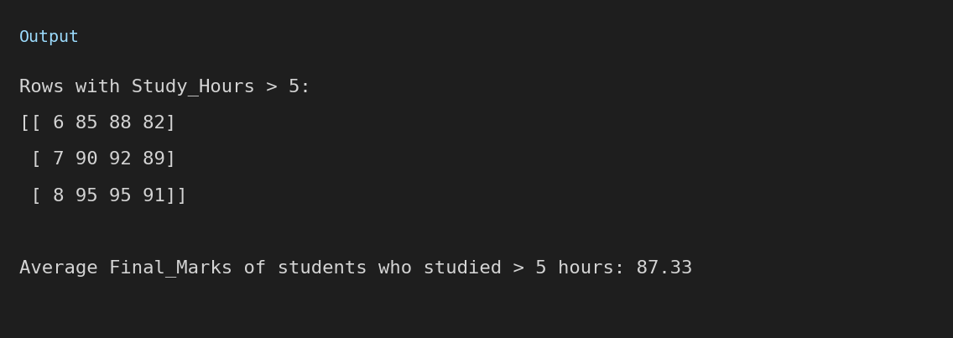

Explanation
- A boolean mask (house_data[:, 0] > 5) filters only the rows meeting the condition.
- The required column of the filtered rows is then averaged with .mean().

Question 4
Scenario: You are working on a project that involves analyzing the sales performance of a company over the past four quarters. The quarterly sales data is stored in a NumPy array named sales_data, where each element represents the sales amount for a specific quarter. Your task is to calculate the total sales for the year and determine the percentage increase in sales from the first quarter to the fourth quarter.
Question: Using NumPy arrays and arithmetic operations, calculate the total sales for the year and determine the percentage increase in sales from the first quarter to the fourth quarter.
Mapping to Day 1 dataset: Final_Marks of four students (Arun, Charu, Esha, Hari) are treated as Q1 to Q4.

Code
# sales_data analogue: Final_Marks of 4 records (Arun, Charu, Esha, Hari)
# treated as Q1, Q2, Q3, Q4
sales_data = df["Final_Marks"].to_numpy()[[0, 2, 4, 7]]
print("sales_data:", sales_data)

total_sales = np.sum(sales_data)
print("Total for the year:", total_sales)

pct_increase = (sales_data[3] - sales_data[0]) / sales_data[0] * 100
print(f"Percentage increase from Q1 to Q4: {pct_increase:.2f}%")

Output
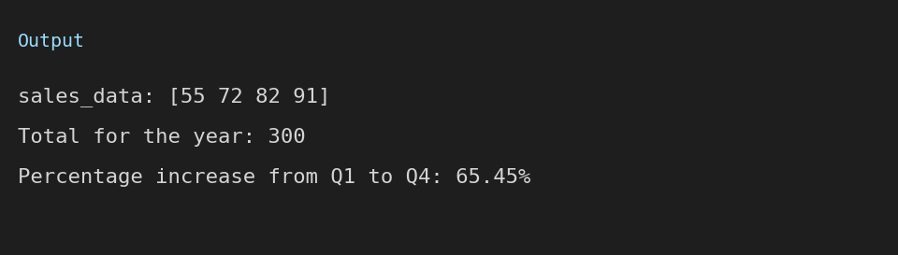

Explanation
- np.sum() gives the total across the four quarters.
- Percentage increase = (Q4 - Q1) / Q1 x 100.

Question 5
Scenario: You are a data analyst working for a car manufacturing company. You have a dataset containing information about the fuel efficiency of different car models. The dataset is stored in a NumPy array named fuel_efficiency, where each element represents the fuel efficiency (in miles per gallon) of a specific car model. Your task is to calculate the average fuel efficiency and determine the percentage improvement in fuel efficiency between two car models.
Question: How would you use NumPy arrays and arithmetic operations to calculate the average fuel efficiency and determine the percentage improvement in fuel efficiency between two car models?
Mapping to Day 1 dataset: Final_Marks of the 10 students act as fuel efficiency values; Dinesh (45) and Farhan (89) are the two "models" compared.

Code
# fuel_efficiency analogue: Final_Marks of all 10 students
fuel_efficiency = df["Final_Marks"].to_numpy()
print("fuel_efficiency:", fuel_efficiency)

avg = np.mean(fuel_efficiency)
print(f"Average: {avg:.2f}")

# Compare two "models": Dinesh (index 3) -> Farhan (index 5)
old, new = fuel_efficiency[3], fuel_efficiency[5]
improvement = (new - old) / old * 100
print(f"Model 1 = {old}, Model 2 = {new}")
print(f"Percentage improvement: {improvement:.2f}%")

Output
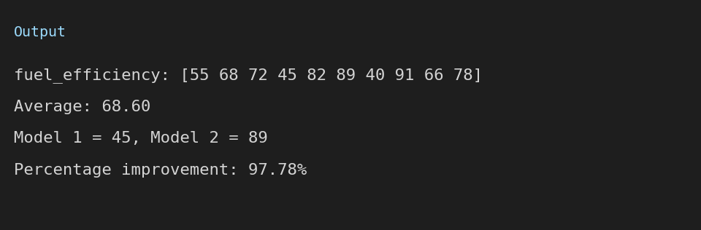

Explanation
- np.mean() gives the average of all values.
- Percentage improvement = (new - old) / old x 100.

