---------------Index---------------

• Tools and Technologies Used

• Abstract

• Introduction

• Objectives

• Dataset Description

• Data Preprocessing and Cleaning

• Exploratory Data Analysis

• SQL-Based Analysis

• Data Visualization (Power BI

Dashboard)

• Key Insights

• Business Recommendations

• Conclusion

• References

TOOLS & TECHNOLOGIES USED

Tools and Technologies Used
This project was completed using multiple tools and technologies to perform data cleaning, analysis, and visualization effectively.

Python
Python was used for data preprocessing and exploratory data analysis. It helped in handling missing values, transforming data, and generating initial insights.
Libraries Used:
- Pandas – for data manipulation and analysis
- Matplotlib – for data visualization
- NumPy – for numerical operations


SQL (PostgreSQL)
SQL was used to perform structured data analysis and extract meaningful business insights from the dataset. It enabled efficient querying of large datasets and answering key analytical questions.
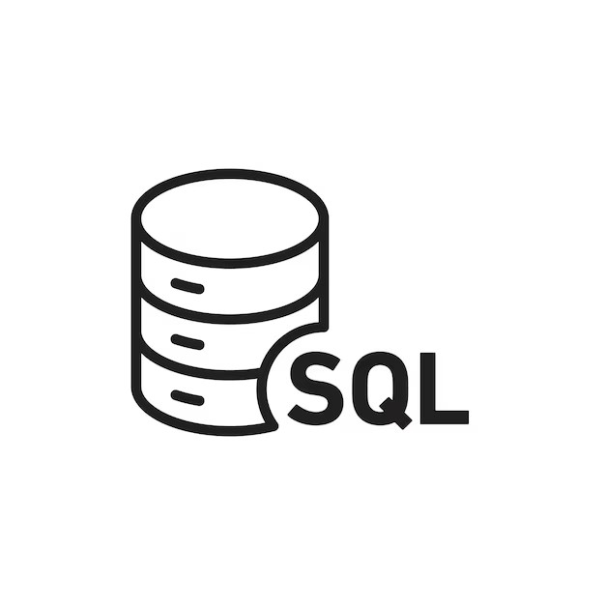

Microsoft Power BI Desktop
Power BI was used to create an interactive dashboard for visualizing the results. It helped in presenting insights through charts, graphs, and filters, making the data easy to understand.

Microsoft Excel
Excel was used for initial data viewing and basic analysis. It also helped in understanding the dataset structure before processing it in Python.
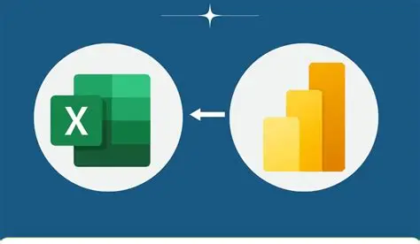

Jupyter Notebook
Jupyter Notebook was used as the development environment for running Python code, performing analysis, and documenting the workflow step by step.



Abstract

This report analyzes customer shopping behavior using transactional data to identify patterns in purchasing, customer preferences, and revenue generation. The study focuses on understanding how demographic factors, product categories, discounts, and subscription status influence customer spending. Tools such as Python, SQL, and Power BI were used to clean, analyze, and visualize the data. The insights derived aim to support data-driven business decisions and improve customer engagement strategies.

In the modern data-driven business environment, understanding customer behavior has become a critical factor in achieving sustainable growth. This report presents a comprehensive analysis of customer shopping behavior using transactional data. The study focuses on identifying patterns in purchasing habits, customer preferences, and the influence of various factors such as age, gender, product categories, discounts, and subscription status on overall revenue.

The analysis was performed using a combination of Python for data preprocessing, SQL for querying and extracting insights, and Microsoft Power BI Desktop for data visualization. The results of this study provide valuable insights that can help businesses optimize marketing strategies, improve customer retention, and enhance overall profitability.

Introduction
In today’s competitive market, understanding customer behavior is crucial for business growth. Organizations rely on data analytics to uncover trends and optimize marketing strategies. This project examines customer transaction data to identify key factors affecting purchasing decisions. The goal is to provide actionable insights that can help improve sales performance, customer retention, and overall business efficiency.

With the rapid growth of e-commerce and digital transactions, businesses are generating vast amounts of customer data. Analyzing this data effectively allows organizations to understand consumer behavior, predict future trends, and make informed decisions. Customer behavior analysis helps businesses identify what drives purchases, which customers are most valuable, and how different strategies impact sales performance.

This project aims to explore customer shopping behavior through a structured approach involving data cleaning, exploratory analysis, and visualization. By examining purchasing trends and customer segments, the study provides insights that can be used to enhance business strategies and improve customer satisfaction.

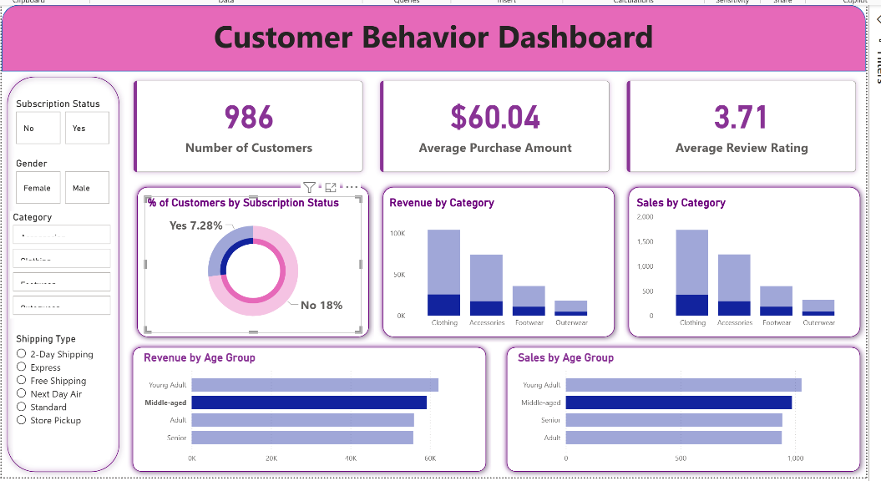

Objectives

- To analyze customer purchasing patterns
- To identify high-value customer segments
- To evaluate the impact of discounts and subscriptions
- To study product category performance
- To provide business recommendations based on data insights

The primary objectives of this project are:
- To analyze customer demographics and their impact on purchasing behavior
- To identify patterns in customer spending and product preferences
- To evaluate the effectiveness of discounts and promotional strategies
- To compare the behavior of subscribed and non-subscribed customers
- To segment customers based on their purchase history
- To provide actionable business recommendations based on data insights

Dataset Description

The dataset consists of 3,900 customer transactions with 18 attributes. It includes demographic details such as age, gender, and location, along with transactional information like product category, purchase amount, and shipping type. Behavioral attributes such as discount usage, previous purchases, and review ratings are also included. This diverse dataset enables a comprehensive analysis of customer behavior.

The dataset used in this analysis contains approximately 3,900 customer transaction records with 18 different attributes. These attributes include both demographic and transactional data, enabling a comprehensive study of customer behavior.
Key variables in the dataset include:
- Demographic Information: Age, gender, and location
- Transaction Details: Product category, item purchased, purchase amount
- Behavioral Data: Frequency of purchases, previous purchases, review ratings
- Promotional Factors: Discount applied, subscription status
- Logistics: Shipping type and delivery preferences
The dataset also contained a small number of missing values in the review rating column, which were addressed during preprocessing. Overall, the dataset provides a strong foundation for analyzing customer behavior across multiple dimensions.

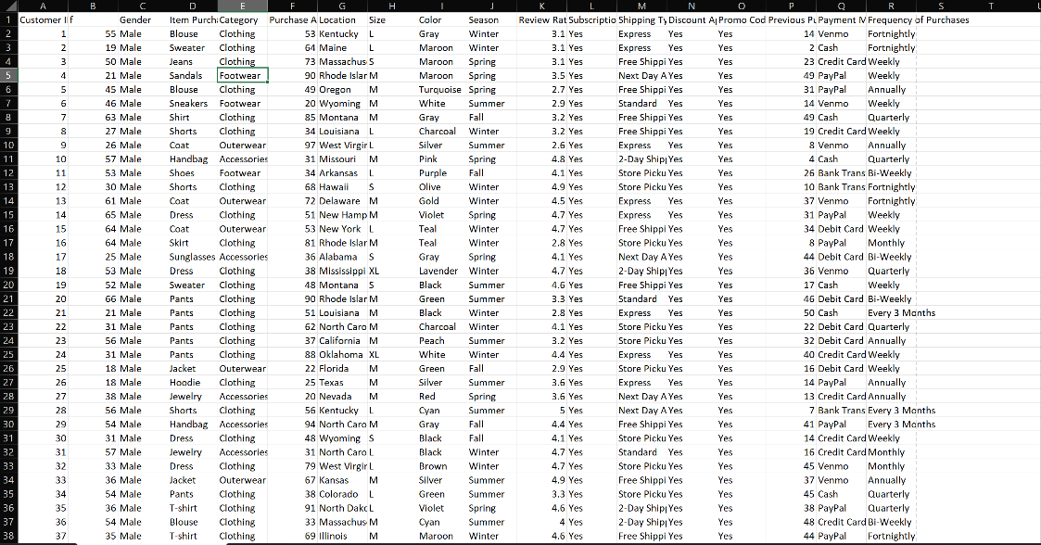
The dataset preview shows the structure of customer transaction data including demographics, purchase details, and behavior attributes.
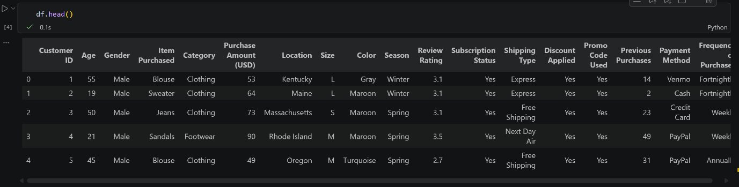

Data Preprocessing

The dataset was cleaned to ensure accuracy and consistency. Missing values in the review rating column were handled using median imputation to maintain data integrity. Column names were standardized for better readability. Additional features such as age groups were created to simplify analysis. Redundant fields were removed to avoid duplication and improve efficiency.

Data preprocessing is a crucial step in any data analysis project, as it ensures the accuracy and reliability of the results. In this project, several preprocessing techniques were applied to prepare the dataset for analysis.

First, the dataset was examined for missing values. It was observed that the review rating column contained some null values. These missing values were handled using median imputation, which helps preserve the distribution of the data while avoiding bias.

Next, column names were standardized into a consistent format to improve readability and usability during analysis. This step is important when working with programming languages and SQL queries.

Feature engineering techniques were also applied to enhance the dataset. A new variable called “age group” was created by categorizing customers into different age ranges. This allowed for easier analysis of trends across different demographic segments.

Additionally, redundant columns were identified and removed to simplify the dataset and reduce unnecessary complexity. These steps ensured that the data was clean, consistent, and ready for further analysis.

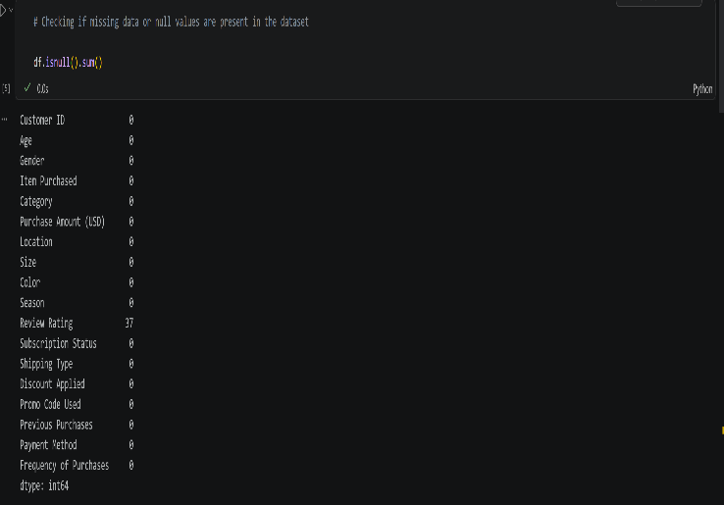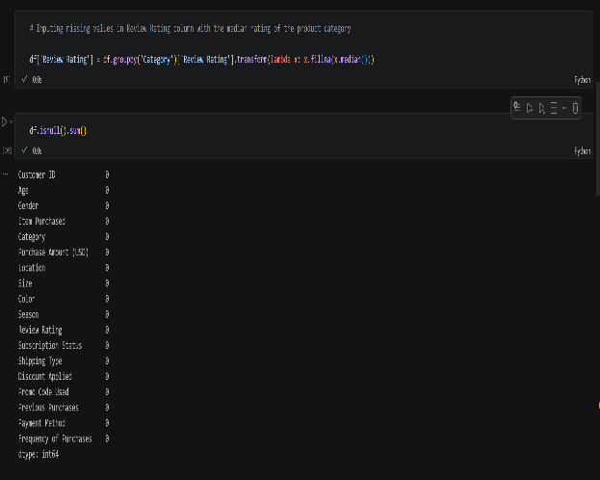
Missing values were identified in the review rating column and handled during data cleaning.
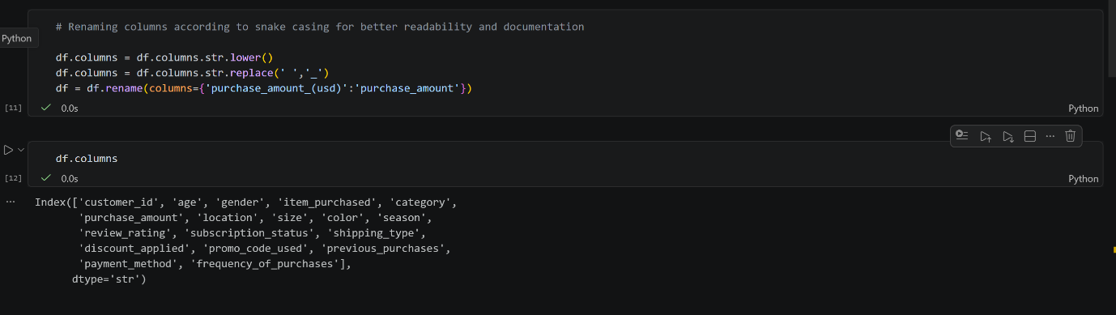
The dataset contains key features such as age, gender, purchase amount, category, and subscription status used for analysis.
The dataset consists of 3,900 entries with multiple numerical and categorical variables.

Exploratory Data Analysis

Exploratory analysis was performed to understand the distribution and relationships within the data. Customer age distribution showed that most buyers belong to a mid-age group. Gender-based analysis revealed differences in spending behavior. Product category analysis indicated that certain categories contribute significantly more to total revenue. Review ratings suggested overall positive customer satisfaction. These patterns provided a foundation for deeper analysis.

Exploratory Data Analysis was conducted to understand the underlying patterns and relationships within the dataset. This step plays a key role in identifying trends and generating hypotheses for deeper analysis.

The age distribution analysis revealed that a large portion of customers falls within the mid-age range, indicating that this group represents a significant portion of the target market. Businesses can focus their marketing efforts on this segment to maximize returns.

Gender-based analysis showed noticeable differences in purchasing behavior. Female customers demonstrated slightly higher average spending compared to male customers. This insight suggests that targeted marketing strategies can be designed to cater to different customer groups.
Product category analysis indicated that certain categories contribute disproportionately to total revenue. Identifying these high-performing categories allows businesses to prioritize inventory, marketing, and promotions accordingly.

Review ratings were also analyzed to assess customer satisfaction. The majority of products received positive ratings, indicating a generally favorable customer experience. However, analyzing lower-rated products can help identify areas for improvement.

Overall, EDA provided a clear understanding of customer behavior patterns and highlighted key factors influencing purchasing decisions.
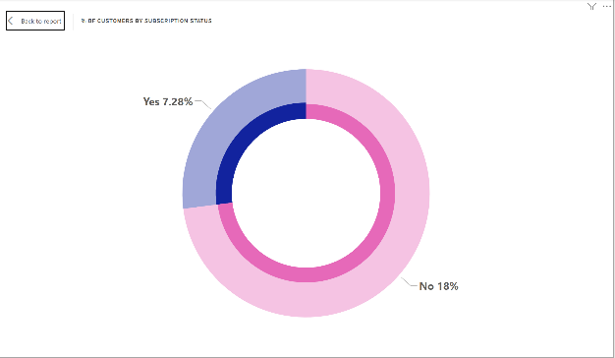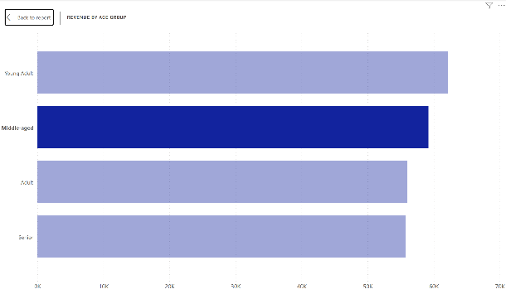
% OF CUSTOMERS BY SUBSCRIPTION STATUS REVENUE BY AGE GROUP

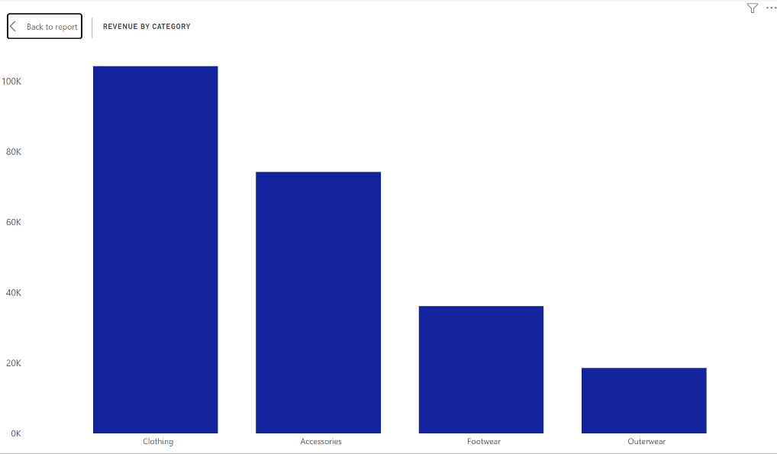
REVENUE BY CATEGORY

SQL-Based Analysis

SQL queries were used to extract meaningful business insights from the dataset.
- Revenue by Gender: Compared total spending between male and female customers to identify dominant contributors.
- High-Spending Discount Users: Identified customers who used discounts but still maintained high purchase values.
- Top Rated Products: Determined products with the highest customer satisfaction.
- Shipping Type Analysis: Compared spending behavior between standard and express shipping users.
- Subscription Analysis: Evaluated differences in spending between subscribers and non-subscribers.
- Customer Segmentation: Classified customers into new, returning, and loyal categories based on purchase frequency.

These analyses helped in understanding customer value and behavior patterns.

Structured Query Language (SQL) was used to perform in-depth analysis and answer specific business questions. SQL queries enabled efficient extraction of insights from the dataset.

One of the key analyses involved comparing revenue generated by different genders. This helped identify which group contributes more significantly to overall sales.

Another important analysis focused on customers who use discounts. It was observed that while discounts increase purchase frequency, some customers continue to spend above average even when discounts are applied. These customers represent high-value segments that businesses should target.

The study also identified top-rated products based on customer reviews. These products can be promoted more aggressively to boost sales and customer satisfaction.

Shipping type analysis revealed that customers opting for express shipping tend to have higher purchase amounts. This indicates that customers willing to pay for faster delivery may also have higher purchasing power.

Subscription analysis showed that subscribed customers generally spend more than non-subscribers. This highlights the importance of subscription programs in driving revenue and customer loyalty.

Customer segmentation was another critical part of the analysis. Customers were classified into new, returning, and loyal segments based on their purchase frequency. Loyal customers were found to contribute a significant portion of total revenue, making them a key focus area for businesses.

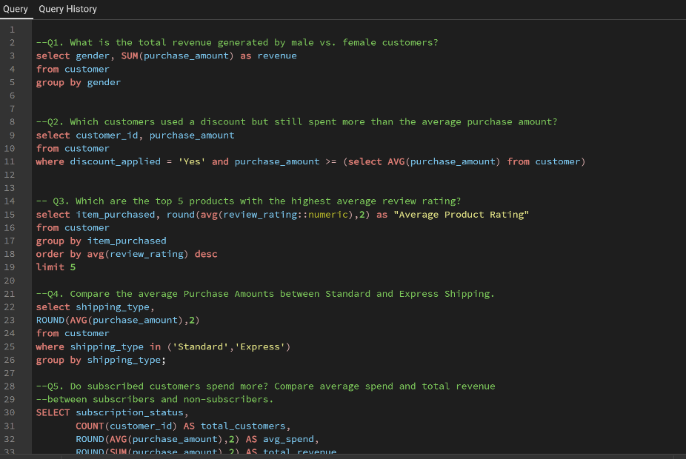
BASIC SQL QURIES TO EXTRACT BUSSINUS INPORTANCE FROM DATA BASE

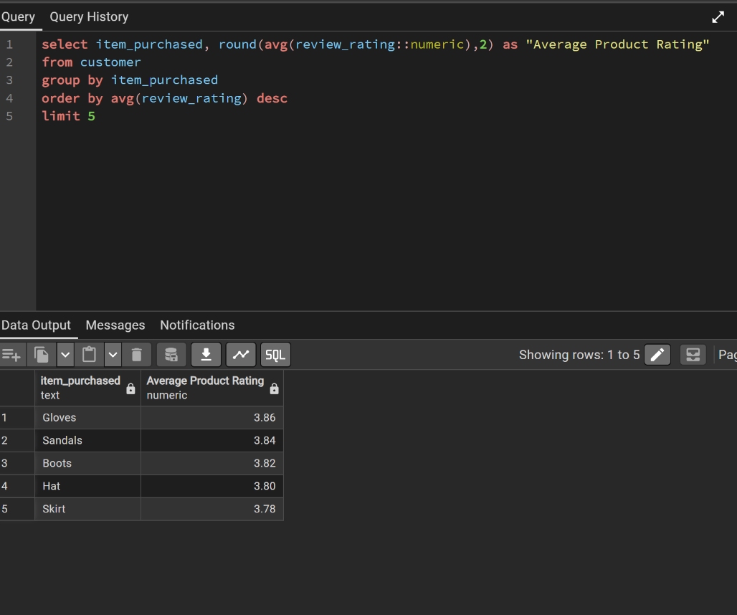
Which are the top 5 products with the highest average review rating?
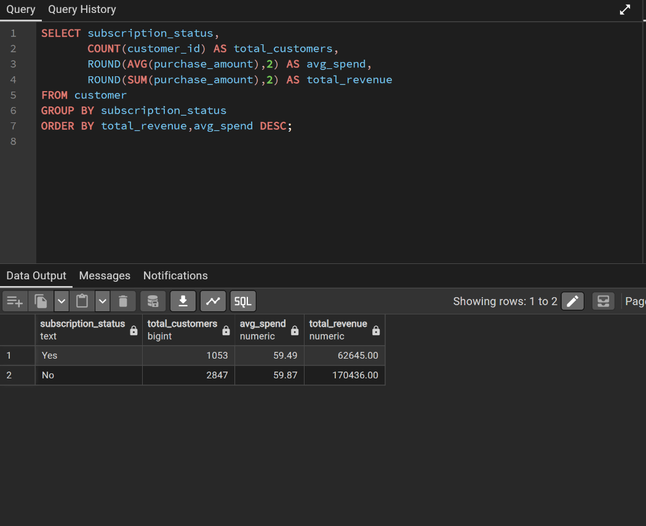
Do subscribed customers spend more? Compare average spend and total revenue between subscribers and non-subscribers.
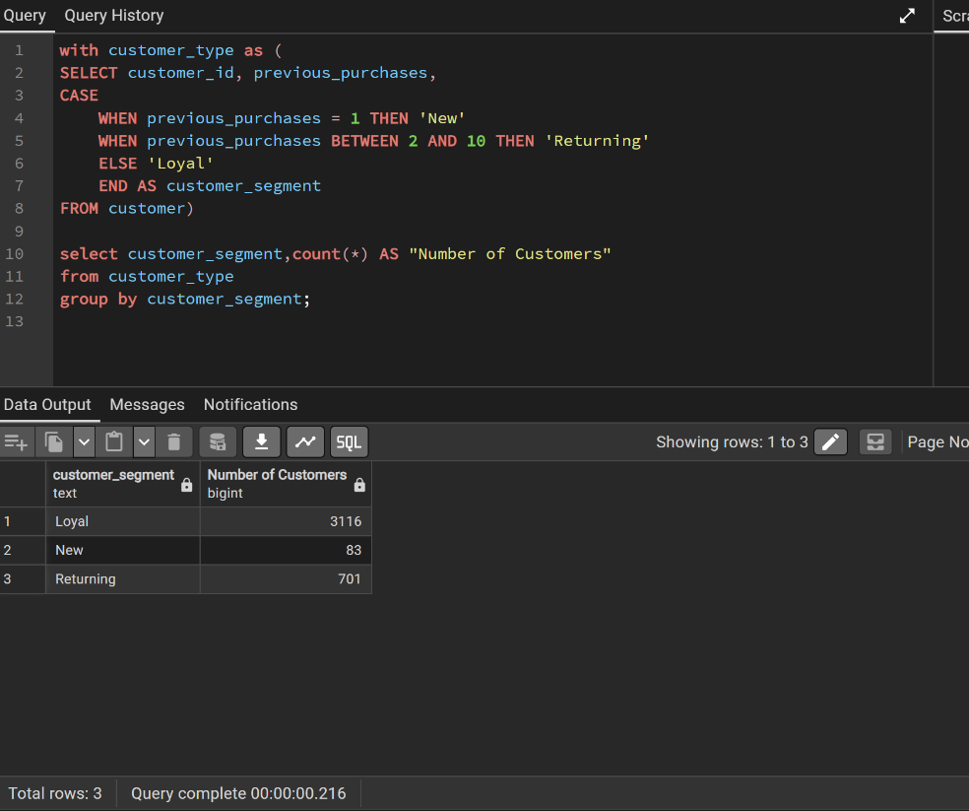
Segment customers into New, Returning, and Loyal based on their total number of previous purchases, and show the count of each segment.
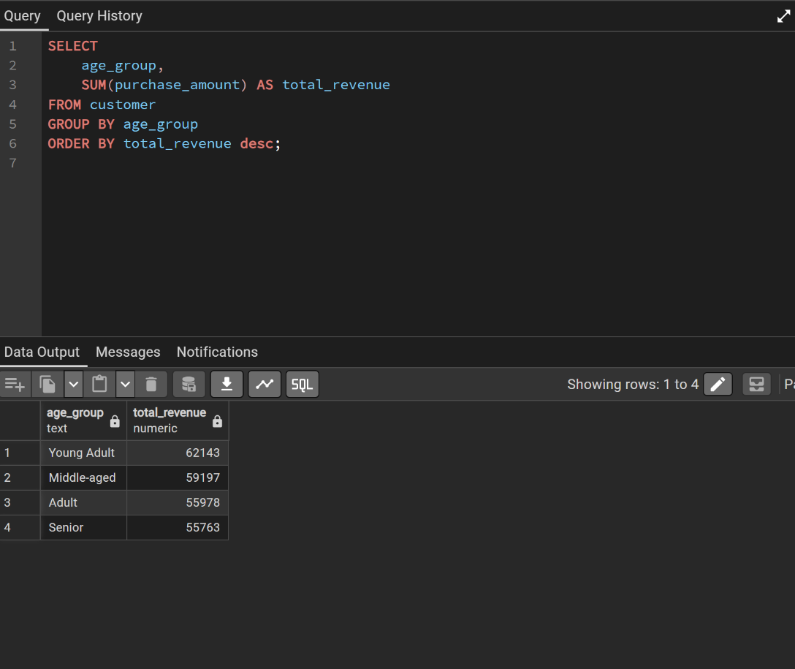
What is the revenue contribution of each age group?

Dashboard Visualization

An interactive dashboard was created using Microsoft Power BI Desktop to present insights visually. The dashboard includes charts for revenue distribution, category performance, and customer segmentation. Filters were added to allow dynamic analysis based on different attributes such as gender, category, and subscription status. This visualization makes it easier to interpret data and identify trends quickly.

To effectively communicate the insights, an interactive dashboard was created using Microsoft Power BI Desktop. Visualization plays a crucial role in transforming raw data into meaningful and actionable insights.

The dashboard includes multiple visual elements such as bar charts, pie charts, and line graphs to represent different aspects of the data. Key metrics such as total revenue, average purchase value, and customer segmentation are displayed clearly.

Interactive filters and slicers were added to allow users to explore the data dynamically. For example, users can filter data based on gender, product category, or subscription status to gain deeper insights.

The dashboard provides a comprehensive overview of customer behavior and enables quick identification of trends and patterns. It serves as a powerful tool for decision-making and strategic planning.

Key Insights

- Customers in the mid-age group contribute the highest share of revenue.
- Female customers show slightly higher average spending.
- Certain product categories dominate overall sales performance.
- Discounts increase purchase frequency but may reduce profit margins.
- Subscribers tend to spend more than non-subscribers.
- Loyal customers contribute significantly to total revenue.

The analysis of the dataset led to several important insights:

- Customers in the mid-age group represent the largest and most active segment
- Female customers tend to spend slightly more on average
- A small number of product categories generate the majority of revenue
- Discounts increase purchase frequency but may impact profit margins
- Subscribers contribute higher revenue compared to non-subscribers
- Loyal customers are the most valuable segment and drive long-term revenue

These insights highlight the importance of targeted marketing and customer retention strategies.

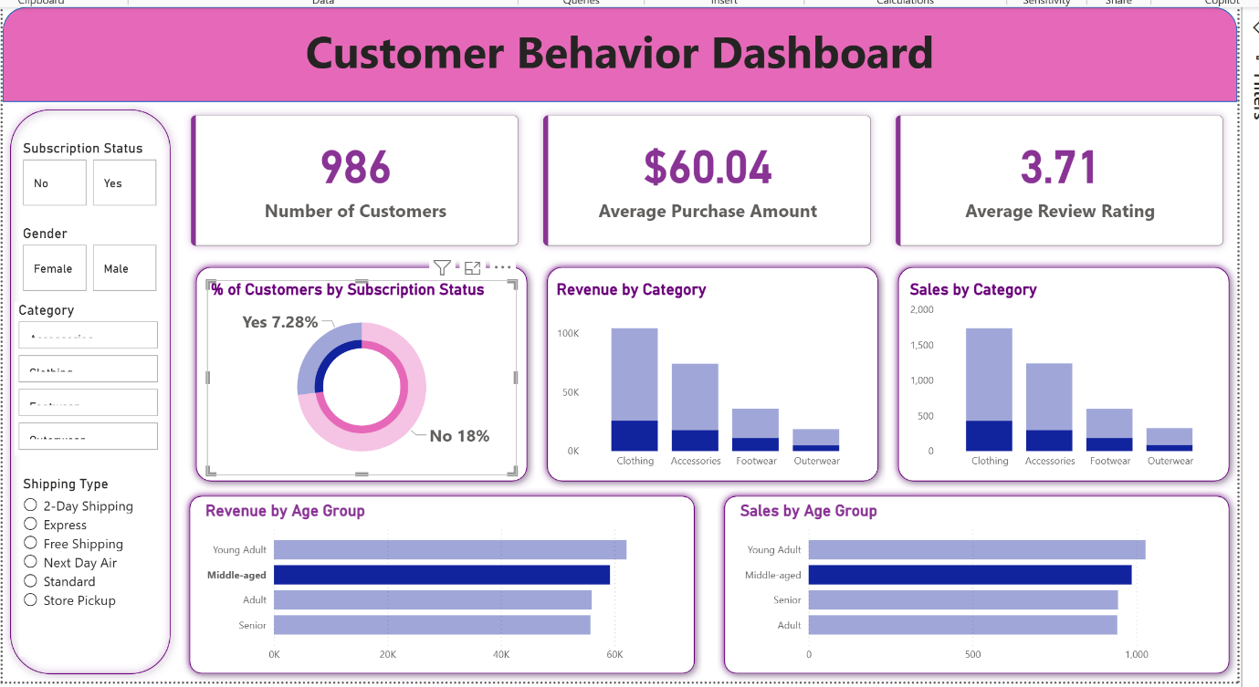
The Power BI dashboard provides an interactive overview of customer behavior and sales performance.

Business Recommendations
- Enhance Subscription Programs: Offer exclusive benefits to increase subscriber base.
- Focus on High-Value Customers: Target loyal customers with personalized offers.
- Optimize Discount Strategies: Use discounts strategically to balance sales and profitability.
- Promote Top Categories: Invest more in high-performing product categories.
- Improve Customer Retention: Introduce loyalty programs and rewards.

Based on the analysis, the following recommendations are proposed:

- Strengthen Subscription Programs: Offer exclusive benefits to encourage more customers to subscribe
- Focus on Customer Retention: Implement loyalty programs to retain high-value customers
- Optimize Discount Strategies: Use discounts strategically to increase sales without significantly reducing profits
- Promote High-Performing Categories: Invest more in marketing and inventory for top-selling categories
- Personalized Marketing: Use customer data to create targeted campaigns for different segments

Implementing these strategies can help businesses improve revenue and customer satisfaction.

Conclusion

The analysis successfully highlights key factors influencing customer shopping behavior. By leveraging data analytics, businesses can better understand their customers and make informed decisions. The findings emphasize the importance of customer segmentation, targeted marketing, and strategic pricing. Implementing the recommended strategies can lead to improved customer satisfaction and increased revenue.

This project demonstrates the power of data analytics in understanding customer behavior and driving business decisions. By analyzing transactional data, valuable insights were obtained regarding customer preferences, spending patterns, and the impact of various factors on revenue.

The use of Python, SQL, and data visualization tools enabled a comprehensive analysis of the dataset. The findings emphasize the importance of customer segmentation, targeted marketing, and strategic planning in achieving business success.

Overall, this study provides a strong foundation for data-driven decision-making and highlights opportunities for improving business performance.

References
- Dataset used for analysis
- Python libraries (Pandas, Matplotlib)
- SQL (PostgreSQL)
- Power BI documentation

Customer Shopping Behavior Analysis

Project Overview
This project analyzes customer shopping behavior using transactional data from 3,900 purchases across various product categories. The goal is to uncover insights into spending patterns, customer segments, product preferences, and subscription behavior to guide strategic business decisions.

Dataset Summary
- Rows: 3,900
  - Columns: 18
  - Key Features:
    - Customer demographics (Age, Gender, Location, Subscription Status)
    - Purchase details (Item Purchased, Category, Purchase Amount, Season, Size, Color)
    - Shopping behavior (Discount Applied, Promo Code Used, Previous Purchases, Frequency of Purchases, Review Rating, Shipping Type)
  - Missing Data: 37 values in Review Rating column

Exploratory Data Analysis using Python
We began with data preparation and cleaning in Python:

- Data Loading: Imported the dataset using pandas.

- Initial Exploration: Used df.info() to check structure and .describe() for summary statistics.
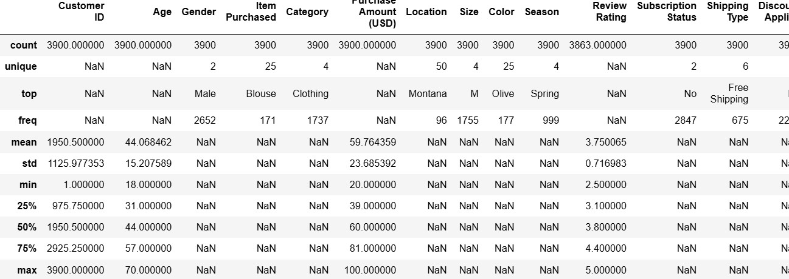

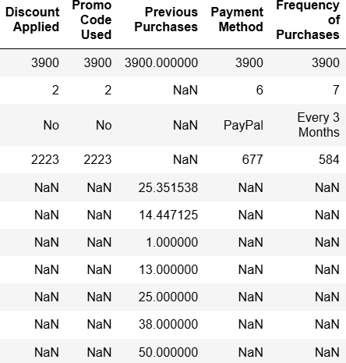

- Missing Data Handling: Checked for null values and imputed missing values in the
Review Rating column using the median rating of each product category.

- Column Standardization: Renamed columns to snake case for better readability and documentation.

Feature Engineering:

  - Created age_group column by binning customer ages.

  - Created purchase_frequency_days column from purchase data.

- Data Consistency Check: Verified if discount_applied and promo_code_used
were redundant; dropped promo_code_used.

- Database Integration: Connected Python script to PostgreSQL and loaded the cleaned DataFrame into the database for SQL analysis.

Data Analysis using SQL (Business Transactions)
We performed structured analysis in PostgreSQL to answer key business questions:

- Revenue by Gender – Compared total revenue generated by male vs. female customers.

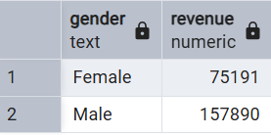

- High-Spending Discount Users – Identified customers who used discounts but still spent above the average purchase amount.
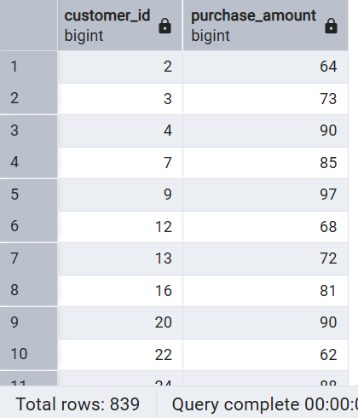

- Top 5 Products by Rating – Found products with the highest average review ratings.

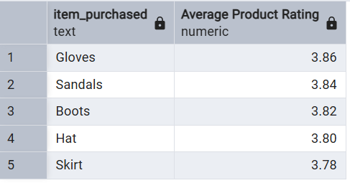

- Shipping Type Comparison – Compared average purchase amounts between Standard and Express shipping.
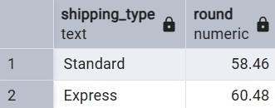

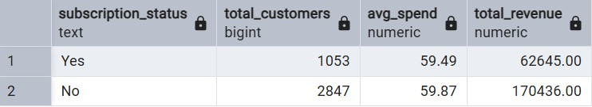
- Subscribers vs. Non-Subscribers – Compared average spend and total revenue across subscription status.

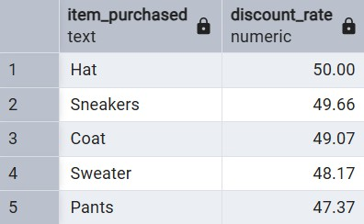
- Discount-Dependent Products – Identified 5 products with the highest percentage of discounted purchases.

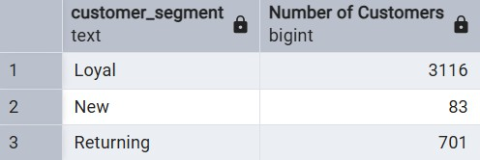
- Customer Segmentation – Classified customers into New, Returning, and Loyal segments based on purchase history.

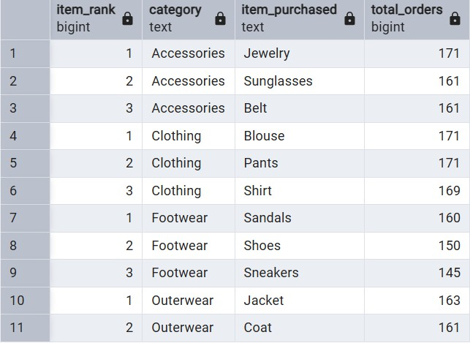
- Top 3 Products per Category – Listed the most purchased products within each category.
- Repeat Buyers & Subscriptions – Checked whether customers with >5 purchases are more likely to subscribe.
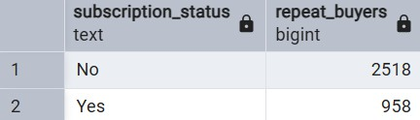
- Revenue by Age Group – Calculated total revenue contribution of each age group.

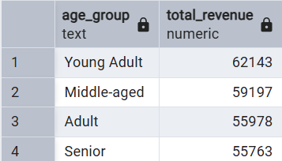

Dashboard in Power BI

Finally, we built an interactive dashboard in Power BI to present insights visually.
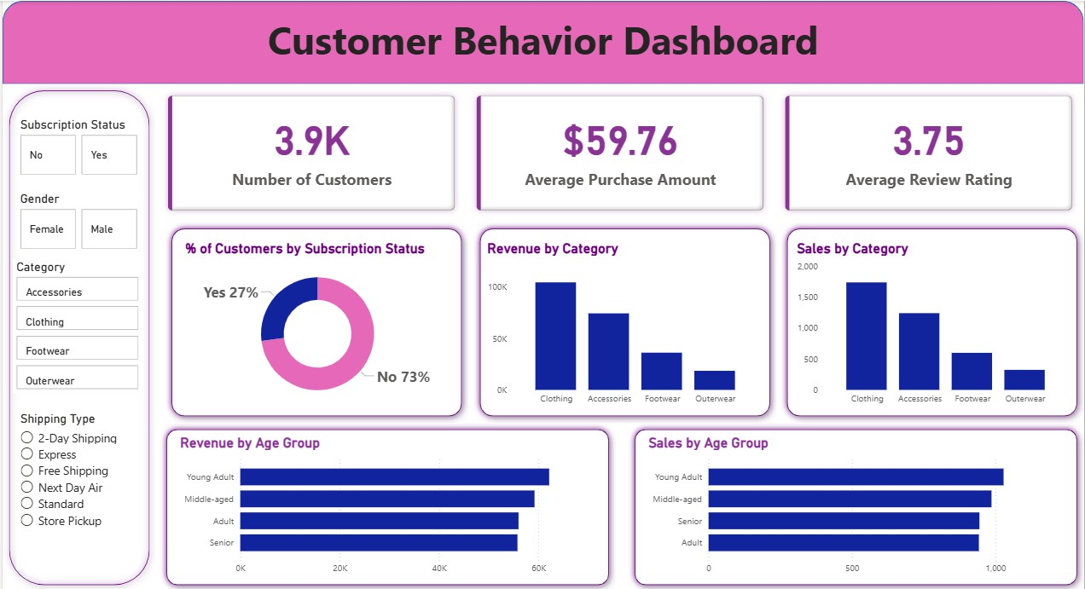

Business Recommendations

- Boost Subscriptions – Promote exclusive benefits for subscribers.

- Customer Loyalty Programs – Reward repeat buyers to move them into the “Loyal” segment.

- Review Discount Policy – Balance sales boosts with margin control.

- Product Positioning – Highlight top-rated and best-selling products in campaigns.

- Targeted Marketing – Focus efforts on high-revenue age groups and express-shipping users.

