**General Instruction:**

* Try to optimize your algorithms as much as possible.
* There will be marks allocated for your code optimization , completeness and theorical understanding.
* Your File and Function names must start with your student no.

Example: 1505xxx_bisection.m

1. Sin (x) function can be expanded using Taylor series and the expanded series is given below.

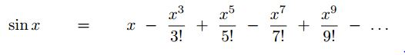

Now write a Matlab function which will take the value of x and iteration (number of terms) number n and return the approximated value of Sin(x).

Write a series of Matlab commands that will do the following things.

* Plot the Sin(x) function for the interval [-2π,2π] with step size 0.2 using the built-in Sin (x) function.
* In the same plot show four approximated functions for the same interval using different number of terms (1, 3, 5, 20).
* Draw another plot showing the relative approx. error for each iteration while determining the value of sin (1.5) upto 50 terms.

2.For fluid flow in pipes, friction is described by a dimensionless number, the Fanning friction factor f. The Fanning friction factor is dependent on a number of parameters related to the size of the pipe and the fluid, which can all be represented by another dimensionless quantity, the Reynolds number Re. A formula that predicts f given Re is the von Karman equation:

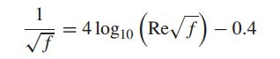

Typical values for the Reynolds number for turbulent flow are 10,000 to 500,000 and for the Fanning friction factor are to 0.001 to 0.01. Find the value of f where Re=20,000.

* Use graphical model to estimate the value.
* Use Bisection method and False Position method to estimate the value for εs=0.5%. Report the number of iterations for each method while achieving the expected result.
* Note: You must write your Bisection method and False Position method on separate .m file and you must pass your function as an argument to the method functions. The prototype is given below.
* Bisection method (function , lower bound of the bracket, upper bound of the bracket, expected relative approximation error, max iteration)
* False Position method (function , lower bound of the bracket, upper bound of the bracket, expected relative approximation error, max iteration)