Project – Voting System

Name – Mrityunjai singh

OKAY LETS GET START:

The main topics of this are as follows:-

**1. Important tasks of this project :-**

So friends this project will work as follows -

1. This project will first create a menu in which you will be told which party is on which number and which key you have to press to vote for whom. This project will do all this work with the help of the main function because the coding related to it has been done in the main function.

2. The second task in this project is to calculate the votes cast by you, who you have voted for. And your vote will be added to the votes of that party. So this project will do all this work with the help of calculateVote function, inside this function we have done all the coding related to it.

3. The third task in this project is to show the result of voting ie election. In this result it will be shown which party has won the election and how many votes it has along with how many votes it has won from other parties. All this result will be shown with the help of electionResult function because all the coding related to it has been done inside this function.

**2. Voting system project Can do :-**

* detect wheather the user put a valid input or not .
* calculate any number of parties and tells us which one got the highest voting score.
* take any numbers of input and claculate the output.
* calculate if some of the parties having same voting points or not.
* calculate and tells that is all of the parties which is particepating in ellection is having same voting score or not.
* identify and checks of the whole code if it is working or not.

Testing

Without auto testing:

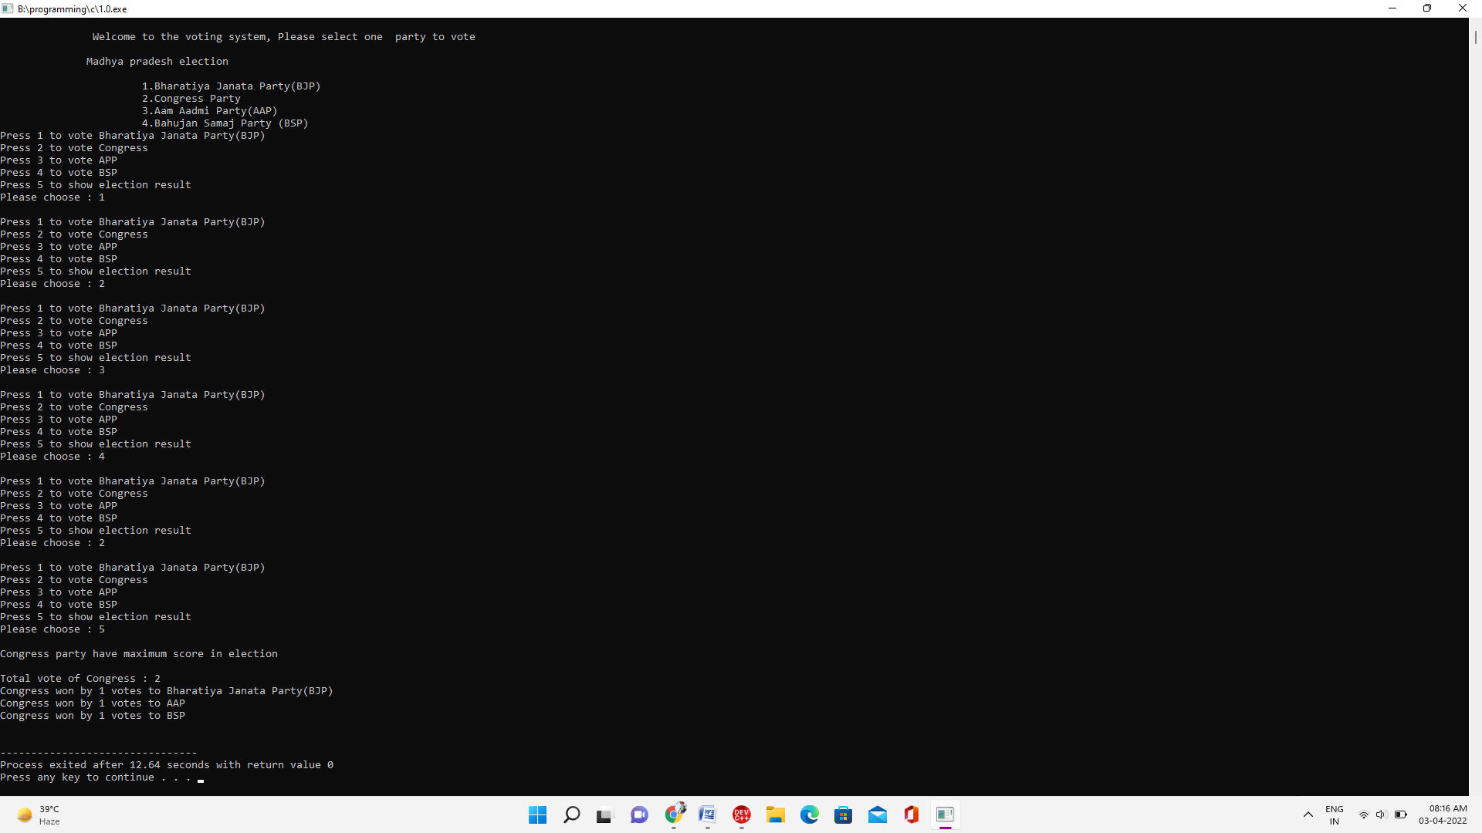

With auto testing:

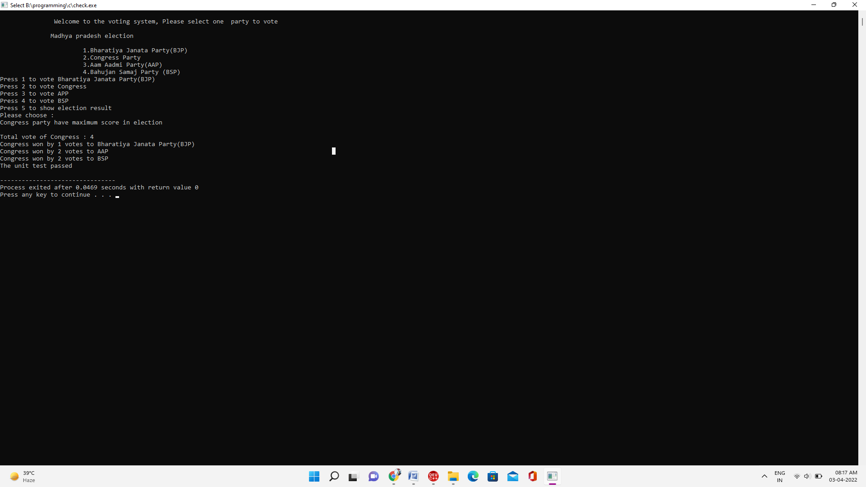

**Source code of voting system project :-**

So now let us see the source code of this project.

project source full code :-

#include <stdio.h>

int bjp=0, congress=0, aap=0, bsp=0;

void electionResult()

{

int wonByVote;

if (bjp > congress && bjp > aap && bjp > bsp)

{

printf("\nBharatiya Janata Party(BJP) have maximux score in election\n\n");

printf("Total vote of Bharatiya Janata Party(BJP): %d\n",bjp);

wonByVote=bjp-congress;

printf("Bharatiya Janata Party(BJP) won by %d votes to Congress\n",wonByVote);

wonByVote=bjp-aap;

printf("Bharatiya Janata Party(BJP) won by %d votes to AAP\n",wonByVote);

wonByVote=bjp-bsp;

printf("Bharatiya Janata Party(BJP) won by %d votes to BSP\n",wonByVote);

}

else if (congress > aap && congress > bsp)

{

printf("\nCongress party have maximum score in election\n\n");

printf("Total vote of Congress : %d\n",congress);

wonByVote=congress-bjp;

printf("Congress won by %d votes to Bharatiya Janata Party(BJP)\n",wonByVote);

wonByVote=congress-aap;

printf("Congress won by %d votes to AAP\n",wonByVote);

wonByVote=congress-bsp;

printf("Congress won by %d votes to BSP\n",wonByVote);

}

else if (aap > bsp)

{

printf("\nAam Aadmi Party(AAP) have maximum score in election\n\n");

printf("Total vote of AAP : %d\n",aap);

wonByVote=aap-congress;

printf("Aam Aadmi Party(AAP) won by %d votes to Congress\n",wonByVote);

wonByVote=aap-bjp;

printf("Aam Aadmi Party(AAP) won by %d votes to BJP\n",wonByVote);

wonByVote=aap-bsp;

printf("Aam Aadmi Party(AAP) won by %d votes to BSP\n",wonByVote);

}

else if(bjp == congress || bjp == aap || bjp == bsp || bsp == congress || congress == aap || bsp == aap)

{

printf("\n some parties having same illection score\n\n");

printf(" Bharatiya Janata Party(BJP)---Congress---Aaam Aadmi Party---Bahujan Samaj Party (BSP)\n");

printf("Total Vote %d %d %d %d\n",bjp,congress,aap,bsp);

}

else if(bjp == congress && bjp == aap && bjp == bsp && bsp == congress)

{

printf("\nAll parties have same election score\n\n");

printf(" Bharatiya Janata Party(BJP)---Congress---Aaam Aadmi Party---Bahujan Samaj Party (BSP)\n");

printf("Total Vote %d %d %d %d\n",bjp,congress,aap,bsp);

}

else

{

printf("\nBahujan Samaj Party (BSP) have maximum score in election\n\n");

printf("Total vote of BSP : %d\n",bsp);

wonByVote=bsp-congress;

printf("Bahujan Samaj Party (BSP)won by %d votes to Congress\n",wonByVote);

wonByVote=bsp-aap;

printf("Bahujan Samaj Party (BSP) won by %d votes to AAP\n",wonByVote);

wonByVote=bsp-bjp;

printf("Bahujan Samaj Party (BSP) won by %d votes to BJP\n",wonByVote);

}

}

void calculateVote(int vote)

{

switch (vote)

{

case 1:

bjp+=1;

break;

case 2:

congress+=1;

break;

case 3:

aap+=1;

break;

case 4:

bsp+=1;

break;

}

}

/* Here i am putting values for votes to check and run program for unit test

i have complete my actual program in single file instead of multifile because it is working same and even more efficientiely

and to check program to ignore human needs put values in this program*/

void runUnitTest(int arr[], int n) {

for(int i = 0; i< n; i++){

if(arr[i]>=6 || arr[i]<=0){

printf("Invalid input");

}

else if(arr[i]==5){

electionResult();

}

else{

calculateVote(arr[i]);

}

}

}

int main()

{

int inputSize = 12;

int inputArr[] = {1, 1, 2, 3, 4, 1, 2, 2, 4, 3, 2, 5}; //different inputs for testing the program working and errors

int expectedBjp = 3;

int expectedCongress = 4;

int expectedAap = 2;

int expectedBsp = 2;

printf("\n Welcome to the voting system, Please select one party to vote\n\n");

printf(" Madhya pradesh election \n\n");

printf(" 1.Bharatiya Janata Party(BJP) \n");

printf(" 2.Congress Party \n");

printf(" 3.Aam Aadmi Party(AAP) \n");

printf(" 4.Bahujan Samaj Party (BSP)\n");

printf("Press 1 to vote Bharatiya Janata Party(BJP)\n");

printf("Press 2 to vote Congress\n");

printf("Press 3 to vote APP\n");

printf("Press 4 to vote BSP\n");

printf("Press 5 to show election result\n");

printf("Please choose : ");

runUnitTest(inputArr, inputSize);

if(bsp == expectedBsp && bjp == expectedBjp && aap == expectedAap && congress == expectedCongress)

printf("The unit test passed\n");

else

printf("The unit test failed");

return 0;

}