28.09.2022 (4 months programm)

1. Gitbash download -<https://www.stanleyulili.com/git/how-to-install-git-bash-on-windows/>
2. Pure basics (initial 2 weeks) – Basics Linux Command
3. CLI = Command Line interface

29.09.2022

ls command – folder u r having, clear

directory -

pwd – present working directory

cd ANK

ls

mkdir movies – create a new folder,

how to move backward- cd ../, cd../../- 2 step backward

without going any folder- ls ‘folder name’/

cd../../../../../Desktop folder name

touch is used create a new file i.e, touch songs.mp3- file

mkdir -p okjannu_film/actress/shraddha-( for creating a sub folder)

mkdir -p ../../../telugu/Bahubali/actress/anuska

cd – home button

mkdir -p parent/child/child/childof chind/ && touch parent/child/child/childof child/dummy.pdf

touch a1.pdf a2.pdf – that’s how u create a bulk

rm a1.pdf – used to delete

rm a1.pdf a2.pdf a3.mp4 (for bulk delete)

rm -rf parent/(delete all thing i.e., all item from folder)

cp source destination= cp songs.mp3 kannada/

cp kannada/songs.mp3 telugu/Bahubali/actor/Prabhas(copy command)

mv source destination(move command)

rm -rf* (all items delete from pwd folder)

git clone <https://github.com/edurekavivekh/linux-content.git>

ls -a (give u a hidden item)

ls -l

nano sample.txt(for editing prpose)

cat sample.txt(for viewing )

03.10.2022

Cat data.csv

grep CAPTAIN data.csv(like filter)-with pipe operation

pipe

cat data.csv | grep PREETI-without pipe operation

cat data.csv | grep PREETI | grep DOCTOR

grep pdf

grep txt

environment variables – hidden variables

.env (private file)

touch .env

ls -a(will show hidden file i.e., .env file)

what is the command to print only folder & files?

There is no command. only filter option are there.

grep /(only give u folder)

grep -v/(only files)

echo(for printing purpose)

echo Hello World

awk (used 4 making filtration / Additional filtration/ Manipulating the data)

echo Hello World | awk ‘{print $0}’ - default

echo Hello World | awk ‘{print $1}’- 1st word

echo Hello World | awk ‘{print $2}’ – 2nd word

echo Hello World | awk ‘{print $3}’ – no output

echo Hello World | awk ‘{print $3}’

echo Hello World | awk ‘{print $1=”Good”}{$2=”evening”}{ print $0}}’

04.10.2022

Loops :-

The loop is called iteration

for ((a=1;a<=10,a++))

{ - do

} – done

for ((a=1;a<3;a++))

{

Echo good mrng

}

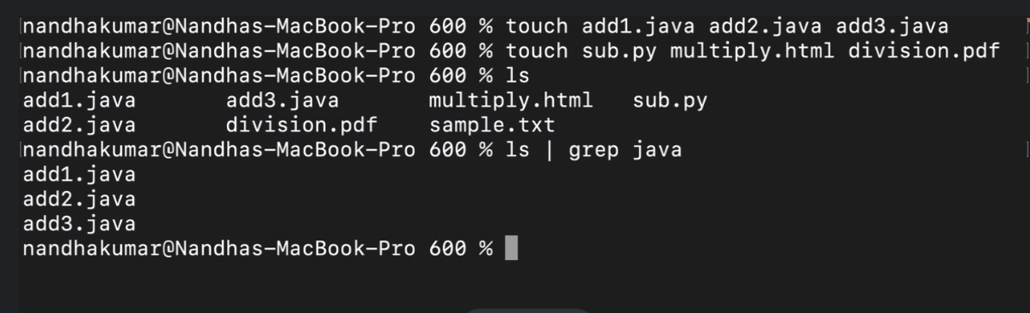

Bash command to execute the self script file

For items in ‘ls’

Do

Echo “ Hello $item”

done

`` - bactics

Algorithm – writing ur procedure

touch algorithm.txt

echo add1.java | awk -F.

06.10.22

In desktop u need a create a folder called items

In item folder we have some set of files like x.pdf y.docs z.png coding.sh algorithm.txt files

Give ur inputs in algorithm.txt

Create a backup folder in desktop in backup folder main , sub main, shuffeling folder

Docs , pdf, png

nandhak907@gmail.com

subject as Batch600 stage1

10.10.22

Function & methods

Function – aspect, repeatability, ignoring repeated code

Toch function.sh

Nano function.sh

function msg () {

echo “hello everyone” / a =25

b=35

echo$(a+b)

}

bash function.sh

two types of fn

void fn & return fn

Parameters & Arguments

Function fullname() {

Echo “mj “

}

Fullname - calling the fn is important

Read -p “enter ur 1st name”

Read -p “enter ur 2nd name”

Void = there will no return value / no return value

Return fn – there will we return value / there Is some use/ it return a value

Shell scripting / bash scripting?

function fullname() {

echo $1$2

}

function age() {

echo $1

}

resultName="$( fullname "Dr" "Jaikal")"

resultAge="$( age 50)"

echo "my name is $resultName and my age is $resultAge"

12.10.22

Arrays & Dictionary

Array is one container & used to store elements in the form of index number

Index number is always starts from 0.

Array is a index based

We can store multiple items in container

touch array.sh

nano.sh

prblm.sh

players=(“Dhoni””Rohit””Virat””rahul”)

echo “The Array is ${players[@]”

echo “The Array is ${players[1]” -for printing rohit

CRUD Operation=

Create read/retrieve update delete

Echo”**********Add********”

Echo[4]=”pant”

Echo[5]=”Bumrah”

Key value pair

Javascipt object notation – json

Dictionary is a container & it is used to store elements in the form of kay/value

Pair

Dictionaryis key/value based

Key should be unique & value can be duplicate/anything.

movies[english]="spiderman" movies[telugu]="pushpa" movies[hindi]="ekvillan" movies[tamil]="ps1" echo "The Dictionary is ${movies[@]}" echo "********ADD********" movies[kannada]="kgf" movies[malayalam]="kurup" echo "********Update*****" movies[telugu]="RRR" movies[kannada]="kgf2" echo "********Delete*****" unset 'movies[tamil]' unset 'movies[english]'

interview question

diff between arrays & dictionary

13.10.22 –

Github