1NT20IS025 (30/05/23)
Ankur Keshri

1) import the dataset from the sales.csv

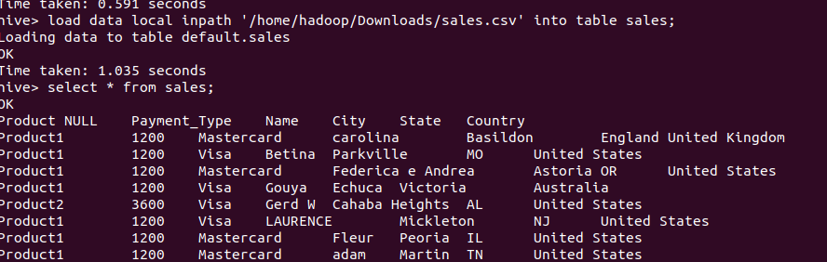

2) Count the number of sales done by each country

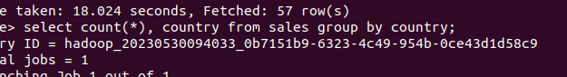

3) Count the number of sales done by each state

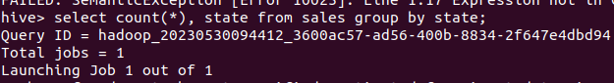

4) Display (Product, name) grouped by product

5) Create separate views for VISA and Mastercard

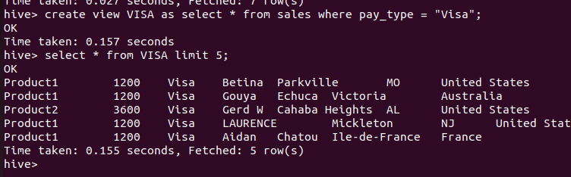

6) Show all the transactions done in Seattle
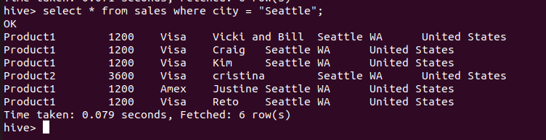

7) Find the max number of transactions done within the state of Ontario

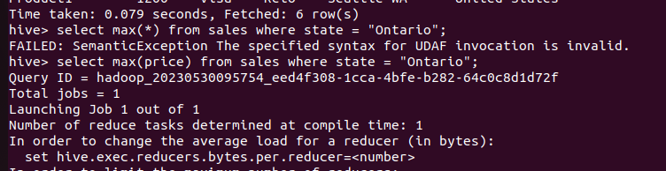

8) Find the number of transactions whose price is in between 1500-3600

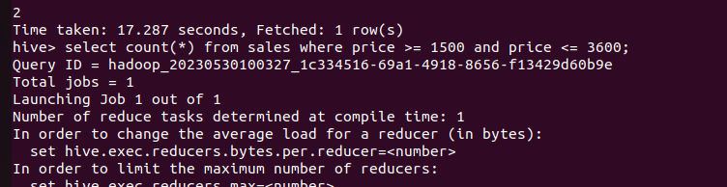

9) List all the transactions done in the United States using Mastercard

