|  |
| --- |
| **NITTE MEENAKSHI INSTITUTE OF TECHNOLOGY**  (ANAUTONOMOUSINSTITUTION,AFFILIATED TO VISVESVARAYA TECHNOLOGICAL UNIVERSITY,  BELGAUM, APPROVED BY AICTE & GOVT.OF KARNATAKA    **PROJECT REPORT**  on  **Doctor’s Appointment System**  *Submitted in partial fulfilment of the requirement for the award of Degree of*  *Bachelor of Engineering*  *in*  *Information Science and Engineering*  *Submitted by:*  SHAURYA SUMAN 1NT20IS153  RIYA JAISWAL 1NT20IS132  SHIVAM MAURYA 1NT20IS155  Under the Guidance of  MRS. VANI K.S.  Assistant Professor, Dept. of ISE, NMIT    Department of Information Science and Engineering  **(Accredited by NBA Tier-1)**  2022-2023  (ANAUTONOMOUSINSTITUTION,AFFILIATED TO VISVESVARAYA TECHNOLOGICAL UNIVERSITY, BELGAUM |
| Department of Information Science and Engineering  **(Accredited by NBA Tier-1)**    **CERTIFICATE**  This is to certify that the Project Report on **DOCTOR APPOINTMENT SYSTEM** is an authentic work carried out by Shaurya suman(1nt20is153),Riya Jaiswal(1nt20is132),Shivam Maurya(1nt20is155) Bonafide students of **Nitte Meenakshi Institute of Technology**, Bangalore in partial fulfilment for the award of the degree of ***Bachelor of Engineering*** in INFORMATION SCIENCE AND ENGINEERING of Visvesvaraya Technological University, Belagavi during the academic year ***2022-2023.*** It is certified that all corrections and suggestions indicated during the internal assessment has been incorporated in the report.  **Internal Guide Signature of the HOD**    Mrs Vani k.s. Dr. Mohan S. G.  Assistant Professor, Dept. ISE, Professor, Head, Dept. ISE,  NMIT Bangalore NMIT Bangalore |

**ACKNOWLEDGEMENT**

The satisfaction and euphoria that accompany the successful completion of any task would be incomplete without the mention of the people who made it possible, whose constant guidance and encouragement crowned our effort with success. I express my sincere gratitude to our Principal **Dr. H. C. Nagaraj**, Nitte Meenakshi Institute of Technology for providing facilities.

We wish to thank our HoD**, Dr. Mohan S. G.** for the excellent environment created to further educational growth in our college. We also thank him for the invaluable guidance provided which has helped in the creation of a better project.

I hereby like to thank our ***Mrs. Vani K.S., Assistant Professor***, Department of Information Science & Engineering on his periodic inspection, time to time evaluation of the project and help to bring the project to the present form.

Thanks to our Departmental Project coordinators. We also thank all our friends, teaching and non-teaching staff at NMIT, Bangalore, for all the direct and indirect help provided in the completion of the project.

|  |  |
| --- | --- |
| NAME | USN |
| SHAURYA SUMAN | 1NT20IS153 |
| RIYA JAISWAL | 1NT20IS132 |
| SHIVAM MAURYA | 1NT20IS155 |

Date: 04th  june 2023

**Abstract**

The Doctor Appointment Management Web Development Project aims to create an efficient and user-friendly online platform that streamlines the process of scheduling and managing appointments with healthcare professionals. With the increasing demand for healthcare services, the traditional method of scheduling appointments over the phone or in-person often leads to inefficiencies and long waiting times. This project addresses these challenges by leveraging web technologies to provide a convenient and accessible solution for patients and healthcare providers.

The web application will offer a user-friendly interface where patients can easily browse through a directory of healthcare providers, view their profiles, and book appointments based on their availability. The system will also incorporate an intelligent appointment scheduling algorithm, which takes into account factors such as the patient's preferred date, time, and specialization of the healthcare provider.

Additionally, the platform will support features such as automated appointment reminders, electronic medical record integration, and feedback mechanisms to enhance patient engagement and improve the overall healthcare experience. Furthermore, healthcare providers will have access to a dedicated portal where they can manage their schedules, view patient details, and communicate with their patients effectively.

By implementing the Doctor Appointment Management Web Development Project, healthcare organizations can optimize their appointment management processes, reduce administrative overheads, and enhance patient satisfaction. This project aligns with the digital transformation trends in the healthcare industry and promises to revolutionize the way patients access and interact with healthcare services.

**Table of Contents**

1.CHAPTER 1: Introduction

2. CHAPTER 2: Problem Statement

3. CHAPTER 3: Technologies used.

4. CHAPTER 4: Implementation

5. CHAPTER 5: Results

6. CHAPTER 6: Conclusion

7. CHAPTER 7: References

CHAPTER 1: INTRODUCTION

The Doctor Appointment Management Web Development Project is a comprehensive solution designed to modernize and streamline the process of scheduling and managing doctor appointments. In today's fast-paced world, traditional methods of appointment booking can be time-consuming, inefficient, and prone to errors. This web development project aims to address these challenges by harnessing the power of technology to provide a user-friendly and efficient platform for patients and healthcare providers. The project's primary objective is to create a web application that enables patients to easily search for healthcare providers, view their profiles, and book appointments at their convenience. By offering an intuitive interface and advanced search functionalities, patients can find the right doctor based on their preferences and easily schedule appointments online. This eliminates the need for phone calls and moreover allows patients to access healthcare services anytime, anywhere., the Doctor Appointment Management Web Development Project incorporates intelligent algorithms to optimize appointment scheduling. These algorithms consider factors such as doctor availability, patient preferences, and medical specializations, ensuring efficient allocation of appointments and minimizing waiting times.For healthcare providers, the web application provides a dedicated portal where they can manage their schedules, access patient information, and communicate effectively. The platform may also integrate with electronic medical record systems, enhancing the accuracy and accessibility of patient data. By implementing this web development project, healthcare organizations can streamline their appointment management processes, improve patient satisfaction, and enhance overall operational efficiency. The project aligns with the growing need for digital transformation in the healthcare sector, promising to revolutionize the way patients and healthcare providers interact and ensuring a more seamless and accessible healthcare experience.

# CHAPTER 2: PROBLEM STATEMENT

The traditional methods of scheduling doctor appointments are time-consuming, inefficient, and often result in long waiting times. This project aims to address these challenges by developing a web application that simplifies the appointment booking process, reduces administrative burdens, and enhances patient satisfaction. Moreover, the lack of centralized appointment management systems leads to coordination issues between healthcare providers and patients. The absence of real-time information and communication channels further exacerbates the problem. This project aims to develop a web-based solution that improves the overall efficiency and effectiveness of doctor appointment management, fostering seamless communication and enhancing the patient experience.Top of Form

**CHAPTER 3: TECHNOLOGIES USED**

The development of the Doctor’s appointment web application involves the utilization of various technologies to ensure its functionality, performance, and user experience. The following technologies are commonly employed in the project:

**Frontend Technologies:**

1. 1.HTML (Hypertext Markup Language): Used for structuring the web pages and content.
2. 2.CSS (Cascading Style Sheets): Utilized for designing and styling the user interface, ensuring visual appeal and consistency.
3. 3.JavaScript: Used for implementing interactive features and functionalities within the web application, such as search functionality and dynamic content loading.
4. Frameworks and Libraries: Frontend frameworks and libraries like React, Angular, or Vue.js can be employed to streamline the development process, enhance code organization, and
5. Front-end Development: HTML, CSS, JavaScript, and popular frameworks like React, Angular, or Vue.js for creating an interactive user interface.
6. Back-end Development: Programming languages such as Python, PHP, or Node.js can be used along with frameworks like Django, Laravel, or Express.js to handle server-side logic, data processing, and integration with databases..

**Backend Technologies:**

1. 1.Server-side Programming: Backend languages such as Node.js are utilized for server-side scripting and handling data processing and retrieval.
2. Frameworks: Backend frameworks like Express.js (Node.js) can be employed to facilitate rapid development, manage routes, handle data storage, and interact with databases.
3. 3.Databases: Technologies such as MongoDB are commonly used for storing and retrieving restaurant data and user information.
4. Database Management: Relational databases like MySQL, PostgreSQL, or Oracle, or NoSQL databases like MongoDB can be employed to store and manage appointment data efficiently.
5. API Development: Representational State Transfer (REST) or GraphQL can be used to design and develop APIs that facilitate communication between the front-end and back-end components of the application.

**CHAPTER 4**

**Implementation Planning and Requirements Gathering for Doctor Appointment Management Web Application:**

1. Identify Stakeholders: Determine the key stakeholders involved in the project, including healthcare providers, patients, administrators, and IT support staff. Understand their needs and expectations to ensure that the web application caters to their requirements effectively.
2. Define Functional Requirements: Gather and document the specific functionalities required for the doctor appointment management web application. This may include features such as patient registration, doctor search and selection, appointment scheduling, appointment reminders, patient record management, and communication channels.
3. Identify Non-Functional Requirements: Identify the non-functional requirements that are crucial for the success of the web application. This may include considerations like performance, scalability, security, usability, and regulatory compliance.
4. System Architecture Design: Determine the overall system architecture, including the front-end, back-end, and database components. Decide on the appropriate technologies and frameworks based on the project's requirements and the team's expertise.
5. User Interface Design: Create wireframes and mockups to visualize the user interface and ensure a user-friendly experience. Incorporate feedback from stakeholders and conduct usability testing to refine the design.
6. Database Design: Design the database schema to efficiently store and manage appointment data, patient information, and other relevant data. Define relationships between entities and ensure data integrity.
7. Development and Testing: Break down the project into smaller development tasks and allocate resources accordingly. Implement the front-end and back-end components, integrating the required functionalities. Conduct thorough testing at each stage to identify and fix any bugs or issues.
8. Deployment and Maintenance: Deploy the web application on an appropriate hosting environment, ensuring scalability and reliability. Set up regular maintenance and monitoring procedures to address any potential issues and ensure smooth operation.
9. User Training and Support: Provide comprehensive training to healthcare providers, administrators, and other users to familiarize them with the web application's features and functionalities. Offer ongoing technical support and address any user concerns or questions.
10. Database Design: Design the database schema to efficiently store and manage appointment data, patient information, and other relevant data. Define relationships between entities and ensure data integrity.
11. Development and Testing: Break down the project into smaller development tasks and allocate resources accordingly. Implement the front-end and back-end components, integrating the required functionalities. Conduct thorough testing at each stage to identify and fix any bugs or issues.
12. Deployment and Maintenance: Deploy the web application on an appropriate hosting environment, ensuring scalability and reliability. Set up regular maintenance and monitoring procedures to address any potential issues and ensure smooth operation.

By following a systematic implementation planning and requirements gathering process, healthcare organizations can effectively develop a doctor appointment management web application that meets the needs of all stakeholders and enhances the overall patient experience.

Top of Form

**CHAPTER 5: RESULTS**

**EXPLANATION:**

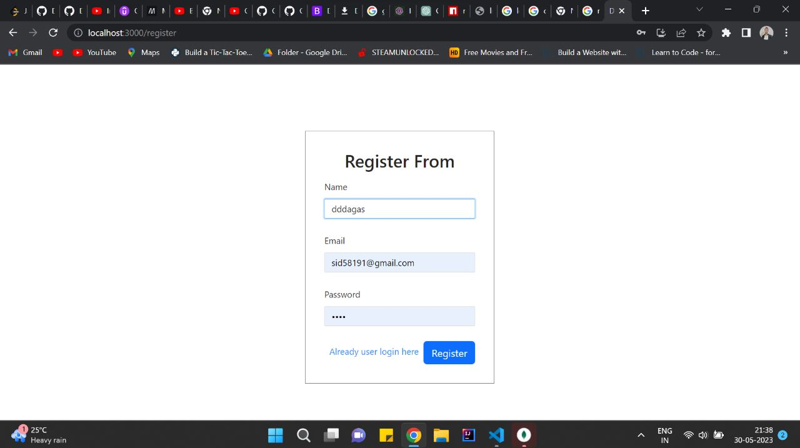

FIG 5.1 REGISTRATION PAGE

The register form in a Doctor Appointment System in web development is a crucial component that enables users to create new accounts and register themselves within the system. It collects relevant information from users to create unique user accounts. Here's a breakdown of the typical fields you would find in a register form for a doctor appointment system:

* Full Name: This field allows users to enter their full name, including their first name and last name.
* Email Address: Users provide their email address, which serves as a unique identifier for their account and a means of communication.
* Password: Users set a password for their account, which should be kept secure and not shared with others.
* Confirm Password: This field requires users to re-enter the same password to ensure they've entered it correctly.

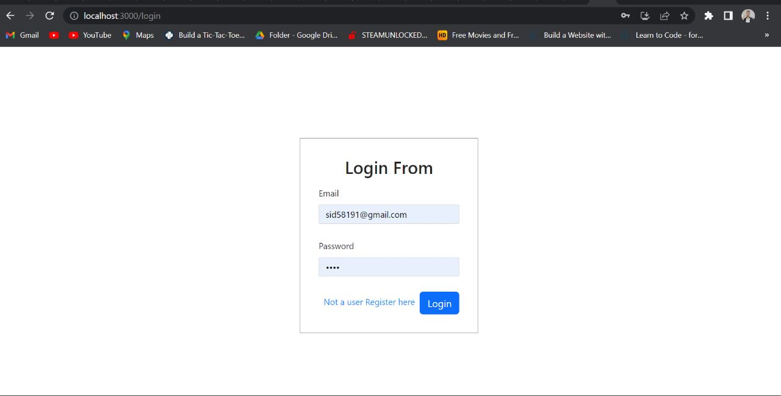

FIG 5.2: LOGIN FORM

In a Doctor Appointment System in web development, a login form is a crucial component that allows users who have already registered to access their accounts. The login form collects the necessary credentials from users to authenticate and grant them access to the system. Here's a breakdown of the typical fields you would find in a login form for a doctor appointment system:

* Email Address or Username: Users enter their registered email address or username, depending on the system's configuration. This field serves as a unique identifier for their account.
* Password: Users provide the password associated with their account. The password is typically masked or hidden for security purposes.

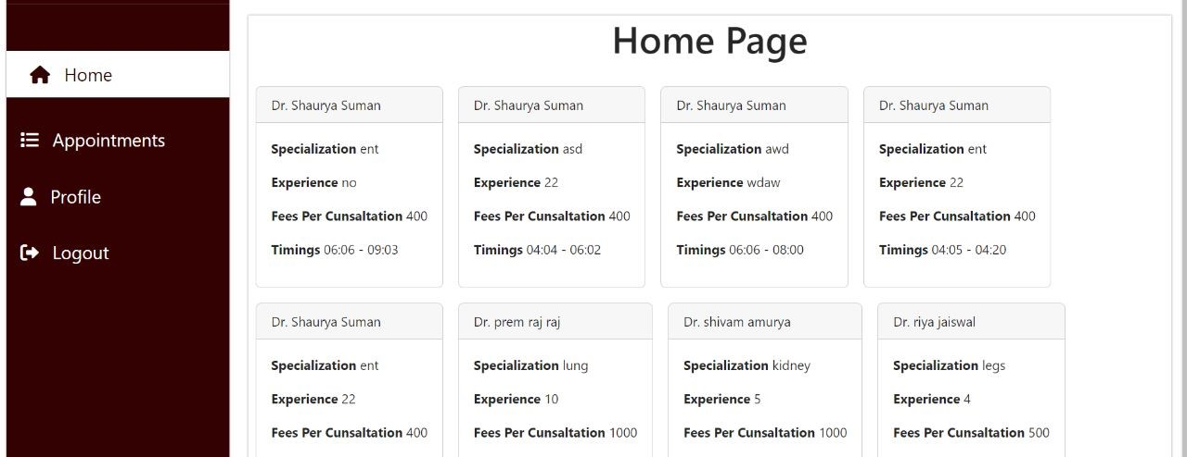

Fig 5.3: Home page

The home page in a Doctor Appointment System in web development serves as the main entry point for users of the system. It is the first page users encounter when they access the system's website or application. The home page is designed to provide essential information, features, and navigation options to users. Here are some common elements and functionalities found on a home page in a doctor appointment system:

* Navigation Menu: A navigation menu or toolbar is often placed at the top or side of the home page. It provides links or buttons to essential sections of the system, such as appointment booking, doctor search, user profile, notifications, and more. Users can easily navigate through different parts of the system using these options.
* Appointment Booking: The home page may include a prominent section or button for booking appointments. Users can initiate the appointment booking process by clicking on this option, which typically leads them to a dedicated appointment booking page.

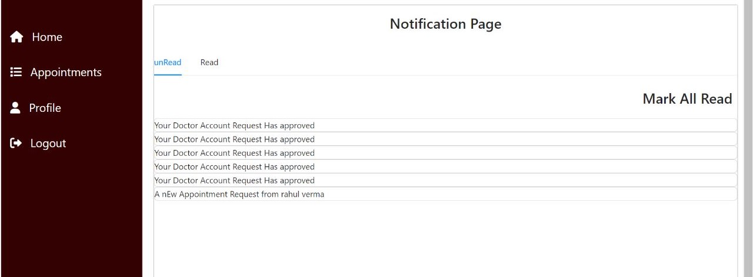

**Fig5.4:Appointment**

The appointment page in a Doctor Appointment System in web development is a dedicated section where users can view, schedule, manage, and cancel their appointments with healthcare providers.

* Appointment Calendar: The appointment page often includes a calendar view where users can see the availability of doctors or specific time slots for appointments. Users can navigate through different dates to find an available slot that suits their schedule.
* Appointment Booking Form: This form allows users to select a preferred doctor, date, and time slot for their appointment. Users may also provide additional details such as the reason for the appointment or any specific requirements. Once the form is submitted, the system processes the booking request and confirms the appointment if it's available.
* Appointment Confirmation: After submitting the appointment booking form, users receive a confirmation message indicating that their appointment request has been successfully submitted. The confirmation may include details such as the appointment date, time, and doctor's name. Users may also receive a confirmation email or SMS notification for their reference.

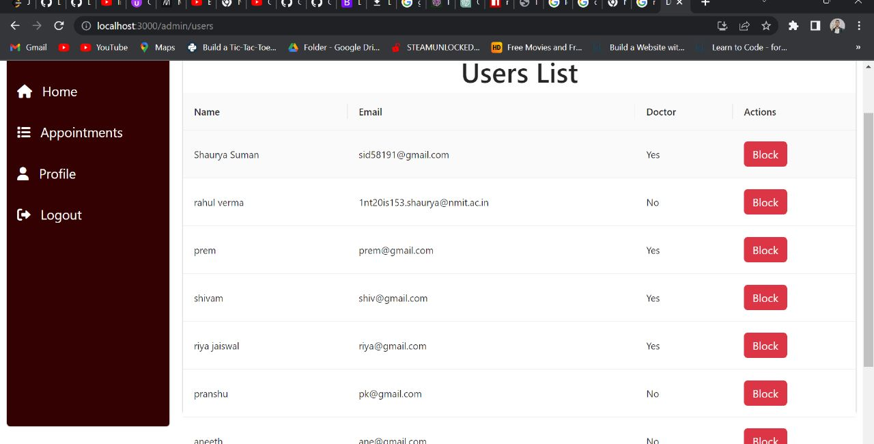

**FIG 5.5: USER PAGE**

**In a doctor appointment system developed for the web, the user page refers to the interface or section of the application that is specifically designed for users or patients. It is the area where users can access and manage their personal information, appointments, medical history, and other related features.**

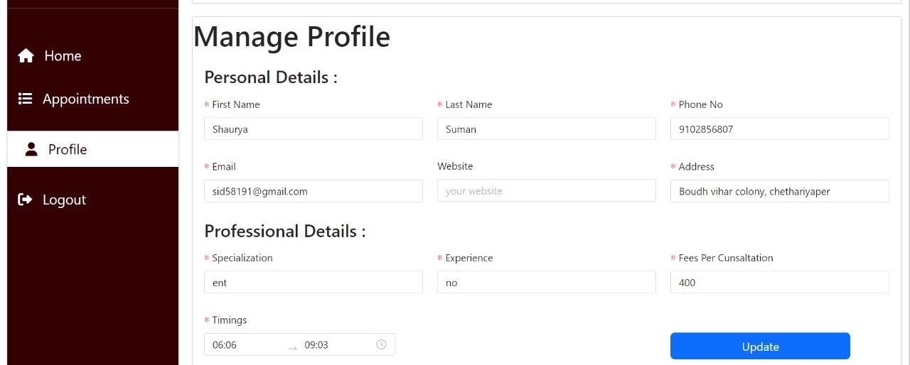

**FIG 5.6: DOCTOR REGISTRATION PAGE**

Overall, the user page in a doctor appointment system serves as a central hub for patients to manage their healthcare-related tasks and access information relevant to their appointments and medical history. It aims to provide a user-friendly and efficient interface that enhances the patient experience and facilitates effective communication between patients and healthcare providers.

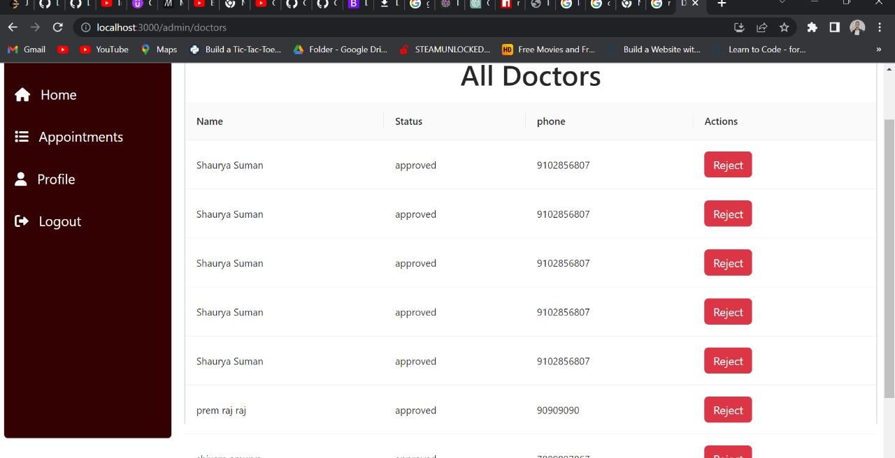

**FIG 5.7 DOCTOR LIST PAGE**

**Users may have the ability to request prescription refills or new prescriptions through the user page. They can enter the required medication details, specify the quantity needed, and provide any additional instructions or notes**

**CHAPTER 6: REFERENCES**

[1] <https://overpass-turbo.eu/>

[2] <https://www.openstreetmap.org/>

[3] <https://www.mongodb.com/docs/manual/geospatial-queries/>

**Conclusion**

The development of a Doctor Appointment Management web application offers significant benefits to both patients and healthcare providers. By streamlining the appointment booking process, reducing waiting times, and enhancing communication, the web application improves overall efficiency and patient satisfaction. It eliminates the traditional challenges associated with manual appointment scheduling and enables patients to conveniently access healthcare services online.

The web application's user-friendly interface, intelligent scheduling algorithms, and integration with electronic medical record systems contribute to a seamless and personalized experience. Healthcare providers can efficiently manage their schedules, access patient information, and optimize their practice's operations.

Furthermore, the adoption of this technology aligns with the ongoing digital transformation in the healthcare industry, promoting the use of innovative solutions to improve patient care delivery.

By implementing a Doctor Appointment Management web application, healthcare organizations can effectively optimize their appointment management processes, reduce administrative burdens, and enhance patient engagement. This ultimately leads to improved healthcare outcomes, increased operational efficiency, and enhanced patient satisfaction.

As technology continues to evolve, the future iterations of the web application can incorporate advanced features such as telemedicine integration, AI-driven appointment recommendations, and data analytics to further enhance the efficiency and effectiveness of healthcare delivery.

In summary, the Doctor Appointment Management web application revolutionizes the way appointments are scheduled **and managed,** providing a modern and efficient platform that benefits both patients and healthcare providers.

Bottom of Form