Project Title
Customer 360 – Next-Generation Customer Decision Platform (CDP)
Project Description

Lenders provide funds to individuals and businesses with the expectation of repayment. They thoroughly assess credit histories, financial health, collateral, and behaviours to decide on loan approvals.

Customer 360 is a CDP platform that turns judgment-based lending decisions into a clear, data-driven process. It interprets customer intent and behaviour in real time and transforms them into personalized, automated actions.

Platform unifies customer signals from across the customer product domain data, applies predictive AI/ML, and uses real-time analytics to generate actionable decision outcomes. The platform is built entirely on open-source technology to eliminate licensing costs, avoid vendor lock-in, and give business teams direct, governed access to data & insight.

Problem Statement

Lending businesses today operate with customer data spread across CRM, core banking, credit bureaus, web/mobile channels, and partner systems. This fragmentation slows decisioning, weakens risk visibility, and limits personalization. Customer 360 addresses this by building a single decision intelligence layer that

- Unifies structured and unstructured customer signals into one queryable, governed view.
- Applies predictive AI/ML models to credit risk, fraud, and engagement propensity.
- Surfaces real-time analytics that drive instant, explainable decisions.
- Transforms raw customer data into measurable business outcomes — conversion, retention, lifetime value.

Project Scope

- Develop a decision intelligence engine that interprets credit histories, financial health.
- Develop a decision intelligence engine that interprets behavioral patterns, intent signals, and engagement metrics.
- Ensure scalability, security, and compliance while maintaining seamless interoperability with existing enterprise systems.

Project Goal

- Deliver AI/ML - driven customer intelligence that empowers loan offering to personalize engagement at scale.
- Achieve sustainable business growth through measurable improvements in customer conversion, retention, and lifetime value.
- Run entirely on open-source components to remove licensing cost as a constraint on scale.

Business Requirement

Customer 360

- Higher Loan Conversions.
- Lower Default Rates, Better risk models spot early warning signs.
- Instant Loan Approvals: Automated risk checks allow low-risk customers to get loan approvals in minutes.
- Personalized cross-selling.
- Reducing bad debt write-offs.

Technical Requirement

- Zero Software Licensing Costs: Eliminates expensive vendor lock-in fees by relying entirely on community-driven open-source tools
- Fewer Data Silos: Business teams access data directly without waiting weeks for a central IT team to build custom pipelines.
- Scalability, security, and regulatory compliance (GDPR, RBI guidelines) by design.
- Seamless interoperability with existing enterprise systems (CRM, core banking, LOS/LMS)

Implementation

Open Source Tools selection –
- Front End - Django + React.js
- Data Storage – Postgres SQL + Delta Lake (Open source)
- Data Processing- Kafka + Flink / Apache Spark
- AI/ML - MLflow, PyTorch, TensorFlow, NLP & Predictive analytics, GeneAI Recommendation Engine, XGBoost.
- Access & Governance – Unity Catalog
- Automation & Monitoring - Apache Airflow, Prometheus + Grafana

Customer 360 — open-source technical architecture and data flow (HLD)

%3CmxGraphModel%3E%3Croot%3E%3CmxCell%20id%3D%220%22%2F%3E%3CmxCell%20id%3D%221%22%20parent%3D%220%22%2F%3E%3CmxCell%20id%3D%222%22%20edge%3D%221%22%20parent%3D%221%22%20style%3D%22shape%3DflexArrow%3BendArrow%3Dclassic%3Bhtml%3D1%3Brounded%3D0%3BstrokeColor%3D%23E07A5F%3BfontColor%3D%23393C56%3BfillColor%3D%23F2CC8F%3BexitX%3D0.988%3BexitY%3D0.414%3BexitDx%3D0%3BexitDy%3D0%3BexitPerimeter%3D0%3B%22%20value%3D%22%22%3E%3CmxGeometry%20height%3D%2250%22%20relative%3D%221%22%20width%3D%2250%22%20as%3D%22geometry%22%3E%3CmxPoint%20x%3D%221007.5%22%20y%3D%22240%22%20as%3D%22sourcePoint%22%2F%3E%3CmxPoint%20x%3D%221048.94%22%20y%3D%22240.41200000000003%22%20as%3D%22targetPoint%22%2F%3E%3C%2FmxGeometry%3E%3C%2FmxCell%3E%3C%2Froot%3E%3C%2FmxGraphModel%3E
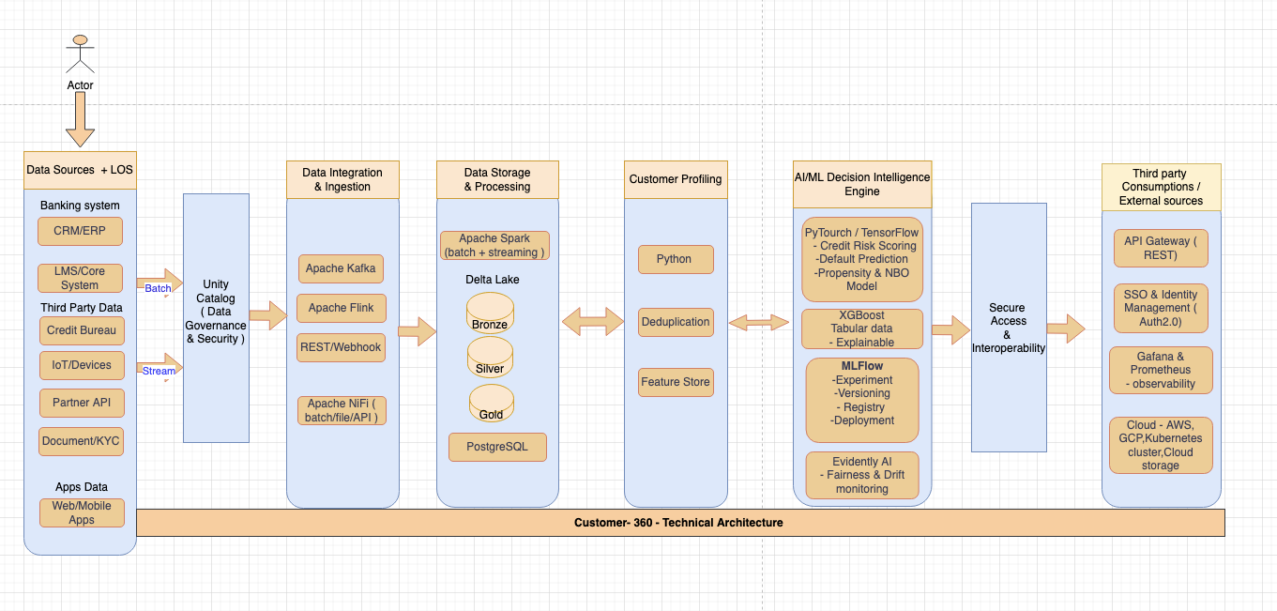

Step 1 – Data Integration & Processing
- Kafka
  - Mobile/web apps emit clickstream and application events.
  - LMS sends loan application records via CDC.
  - CRM, ERP, IoT, and social sources publish streams into Kafka topics.
  - Each domain acts as a data product owner in the mesh.

Step 2 – Data Storage
- PostgreSQL + Delta Lake
  - Spark/Flink jobs consume Kafka topics.
  - Write Bronze (raw), Silver (cleaned), Gold (business-ready) tables into Delta Lake.
  - Operational fields (loan_id, customer_id, status, timestamp) stored in PostgreSQL for transactional consistency.
  - Unity Catalog governs schemas, lineage, and access across Delta tables.

Step 3 – Customer Identity Resolution/Customer profiling
- Python
  - Match and merge customer records across systems.
  - Probabilistic matching updates the Single Customer View (SCV).
  - Segment membership recalculated in near real time.

Step 4 – Customer Segmentation & Feature Creation
- Python
  - Identify high-value customers.
  - Create ML-ready features for downstream models.

Step 5 – Data Privacy & Governance
- Unity Catalog + compliance policies
  - Enforce GDPR, RBI guidelines.
  - Apply access control, auditing, and lineage tracking.

Step 6 – AI/ML & Advanced Analytics
- MLflow, PyTorch, TensorFlow, XGBoost, NLP, Generative AI Recommendation Engine.
  - Predict risk, detect fraud, recommend offers.
  - Features (loan amount, bureau score, transaction behaviour, customer segment) passed to deployed models.
  - MLflow manages experiments, registry, and deployment lifecycle.

Step 7 – Automation & Monitoring
- Apache Airflow, Prometheus, Grafana
  - Automate workflows and orchestrate pipelines.
  - Monitor health, performance, and drift.
  - Dashboards provide real-time observability.
  - Unity Catalog ensures metadata consistency across orchestrated jobs.

Step 8 – Front End
- Django + React.js
  - Customer portal and apps for interaction.
  - Business dashboards for decision outcomes.
  - Integrated with Grafana for model observability and Python libraries for visualization.

AI/ML & Advanced Analytics
Core Components
  - MLflow – experiment tracking, model registry, deployment lifecycle.
  - PyTorch / TensorFlow – deep learning frameworks for training and serving models.
  - XGBoost – tabular, explainable ML for credit scoring and fraud detection.
  - NLP Models – extract meaning from unstructured text (emails, chat, social feeds).
  - LLMs (Large Language Models) – interpret customer intent, generate personalized responses, and reason across multiple signals.
  - Agentic Recommendation Engine – orchestrates multiple models and tools to deliver contextual, real-time recommendations.
Detailed Flow
- Feature Engineering
  - Structured features: loan amount, bureau score, transaction behaviour, customer segment.
  - Unstructured features: text from applications, call transcripts, social signals.
  - Stored in Delta Lake and governed by Unity Catalog.
- LLM Layer
  - Fine-tuned LLMs (via PyTorch/TensorFlow) interpret customer intent and behaviour.
  - NLP pipelines extract sentiment, intent, and risk signals.
  - LLMs generate contextual embeddings that feed into downstream models.
- Agentic Orchestration
  - Agent framework (LangChain, LangGraph) coordinates multiple tasks:
    - Query vector databases for customer history.
    - Call predictive models (fraud detection, credit scoring).
    - Trigger recommendation logic (offers, next best action).
  - Agents reason step-by-step, plan workflows, and adapt recommendations in real time.
- Recommendation Engine
  - Combines predictive ML (risk/fraud) with generative AI (personalized offers, explanations).
  - Outputs actionable decisions: approve/decline loan, flag fraud, suggest tailored product.
  - Results are logged in MLflow for monitoring and retraining.
- Governance & Monitoring
  - Unity Catalog ensures lineage and compliance.
  - Prometheus + Grafana monitor drift, latency, and fairness metrics.
  - Evidently AI checks bias and drift in LLM outputs.

