Project Title
Customer 360 – Next-Generation Customer Decision Platform (CDP)
Project Description

Lenders play a crucial role in providing funds to individuals and businesses with the expectation of repayment. They thoroughly assess credit histories, financial health, collateral, and behaviours to decide on loan approvals.

Customer 360 is a CDP platform converts this judgment-driven process into a systematic, data-driven decision intelligence capability- one that interprets customer intent and behaviour in real time and converts it into personalized, automated action.
Platform unifies customer signals from across the customer domain data mesh, applies predictive AI/ML, and uses real-time analytics to generate actionable decision outcomes. The platform is built entirely on open-source technology to eliminate licensing costs, avoid vendor lock-in, and give business teams direct, governed access to data and insight.

Problem Statement

Lending businesses today operate with customer data spread across CRM, core banking, credit bureaus, web/mobile channels, and partner systems. This fragmentation slows decisioning, weakens risk visibility, and limits personalization. Customer 360 addresses this by building a single decision intelligence layer that

- Unifies structured and unstructured customer signals into one queryable, governed view.
- Applies predictive AI/ML models to credit risk, fraud, and engagement propensity.
- Surfaces real-time analytics that drive instant, explainable decisions.
- Transforms raw customer data into measurable business outcomes — conversion, retention, lifetime value.

Project Scope

- Develop a decision intelligence engine that interprets credit histories, financial health.
- Develop a decision intelligence engine that interprets behavioral patterns, intent signals, and engagement metrics.
- Ensure scalability, security, and compliance while maintaining seamless interoperability with existing enterprise systems.

Project Goal

- Deliver AI/ML - driven customer intelligence that empowers loan offering to personalize engagement at scale.
- Achieve sustainable business growth through measurable improvements in customer conversion, retention, and lifetime value.
- Run entirely on open-source components to remove licensing cost as a constraint on scale.

Business Requirement

Customer 360

- Higher Loan Conversions.
- Lower Default Rates, Better risk models spot early warning signs.
- Instant Loan Approvals: Automated risk checks allow low-risk customers to get loan approvals in minutes.
- Personalized cross-selling.
- Reducing bad debt write-offs.

Technical Requirement

- Zero Software Licensing Costs: Eliminates expensive vendor lock-in fees by relying entirely on community-driven open-source tools
- Fewer Data Silos: Business teams access data directly without waiting weeks for a central IT team to build custom pipelines.
- Scalability, security, and regulatory compliance (GDPR, RBI guidelines) by design.
- Seamless interoperability with existing enterprise systems (CRM, core banking, LOS/LMS)

Implementation

Open Source Tools selection –

- Front End - Django + React.js
- Data Storage – Postgres SQL
- Data Processing- Kafka + Flink / Apache Spark
- AI/ML - MLflow, PyTorch, TensorFlow
- Automation & Monitoring - Apache Airflow, Prometheus + Grafana

Customer 360 — open-source technical architecture and data flow (HLD)

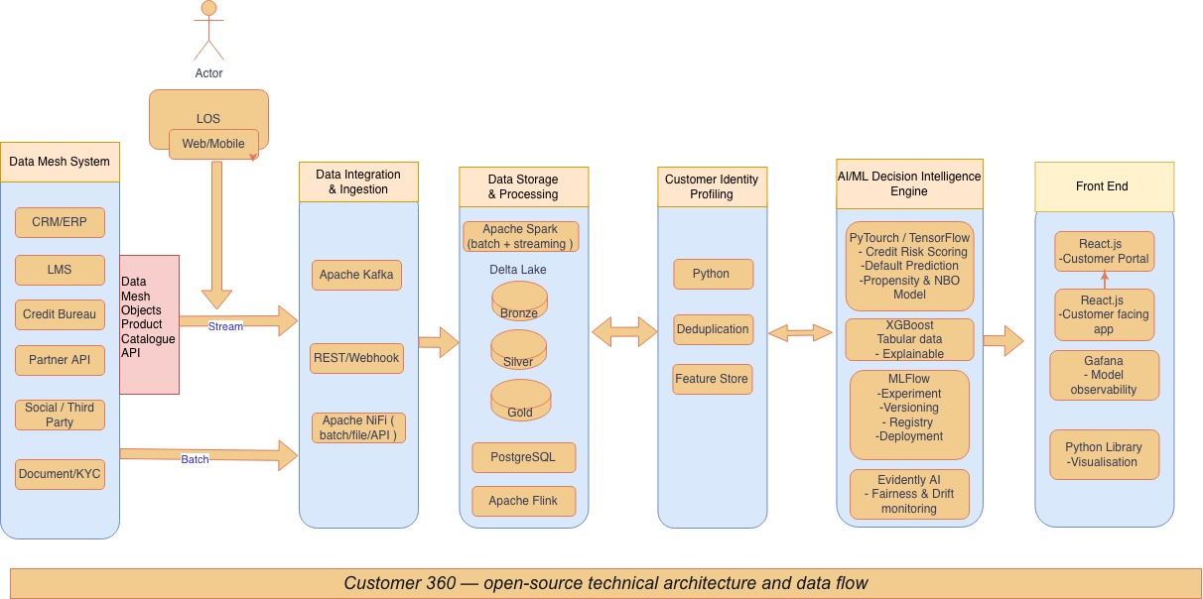

Stpe1 - Data Integration & Processing (Capture)

- Kafka

- The mobile app and web channel emit clickstream and application events, the core LMS system emits the loan application record via CDC. Both land on Kafka topics within milliseconds.

- To gather data from CRM, ERP, web, mobile, IoT, and social sources into a Kafka topic within a data mesh architecture, essentially treat each domain as a data product owner that publishes its data streams into Kafka.

Step 2 - Data Storage & Processing - Store structured + unstructured data, enable analytics

- Apache Spark, PostgreSQL

- Spark Structured Streaming jobs consume the Kafka topics and write Bronze (raw), then Silver (cleaned/conformed), then Gold (business-ready) tables into Delta Lake. Operational fields needed for transactional consistency are simultaneously written to PostgreSQL. (Example - operational fields (loan_id, customer_id, status, timestamp) to maintain transactional consistency.

Step 3 - Customer Data & Identity Resolution

- Python.

- Identity Resolution & Single Customer View - Match and merge customer records across systems .
- The identity-resolution job matches the incoming application against existing customer records using probabilistic matching, updating the Single Customer View. Segment membership is recalculated in near-real-time.

Step 4- Customer Segmentation / Feature creation

Identify and Segment High-Value Customers and technically create features that going to participant to models.

- Python

Step 5 - Data Privacy, Compliance, and Governance

Ensure compliance (GDPR, RBI guidelines), access control etc.

Step 6 - Artificial Intelligence and Advanced Analytics

- MLflow, PyTorch, TensorFlow

Predict risk, detect fraud, recommend offers.
Features (Loan Amount, bureau score, transaction behavior,Customer_Segment ) and passes them to the deployed PyTorch/XGBoost served models.

Step 7- Improving Operational Efficiency & Orchestration

Automate workflows, monitor pipeline

- Apache Airflow, Prometheus + Grafana

***End of Business Requirements Document***

