SRS Project - SmartBox
Team Members: Jeremy Sanders

Description of project: SmartBox is a Raspberry Pi–based device monitoring and recovery system that automatically detects when smart home or network devices go offline and attempts recovery through controlled power cycling using TASMOTA-enabled smart plugs. The system provides a local web interface for monitoring device status, manually controlling plugs, and configuring restart policies. SmartBox operates locally without requiring continuous internet connectivity, making it suitable for home labs, small offices, and edge environments.

Section 1:
In modern home networks and small IT environments, smart devices, routers, and IoT components frequently become unresponsive due to firmware instability, memory leaks, or temporary network failures. Recovery often requires manual intervention, such as physically unplugging and reconnecting power. This becomes problematic when devices are located remotely or unattended. SmartBox was created to provide an automated, local recovery system that detects device outages and safely power cycles them without human intervention.

SmartBox will:
- Monitor specified devices on a local network.
- Detect when a device becomes unreachable.
- Automatically power cycle the device using a Tasmota smart plug.
- Provide a local web interface for monitoring and manual control.
- Maintain logs of device outages and restart attempts.
The system improves reliability and reduces downtime in local networks.

The project WILL:
- Operate on a Raspberry Pi running Linux.
- Monitor devices via local network scanning (ping/ARP).
- Control Tasmota smart plugs over HTTP.
- Provide a browser-based monitoring dashboard.
- Log restart events locally.
- Operate without cloud dependency.
The project WILL NOT:
- Provide remote internet-based cloud access.
- Use AI-based predictive failure analysis.
- Support non-Tasmota plug firmware.
- Provide enterprise-grade scalability beyond small LAN environments.

Technologies Used
- Hardware: Raspberry Pi 4
- OS: Raspberry Pi OS (Linux)
- Backend: Python 3
- Web Framework: Flask
- Networking Tools: ping, arp
- Smart Plug Firmware: Tasmota
- Frontend: HTML, CSS (basic Bootstrap optional)
- Communication Protocol: HTTP (local network)
- Data Storage: Local file-based logging (JSON or text logs)

Section 2a:
- The system shall display the IP address and MAC address of devices connected to the same local network as SmartBox.
- The system shall identify and label devices running TASMOTA firmware.
- The system shall log all system events including user login attempts, device detection events, and smart plug power actions.
- The system shall require user authentication before granting access to the monitoring dashboard.
- The system shall allow authenticated users to manually turn TASMOTA smart plugs ON and OFF from the web interface.
- The system shall allow users to assign and update nicknames for detected devices.

Section 2b:
Stretch Requirements:
- The system shall automatically enable a local hotspot if no Wi-Fi connection is detected.
- The system shall allow the user to scan for available Wi-Fi networks and connect SmartBox to a selected network through the web interface.
- The system shall allow users to filter activity logs by event type, user, or device IP.
- The system shall allow the user to configure automatic restart policies for individual devices.
- The system shall support Administrator and Standard roles with different permission levels.
- The system shall allow users to export activities as a downloadable file.

Section 2c:
Weekly schedule:

Requirement | Description | Acceptance Criteria | Hours | Due Date
Per-Device Automatic Restart Policy | Each monitored device can have automatic restart enabled or disabled individually. If enabled and device becomes unreachable, its smart plug will cycle power automatically. | Enable restart for Device A and disconnect it. Within 60 seconds, SmartBox power cycles the assigned plug and logs “SMARTPLUG_RESTART.” Disable restart and confirm no power cycle occurs when device disconnects. | 10 | 2/21
Continuous Background Monitoring Loop | The system continuously checks device availability at fixed intervals without requiring manual scans. | Start SmartBox and disconnect a monitored device. Within 60 seconds, the dashboard updates device status to “Offline” automatically and logs “DEVICE_OFFLINE.” | 10 | 2/28
Activity Log Filtering | Users can filter activity logs by event type, user, or device IP from the dashboard. | Generate multiple events (login, nickname change, plug ON/OFF). Apply filter (e.g., SMARTPLUG_ON). Only matching log entries appear. | 10 | 3/7
Wi-Fi Network Configuration | Users can configure SmartBox to connect to a selected Wi-Fi network via the web interface. | From hotspot mode, select a Wi-Fi network and enter credentials. SmartBox connects successfully and logs “WIFI_CONNECTED.” If credentials are incorrect, error is displayed and logged. | 10 | 3/14
Automatic Hotspot Fallback | If SmartBox cannot connect to saved Wi-Fi at startup, it automatically enables hotspot mode for recovery access. | Power on SmartBox with router offline. Verify hotspot appears within 60 seconds and logs “HOTSPOT_ENABLED.” Restore Wi-Fi and confirm reconnection works. | 12 | 3/21
Role-Based Access Control | The system supports two roles: Administrator and Standard User. Administrators can modify Wi-Fi and restart policies. Standard Users can only view device status and manually toggle plugs. | Log in as Administrator and verify access to Wi-Fi setup and restart controls. Log in as Standard User and confirm those controls are hidden or restricted. Attempt direct URL access and confirm restriction. | 14 | 3/28
Log Export Functionality | Users can export all activity logs as a downloadable file (.txt or .json). | Click “Export Logs.” A file downloads containing all log entries. File contents match displayed logs. | 7 | 3/4

Section 3: Design Overview of the Product.
Workflow:

The SmartBox system follows continuous monitoring and management workflow:
- System Startup
  - SmartBox powers on.
  - Attempts connection to stored Wi-Fi credentials.
  - If connection fails, Automatic Hotspot Fallback activates.
- User Authentication
  - User accesses web interface.
  - Logs in as Administrator or Standard User.
  - Role-based permissions are enforced.
- Device Monitoring
  - Continuous Background Monitoring Loop runs every 60 seconds.
  - Each registered device is checked for availability.
  - Device state updates automatically on the dashboard.
- Policy Enforcement
  - If a device becomes unreachable:
    - Log entry is created.
    - If automatic restart policy is enabled:
      - Smart plug power cycle is triggered.
      - Restart event is logged.
- Logging and Reporting
  - All system events are recorded.
  - Users can filter logs.
  - Logs can be exported as a downloadable file.

Resources:

Hardware Resources
- Raspberry Pi (SmartBox host device)
- TASMOTA Smart Plugs
- Network Router / Local Wi-Fi
- Ethernet or Wi-Fi interface
Software Resources
- Python (backend logic)
- Flask (web framework)
- HTML/CSS (web interface)
- JSON configuration storage
External Dependencies
- Local Network (LAN)
- Smart Plug API communication
- Wi-Fi interface management tools

Data at Rest:

Data stored locally on SmartBox includes:
- User credentials (hashed passwords)
- Role definitions (Administrator / Standard)
- Device registry (IP address, plug mapping, restart policy)
- Wi-Fi configuration data
- Activity logs
- Restart policy settings
Storage format:
- JSON configuration files
- Plain text or structured log files
Sensitive data such as passwords are stored in hashed format.

Data on the Wire:

The system communicates across the network using:
- HTTP/HTTPS
  - Between user browser and SmartBox web interface.
- LAN Device Probing
  - Ping/ARP requests to determine device availability.
- Smart Plug API Communication
  - Commands sent over local network to toggle power state.
No external cloud communication is required for core functionality.

Data State:
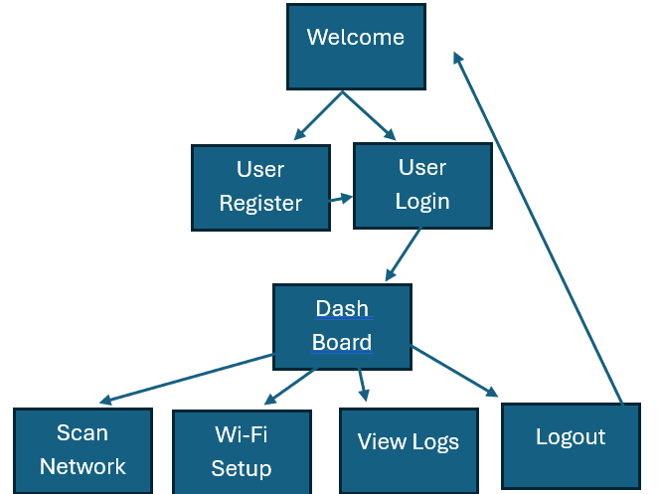

HMI/HCI/GUI:
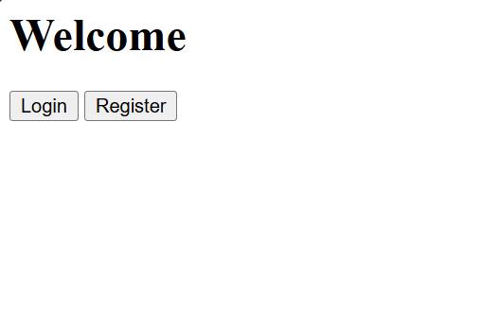
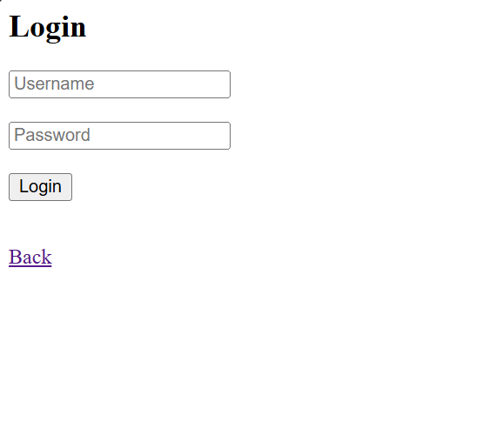
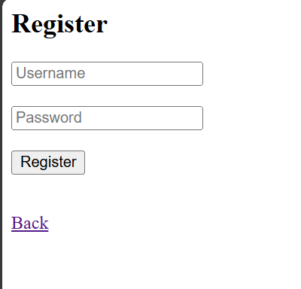
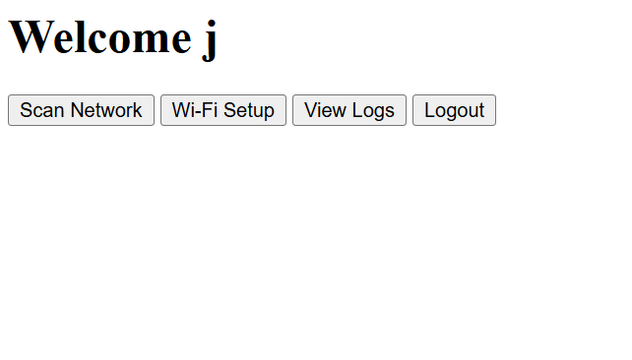
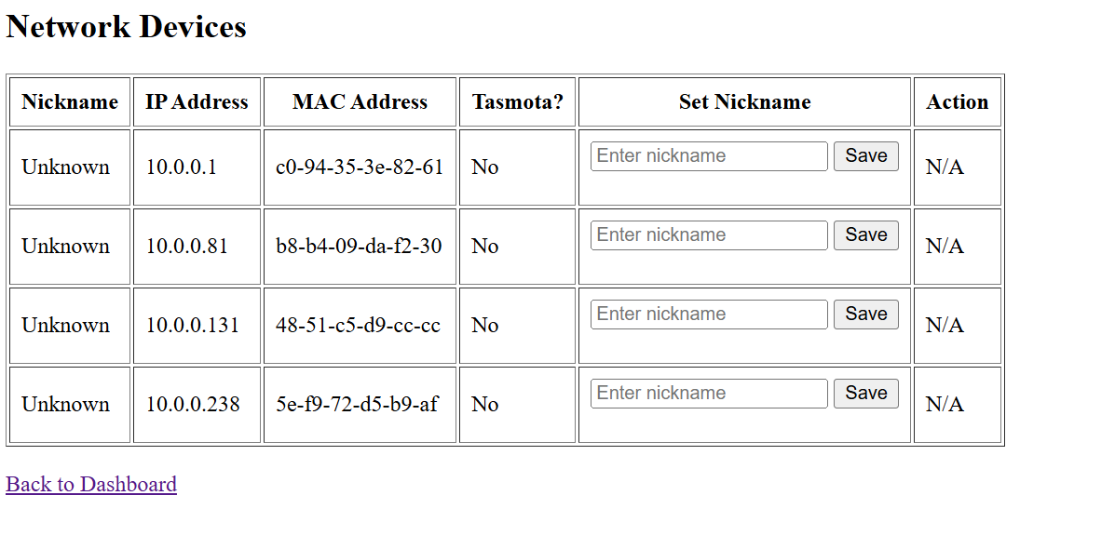

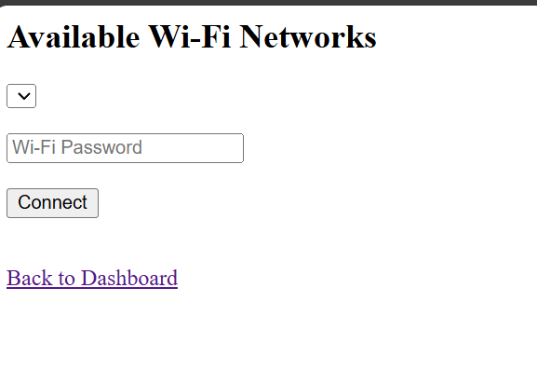
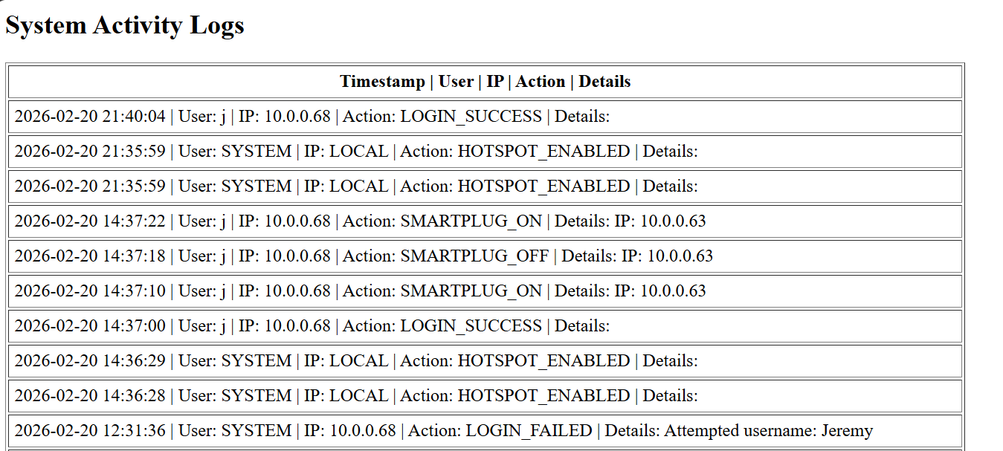

Section 4: Verification:

1. Continuous Background Monitoring Loop
Steps:
- Power on SmartBox.
- Display dashboard.
- Disconnect a registered device from Wi-Fi.
- Wait one monitoring cycle (≤ 60 seconds).
Verification:
- Device status changes from Online → Offline automatically.
- Log entry "DEVICE_OFFLINE" appears.
- No manual refresh or scan required.

2. Automatic Restart Policy
Steps:
- Enable automatic restart for Device A.
- Disconnect Device A from network.
- Observe system response.
Verification:
- Within one monitoring cycle:
  - Smart plug power cycles.
  - Log entry "SMARTPLUG_RESTART" is created.
- Repeat with restart disabled and confirm:
  - No power cycle occurs.
  - Only offline log appears.

3. Activity Log Filtering
Steps:
- Generate multiple log events (login, offline, restart).
- Navigate to Logs page.
- Apply filter by event type.
Verification:
- Only matching log entries are displayed.
- Removing filter restores full log list.

4. Wi-Fi Network Configuration
Steps:
- Start SmartBox in hotspot mode.
- Enter valid Wi-Fi credentials.
- Observe system reconnect to router.
Verification:
- SmartBox joins selected Wi-Fi network.
- Hotspot disables automatically.
- Connection success logged.
Negative Test:
- Enter incorrect password.
- System displays error.
- No connection established.

5. Automatic Hotspot Fallback
Steps:
- Power on SmartBox with router turned off.
- Wait for startup sequence.
Verification:
- Hotspot becomes visible within 60 seconds.
- Log entry confirms fallback activation.

6. Role-Based Access Control
Steps:
- Log in as Administrator.
- Access restart policy and Wi-Fi configuration pages.
- Log out and log in as Standard User.
Verification:
- Administrator can modify configuration.
- Standard User cannot access configuration pages.
- Direct URL access is blocked.

7. Log Export Functionality
Steps:
- Navigate to Logs page.
- Click "Export Logs".
- Open downloaded file.
Verification:
- File downloads successfully.
- File contents match displayed log entries.

Sources/Citation/Resources Links:
https://www.raspberrypi.com/tutorials/host-a-hotel-wifi-hotspot/
https://www.digitalocean.com/community/tutorials/understanding-systemd-units-and-unit-files
https://www.raspberrypi.com/documentation/computers/configuration.html#setting-up-a-wireless-access-point
https://linux-audit.com/cheat-sheets/systemctl/
https://www.youtube.com/watch?v=e9YZmZ6HQhY
https://thepi.io/how-to-use-your-raspberry-pi-as-a-wireless-access-point/
https://www.w3schools.com/python/default.asp

