Filter，拦截器，aop拦截的实现与区别
效果
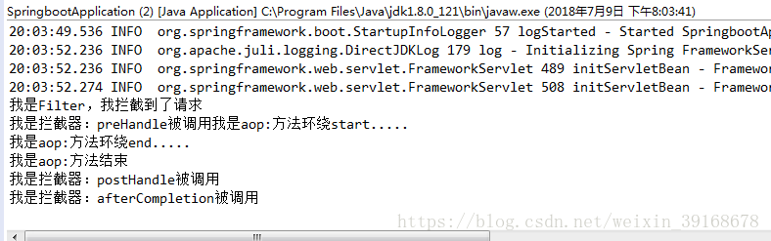
实现
1 Filter
直接实现Filter接口，重写拦截方法，再到@WebFilter注解上配置拦截规则即可实现
@Component
@WebFilter(urlPatterns = { "/**" }, filterName = "tokenAuthorFilter")
public class ConfigurationFilter implements Filter{
@Override
public void destroy() {
// TODO Auto-generated method stub
}
@Override
public void doFilter(ServletRequest request, ServletResponse response, FilterChain chain)
throws IOException, ServletException {
// TODO Auto-generated method stub
System.out.println("我是Filter，我拦截到了请求");
chain.doFilter(request, response);//到下一个链
}
@Override
public void init(FilterConfig arg0) throws ServletException {
// TODO Auto-generated method stub

}
}

拦截器
和filter类似 实现HandlerInterceptor接口并重写拦截方法
public class MyInterceptor implements HandlerInterceptor{

//在请求处理之前进行调用（Controller方法调用之前
@Override
public boolean preHandle(HttpServletRequest httpServletRequest, HttpServletResponse httpServletResponse, Object o) throws Exception {
System.out.printf("我是拦截器：preHandle被调用");

HandlerMethod handlerMethod = (HandlerMethod) o;
Method method = handlerMethod.getMethod();
if (method.getAnnotation(interceptorLog.class) != null) {
return true;
}else{
return false;
}
}

//请求处理之后进行调用，但是在视图被渲染之前（Controller方法调用之后）
@Override
public void postHandle(HttpServletRequest httpServletRequest, HttpServletResponse httpServletResponse, Object o, ModelAndView modelAndView) throws Exception {
System.out.println("我是拦截器：postHandle被调用");
}

//在整个请求结束之后被调用，也就是在DispatcherServlet 渲染了对应的视图之后执行（主要是用于进行资源清理工作）
@Override
public void afterCompletion(HttpServletRequest httpServletRequest, HttpServletResponse httpServletResponse, Object o, Exception e) throws Exception {
System.out.println("我是拦截器：afterCompletion被调用");
}

}
像spring容器内将创建的拦截器注册进去
@Configurationpublic class interceptorConfig extends WebMvcConfigurerAdapter{
public void addInterceptors(InterceptorRegistry registry){
registry.addInterceptor(new MyInterceptor()) //指定拦截器类
.addPathPatterns("/**"); //指定该类拦截的url
}
}
自定义一个注解用于拦截标识
@Retention(RetentionPolicy.RUNTIME) // 表示注解在运行时依然存在
@Target(ElementType.METHOD)
@Documentedpublic
@interface interceptorLog {
}
aop拦截
pom
<!--AOP-->
<dependency>
<groupId>org.springframework.boot</groupId>
<artifactId>spring-boot-starter-aop</artifactId>
</dependency>
<!--druid -->
配置aop
@Component@Aspect public class HttpAspect {
@Pointcut("execution(* spring.controller..*.*(..)) && @annotation(spring.annotation.aopLog)")
// @Pointcut("public * *(..)")
public void log(){
}

@Around("log()")
public void aroundLogCalls(JoinPoint joinPoint) throws Throwable {

System.out.println("我是aop:方法环绕start.....");

System.out.println("我是aop:方法环绕end.....");

}
/**
* 打印请求的ur l method ip 类方法 参数
* @param joinPoint
*/
@Before("log()")
public void doBefore(JoinPoint joinPoint){
ServletRequestAttributes attributes= (ServletRequestAttributes)RequestContextHolder.getRequestAttributes();
HttpServletRequest request =attributes.getRequest();

System.out.println("我是aop:方法开始");

}

// @After("execution(public * com.tg.controller.GirlController.*(..))")
@After("log()")
public void doAfter(){
System.out.println("我是aop:方法结束");
}

/**
* 打印请求的具体内容
* @param objects
*/
@AfterReturning(returning = "objects",pointcut = "log()")
public void doAfterReturning(Objects objects){

}

@AfterThrowing("log()")
public void cathInfo(){
System.out.println("异常信息");
}

}

自定义注解用于拦截标识
@Retention(RetentionPolicy.RUNTIME) // 表示注解在运行时依然存在@Target(ElementType.METHOD) @Documentedpublic @interface aopLog {

}

被请求方法
@RequestMapping(value = "/userInfo", method = RequestMethod.GET)
@ApiOperation("登录")
@ResponseBody
@aopLog
@interceptorLog
public Map<String, Object> login(
@RequestParam(value="useName", required=true) String useName,
@RequestParam(value="passWord", required=true) String passWord
){
Map<String,Object> result=new HashMap<String,Object>();
try{
//查询
userInfo selectedUser= dao.selectUserInfo(useName);
//更新
dao.updateFrequency(useName);
if(selectedUser.getPassWord().equals(passWord)){
result.put("userInfo", selectedUser);
result.put("code", "200");
}else{
result.put("msg", "账号密码错误");
}
}catch(Exception e){
result.put("code", "404");
}
return result;
}

总结：
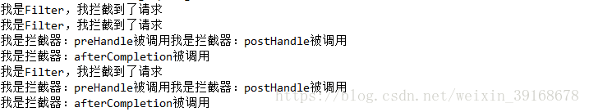
这是swagger连接到服务器所触发的拦截信息，可以看到所有的请求都会被filter首先拦截，并可以预处理request,
而拦截器可以调用IOC容器中的各种依赖，filter就不能获取注解信息并拦截，因为它和框架无关，但拦截器不能修改request,filter基于回调函数，我们需要实现的filter接口中doFilter方法就是回调函数，而interceptor则基于java本身的反射机制，而@Aspect与Interceptor的都是基于spring aop的实现，@Aspect粒度更细
拦截顺序：filter—>Interceptor—->@Aspect
