密微信退款结果通知中的加密信息req_info

在微信返回的退款结果通知中，包含了一个加密信息字段req_info
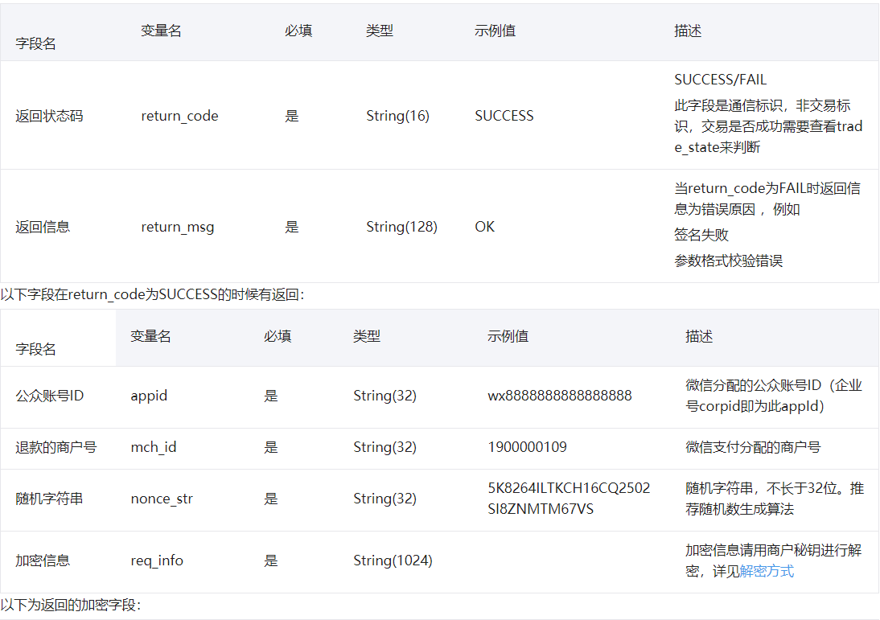
微信支付文档中有提及到如何解密：
解密步骤如下：
（1）对加密串A做base64解码，得到加密串B
（2）对商户key做md5，得到32位小写key* ( key设置路径：微信商户平台(pay.weixin.qq.com)-->账户设置-->API安全-->密钥设置 )
（3）用key*对加密串B做AES-256-ECB解密（PKCS7Padding）

现在我们就一步一步解密得到返回的字段信息：

前提工作：
1、添加maven依赖
<dependency>
<groupId>org.bouncycastle</groupId>
<artifactId>bcprov-jdk15on</artifactId>
<version>1.47</version>
</dependency>

2、替换jar包
JAVA运行环境默认不允许256位密钥的AES加解密，解决方法就是修改策略文件

在官方网站下载JCE无限制权限策略文件
JDK7版本JCE下载地址： http://www.oracle.com/technetwork/java/javase/downloads/jce-7-download-432124.html
JDK8版本JCE下载地址：http://www.oracle.com/technetwork/java/javase/downloads/jce8-download-2133166.html
- 下载后解压，可以看到local_policy.jar和US_export_policy.jar以及readme.txt
- 如果安装了JRE，将两个jar文件放到%JRE_HOME%\lib\security目录下覆盖原来的文件
- 如果安装了JDK，将两个jar文件放到%JDK_HOME%\jre\lib\security目录下覆盖原来文件
实践：
以JDK8为例，系统为WIN10，替换上述security文件夹下\policy\limited文件夹和\policy\unlimited文件夹里面的local_policy.jar和US_export_policy.jar这两个文件。
若是在服务器上，则只有在security目录下有local_policy.jar和US_export_policy.jar，替换即可

开始解密：
1、用到的工具类Base64Util.java 和 MD5Util.java

Base64Util
import java.io.IOException;import java.io.OutputStream;import java.io.Writer;
public class Base64Util {

private static final char S_BASE64CHAR[] = {'A', 'B', 'C', 'D', 'E', 'F', 'G', 'H', 'I', 'J', 'K', 'L', 'M', 'N', 'O', 'P', 'Q', 'R', 'S',
'T', 'U', 'V', 'W', 'X', 'Y', 'Z', 'a', 'b', 'c', 'd', 'e', 'f', 'g', 'h', 'i', 'j', 'k', 'l', 'm', 'n', 'o', 'p', 'q', 'r', 's', 't',
'u', 'v', 'w', 'x', 'y', 'z', '0', '1', '2', '3', '4', '5', '6', '7', '8', '9', '+', '/'};
private static final byte S_DECODETABLE[];

static {
S_DECODETABLE = new byte[128];
for (int i = 0; i < S_DECODETABLE.length; i++)
S_DECODETABLE[i] = 127;

for (int i = 0; i < S_BASE64CHAR.length; i++)
S_DECODETABLE[S_BASE64CHAR[i]] = (byte) i;

}

/**
* @param ibuf
* @param obuf
* @param wp
* @return
*/
private static int decode0(char ibuf[], byte obuf[], int wp) {
int outlen = 3;
if (ibuf[3] == '=')
outlen = 2;
if (ibuf[2] == '=')
outlen = 1;
int b0 = S_DECODETABLE[ibuf[0]];
int b1 = S_DECODETABLE[ibuf[1]];
int b2 = S_DECODETABLE[ibuf[2]];
int b3 = S_DECODETABLE[ibuf[3]];
switch (outlen) {
case 1: // '\001'
obuf[wp] = (byte) (b0 << 2 & 252 | b1 >> 4 & 3);
return 1;

case 2: // '\002'
obuf[wp++] = (byte) (b0 << 2 & 252 | b1 >> 4 & 3);
obuf[wp] = (byte) (b1 << 4 & 240 | b2 >> 2 & 15);
return 2;

case 3: // '\003'
obuf[wp++] = (byte) (b0 << 2 & 252 | b1 >> 4 & 3);
obuf[wp++] = (byte) (b1 << 4 & 240 | b2 >> 2 & 15);
obuf[wp] = (byte) (b2 << 6 & 192 | b3 & 63);
return 3;
}
throw new RuntimeException("Internal error");
}

/**
* @param data
* @param off
* @param len
* @return
*/
public static byte[] decode(char data[], int off, int len) {
char ibuf[] = new char[4];
int ibufcount = 0;
byte obuf[] = new byte[(len / 4) * 3 + 3];
int obufcount = 0;
for (int i = off; i < off + len; i++) {
char ch = data[i];
if (ch != '=' && (ch >= S_DECODETABLE.length || S_DECODETABLE[ch] == 127))
continue;
ibuf[ibufcount++] = ch;
if (ibufcount == ibuf.length) {
ibufcount = 0;
obufcount += decode0(ibuf, obuf, obufcount);
}
}

if (obufcount == obuf.length) {
return obuf;
} else {
byte ret[] = new byte[obufcount];
System.arraycopy(obuf, 0, ret, 0, obufcount);
return ret;
}
}

/**
* @param data
* @return
*/
public static byte[] decode(String data) {
char ibuf[] = new char[4];
int ibufcount = 0;
byte obuf[] = new byte[(data.length() / 4) * 3 + 3];
int obufcount = 0;
for (int i = 0; i < data.length(); i++) {
char ch = data.charAt(i);
if (ch != '=' && (ch >= S_DECODETABLE.length || S_DECODETABLE[ch] == 127))
continue;
ibuf[ibufcount++] = ch;
if (ibufcount == ibuf.length) {
ibufcount = 0;
obufcount += decode0(ibuf, obuf, obufcount);
}
}

if (obufcount == obuf.length) {
return obuf;
} else {
byte ret[] = new byte[obufcount];
System.arraycopy(obuf, 0, ret, 0, obufcount);
return ret;
}
}

/**
* @param data
* @param off
* @param len
* @param ostream
* @throws IOException
*/
public static void decode(char data[], int off, int len, OutputStream ostream) throws IOException {
char ibuf[] = new char[4];
int ibufcount = 0;
byte obuf[] = new byte[3];
for (int i = off; i < off + len; i++) {
char ch = data[i];
if (ch != '=' && (ch >= S_DECODETABLE.length || S_DECODETABLE[ch] == 127))
continue;
ibuf[ibufcount++] = ch;
if (ibufcount == ibuf.length) {
ibufcount = 0;
int obufcount = decode0(ibuf, obuf, 0);
ostream.write(obuf, 0, obufcount);
}
}

}

/**
* @param data
* @param ostream
* @throws IOException
*/
public static void decode(String data, OutputStream ostream) throws IOException {
char ibuf[] = new char[4];
int ibufcount = 0;
byte obuf[] = new byte[3];
for (int i = 0; i < data.length(); i++) {
char ch = data.charAt(i);
if (ch != '=' && (ch >= S_DECODETABLE.length || S_DECODETABLE[ch] == 127))
continue;
ibuf[ibufcount++] = ch;
if (ibufcount == ibuf.length) {
ibufcount = 0;
int obufcount = decode0(ibuf, obuf, 0);
ostream.write(obuf, 0, obufcount);
}
}

}

/**
* @param data
* @return
*/
public static String encode(byte data[]) {
return encode(data, 0, data.length);
}

/**
* @param data
* @param off
* @param len
* @return
*/
public static String encode(byte data[], int off, int len) {
if (len <= 0)
return "";
char out[] = new char[(len / 3) * 4 + 4];
int rindex = off;
int windex = 0;
int rest;
for (rest = len - off; rest >= 3; rest -= 3) {
int i = ((data[rindex] & 255) << 16) + ((data[rindex + 1] & 255) << 8) + (data[rindex + 2] & 255);
out[windex++] = S_BASE64CHAR[i >> 18];
out[windex++] = S_BASE64CHAR[i >> 12 & 63];
out[windex++] = S_BASE64CHAR[i >> 6 & 63];
out[windex++] = S_BASE64CHAR[i & 63];
rindex += 3;
}

if (rest == 1) {
int i = data[rindex] & 255;
out[windex++] = S_BASE64CHAR[i >> 2];
out[windex++] = S_BASE64CHAR[i << 4 & 63];
out[windex++] = '=';
out[windex++] = '=';
} else if (rest == 2) {
int i = ((data[rindex] & 255) << 8) + (data[rindex + 1] & 255);
out[windex++] = S_BASE64CHAR[i >> 10];
out[windex++] = S_BASE64CHAR[i >> 4 & 63];
out[windex++] = S_BASE64CHAR[i << 2 & 63];
out[windex++] = '=';
}
return new String(out, 0, windex);
}

/**
* @param data
* @param off
* @param len
* @param ostream
* @throws IOException
*/
public static void encode(byte data[], int off, int len, OutputStream ostream) throws IOException {
if (len <= 0)
return;
byte out[] = new byte[4];
int rindex = off;
int rest;
for (rest = len - off; rest >= 3; rest -= 3) {
int i = ((data[rindex] & 255) << 16) + ((data[rindex + 1] & 255) << 8) + (data[rindex + 2] & 255);
out[0] = (byte) S_BASE64CHAR[i >> 18];
out[1] = (byte) S_BASE64CHAR[i >> 12 & 63];
out[2] = (byte) S_BASE64CHAR[i >> 6 & 63];
out[3] = (byte) S_BASE64CHAR[i & 63];
ostream.write(out, 0, 4);
rindex += 3;
}

if (rest == 1) {
int i = data[rindex] & 255;
out[0] = (byte) S_BASE64CHAR[i >> 2];
out[1] = (byte) S_BASE64CHAR[i << 4 & 63];
out[2] = 61;
out[3] = 61;
ostream.write(out, 0, 4);
} else if (rest == 2) {
int i = ((data[rindex] & 255) << 8) + (data[rindex + 1] & 255);
out[0] = (byte) S_BASE64CHAR[i >> 10];
out[1] = (byte) S_BASE64CHAR[i >> 4 & 63];
out[2] = (byte) S_BASE64CHAR[i << 2 & 63];
out[3] = 61;
ostream.write(out, 0, 4);
}
}

/**
* @param data
* @param off
* @param len
* @param writer
* @throws IOException
*/
public static void encode(byte data[], int off, int len, Writer writer) throws IOException {
if (len <= 0)
return;
char out[] = new char[4];
int rindex = off;
int rest = len - off;
int output = 0;
do {
if (rest < 3)
break;
int i = ((data[rindex] & 255) << 16) + ((data[rindex + 1] & 255) << 8) + (data[rindex + 2] & 255);
out[0] = S_BASE64CHAR[i >> 18];
out[1] = S_BASE64CHAR[i >> 12 & 63];
out[2] = S_BASE64CHAR[i >> 6 & 63];
out[3] = S_BASE64CHAR[i & 63];
writer.write(out, 0, 4);
rindex += 3;
rest -= 3;
if ((output += 4) % 76 == 0)
writer.write("\n");
}
while (true);
if (rest == 1) {
int i = data[rindex] & 255;
out[0] = S_BASE64CHAR[i >> 2];
out[1] = S_BASE64CHAR[i << 4 & 63];
out[2] = '=';
out[3] = '=';
writer.write(out, 0, 4);
} else if (rest == 2) {
int i = ((data[rindex] & 255) << 8) + (data[rindex + 1] & 255);
out[0] = S_BASE64CHAR[i >> 10];
out[1] = S_BASE64CHAR[i >> 4 & 63];
out[2] = S_BASE64CHAR[i << 2 & 63];
out[3] = '=';
writer.write(out, 0, 4);
}
}
}

MD5Util
import java.security.MessageDigest;
public class MD5Util {
public final static String MD5(String s) {
char hexDigits[] = {'0', '1', '2', '3', '4', '5', '6', '7', '8', '9', 'A', 'B', 'C', 'D', 'E', 'F'};
try {
byte[] btInput = s.getBytes();
// 获得MD5摘要算法的 MessageDigest 对象
MessageDigest mdInst = MessageDigest.getInstance("MD5");
// 使用指定的字节更新摘要
mdInst.update(btInput);
// 获得密文
byte[] md = mdInst.digest();
// 把密文转换成十六进制的字符串形式
int j = md.length;
char str[] = new char[j * 2];
int k = 0;
for (int i = 0; i < j; i++) {
byte byte0 = md[i];
str[k++] = hexDigits[byte0 >>> 4 & 0xf];
str[k++] = hexDigits[byte0 & 0xf];
}
return new String(str);
} catch (Exception e) {
e.printStackTrace();
return null;
}
}

private static String byteArrayToHexString(byte b[]) {
StringBuffer resultSb = new StringBuffer();
for (int i = 0; i < b.length; i++)
resultSb.append(byteToHexString(b[i]));

return resultSb.toString();
}

private static String byteToHexString(byte b) {
int n = b;
if (n < 0)
n += 256;
int d1 = n / 16;
int d2 = n % 16;
return hexDigits[d1] + hexDigits[d2];
}

public static String MD5Encode(String origin, String charsetname) {
String resultString = null;
try {
resultString = new String(origin);
MessageDigest md = MessageDigest.getInstance("MD5");
if (charsetname == null || "".equals(charsetname))
resultString = byteArrayToHexString(md.digest(resultString.getBytes()));
else
resultString = byteArrayToHexString(md.digest(resultString.getBytes(charsetname)));
} catch (Exception exception) {
}
return resultString;
}

private static final String hexDigits[] = {"0", "1", "2", "3", "4", "5", "6", "7", "8", "9", "a", "b", "c", "d", "e", "f"};

}
2、解密
import org.bouncycastle.jce.provider.BouncyCastleProvider;
import javax.crypto.Cipher;import javax.crypto.spec.SecretKeySpec;import java.security.Security;
public class AESUtil {

/**
* 密钥算法
*/
private static final String ALGORITHM = "AES";
/**
* 加解密算法/工作模式/填充方式
*/
private static final String ALGORITHM_MODE_PADDING = "AES/ECB/PKCS7Padding";
/**
* 生成key
*/
//微信支付API密钥设置路径：微信商户平台(pay.weixin.qq.com)-->账户设置-->API安全-->密钥设置
private static String paySign = "微信支付API密钥";
//对商户key做md5，得到32位小写key*
private static SecretKeySpec key = new SecretKeySpec(MD5Util.MD5Encode(paySign, "UTF-8").toLowerCase().getBytes(), ALGORITHM);

static {

}

/**
* AES加密
*
* @param data
* @return
* @throws Exception
*/
public static String encryptData(String data) throws Exception {
Security.addProvider(new BouncyCastleProvider());
// 创建密码器
Cipher cipher = Cipher.getInstance(ALGORITHM_MODE_PADDING, "BC");
// 初始化
cipher.init(Cipher.ENCRYPT_MODE, key);
return Base64Util.encode(cipher.doFinal(data.getBytes()));
}

/**
* AES解密
*
*（1）对加密串A做base64解码，得到加密串B
*（2）用key*对加密串B做AES-256-ECB解密（PKCS7Padding）
* @param base64Data
* @return
* @throws Exception
*/
public static String decryptData(String base64Data) throws Exception {
Security.addProvider(new BouncyCastleProvider());
Cipher cipher = Cipher.getInstance(ALGORITHM_MODE_PADDING, "BC");
cipher.init(Cipher.DECRYPT_MODE, key);
return new String(cipher.doFinal(Base64Util.decode(base64Data)));
}

public static void main(String[] args) throws Exception {
String A = "微信返回的加密信息req_info";
System.out.println(AESUtil.decryptData(A));
}

至此就解密完毕啦，返回的的xml结构的数据，包含微信退款单号等数据，之后就可以自由处理啦！
注意事项：测试的时候需要拿微信的真实返回的加密数据进行测试，因为只有真实的加密数据才会被真正解密成功，因为使用到了商户的api key

