Waterfall

Laura Flaherty  
G00348586

# Game Type

Waterfall is a classic shooter arcade type game. This game is designed with a simple user experience in mind. This game should encourage the reader to keep playing until it’s completed. The main inspirations for this project are the iOS and Android application called Crossy Road and the classic arcade game Space Invaders. Crossy Road was considered one of the most addictive phone games in 2019 (*) and the Space Invaders concept is universally known. **

The platform game type such as Super Mario was also considered because it’s also a universally known concept that most users would be familiar with. However, it was not chosen because it relies on the user to be fully interested. The background graphics would need to be credible. According to the Playtonic Games team***“The world design must surprise the player in lots of ways across everything the game does.” Waterfall is a game where the user doesn’t need to be surprised. It’s a game that should be appealing to all demographics. It doesn’t need to be complicated.

The traditional game type such as a board game was very briefly considered. Games such as Monopoly, Connect 4, Snakes and Ladders are widely known. It would not take long for a user to understand the rules and start playing. However, these games occupy a lot of time and like the platform game type, it requires a fully invested user. While the competitiveness boosts the addictiveness by feeding the ego of the user, **** board games mostly leave the user frustrated and resenting their opponent *****.

# Front End

\***Assets will be provided on a later date**

The screen will first display the Waterfall Logo above a menu. The menu shows four options Play, High scores, Instructions, Music. A back arrow is displayed to return to this menu when High scores, Instructions and Music are clicked.

* Play – This directs the user straight to the game
* High scores – This shows the five highest scores accompanied by a nickname with a ten character limit. There should also be a title, clearly indicating that this is the highs scores panel. This is a staple in arcade games and increases user’s engagement with ­­the game by introducing a light competitive feature. There are five slots available to fill on the high score menu. Each name will be underlined.

* Instructions – To show the user how to play. The game should be quick to understand, and this page is more of a formality.

* Music – The user should be given the option to adjust both the music and the sound in the game with a slider. The music indicates the background music that is continuous for the entire play time. The sound indicates the noises made when the user shoots, dies, and collects the mice.

In-Game Menus

When P is pressed the game should pause. There should be two options to mute the game and to quit the game.

* Mute should turn off all sound and music. The loudspeaker symbol should change between a muted loudspeaker and a non- muted loudspeaker.

* Quit game should then give option to make sure the user wants to leave the game. This ensures that the user did not quit the game by accident. If y is typed or Yes is clicked, then the user is immediately brought to the front menu. If N is typed or No is clicked, then the pause menu should reappear. Anything else pressed is invalid. N and Y typed are options to keep the player invested in the game mechanics by avoiding use of the cursor.

If p is pressed again the game should give a 3 second count down in the middle of the screen and continue.

**Player dies:** If the player dies the screen shows their score, a short message and the option to play again or to quit. If play again is clicked, it restarts the game. If Quit is clicked the user should be brought to the front menu.

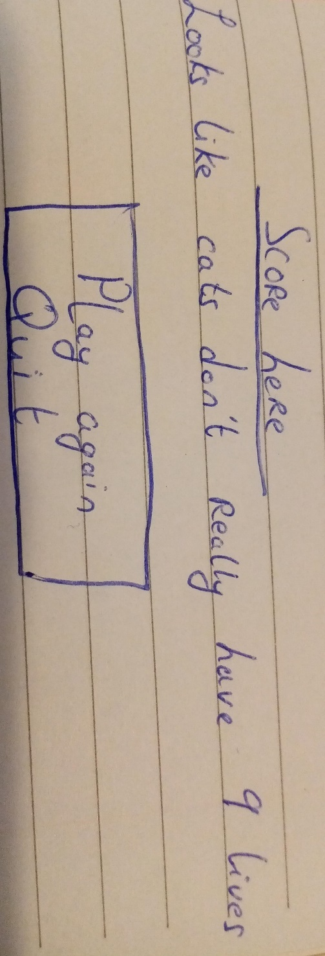

**Player dies and has a top 5 score/Game is completed:** Player sees a congratulatory message, and the high score list. The player types in their name beside their ranking. The max score is 1620. If there are five scores of 1620, the player gets the option to overwrite the number one ranking, and bump the rankings down. An OK button is displayed, which directs the user to the front menu.

Control Mechanisms:

The user controls a cat face. The left arrow moves the cat face to the left. The right arrow moves the cat to the right. The space bar lets the cat face shoot a fireball. If three mice are collected the cat face immediately turns green, angry and invincible for 5 seconds, so no buttons are necessary to trigger this ability. An easy control mechanism makes for a very enjoyable game. There is no overcomplication.

While waterfall is not a hyper casual game ******, it still has the timing mechanics that hooks the user in.

The Game

Objective

The objective of this game is to avoid the water. The user controls the cat to navigate between the water droplets. The cat can shoot up to 5 fireballs per level. If the fireball collides with the water droplet, the water droplet disappears, rendering it useless. If the cat collides with 3 Mice, it is invincible for 10 seconds. The cat only has one life.

Levels

There are three levels in this game. Each level lasts for sixty seconds. As each level progresses, the speed at which the droplets fall increases, making it more difficult for the cat to survive. The user is notified of level progression by a sound effect and the background will change.

There will be a total of 8 possible droplets to fall at the same time. It must be possible for the cat to navigate between drops. There does not have to be a total of seven drops per row at one time. The drops can fall randomly, but it must be possible for the cat to avoid them.

**Level 1:** Up to 4 drops can fall at the same time. The speed of the fall is acceptable, helps the user get used to playing.

**Level 2:** Up to 5 drops falling. Speed increases. Mice starts to appear. Fireball amount are reset to 5. Timer reset to 60 seconds

**Level 3:** Up to 6 drops falling at the same time. Speed increases again. Mice appear. Timer resets to 60 seconds

Scores

The score is calculated by the seconds played by 7. Eg if the player lasted 1 minute and 12 seconds (72 x 7) the score is 504. 7 is chosen to multiply seconds to coincide with the common misconception that cats have 9 lives

Header

The header should include the pause play toggle, the number of fireballs beside the fireball icon and the seconds remaining in the level.

Test plan

Game tests

Left arrow moves cat left  
Right arrow moves cat right  
Space bar shoots fireball  
When fireball collides with water drop, water drop disappears  
When fire ball shot fire ball count is reduced  
The water drops fall  
Sound for fireball  
Music starts when game is play is clicked   
Cat disappears when hit by drop  
Sound for cat dying  
Only 5 fireballs can be shot per level  
P pauses the game  
The pause symbol is toggled to the play symbol  
P to resume the game after 3 second count down  
Play symbol toggles to pause symbol

Level 1

* Only up to four water drops are falling at the same time
* Cat can navigate successfully move between water drops

Level 2

* Only up to 5 water drops are falling at the same time.
* Rate at which the water drops are falling increases
* Cat can navigate successfully move between water drops
* Background changes.
* Mice start appearing between water drops
* If three mice are collected cat changes colour
* If three mice are collected, sound notifies player

Level 3

* Only up to 6 water drops are falling at the same time.
* Rate at which the water drops are falling increases
* Cat can navigate successfully move between water drops
* Background changes.

Menu tests

Front menu is displayed.   
Front menu has 4 options  
Each option has a back button to return to front menu  
The play button allows user to play game  
The high scores button shows player the top 5 high scores

High Scores

* Top 5 high scores are displayed correctly
* If the game was only played once, the four empty slots should have a zero beside them

Sound

* Sound slider increases and decreases sounds in the game
* Music slider increases and decreases music in the game

Instructions tell the player the instructions.

When player dies

* show score
* Score must be accurate
* Option to play again and to quit
* Play again: restarts game
* **Quit**: brings user to front menu
* If it’s **a top 5 high score**, Ranking system updates
* User can enter their name
* 10 character limit
* Ok returns player to front menu

Pause menu

Two options should be shown

* Mute clicked:

Mutes sounds and music

Sound symbol toggles

* Quit clicked

Asks are they sure.   
Y typed brings user to front menu

YES clicked brings user to front menu

N typed, the original pause menu is displayed

NO clicked, the original pause menu is displayed

References

“*” <https://uk.pcmag.com/mobile-games/44845/21-addictive-phone-games>

** <https://www.youtube.com/watch?v=MU4psw3ccUI>

*** <https://cutt.ly/rw7IPP4>

**** <https://www.brainscape.com/blog/2011/06/what-makes-game-addictive/>

***** <https://www.nbcnews.com/better/pop-culture/why-board-games-bring-out-worst-us-ncna828726>

****** <https://mobilefreetoplay.com/top-10-game-mechanics-for-hyper-casual-games/>