Mini Project Report
of
Database Systems Lab (CSS 2212)

PayRoll Management System

SUBMITTED
BY

Student Name | Reg. No. | Roll No. | Section
Chiranthan Padmashali | 240911614 | 52 | C
Manathan S Rao | 240911100 | 10 | C
Utkarsh | 240911622 | 53 | C

School of Computer Engineering
Manipal Institute of Technology, Manipal.
April 2026

DEPARTMENT OF COMPUTER SCIENCE & ENGINEERING

Manipal
30/03/2026

CERTIFICATE

This is to certify that the project titled Library Management System is a record of the bonafide work done by Chiranthan Padmashali (Reg. No. 240911614), Manthan S Rao (Reg. No. 240911100) and Utkarsh (Reg. No. 240911622) submitted in partial fulfilment of the requirements for the award of the Degree of Bachelor of Technology (B.Tech.) in Information Technology Engineering of Manipal Institute of Technology, Manipal, Karnataka (A Constituent Institute of Manipal Academy of Higher Education), during the academic year 2025–2026.

Name and Signature of Examiners:

- Dr. Roopalakshmi R, Associate Professor, SCE.

- Prof. Giridhar N S, Assistant Professor-Selection Grade, SCE.

ABSTRACT
The Payroll Management System is a desktop application that automates the complete lifecycle of employee payroll operations for an organisation. Built using JavaFX 17 as the graphical front-end and MySQL 8.x as the relational database engine, the system handles employee record management, salary configuration, leave tracking, payslip generation, and role-based user authentication through a single integrated platform.
The database schema, contained in payrolldbs_project.sql, is designed to satisfy all concepts prescribed in the CSS 2212 Database Systems Lab manual at MIT Manipal. It comprises thirteen normalised tables that collectively achieve Fourth Normal Form (4NF). The schema includes five database views for complex multi-table joins, five stored procedures that demonstrate IN, OUT, and INOUT parameter modes, four user-defined functions for reusable scalar calculations, and five triggers that enforce business rules and automate audit logging entirely at the database level, independent of the Java application.
The application follows a two-tier architecture: the JavaFX presentation layer communicates with MySQL exclusively through JDBC, using PreparedStatement for all parameterised queries to prevent SQL injection and explicit transactions with SAVEPOINT and ROLLBACK for multi-step atomic operations. The system supports three user roles — Admin, HR Manager, and Employee — each with role-specific access enforced both by a database trigger (auto-assignment) and by the application's authentication query. The project demonstrates a complete integration of relational database theory with a working deployable desktop application.

CHAPTER 1: INTRODUCTION
1.1 Background
Employee payroll management is one of the most data-intensive processes in any organisation. Computing salaries that depend on allowance packages, deductions such as EPF and income tax, and performance bonuses; tracking three distinct types of leave balances; generating monthly payslips; and managing role-based system access are all tasks that demand precision and guaranteed consistency. When managed through disconnected spreadsheets or simple flat files, these operations suffer from update anomalies, inconsistent deduction calculations, and the complete absence of an audit trail.
A well-designed relational database management system (RDBMS) with referential integrity constraints, normalised tables, and database-level automation through triggers and stored procedures provides the ideal foundation. This project demonstrates that approach in a working, deployable JavaFX desktop application backed by a MySQL 8.x database that embodies all the SQL concepts from Labs 1 through 11 of the CSS 2212 course.
1.2 Scope
The system covers the following functional areas:
1. Employee record management: personal data, addresses (decomposed into atomic columns), and multiple contact numbers stored as typed rows.
2. Department and designation management: lookup tables linked to employees via foreign keys with ON DELETE SET NULL referential integrity.
3. Salary configuration: reusable salary structure packages (allowances) linked to individual employee salary records (base, EPF, tax, PAYE) with a last_revised_date column updated automatically.
4. Leave management: dynamic leave type system where Annual, Casual, and Optional balances are stored as rows — not columns — enabling future leave types to be added with a single INSERT.
5. Payslip generation: gross pay, total deductions, and net pay calculated and displayed on a printable payslip.
6. User authentication: username/password login with role detection via a three-table JOIN and conditional aggregation.
7. Salary hike: percentage-based salary increase via a stored procedure with an INOUT parameter; every change is logged automatically by a database trigger.
8. Audit trail: payroll_audit_log table written exclusively by database triggers — never by application code.

1.3 Technology Stack
Component | Technology | Version / Detail
Database Engine | MySQL | 8.x — InnoDB engine, utf8mb4 charset
Application Layer | JavaFX | 17 (OpenJFX) — Desktop GUI
Build Tool | Apache Maven | 3.x — dependency & build management
DB Driver | MySQL Connector/J | com.mysql.cj.jdbc.Driver (JDBC 4.2)
Language | Java | 17 LTS
DB Script | payrolldbs_project.sql | 13 tables, 5 views, 5 procs, 4 functions, 5 triggers
Configuration | config/db.properties | Externalised DB connection settings

CHAPTER 2: PROBLEM STATEMENT & OBJECTIVES
2.1 Problem Statement
Most organisations without a dedicated HRMS rely on spreadsheets to manage payroll data. This approach introduces several critical problems:
- Data Inconsistency: An employee's salary, leave balance, and contact details exist in separate sheets with no referential link. Updating one without the other creates inconsistencies that go undetected.
- No Business Rule Enforcement: Nothing prevents entering a negative salary, assigning a non-existent department, or creating a duplicate NIC number. Validation, if any, exists only in application code that can be bypassed.
- Manual Salary Calculations: Deductions such as EPF (9% of base), income tax, and PAYE are computed manually per payslip, leading to arithmetic errors and disputes with no audit trail of changes.
- No Audit Trail: When a salary is revised, the previous value is overwritten with no record of who changed it, what the old value was, or when the change occurred.
- Lack of Role-Based Access: Any user with file access can modify any record. There is no concept of an Admin who can change salaries versus an Employee who can only view their own payslip.
- Leave Management Inflexibility: Hard-coding three leave-type columns (annual_leaves, casual_leaves, optional_leaves) in the employee table violates First Normal Form and makes adding a new leave category (e.g. Sick Leave) require an ALTER TABLE on the production database.
This project addresses all six problems through proper relational database design, named constraint enforcement at the database level, database-level automation via triggers and stored procedures, and a JavaFX interface that exposes only role-appropriate operations.
2.2 Objectives
1. Design and implement a fully normalised relational database schema (1NF through 4NF) for the payroll management domain, demonstrating resolution of multi-valued dependencies.
2. Demonstrate all SQL constraint types: PRIMARY KEY, UNIQUE, NOT NULL, DEFAULT, CHECK, FOREIGN KEY (with CASCADE, SET NULL, and RESTRICT), ENUM, and named constraints.
3. Implement five database views using multi-table LEFT JOINs, conditional aggregation (MAX CASE WHEN), and computed columns for payslip calculations.
4. Implement five database triggers to enforce business rules (NIC validation, Admin delete protection), automate audit logging, and auto-assign user roles — all at the database level.
5. Implement five stored procedures that demonstrate IN, OUT, and INOUT parameter modes (Lab 9), including an atomic multi-step employee insertion procedure.
6. Implement four user-defined functions for reusable scalar computations (net pay, employee count, years of service, leave balance).
7. Build a JavaFX 17 desktop application that connects to MySQL via JDBC, using PreparedStatement for all parameterised queries, explicit transactions for multi-step operations, and CallableStatement for stored procedure invocation.
8. Implement role-based access control at both the database level (trigger auto-assigns Employee role) and the application level (HomeView shows/hides tabs based on the authenticated role).

CHAPTER 3: METHODOLOGY
3.1 Database Design Methodology
3.1.1 Entity Identification
The real-world entities in a payroll domain were identified: Employee, Department, Designation, Address, ContactNumber, SalaryStructure, EmployeeSalary, LeaveType, LeaveBalance, SystemUser, UserRole, and RoleAssignment. An additional Audit entity (payroll_audit_log) was introduced to satisfy the audit trail requirement. Each entity became a candidate table.
3.1.2 Attribute Definition and 1NF
For each entity, attributes were made atomic. A critical 1NF violation in the naive design was the storage of three leave types as columns (annual_leaves, casual_leaves, optional_leaves) in the employee table — a repeating group. This was eliminated by creating employee_leave_balances with one row per (employee, leave_type) pair. Similarly, phone numbers were extracted from the employee table into employee_contact_numbers, with a contact_type ENUM column (home/mobile/work) ensuring each number is stored atomically.
3.1.3 Normalisation (2NF, 3NF, 4NF)
The schema was normalised progressively. All tables use single-column surrogate primary keys, making partial dependencies structurally impossible (2NF trivially satisfied). Transitive dependencies were eliminated: dept_name was moved to the departments table (not stored in employees alongside current_dept_id), designation_name to designations, leave_type_name to leave_types, and role_name to user_roles. Multi-valued dependencies (4NF) were resolved by ensuring each table contains at most one independent multi-valued fact about its subject: contact numbers and leave balances are each in their own tables.
3.1.4 Relationship Modelling
Foreign keys were defined between all related tables. ON DELETE CASCADE was applied to all weak-entity tables (employee_addresses, employee_contact_numbers, employee_salaries, employee_leave_balances, system_users) so that deleting an employee removes all dependent records automatically. ON DELETE SET NULL was applied to current_dept_id and current_designation_id in employees so that deleting a department preserves the employee record. ON DELETE RESTRICT was applied to salary_structures and leave_types to prevent deletion of a package or leave category that is still in use.
3.1.5 Constraint Design
Named constraints were used throughout (e.g., pk_employees, uq_nic, fk_emp_dept, chk_gender) following Lab 2 guidelines. CHECK constraints enforce business rules at the database layer: gender IN ('Male','Female','Other'), base_salary > 0, epf/tax/paye >= 0, performance_rating BETWEEN 1 AND 5, and available_leaves >= 0. ENUM constraints restrict contact_type and action_type to defined value sets.
3.1.6 Trigger Design
Five triggers were designed: two validation triggers (BEFORE INSERT on employees — NIC length and name format; BEFORE DELETE on employees — Admin protection), two audit triggers (AFTER INSERT and AFTER UPDATE on employee_salaries — write to payroll_audit_log), and one automation trigger (AFTER INSERT on system_users — auto-assign Employee role). These enforce business rules at the database level independently of the application.
3.1.7 Stored Procedure and Function Design
Procedures were designed for complex multi-step operations. sp_add_employee demonstrates an IN/OUT parameter pattern and wraps five INSERT statements in a single transaction. sp_apply_salary_hike demonstrates the INOUT parameter mode — the current salary is passed in and the new salary is returned in the same parameter. Functions were designed for calculations reused in multiple queries: fn_get_net_pay computes gross minus deductions; fn_dept_emp_count counts employees in a department; fn_years_of_service computes tenure; fn_get_leave_balance returns available leave for a given type.
3.2 Application Architecture
The application follows a two-tier (client-server) architecture with three logical layers:
Layer | Technology | Classes / Files
Presentation (UI) | JavaFX 17 | LoginView, HomeView, EmployeeView, PayrollView, LeaveView, PaySlipView, CreateUserView
Business Logic / DAO | Java 17 | Employee, Payroll, PaySlip, Leave, User, Person (base class)
Data Access / Connection | JDBC 4.2 | DbConnection, config/db.properties, MySQL Connector/J
3.3 Java–Database Integration Methodology
Every user action in the JavaFX UI triggers a method call on a model class (DAO layer). Model classes construct SQL statements, obtain a JDBC connection from DbConnection, execute the query using PreparedStatement (for parameterised input) or CallableStatement (for stored procedures), process the ResultSet, and return results to the view layer. Multi-step operations set AutoCommit to false, execute each step, and commit on success or rollback on any exception — mirroring the START TRANSACTION / ROLLBACK / COMMIT pattern from the SQL script.

CHAPTER 4: ER DIAGRAM & RELATIONAL TABLES WITH SAMPLE DATA
4.1 ER Diagram
The ER diagram below shows all entities, their attributes, primary keys (underlined), and relationships with cardinalities. The diagram is described textually as an image placeholder — insert the actual ER diagram image here.
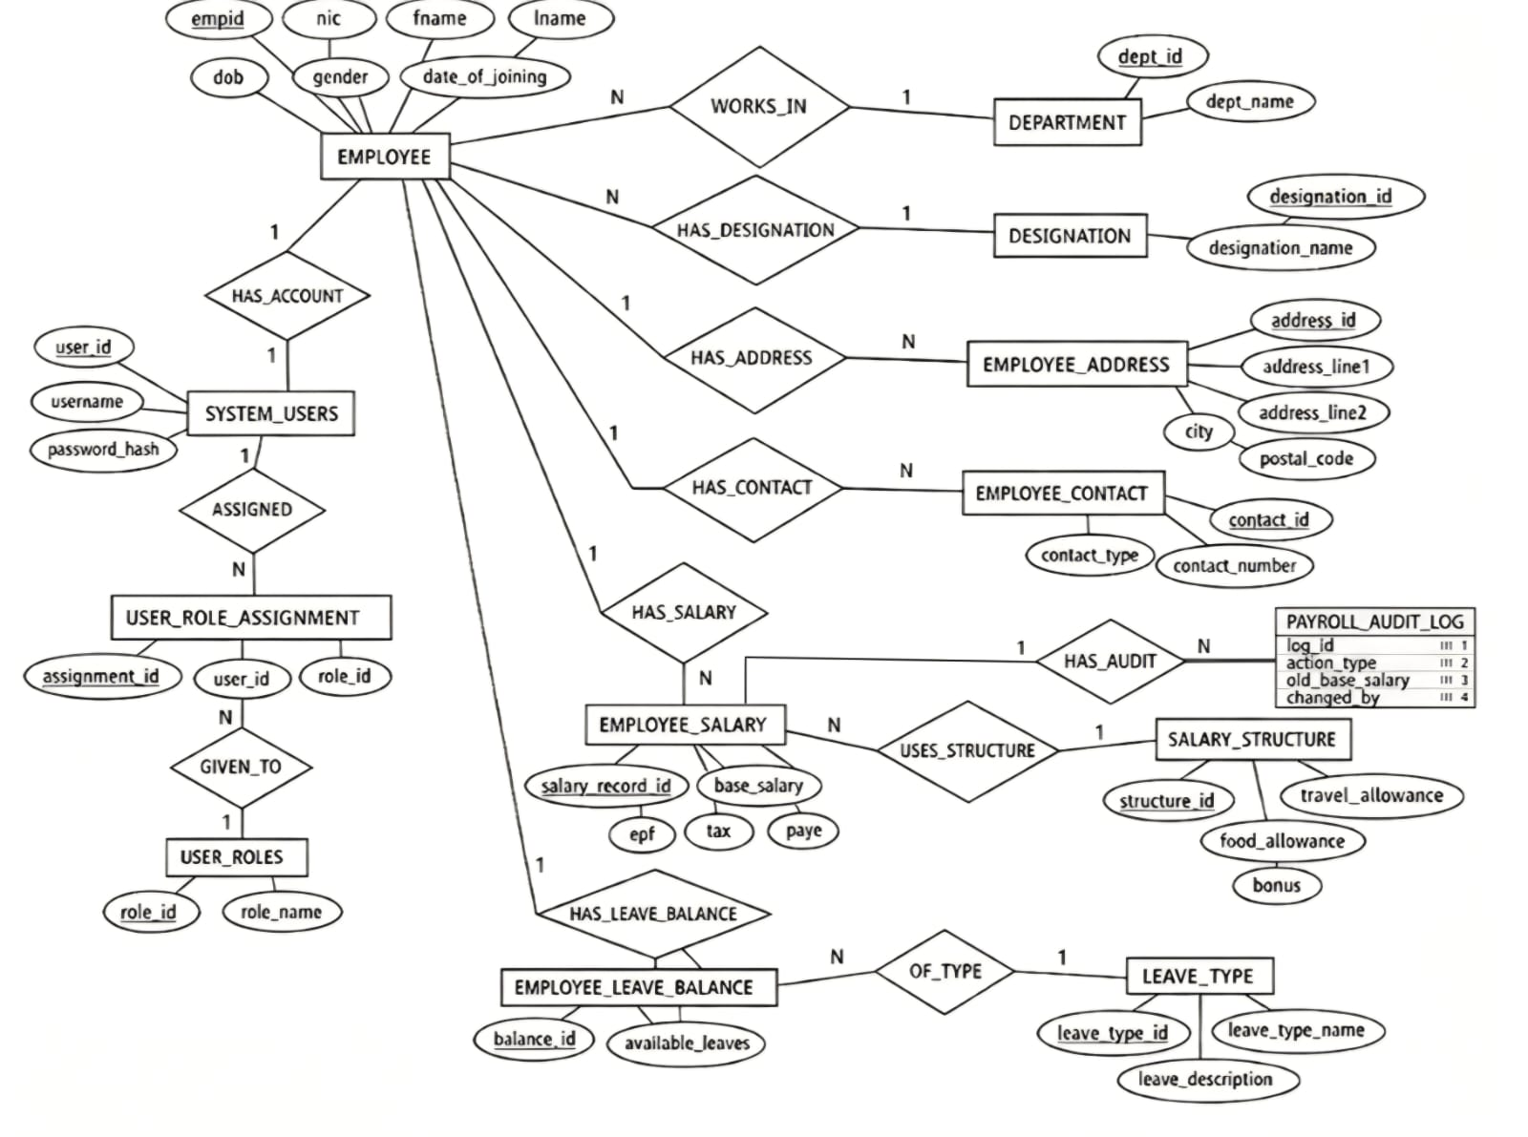Key design decisions reflected in the ER diagram: (1) Phone numbers are modelled as a multi-valued attribute of Employee, resolved into the employee_contact_numbers table with a contact_type discriminator. (2) Leave balances are modelled as a M:N associative entity between Employee and LeaveType, resolved into employee_leave_balances. (3) The M:N relationship between SystemUser and UserRole is resolved by the user_role_assignments junction table. (4) SalaryStructure is an independent entity shared by multiple employees, preventing allowance redundancy.
4.2 Table Catalogue with Sample Data
The following tables make up the schema. Each table's purpose, primary key, foreign keys, constraints, and sample data are listed below.

Table 1: departments
Lookup table for organisational departments. Satisfies 3NF: dept_name depends only on dept_id.
Relationships: departments → employees (One-to-Many, ON DELETE SET NULL)
Column | Type | Constraints | Description
dept_id | INT | PRIMARY KEY, AUTO_INCREMENT | Unique department ID
dept_name | VARCHAR(250) | NOT NULL, UNIQUE, CHECK(≠blank) | Department name

dept_id | dept_name
1 | Human Resources
2 | Software Engineering
3 | Finance
4 | Marketing

Table 2: designations
Stores job titles / designations. Eliminating designation_name from employees satisfies 3NF.
Relationships: designations → employees (One-to-Many, ON DELETE SET NULL)
Column | Type | Constraints | Description
designation_id | INT | PRIMARY KEY, AUTO_INCREMENT | Unique designation ID
designation_name | VARCHAR(300) | NOT NULL | Job title (widened by ALTER TABLE)

designation_id | designation_name
1 | HR Manager
2 | Senior Software Engineer
3 | Junior Software Engineer
4 | Finance Analyst
9 | DevOps Engineer

Table 3: employees
Core employee entity. Personal data only — address and contacts are in separate tables (1NF).
Relationships: employees → employee_addresses (1:1), → employee_contact_numbers (1:N), → employee_salaries (1:1), → employee_leave_balances (1:N), → system_users (1:1)
Column | Type | Constraints | Description
empid | INT | PRIMARY KEY, AUTO_INCREMENT | Unique employee ID
nic | VARCHAR(35) | NOT NULL, UNIQUE | National ID (≥10 chars — trigger validated)
fname | VARCHAR(30) | NOT NULL | First name (alpha only — trigger validated)
lname | VARCHAR(30) | NOT NULL | Last name
dob | DATE |  | Date of birth
gender | VARCHAR(10) | NOT NULL, DEFAULT 'Male', CHECK(IN 3 values) | Male / Female / Other
date_of_joining | DATE | NOT NULL | Employment start date
current_dept_id | INT | FK → departments(dept_id) ON DELETE SET NULL | Current department
current_designation_id | INT | FK → designations ON DELETE SET NULL | Current designation
performance_rating | TINYINT | NOT NULL, DEFAULT 3, CHECK(BETWEEN 1 AND 5) | Added via ALTER TABLE

empid | nic | fname | lname | gender | date_of_joining | dept_id | desig_id | rating
1 | 199056781234 | Aarav | Mehta | Male | 2018-06-01 | 1 | 1 | 3
2 | 199212345678 | Chiranthan | Padmashali | Male | 2025-03-10 | 2 | 2 | 3
3 | 199578901234 | Rahul | Verma | Male | 2021-01-15 | 2 | 3 | 3

Table 4: employee_addresses
Physical address split from employees into atomic columns — satisfies 1NF. One row per employee (1:1).
Relationships: employee_addresses → employees (Many-to-One, ON DELETE CASCADE)
Column | Type | Constraints | Description
address_id | INT | PRIMARY KEY, AUTO_INCREMENT | Unique address ID
empid | INT | NOT NULL, FK → employees ON CASCADE | Parent employee
address_line1 | TEXT | NOT NULL | Street address
address_line2 | TEXT |  | Apartment / area (optional)
city | VARCHAR(30) | NOT NULL, DEFAULT 'Unknown' | City
postal_code | VARCHAR(20) |  | PIN code

address_id | empid | address_line1 | city | postal_code
1 | 1 | 45, Park Street, Apartment 3B | Mumbai | 400001
2 | 2 | Santhekatte | Udupi | 576102

Table 5: employee_contact_numbers
Multi-valued attribute resolved into its own table (Lab 5 pattern). ENUM restricts contact_type to defined values.
Relationships: employee_contact_numbers → employees (Many-to-One, ON DELETE CASCADE)
Column | Type | Constraints | Description
contact_id | INT | PRIMARY KEY, AUTO_INCREMENT | Unique contact ID
empid | INT | NOT NULL, FK → employees ON CASCADE | Parent employee
contact_type | ENUM | NOT NULL — 'home' / 'mobile' / 'work' | Contact category
contact_number | VARCHAR(15) | NOT NULL | Phone number

contact_id | empid | contact_type | contact_number
1 | 1 | home | 02267890123
2 | 1 | mobile | 9876543210
3 | 2 | home | 08023456789
4 | 2 | mobile | 9812345670

Table 6: salary_structures
Reusable allowance packages shared across multiple employees. Shared structure prevents redundancy and satisfies 3NF.
Relationships: salary_structures → employee_salaries (One-to-Many, ON DELETE RESTRICT)
Column | Type | Constraints | Description
structure_id | INT | PRIMARY KEY, AUTO_INCREMENT | Unique structure ID
travel_allowance | DOUBLE | NOT NULL, DEFAULT 0.00, CHECK ≥ 0 | Travel allowance amount
food_allowance | DOUBLE | NOT NULL, DEFAULT 0.00, CHECK ≥ 0 | Food allowance amount
bonus | DOUBLE | NOT NULL, DEFAULT 0.00, CHECK ≥ 0 | Performance bonus amount

structure_id | travel_allowance | food_allowance | bonus
1 | 5000.00 | 3000.00 | 15000.00 (Senior roles)
2 | 3000.00 | 2000.00 | 8000.00 (Junior roles)
3 | 4500.00 | 2500.00 | 12000.00 (Mid-level)

Table 7: employee_salaries
Links each employee to a salary structure and stores their personal deduction amounts. last_revised_date added via ALTER TABLE.
Relationships: employee_salaries → employees (ON DELETE CASCADE) | → salary_structures (ON DELETE RESTRICT)
Column | Type | Constraints | Description
salary_record_id | INT | PRIMARY KEY, AUTO_INCREMENT | Unique salary record ID
empid | INT | NOT NULL, FK → employees ON CASCADE | Parent employee
structure_id | INT | NOT NULL, FK → salary_structures | Allowance package reference
base_salary | INT | NOT NULL, CHECK > 0 | Monthly base salary
epf | DOUBLE | NOT NULL, DEFAULT 0, CHECK ≥ 0 | EPF deduction amount
tax | DOUBLE | NOT NULL, DEFAULT 0, CHECK ≥ 0 | Income tax deduction
paye | DOUBLE | NOT NULL, DEFAULT 0, CHECK ≥ 0 | PAYE deduction
last_revised_date | DATE | NOT NULL, DEFAULT CURRENT_DATE | Last salary update date (ALTER TABLE)

empid | structure_id | base_salary | epf | tax | paye
1 | 1 | 85000 | 7650.00 | 17000.00 | 10200.00
2 | 1 | 95000 | 8550.00 | 19000.00 | 11400.00
3 | 2 | 45000 | 4050.00 | 6750.00 | 4050.00

Table 8: leave_types
Master lookup for leave categories. Storing leave_type_name here instead of as column names in employee tables satisfies 1NF and makes the system extensible.
Relationships: leave_types → employee_leave_balances (One-to-Many, ON DELETE RESTRICT)
Column | Type | Constraints | Description
leave_type_id | INT | PRIMARY KEY, AUTO_INCREMENT | Unique leave type ID
leave_type_name | VARCHAR(50) | NOT NULL, UNIQUE | Annual / Casual / Optional
leave_description | TEXT |  | Description of leave policy

leave_type_id | leave_type_name | leave_description
1 | Annual | Paid annual leave accrued per year
2 | Casual | Short-notice casual leave
3 | Optional | Optional/festive leave chosen by employee

Table 9: employee_leave_balances
Resolves the M:N between employees and leave_types. Composite UNIQUE (empid, leave_type_id) enforces one balance row per employee per leave type — a 4NF design.
Relationships: → employees (ON DELETE CASCADE) | → leave_types (ON DELETE RESTRICT)

Column | Type | Constraints | Description
balance_id | INT | PRIMARY KEY, AUTO_INCREMENT | Unique balance ID
empid | INT | NOT NULL, FK → employees ON CASCADE | Employee
leave_type_id | INT | NOT NULL, FK → leave_types ON RESTRICT | Leave type
available_leaves | INT | NOT NULL, DEFAULT 0, CHECK ≥ 0 | Remaining leave days
UNIQUE KEY unique_emp_leave (empid, leave_type_id) — prevents duplicate balance rows

balance_id | empid | leave_type_id | available_leaves
1 | 1 | 1 | 22
2 | 1 | 2 | 10
3 | 1 | 3 | 5
4 | 2 | 1 | 22
5 | 2 | 2 | 10
Table 10: system_users
Stores login credentials for employees. UNIQUE(empid) enforces the 1:1 relationship with employees.
Relationships: → employees (ON DELETE CASCADE) | system_users ↔ user_roles via user_role_assignments (M:N)
Column | Type | Constraints | Description
user_id | INT | PRIMARY KEY, AUTO_INCREMENT | Unique user ID
empid | INT | NOT NULL, UNIQUE, FK → employees | Linked employee (UNIQUE = 1:1)
username | VARCHAR(50) | NOT NULL, UNIQUE | Login username
password_hash | VARCHAR(255) | NOT NULL | Password (plain-text in dev build)

user_id | empid | username | password_hash
1 | 1 | aarav.hr | admin123
2 | 2 | sneha.se | sneha123
6 | 6 | anjali.hr | anjali123

Table 11: user_roles
Lookup table for user roles. Separating role_name from system_users satisfies 3NF.
Relationships: user_roles ↔ system_users via user_role_assignments (M:N, ON DELETE RESTRICT)
Column | Type | Constraints | Description
role_id | INT | PRIMARY KEY, AUTO_INCREMENT | Unique role ID
role_name | VARCHAR(50) | NOT NULL, UNIQUE | Admin / Employee / HR Manager

role_id | role_name
1 | Admin
2 | Employee
3 | HR Manager
Table 12: user_role_assignments
Junction table resolving the M:N between system_users and user_roles. A user may hold multiple roles simultaneously (e.g., Employee + HR Manager).
Relationships: → system_users (ON DELETE CASCADE) | → user_roles (ON DELETE RESTRICT)
Column | Type | Constraints | Description
assignment_id | INT | PRIMARY KEY, AUTO_INCREMENT | Unique assignment ID
user_id | INT | NOT NULL, FK → system_users ON CASCADE | System user
role_id | INT | NOT NULL, FK → user_roles ON RESTRICT | Role assigned
UNIQUE KEY unique_user_role (user_id, role_id) — prevents duplicate assignments

assignment_id | user_id | role_id
1 | 1 | 1 (Aarav — Admin)
2 | 2 | 2 (Sneha — Employee)
6 | 6 | 2 (Anjali — Employee)
11 | 6 | 3 (Anjali — HR Manager)

Table 13: payroll_audit_log
Written exclusively by database triggers trg_salary_after_insert and trg_salary_after_update. Java code never writes to this table directly. CHECK constraint on action_type restricts entries to INSERT, UPDATE, or DELETE.
Column | Type | Constraints | Description
log_id | INT | PRIMARY KEY, AUTO_INCREMENT | Unique log entry ID
empid | INT | NOT NULL | Employee whose salary changed
action_type | VARCHAR(10) | NOT NULL, CHECK IN ('INSERT','UPDATE','DELETE') | Type of change
old_base_salary | INT |  | Salary before change (NULL on INSERT)
new_base_salary | INT |  | Salary after change
changed_by | VARCHAR(50) | NOT NULL, DEFAULT 'system' | Who made the change
changed_at | DATETIME | NOT NULL, DEFAULT CURRENT_TIMESTAMP | When the change occurred

log_id | empid | action_type | old_base_salary | new_base_salary | changed_at
1 | 1 | INSERT | NULL | 85000 | auto-written by trigger
2 | 1 | UPDATE | 85000 | 89250 | after 5% hike via stored procedure

CHAPTER 5: DDL COMMANDS & PL/SQL PROCEDURES / FUNCTIONS / TRIGGERS
5.1 DDL Commands
5.1.1 Database Creation
DROP DATABASE IF EXISTS payrolldbs;
CREATE DATABASE payrolldbs
CHARACTER SET utf8mb4
COLLATE utf8mb4_unicode_ci;
USE payrolldbs;
5.1.2 Key Table DDL Samples
The following representative CREATE TABLE statements illustrate the constraint design. Full DDL is in payrolldbs_project.sql.
CREATE TABLE employees (
empid INT NOT NULL AUTO_INCREMENT,
nic VARCHAR(35) NOT NULL,
fname VARCHAR(30) NOT NULL,
lname VARCHAR(30) NOT NULL,
dob DATE,
gender VARCHAR(10) NOT NULL DEFAULT 'Male',
date_of_joining DATE NOT NULL,
current_dept_id INT,
current_designation_id INT,
CONSTRAINT pk_employees PRIMARY KEY (empid),
CONSTRAINT uq_nic UNIQUE (nic),
CONSTRAINT chk_gender CHECK (gender IN ('Male','Female','Other')),
CONSTRAINT fk_emp_dept FOREIGN KEY (current_dept_id)
REFERENCES departments(dept_id) ON DELETE SET NULL,
CONSTRAINT fk_emp_desig FOREIGN KEY (current_designation_id)
REFERENCES designations(designation_id) ON DELETE SET NULL
);
CREATE TABLE employee_contact_numbers (
contact_id INT NOT NULL AUTO_INCREMENT,
empid INT NOT NULL,
contact_type ENUM('home','mobile','work') NOT NULL,
contact_number VARCHAR(15) NOT NULL,
CONSTRAINT pk_contacts PRIMARY KEY (contact_id),
CONSTRAINT fk_contact_emp FOREIGN KEY (empid)
REFERENCES employees(empid) ON DELETE CASCADE
);
CREATE TABLE employee_leave_balances (
balance_id INT NOT NULL AUTO_INCREMENT,
empid INT NOT NULL,
leave_type_id INT NOT NULL,
available_leaves INT NOT NULL DEFAULT 0,
CONSTRAINT pk_leave_balances PRIMARY KEY (balance_id),
CONSTRAINT uq_emp_leave UNIQUE (empid, leave_type_id),
CONSTRAINT chk_avail_leaves CHECK (available_leaves >= 0),
CONSTRAINT fk_lb_emp FOREIGN KEY (empid)
REFERENCES employees(empid) ON DELETE CASCADE,
CONSTRAINT fk_lb_leave_type FOREIGN KEY (leave_type_id)
REFERENCES leave_types(leave_type_id) ON DELETE RESTRICT
);
5.1.3 DDL Alterations (Lab 1 — ALTER TABLE)
Two columns were added after the initial design to demonstrate ALTER TABLE:
-- Add performance_rating with CHECK constraint
ALTER TABLE employees
ADD COLUMN performance_rating TINYINT NOT NULL DEFAULT 3;
ALTER TABLE employees
ADD CONSTRAINT chk_perf_rating CHECK (performance_rating BETWEEN 1 AND 5);
-- Add last_revised_date to employee_salaries
ALTER TABLE employee_salaries
ADD COLUMN last_revised_date DATE NOT NULL DEFAULT (CURRENT_DATE);
-- Widen designation_name (Lab 1 - MODIFY)
ALTER TABLE designations
MODIFY designation_name VARCHAR(300) NOT NULL;
5.2 Views
Five views are defined in the database (SQL Section 4). They encapsulate complex multi-table JOINs for reuse by both the Java application and ad-hoc reporting.
View 1: vw_employee_full
Property | Value
Purpose | Full employee profile combining 5 tables with conditional aggregation for phone numbers.
Tables Joined | employees, departments, designations, employee_addresses, employee_contact_numbers
Key Feature | MAX(CASE WHEN cn.contact_type='home' THEN ...) pivots contact rows into columns
Used By | Employee.java buildSelectSQL() — getAllEmployees(), searchEmployees()

CREATE VIEW vw_employee_full AS
SELECT e.empid, e.fname, e.lname,
TIMESTAMPDIFF(YEAR, e.dob, CURDATE()) AS age,
e.gender, e.date_of_joining, e.performance_rating,
d.dept_name, ds.designation_name,
a.address_line1, a.city, a.postal_code,
MAX(CASE WHEN cn.contact_type='home' THEN cn.contact_number END) AS tel_home,
MAX(CASE WHEN cn.contact_type='mobile' THEN cn.contact_number END) AS tel_mobile
FROM employees e
LEFT JOIN departments d ON e.current_dept_id=d.dept_id
LEFT JOIN designations ds ON e.current_designation_id=ds.designation_id
LEFT JOIN employee_addresses a ON e.empid=a.empid
LEFT JOIN employee_contact_numbers cn ON e.empid=cn.empid
GROUP BY e.empid, ...;
View 2: vw_payslip
Property | Value
Purpose | Complete payslip data with computed gross, deductions, and net pay.
Tables Joined | employees, departments, designations, employee_salaries, salary_structures
Key Feature | Computed columns: gross_pay, total_deductions, net_pay calculated inside the view
Used By | PaySlip.java getPayDetails() and PayrollView searches
View 3: vw_leave_summary
Property | Value
Purpose | Leave balances per employee per leave type — one row per (employee, leave_type).
Tables Joined | employees, departments, designations, employee_leave_balances, leave_types
Used By | LeaveView.java — dynamic panel construction
View 4: vw_user_auth
Property | Value
Purpose | Authentication view — per-user admin flag computed via MAX(CASE WHEN role_name='Admin').
Tables Joined | system_users, user_role_assignments, user_roles
Used By | Equivalent SQL used inline in User.java authenticate()

View 5: vw_dept_salary_stats
Property | Value
Purpose | Department-level statistics: headcount, min/max/avg/total salary.
Tables Joined | departments, employees, employee_salaries
Used By | Ad-hoc reporting and the sp_dept_salary_stats procedure
5.3 Triggers
Five triggers enforce business rules and automate database operations. All are row-level triggers (FOR EACH ROW) as per Lab 10 guidelines.
Trigger 1: trg_emp_before_insert
Property | Value
Name | trg_emp_before_insert
Event | BEFORE INSERT
Table | employees
Purpose | Validates NIC (minimum 10 characters) and first name (alphabetic only). Raises SQLSTATE 45000 on violation.

CREATE TRIGGER trg_emp_before_insert
BEFORE INSERT ON employees
FOR EACH ROW
BEGIN
IF LENGTH(TRIM(NEW.nic)) < 10 THEN
SIGNAL SQLSTATE '45000'
SET MESSAGE_TEXT = 'NIC must be at least 10 characters long.';
END IF;
IF NEW.fname REGEXP '[^a-zA-Z ]' THEN
SIGNAL SQLSTATE '45000'
SET MESSAGE_TEXT = 'First name must contain only alphabetic characters.';
END IF;
END;
Explanation: This BEFORE trigger intercepts the INSERT before it is written to disk. It applies two validation rules that reinforce the database-level constraints. The REGEXP check ensures no numeric or special characters appear in the employee's first name. The Java EmployeeView also validates NIC length before calling insertEmployee(), providing a dual-layer guard.
Trigger 2: trg_salary_after_insert
Property | Value
Name | trg_salary_after_insert
Event | AFTER INSERT
Table | employee_salaries
Purpose | Automatically writes an INSERT audit entry to payroll_audit_log when a new salary record is created.

CREATE TRIGGER trg_salary_after_insert
AFTER INSERT ON employee_salaries
FOR EACH ROW
BEGIN
INSERT INTO payroll_audit_log (empid, action_type, old_base_salary, new_base_salary)
VALUES (NEW.empid, 'INSERT', NULL, NEW.base_salary);
END;
Explanation: Fires automatically when Payroll.java calls insertSalaryDetails(). Java never writes to payroll_audit_log — the trigger handles it entirely. old_base_salary is NULL for an INSERT event because there was no previous salary.
Trigger 3: trg_salary_after_update
Property | Value
Name | trg_salary_after_update
Event | AFTER UPDATE
Table | employee_salaries
Purpose | Records old and new base_salary in payroll_audit_log whenever the salary changes. Fires for both manual updates and stored procedure hikes.

CREATE TRIGGER trg_salary_after_update
AFTER UPDATE ON employee_salaries
FOR EACH ROW
BEGIN
IF OLD.base_salary <> NEW.base_salary THEN
INSERT INTO payroll_audit_log
(empid, action_type, old_base_salary, new_base_salary)
VALUES (NEW.empid, 'UPDATE', OLD.base_salary, NEW.base_salary);
END IF;
END;
Explanation: The IF OLD.base_salary <> NEW.base_salary condition prevents unnecessary audit rows when other columns (e.g., last_revised_date) are updated without a salary change. Fires both when Payroll.java calls updateSalaryDetails() and when sp_apply_salary_hike executes.
Trigger 4: trg_emp_before_delete
Property | Value
Name | trg_emp_before_delete
Event | BEFORE DELETE
Table | employees
Purpose | Prevents deletion of any employee who holds the Admin role. Raises SQLSTATE 45000, which Java surfaces as an error message.

CREATE TRIGGER trg_emp_before_delete
BEFORE DELETE ON employees
FOR EACH ROW
BEGIN
DECLARE v_is_admin INT DEFAULT 0;
SELECT COUNT(*) INTO v_is_admin
FROM system_users su
JOIN user_role_assignments ura ON su.user_id = ura.user_id
JOIN user_roles ur ON ura.role_id = ur.role_id
WHERE su.empid = OLD.empid AND ur.role_name = 'Admin';
IF v_is_admin > 0 THEN
SIGNAL SQLSTATE '45000'
SET MESSAGE_TEXT = 'Cannot delete an Admin user employee.';
END IF;
END;
Explanation: This is a database-enforced business rule that cannot be bypassed through application code. Even a direct SQL DELETE from a MySQL client will be blocked. The Java EmployeeView.handleDelete() method catches the resulting SQLException and displays the error to the user.

Trigger 5: trg_user_after_insert
Property | Value
Name | trg_user_after_insert
Event | AFTER INSERT
Table | system_users
Purpose | Automatically assigns the 'Employee' role to every new user account. Uses INSERT IGNORE to avoid duplicate assignment if the role is already present.

CREATE TRIGGER trg_user_after_insert
AFTER INSERT ON system_users
FOR EACH ROW
BEGIN
DECLARE v_emp_role_id INT;
SELECT role_id INTO v_emp_role_id
FROM user_roles WHERE role_name = 'Employee';
INSERT IGNORE INTO user_role_assignments (user_id, role_id)
VALUES (NEW.user_id, v_emp_role_id);
END;
Explanation: Guarantees no user account is ever role-less. When the admin creates a new user in CreateUserView and selects Admin as the role, the trigger first adds Employee, then User.createUser() adds Admin. This ensures every user always retains the base Employee access level.
5.4 Stored Procedures
Five stored procedures encapsulate complex multi-step operations. Calling a single CALL statement from the Java backend is safer than executing multiple statements individually and managing partial failures.
Procedure 1: sp_get_employee
Parameter | Direction | Data Type | Description
p_empid | IN | INT | Employee ID to retrieve full profile for
CALL sp_get_employee(1);
Logic: Executes SELECT * FROM vw_employee_full WHERE empid = p_empid. Returns the complete employee profile in one result set.

Procedure 2: sp_add_employee (Atomic Multi-Step Transaction)
Parameter | Direction | Data Type | Description
p_nic | IN | VARCHAR(35) | National ID number
p_fname | IN | VARCHAR(30) | First name
p_lname | IN | VARCHAR(30) | Last name
p_dob | IN | DATE | Date of birth
p_gender | IN | VARCHAR(10) | Male / Female / Other
p_joining | IN | DATE | Date of joining
p_dept_id | IN | INT | Department ID
p_desig_id | IN | INT | Designation ID
p_addr1 | IN | TEXT | Address line 1
p_city | IN | VARCHAR(30) | City
p_mobile | IN | VARCHAR(15) | Mobile phone number
p_base_salary | IN | INT | Base salary amount
p_structure_id | IN | INT | Salary structure ID
p_new_empid | OUT | INT | Generated employee ID (returned)
p_message | OUT | VARCHAR(255) | Success or error message
CALL sp_add_employee('199056781234','Aarav','Mehta',
'1985-04-15','Male','2018-06-01',1,1,
'45, Park Street','Mumbai','9876543210',
85000,1, @new_id, @msg);
SELECT @new_id, @msg;
Logic: Wraps five INSERT statements in a START TRANSACTION block. Computes EPF/tax/paye automatically. Uses INSERT IGNORE … SELECT from leave_types to seed leave balances. Uses EXIT HANDLER FOR SQLEXCEPTION to ROLLBACK on any failure. Returns the new empid via OUT parameter.

Procedure 3: sp_dept_salary_stats (IN + OUT parameters)
Parameter | Direction | Data Type | Description
p_dept_name | IN | VARCHAR(250) | Department name to analyse
p_headcount | OUT | INT | Number of employees in department
p_avg_sal | OUT | DOUBLE | Average base salary
p_max_sal | OUT | INT | Maximum base salary
p_min_sal | OUT | INT | Minimum base salary
CALL sp_dept_salary_stats('Software Engineering',
@hc, @avg, @mx, @mn);
SELECT @hc, @avg, @mx, @mn;
Logic: Executes a GROUP BY query across departments, employees, and employee_salaries. Returns four aggregate statistics via OUT parameters — demonstrating multiple OUT parameters from Lab 9.

Procedure 4: sp_apply_salary_hike (INOUT Parameter — Lab 9 Key Concept)
Parameter | Direction | Data Type | Description
p_empid | IN | INT | Employee to apply hike to
p_hike_pct | IN | DOUBLE | Hike percentage (e.g. 10 for 10%)
p_old_salary | INOUT | INT | Pass current salary IN; receives new salary OUT
SET @current_sal = 85000;
CALL sp_apply_salary_hike(1, 10.0, @current_sal);
SELECT @current_sal; -- now contains 93500
Logic: Computes new salary as ROUND(p_old_salary * (1 + p_hike_pct/100)). Updates employee_salaries with new salary and CURDATE() for last_revised_date. Sets p_old_salary = new value (INOUT return). trg_salary_after_update fires automatically and writes the audit log.

Java invocation using CallableStatement (JDBC):
CallableStatement cs = c.prepareCall("{CALL sp_apply_salary_hike(?,?,?)}");
cs.setInt(1, empId);
cs.setDouble(2, hikePct);
cs.setInt(3, (int) baseSalary); // INOUT: pass current salary IN
cs.registerOutParameter(3, Types.INTEGER); // register the OUT side
cs.execute();
double newSalary = cs.getInt(3); // retrieve new salary

Procedure 5: sp_list_dept_employees
Parameter | Direction | Data Type | Description
p_dept_name | IN | VARCHAR(250) | Department name to list employees for
CALL sp_list_dept_employees('Finance');
Logic: Joins employees, departments, designations, and employee_salaries. Returns a ranked list of employees in the department ordered by base_salary descending.
5.5 Functions
Four functions provide reusable scalar computations. Unlike procedures, functions return a single value and can be called inline in SELECT statements.
Function 1: fn_get_net_pay
Property | Value
Returns | DOUBLE
Deterministic | Yes — READS SQL DATA
Purpose | Calculates net pay (gross minus deductions) for a given employee.
Formula | net = base_salary + travel + food + bonus - epf - tax - paye
SELECT empid, fname, fn_get_net_pay(empid) AS net_pay FROM employees;

Function 2: fn_dept_emp_count
Property | Value
Returns | INT
Deterministic | Yes — READS SQL DATA
Purpose | Returns the number of employees in the given department by name.
SELECT fn_dept_emp_count('Software Engineering') AS headcount;

Function 3: fn_years_of_service
Property | Value
Returns | INT
Deterministic | Yes — READS SQL DATA
Purpose | Returns years of service for an employee using TIMESTAMPDIFF(YEAR, date_of_joining, CURDATE()).
SELECT fname, fn_years_of_service(empid) AS years FROM employees;

Function 4: fn_get_leave_balance
Property | Value
Returns | INT
Deterministic | Yes — READS SQL DATA
Purpose | Returns the available leave days for a specific employee and leave type name.
SELECT fn_get_leave_balance(1, 'Annual') AS annual_remaining;

CHAPTER 6: RESULTS & SNAPSHOTS
6.1 Login Screen
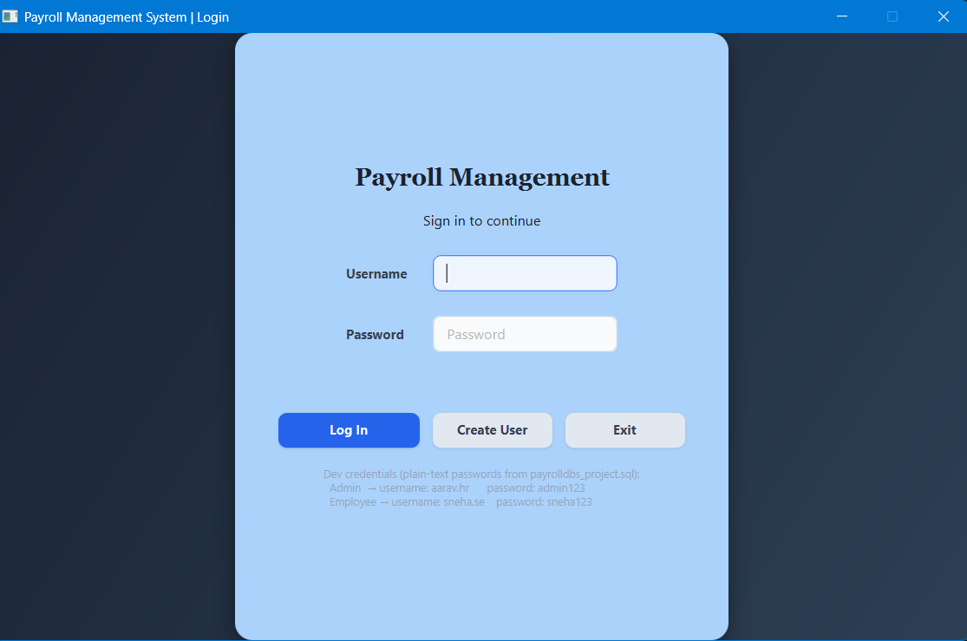Shows the login form with username/password fields, Create User button
6.2HomeScreen(Admin) 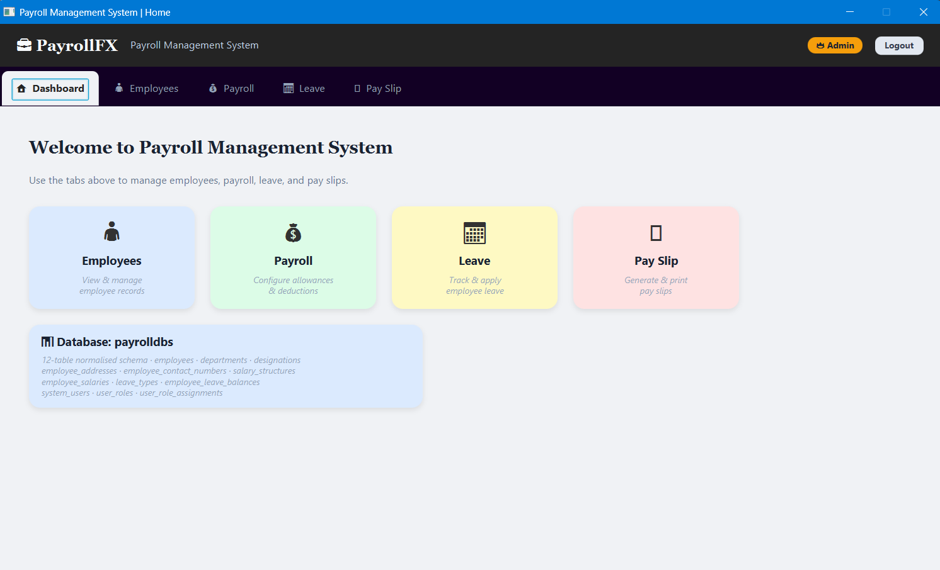
TabPane with four tabs: Employee, Payroll, Leave, Pay Slip. Role badge shows 'Admin' in the header.

6.3 Employee Management
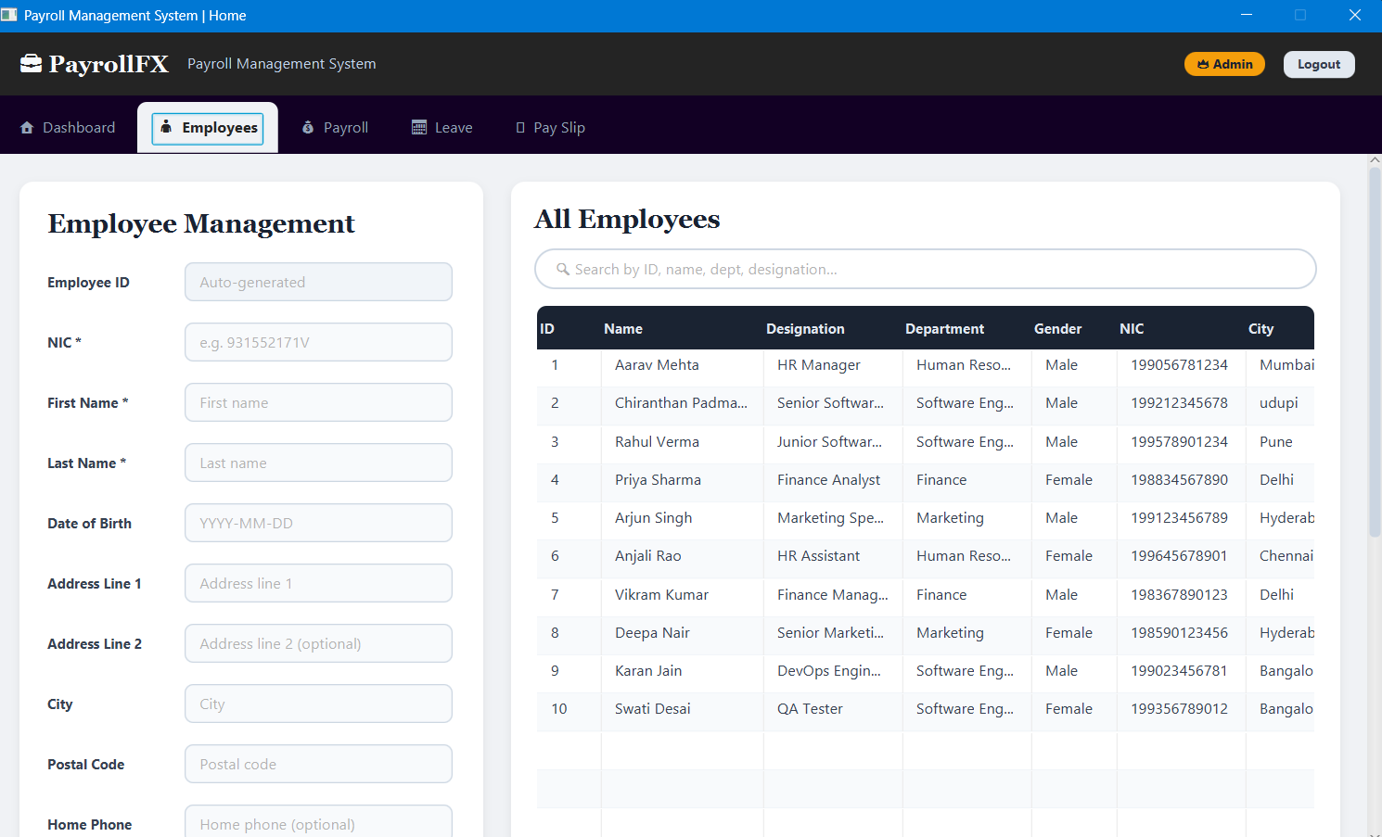
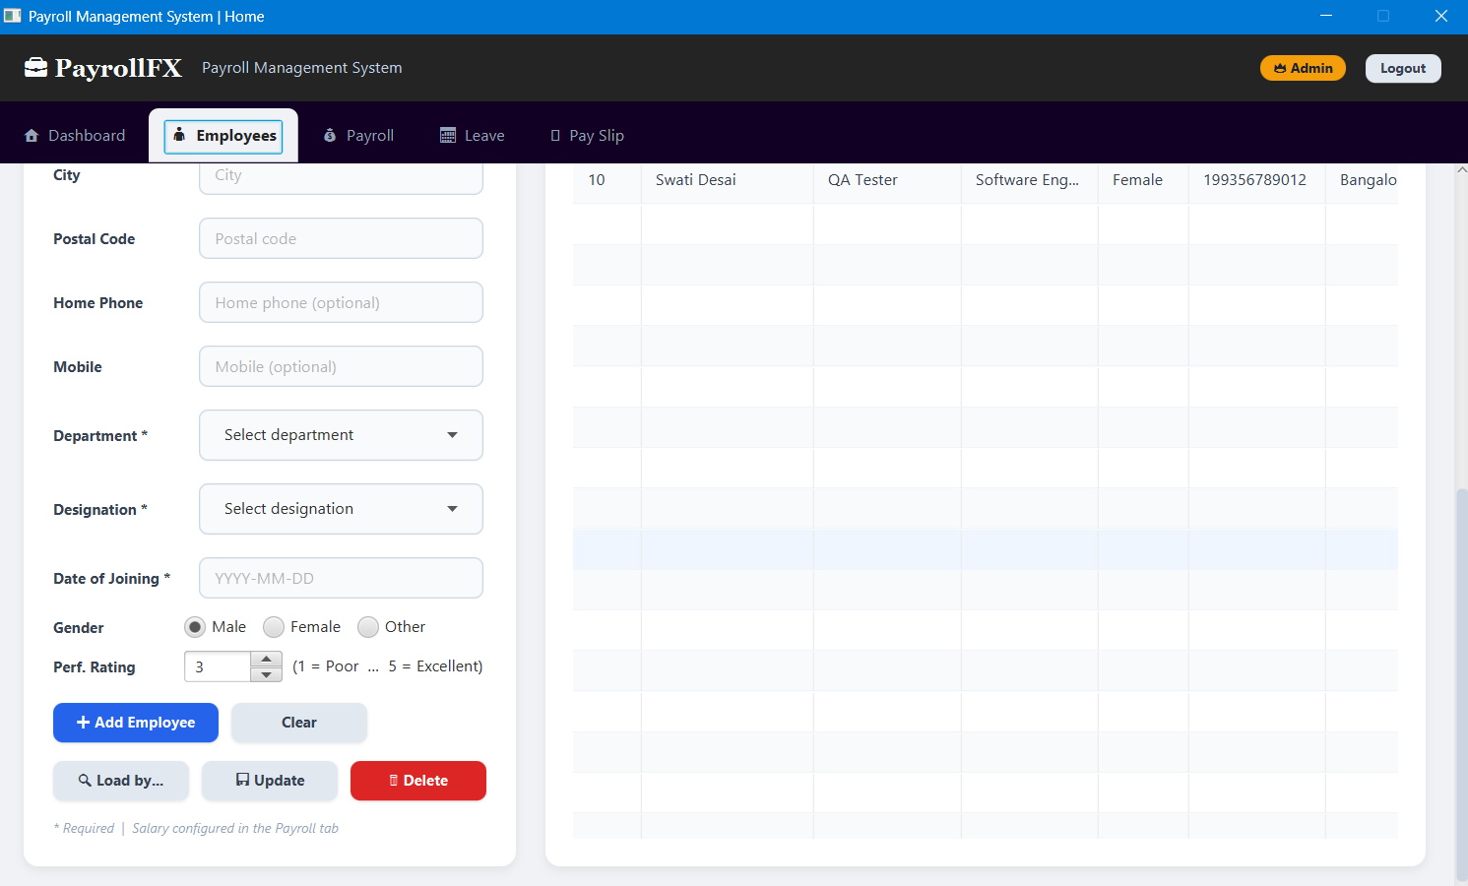Left panel: form with all fields including Performance Rating spinner (1–5) and Gender radio buttons (Male/Female/Other). Right panel: real-time searchable TableView showing all 10 seed employees with Rating column.

6.4 Payroll Management
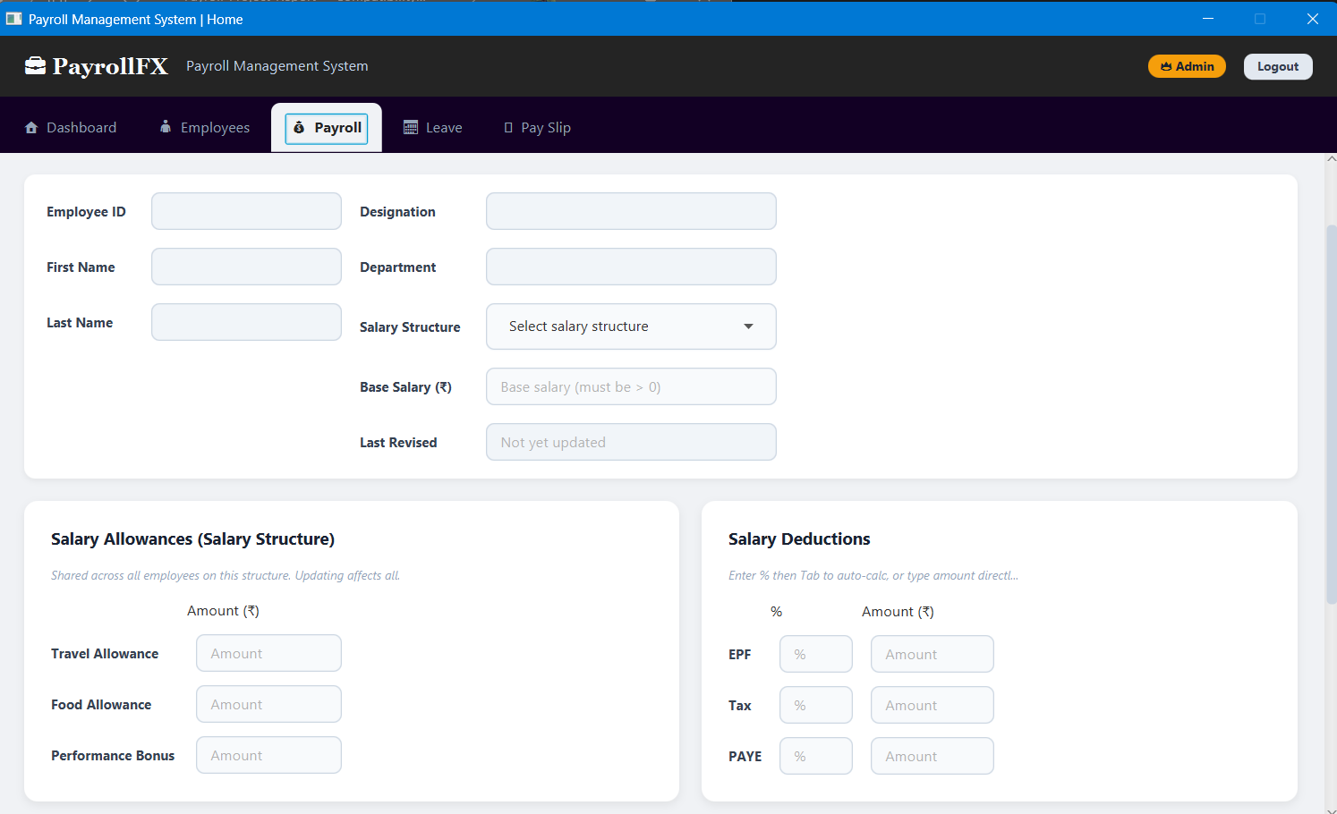
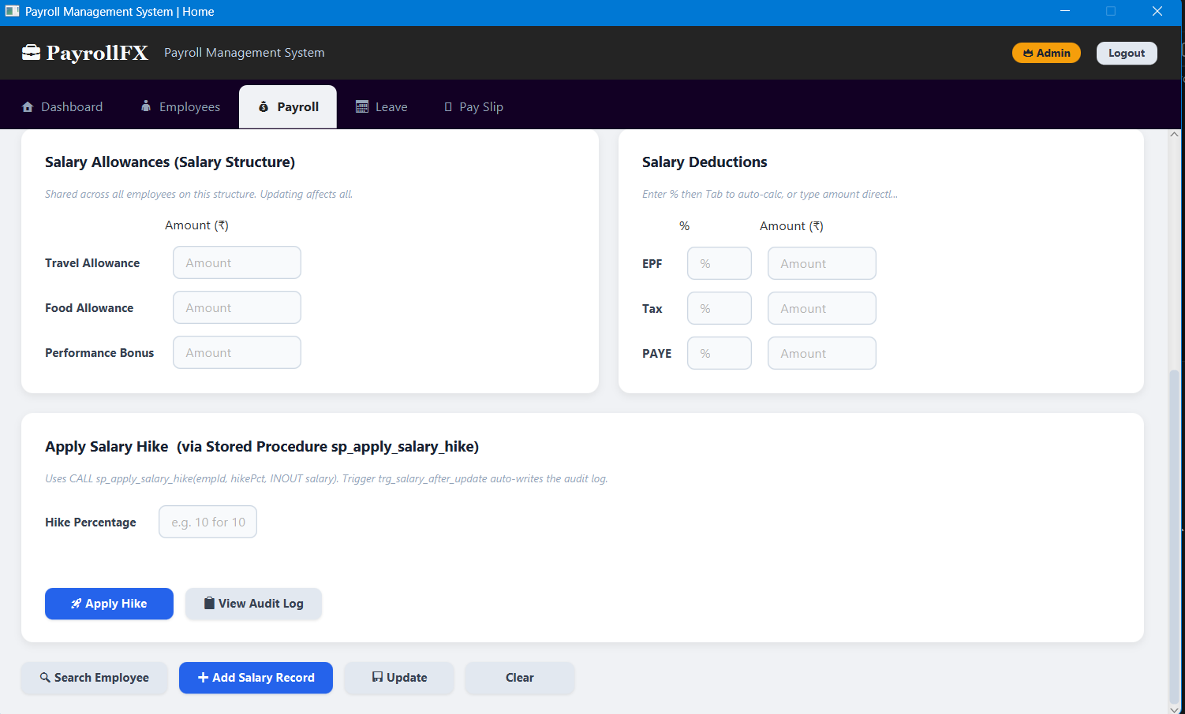Employee info strip showing last_revised_date field. Allowances and deductions panels with percentage auto-calculator. Apply Salary Hike panel calling sp_apply_salary_hike via INOUT parameter. Audit Log viewer.
6.5 Leave Management
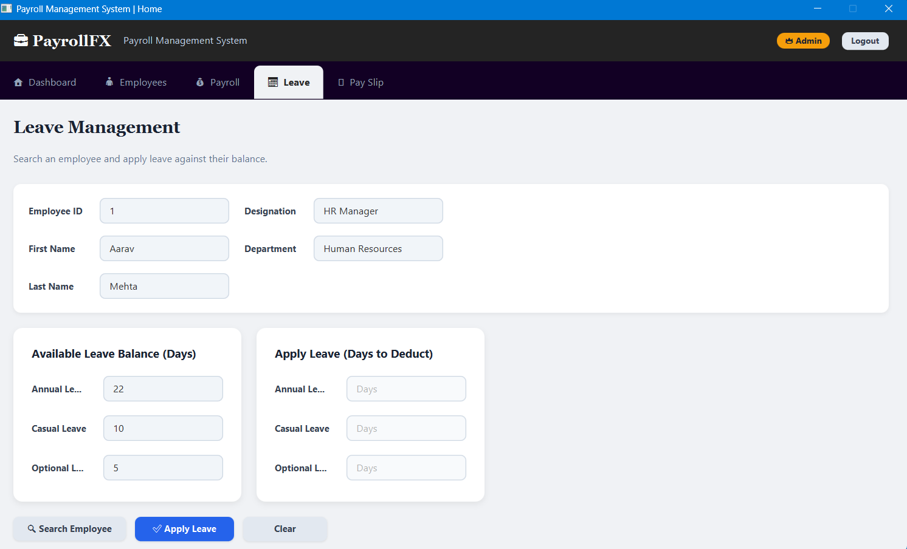Dynamic leave cards built from whatever leave_types exist in the database. Balance display and deduction input per leave type.

6.6 Pay Slip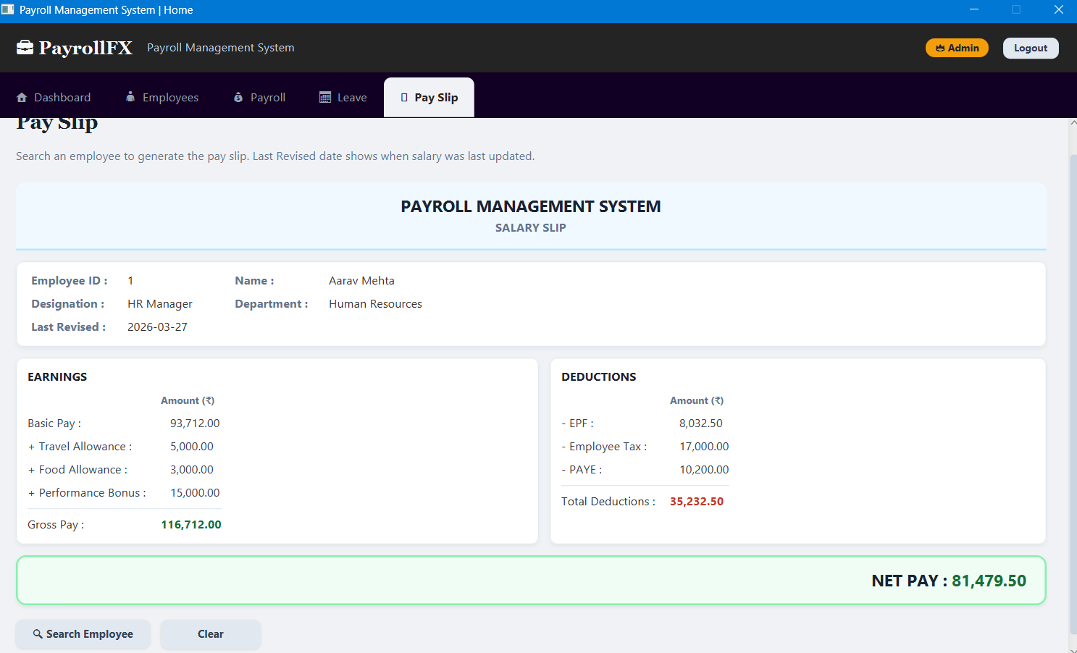Formatted pay slip showing Employee ID, name, designation, department, Last Revised date, earnings breakdown, deductions, and bold NET PAY. Print button.
6.7 Create User Screen
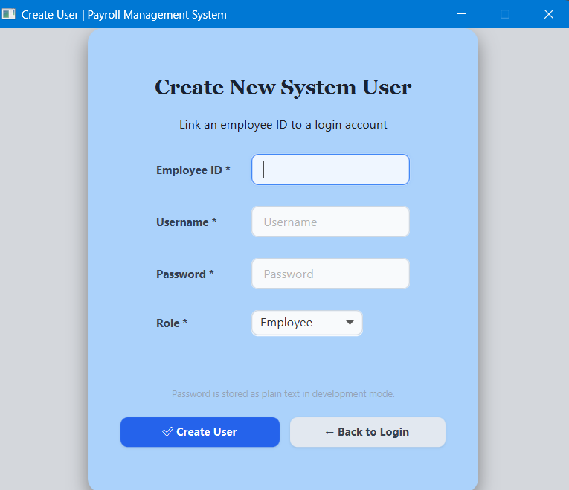
Form with Employee ID, username, password, and role dropdown (Admin/Employee/HR Manager matching DB values exactly).
6.8 Salary Audit Log
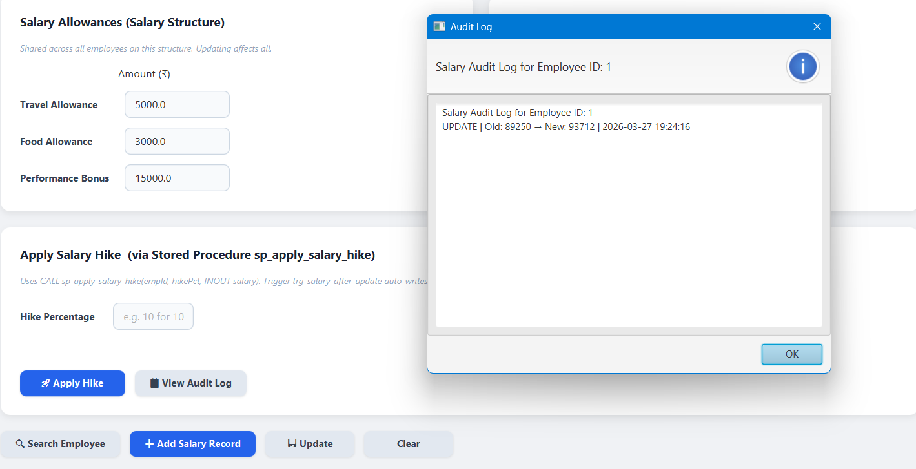Dialog showing payroll_audit_log entries: INSERT on initial salary creation, UPDATE on hike — all written by triggers, never by Java.

6.9 Functions
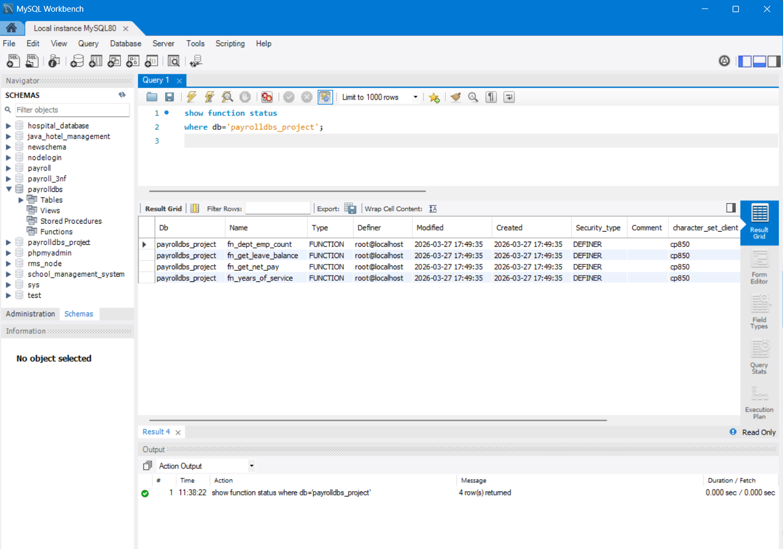
6.10 Triggers
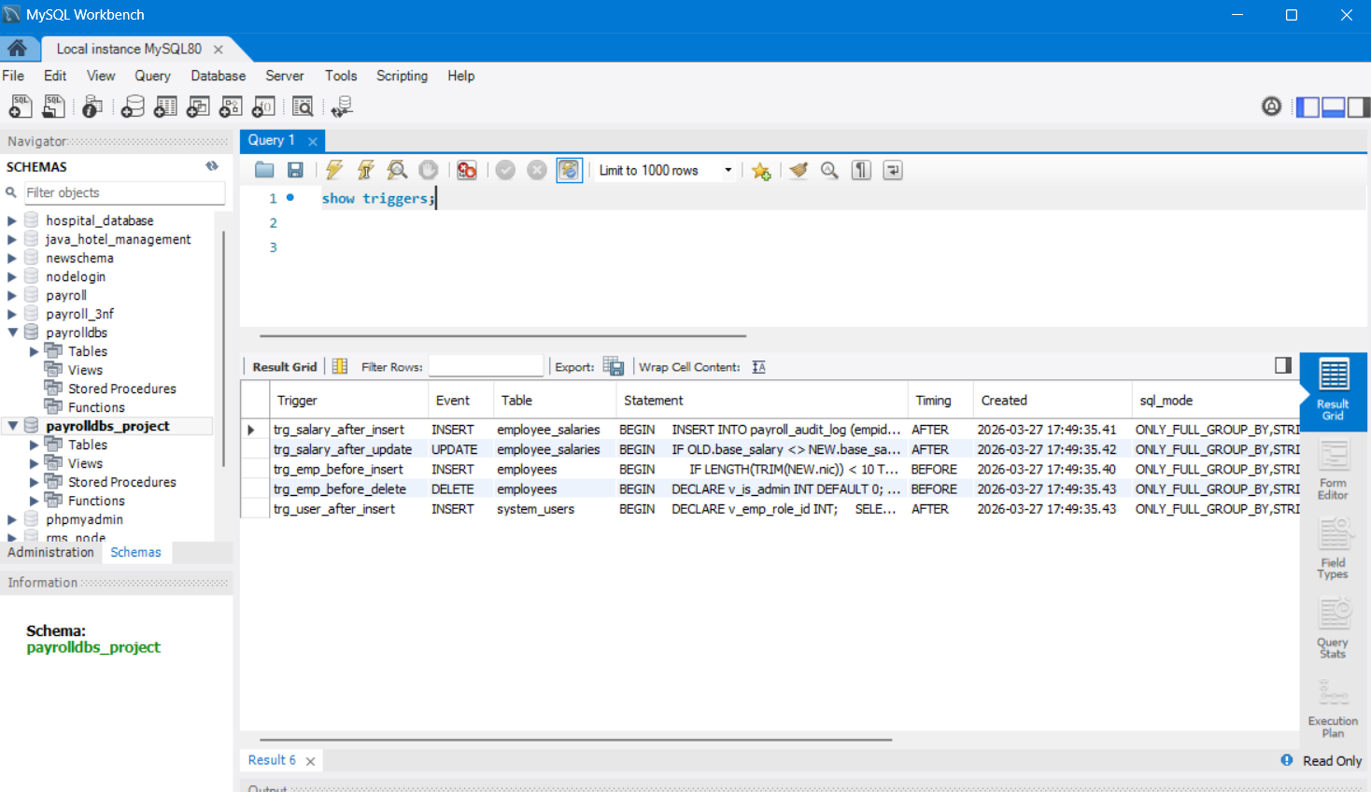

6.11 Procedures
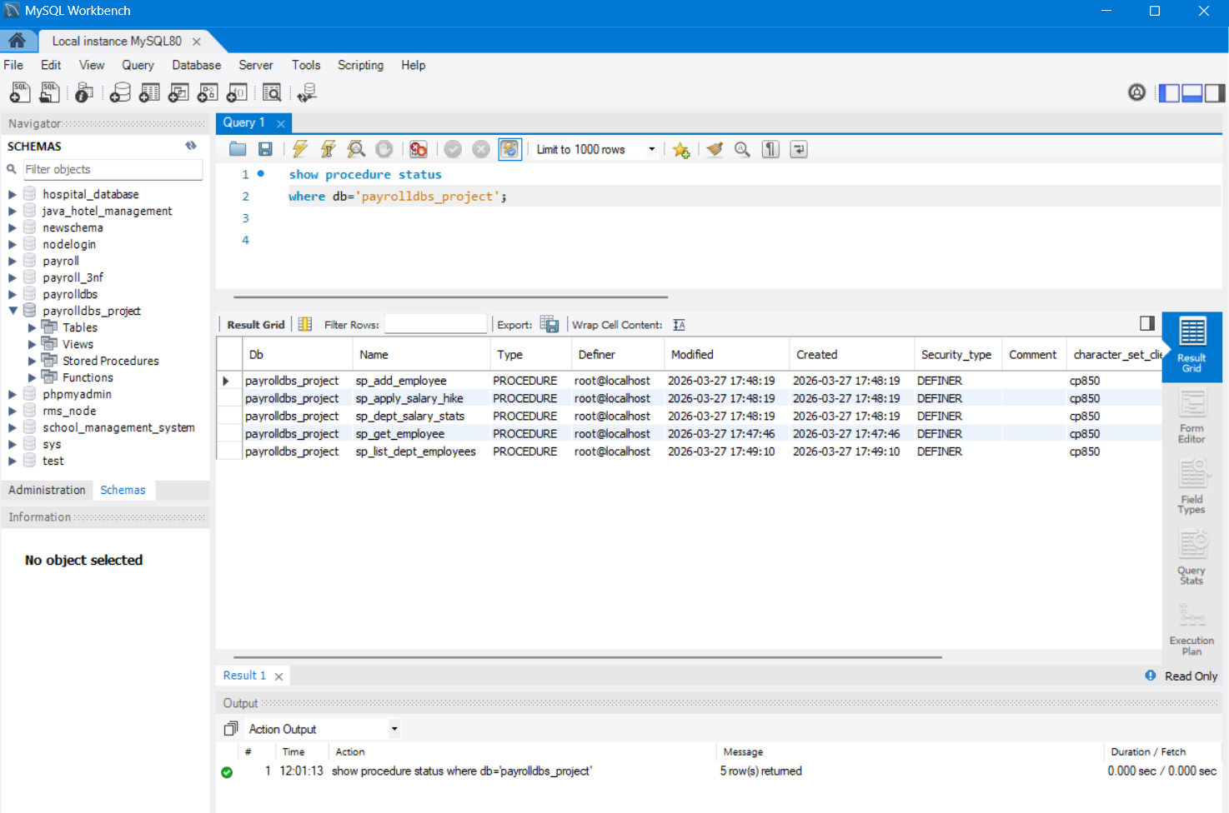
CHAPTER 7: CONCLUSION, LIMITATIONS & FUTURE WORK
7.1 Conclusion
This project successfully demonstrates the design and implementation of a complete, production-quality Payroll Management System using a two-tier JavaFX and MySQL architecture. The system fulfils all stated objectives:
- A thirteen-table relational database schema normalised to Fourth Normal Form (4NF) was designed and implemented. All multi-valued dependencies were identified and resolved through proper table decomposition — phone numbers into employee_contact_numbers and leave balances into employee_leave_balances.
- Five database triggers enforce business rules (NIC validation, Admin delete protection) and automate audit logging (salary change history) entirely at the database level, independent of application code.
- Five stored procedures encapsulate complex multi-step transactions. sp_add_employee wraps five INSERT statements in a single atomic transaction. sp_apply_salary_hike demonstrates the INOUT parameter mode from Lab 9.
- Four user-defined functions (fn_get_net_pay, fn_dept_emp_count, fn_years_of_service, fn_get_leave_balance) provide reusable scalar calculations callable inline in any SELECT query.
- Five database views (vw_employee_full, vw_payslip, vw_leave_summary, vw_user_auth, vw_dept_salary_stats) encapsulate complex multi-table JOINs for reuse by both the Java application and ad-hoc reporting.
- A JavaFX 17 desktop application connects to MySQL via JDBC, using PreparedStatement for parameterised queries, explicit transactions for multi-step operations, and CallableStatement with registerOutParameter for INOUT stored procedure invocation.
- Role-based access control is enforced at both layers: trg_user_after_insert auto-assigns the Employee role; authenticate() detects Admin role via MAX(CASE WHEN) aggregate; HomeView conditionally shows tabs.
The project demonstrates that placing business logic at the correct architectural layer — validation at the UI, API enforcement in Java, and data integrity rules at the database — produces a system that is more reliable and consistent than one where all logic lives in application code alone.
7.2 Current Limitations
Security
- Passwords are stored as plain text in the database for simplicity in this development build. A production deployment must use a strong hashing algorithm such as bcrypt before storing credentials.
- There is no session timeout. Once logged in, the application remains authenticated indefinitely until closed.
- The JDBC connection string includes useSSL=false, which is acceptable only in a local network or development environment.
Salary Calculation
- EPF, Tax, and PAYE are entered as amounts, not computed by the database from statutory rules. A production system should implement the current EPF contribution rates and income tax slabs in a function or procedure.
- DOUBLE is used for monetary columns instead of DECIMAL(10,2). This introduces floating-point precision risks in edge cases. A production payroll system should use DECIMAL.
UI / UX Gaps
- There are no loading indicators during database queries. The UI may appear frozen briefly during slow queries.
- The Payroll tab requires the user to manually enter salary structure amounts. Integration with salary_structures selection should auto-fill allowance fields.
7.3 Future Enhancements
- Password hashing: integrate the jBCrypt library to hash passwords with bcrypt on storage and use BCrypt.checkpw() in User.authenticate().
- Attendance integration: add an attendance table linked to employees; auto-compute present-day salary deductions from absent days.
- Payslip PDF export: use Apache PDFBox or iTextPDF to export the payslip as a PDF file rather than only supporting JavaFX print.
- Email notifications: send payslip PDFs to employee email addresses via JavaMail when salary is finalised.
- Multi-currency support: extend salary_structures with a currency_code column and a currency_rates lookup table for organisations with international staff.
- Reports module: add a new Reports tab with GROUP BY queries and bar charts (using JavaFX Chart API) for department salary distribution, leave utilisation trends, and audit log history.
- RFID / biometric integration: connect to a fingerprint reader API to auto-record attendance, eliminating manual leave applications.
- Cloud database: migrate from a local MySQL instance to AWS RDS or Google Cloud SQL for remote access and automated backups.

CHAPTER 8: REFERENCES
[1] Silberschatz, A., Korth, H. F., and Sudarshan, S. (2019). Database System Concepts, 7th Edition. McGraw-Hill Education.
[2] Ramakrishnan, R. and Gehrke, J. (2003). Database Management Systems, 3rd Edition. McGraw-Hill.
[3] Oracle Corporation. MySQL 8.0 Reference Manual — CREATE TABLE, CREATE TRIGGER, CREATE PROCEDURE, CREATE FUNCTION. Available at: https://dev.mysql.com/doc/refman/8.0/en/
[4] Oracle Corporation. MySQL 8.0 Reference Manual — Stored Routines. Available at: https://dev.mysql.com/doc/refman/8.0/en/stored-routines.html
[5] Oracle Corporation. MySQL 8.0 Reference Manual — Using Triggers. Available at: https://dev.mysql.com/doc/refman/8.0/en/triggers.html
[6] OpenJFX. JavaFX 17 Documentation and API Reference. Available at: https://openjfx.io/javadoc/17/
[7] Oracle Corporation. JDBC 4.2 API Specification. Available at: https://docs.oracle.com/javase/8/docs/technotes/guides/jdbc/
[8] MySQL Connector/J 8.0 Developer Guide. Available at: https://dev.mysql.com/doc/connector-j/8.0/en/
[9] Apache Maven. Maven Project Documentation. Available at: https://maven.apache.org/guides/
[10] Codd, E. F. (1970). A Relational Model of Data for Large Shared Data Banks. Communications of the ACM, 13(6), 377–387.
[11] Date, C. J. (2003). An Introduction to Database Systems, 8th Edition. Addison-Wesley.
[12] Fagin, R. (1977). Multivalued Dependencies and a New Normal Form for Relational Databases. ACM Transactions on Database Systems, 2(3), 262–278.
[13] MIT Manipal. (2025). CSS 2212 — Database Systems Lab Manual. School of Computer Engineering, Manipal Institute of Technology.

