**Name : Yedatkar Mohan Lobhaji Sub : Sem-II**

**Roll No : 271 Practical : 05**

**Aim: Develop and demonstrate a HTML file that includes JavaScript script that uses functions for the following problems:**

**a. Parameter: A string Output: Length of the String**

**b. Parameter: A number Output: The number with its digits in the reverse order**

**Code:**

<!DOCTYPE html>

<html lang="en">

<head>

  <meta charset="UTF-8">

  <title>String Length and Number Reverse</title>

  <style>

    body {

      font-family: Arial, sans-serif;

      margin: 40px;

      background-color: #f4f4f4;

    }

    .container {

      background-color: #fff;

      padding: 30px;

      border-radius: 10px;

      max-width: 500px;

      margin: auto;

      box-shadow: 0 0 10px rgba(0,0,0,0.1);

    }

    h2 {

      text-align: center;

      margin-bottom: 20px;

    }

    .input-group {

      margin-bottom: 20px;

    }

    label {

      display: block;

      margin-bottom: 8px;

      font-weight: bold;

    }

    input[type="text"], input[type="number"] {

      width: 100%;

      padding: 10px;

      border-radius: 5px;

      border: 1px solid #ccc;

    }

    button {

      width: 100%;

      padding: 10px;

      background-color: #4CAF50;

      color: white;

      border: none;

      border-radius: 5px;

      margin-top: 10px;

      font-size: 16px;

      cursor: pointer;

    }

    button:hover {

      background-color: #45a049;

    }

    .result {

      margin-top: 20px;

      font-size: 18px;

      text-align: center;

      color: #333;

    }

  </style>

</head>

<body>

<div class="container">

  <h2>String and Number Operations</h2>

  <div class="input-group">

    <label for="inputString">Enter a String:</label>

    <input type="text" id="inputString">

    <button onclick="getStringLength()">Get String Length</button>

  </div>

  <div class="input-group">

    <label for="inputNumber">Enter a Number:</label>

    <input type="number" id="inputNumber">

    <button onclick="reverseNumber()">Reverse Digits</button>

  </div>

  <div class="result" id="output"></div>

</div>

<script>

// a. Function to find the length of a string

function getStringLength() {

  let str = document.getElementById('inputString').value;

  let length = str.length;

  document.getElementById('output').innerText = `Length of the String: ${length}`;

}

// b. Function to reverse the digits of a number

function reverseNumber() {

  let num = document.getElementById('inputNumber').value;

  let reversed = num.toString().split('').reverse().join('');

  document.getElementById('output').innerText = `Reversed Number: ${reversed}`;

}

</script>

</body>

</html>

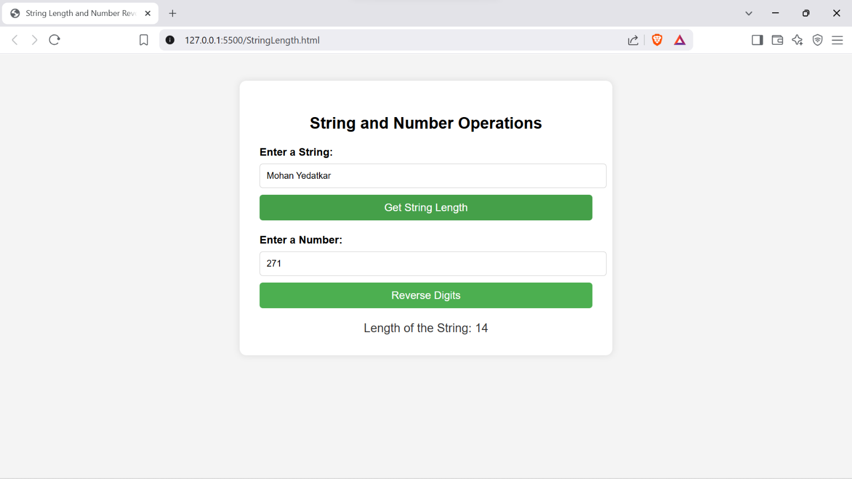**OUTPUT:**

