Coursework 2 – Kahoot Rework

Continuing from the first coursework, we found that there were some flaws when using Kahoot (mobile) in mixed mode education and so I wanted to use the principles from this module to improve upon its mobile experience. Since the mobile app was just web-based, it lacked accessibility features and other functionality to further enrich the user experience while also having no variety in multimodal interactions. This meant that the user was stuck to a touch interface where that might not be ideal while also allowing for accidental taps which is possible due to the time constraint task.

My idea is to avoid using the HCI approach and including social and physical context to Kahoot. My proposed rework would start off with improving visibility in the app by including the question at the top of the screen. Most modern phones are above 6 inches and so using nearly all of it for answering wouldn’t make sense. Also, because newer phones have a taller aspect ratio, only the bottom half of the screen would be the easiest for the user to access anyway. So, I have chosen to move the answering section to the bottom half of the phone.

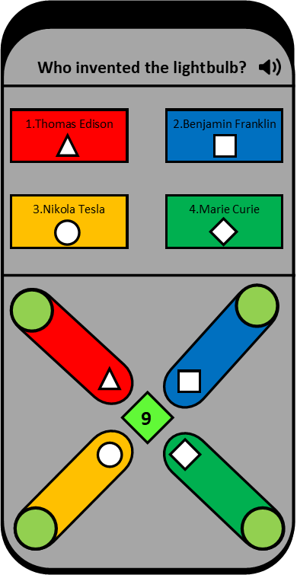

The bottom half of the screen can be used as an input for the question and the top half would contain the question and the answers as seen in figure A. Each answer will also be associated with a colour and a shape which makes it easier for people to associate the correct answer with the correct shape and the answers at the top and the input selection have been separated to ensure prevention of accidental and unwanted inputs as you cannot change your answer once you have selected it.

Figure - Base state of the app

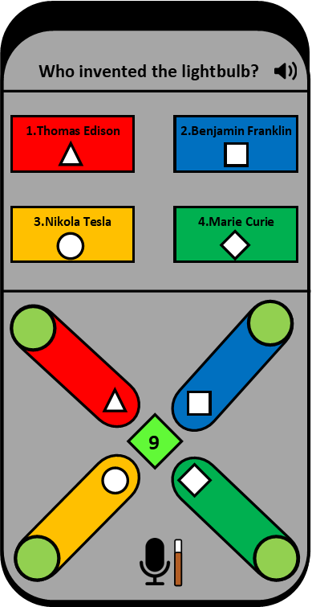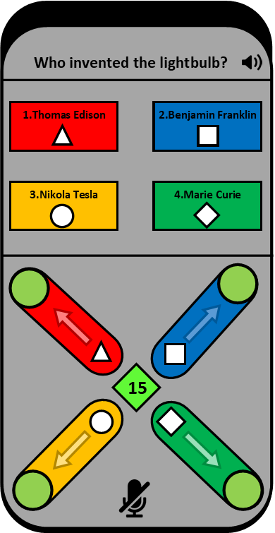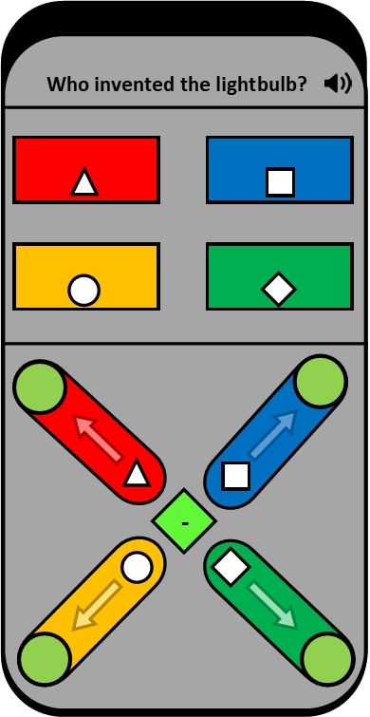

Figure - Starting quiz

Figure - Answers appear synchronised with class

Figure - User has turned on their mic

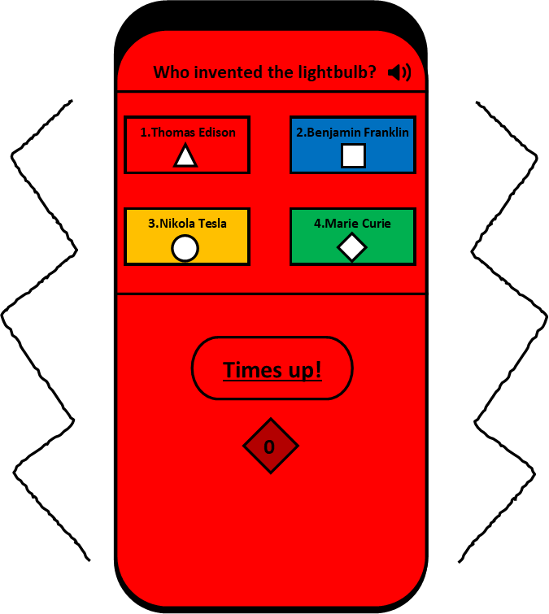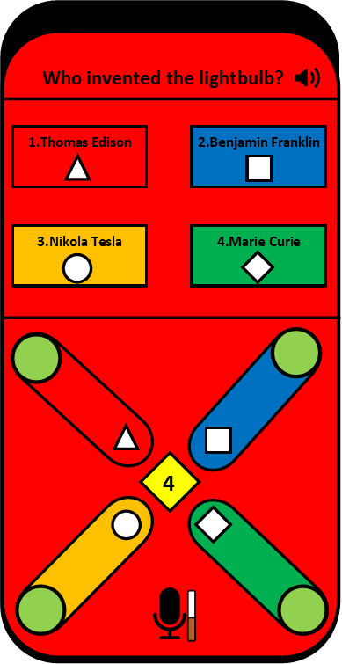

Figure - Timer is low

Figure - Time has run out

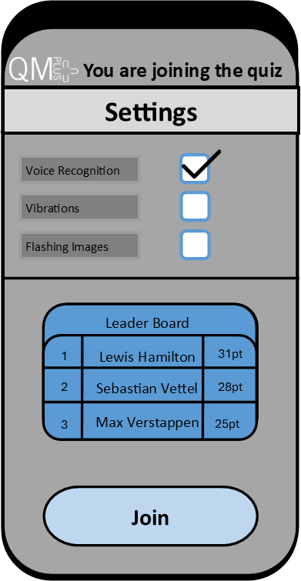

Figure - Pre-Quiz screen

When the user Joins the session, they will be prompted with a pre-quiz screen which includes the settings for the quiz such as voice recognition, vibrations and flashing images. Voice recognition was included as a form of multimodal interactions which can aid people with motor skills disorders or just help people answer the questions quickly, it depends on their situation. Each answer has a representing number which they can say at any point to answer the question. The user’s mic can be muted and unmuted at any point by tapping the icon at the bottom. Since this is used in mixed-mode education, it may not be suitable in class however while at home it would be more suitable. There is also an option to turn vibrations on which will give the user force feedback when they swipe to input the answer. This is part of Normans principles of useability where the system should provide feedback once the user has completed a task otherwise, they would be left confused. Furthermore, adding swipe gestures has also become the norm with mobile devices having less physical input methods and input gestures becoming more popular, including it in the quiz would fit with their natural instincts.

Looking at figure B, the program starts the quiz off by showing the question (like it would with the teacher’s screen) and would show the arrows indicating that the shapes must be dragged to the circles. These arrows will blink to provide emphasis reducing the thought process required by the user to understand the input interface. Once the answers are revealed by the teacher, the answers will also show on the user’s mobile devices implying that they wouldn’t have to look at the screen again especially in mixed mode education. Most users who come in-person would choose to use their phones for Kahoot whereas the users watching online are more likely to use their pc or laptop. This means that the users at home already have an advantage by having the questions and answers on their screens whereas the mobile users do not so by adding the question to the app. Figure D shows the user activating their mic and the app shows that its listening with the bar on the side further emphasising on feedback to the user, so they always know what’s going on. When the timer is getting low, the screen will start blinking between light and dark red (If flashing images were turned on in the settings) and then when the timer has run out, the screen will go red. The user’s ability to input any thing regarding the question has been removed to make it clear that they have run out of time and their phone will also vibrate to emphasise that.

Another feature added to improve affordance is to include an audio symbol next to the question. This allows the user to get a speech synthesiser to read the question out for them for any reason from not understanding the question to difficulties with reading.

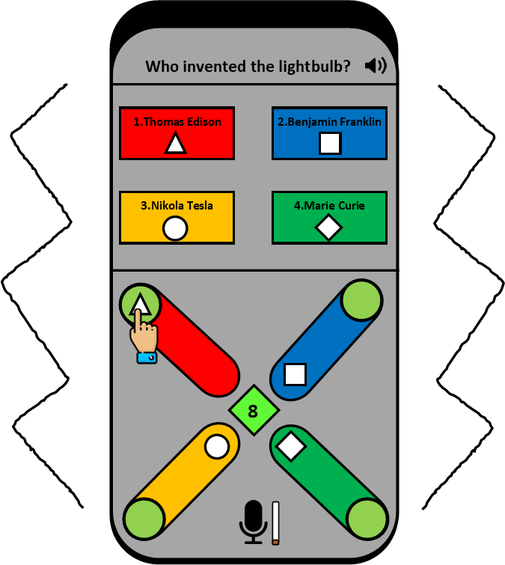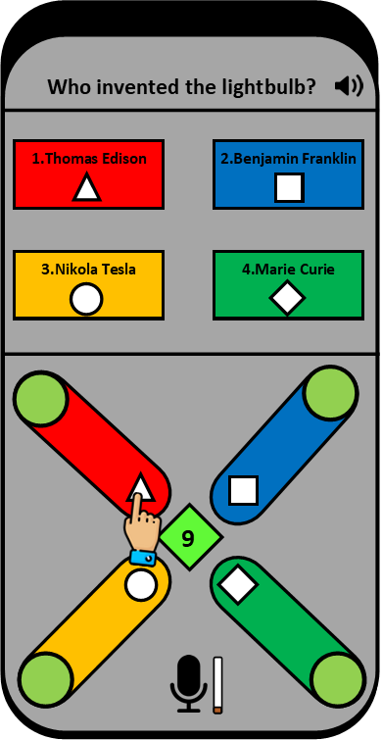

Figure I- User moving the triangle

Figure H- User selecting the triangle

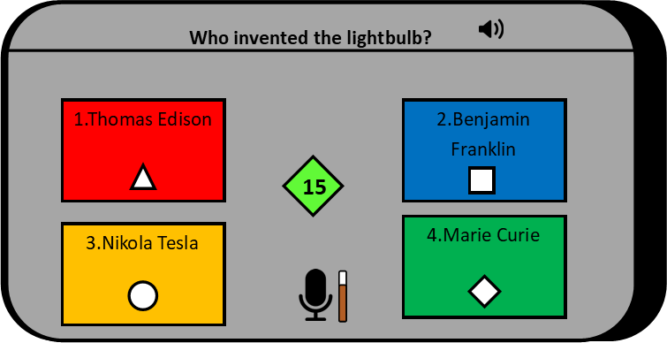

Figure - landscape

The user may also choose to rotate the screen at any point and would realise that if they rotate the screen, they can use larger buttons. In this form, the requirement of sliders is unnecessary since when in landscape, it’s harder for them to accidentally tap the wrong answer and usually the user would be more engaged with their devices but all other features from portrait mode applies here too.

To use this version of Kahoot, they must login with their QMplus accounts which includes a leader board of the top scorers which can be used as a form of motivation.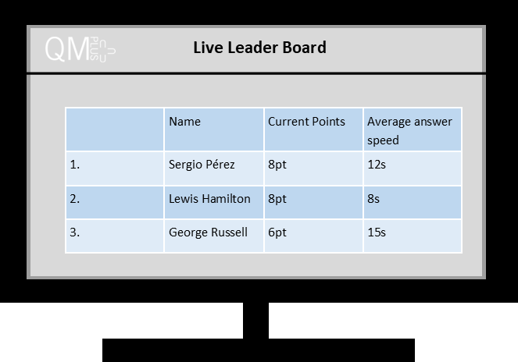

Figure - Live Leader board

The users may choose to have the live leader board up too on their laptops during lectures or on a second device at home to see who’s doing the best and how quickly they are answering the questions.

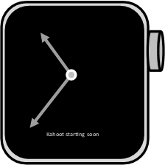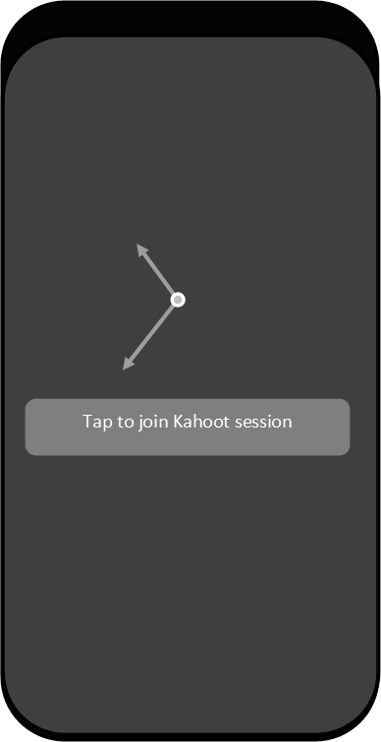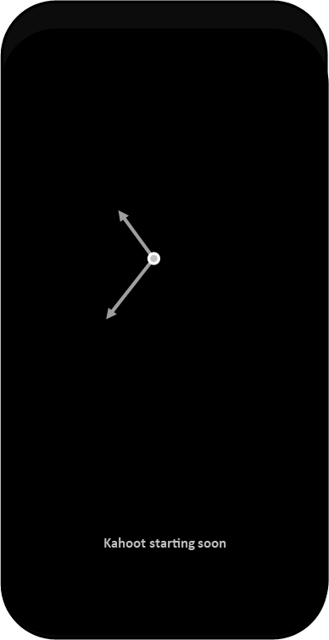Before the users even join the Kahoot session, since this is a Kahoot mobile app, they would now receive push notifications for the Kahoot session, and they can even join the session quickly by tapping on the notification as seen in Figure M which is a natural thought process and would make it quicker for the users to join without the requirement of a code (removing a point of failure).

Figure - Smart watch notification

Figure - Smartphone notification

Figure - Smartphone AOD notification

The only change the laptop and desktop space will see with the improved Kahoot is the option to add key bindings to 4 options (By default they will be the arrow keys) which would allow a more diverse experience with user inputs and allows them to be quicker at answering the questions.

Word count = 1131

Distributed Cognition Analysis

Human cognitive interactions are a linear thought process in which there is one user and one system however this is not the case. It also doesn’t take into consideration social and physical context which can change someone’s decisions for example, my app would be prematurely muted to prevent it from disrupting a lecture if the user is using the Kahoot app in person however this wouldn’t be the same issue for a user using the app at home. All these thought processes that are not seen in HCI can be identified in an ethnographic study which is used to generate qualitative information based on the real user behaviours which could show unexpected user behaviours and outcomes. Distributed cognition is the idea that computation and memory can be offloaded from the user to other systems which reduces the load on the user and improves user experience.

Unit of analysis of the Kahoot Rework (Second stage of DCA)

* User
* Mobile phone
* Screen
* Vibration motors
* Microphone
* Speakers
* Laptop /Desktop
* Teacher
* Teacher’s Display
* Smart watch

We can now identify the cognitive elements (Third stage of DCA) that make up the Kahoot system which allows for the offloading of computation and memory which includes internal and external memory representations as well as information channels and flows.

Internal memory representations include:

* Remembering the question
* Understanding and figuring out the answer to the question (pre-existing knowledge)
* Checking if internal answer matches once of the options
* Check which options belong to which colour and/or shape
* Decision to choose an option
* Understanding the importance of the settings page
* Checking if they have enough time to answer the question
* Checking if they joined the Kahoot in time (May miss question)
* Understanding who’s on the top of the leader board
* Knowing how many points they need to get to the top

External memory representations include:

* Mobile Screen to show the question and answers
* Calculating average answer speeds and showing them on a table
* Checking if input answer is correct
* Reading out question when user presses button (Voice synthesis)
* Voice recognition to take the user voice input as data
* Timer displayed
* Notify the user when Kahoot sessions are near
* Play audio when notification is received
* Show questions on lecturer’s screen



Figure - Information flow diagram [Information = I , Cognitive = C , Motor = M , Auditory = A and Visual = V]

The above information flow diagram clearly shows multiple systems working together with multiple users which include the teacher to give the instructions to start the Kahoot which shows an improvement over the HCI model. We are converting conceptual tasks into perceptual tasks which would in theory, remove some computation from the user. However, the number of inputs the user receives might be excessive for the task at hand compared to a HCI model which wouldn’t be interactive.

From the previous coursework we found out that user had an issue with the question being missing with the mobile version of Kahoot which would reduce visibility for the users forcing them to look at the question and answers more than once which takes time resulting in reduced scores. This model fixes this issue as all the questions and answers are on the mobile device and can theoretically be used independently from the lecture. This wouldn’t constitute to a security risk since their Plus is required to use this service in the first place.

Some problems with the reworked model include the extra step of selecting an answer which will take additional time for each user at the benefit of not accidentally selecting the wrong answer. The user will also be able to change their answer if they slide the shape back and not commit to the answer however this could be seen as a fault since the quiz is time based and rewarded based on the time taken to answer the said question. In figure M we can see that there many instances of information going to the user which could cause overload which could make the extra display for the leader board seem redundant as it causes the user to lose focus on the quiz. Another issue is still fundamentally the same principle as before where colours and shapes are associated with an answer however there most definitely a better solution to avoid the colour and shape system to reduce the workload on the user.

This rework can further be improved with better integration into QMplus which could give lecturers and module organisers a better understanding of where the students are currently since they wouldn’t have revised for a Kahoot quiz in the first place. Also, further integration would allow users to check past Kahoot quizzes and see where they went wrong so they can learn from their mistakes and offload their memory to the system which they can reference in the future.

Word count = 833