806-960MHz定向板状天线
806-960MHz Directional Panel Antenna
AMXP-8090V-D15L120
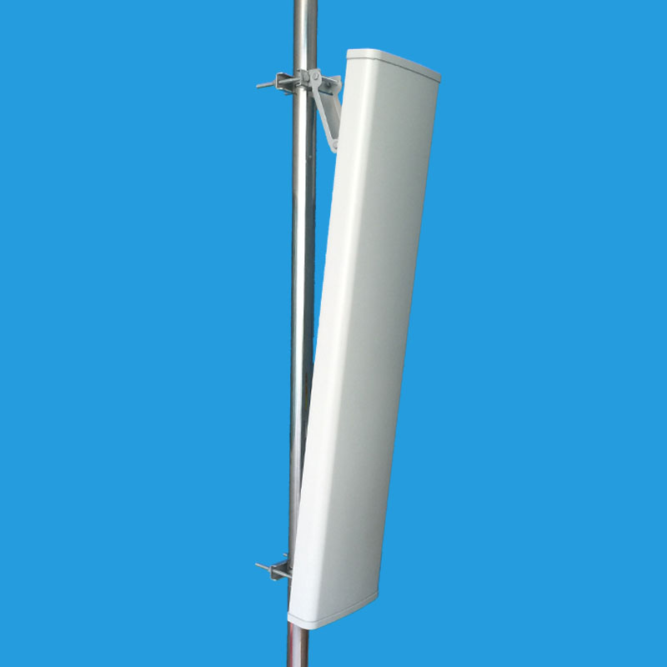
特点Feature：
● 高增益 High gain
● 全天候工作 Full day working
● 优化的尺寸Optimized dimension
● 双极化Dual polarization
应用Application：
● CDMA,GSM系统 CDMA,GSM system
● 无线通信和数据传输系统
Wireless communication and data transmission system

AMXP-8090V-D15L120
电气参数 Electrical Specifications
频率范围 Frequency range（MHz） | 806～960
极化方式 Polarization | 垂直Vertical
增益 Gain（dBi） | 15
半功率波瓣宽度Half-power beam width（°） | H:120 V:7
前后比Front-to-back ratio（dB） | ≥18
输入阻抗Input Impedance（Ω） | 50
电压驻波比 VSWR | ≤1.5
上第一副瓣抑制Sidelobe suppression for first sidelobe above horizon | 15 dB
最大功率Maximum input power（W） | 400
雷电保护Lightning protection | 直流接地DC Ground
机械参数Mechanical Specifications
接头类型Input connector type | N母头 N Female
天线尺寸Dimensions-mm (Height/Width/Depth) | 2430*280*125
包装尺寸Packing size-mm | 2480*320*210
天线重量Antenna weight （kg） | 15
天线罩材料Radome material | UPVC
天线罩颜色Radome color | 灰色Gray
机械可调倾角Mechanical tilt（°） | 0～10
工作温度Operating temperature（°c） | -40～60
极限风速Rated Wind Velocity（m/s） | 60
抱杆直径Mounting hardware（mm） | ￠35～￠90

测试报告，驻波图Testing Report、VSWR Curve

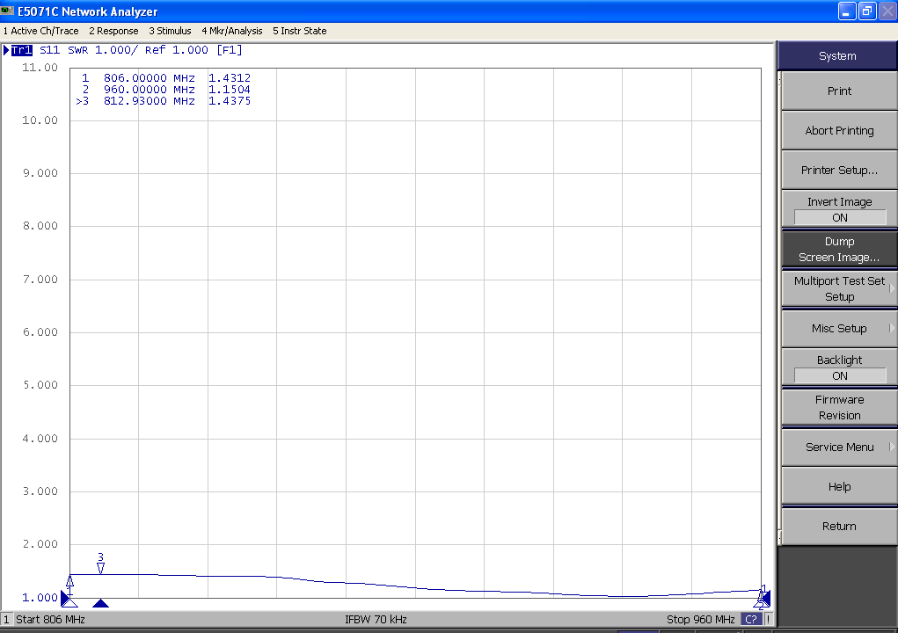

天线安装使用说明书
Antenna Installation Instructions
一、安装示意图Install as the pictures below
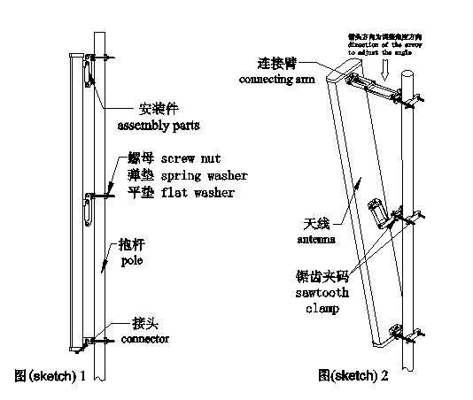
二、安装说明Installation Steps
如图所示：按以下步骤把天线架设在抱杆上，注意调节好天线的倾斜角度，拧紧连接螺丝、螺母。
Please following the steps below: place the antenna on the pole, and adjust the inclination of the antenna, then fasten the screw to the screw nut. The final structure is just like the pictures above.
1、把天线上下端锯齿夹码上的螺母、弹垫及平垫拧下，拿下外边的锯齿夹码，将天线有接头的一端朝下，用锯齿夹码抱在外径为￠35～￠90mm的抱杆上，再把拿下的锯齿夹码穿过M10的螺杆，放上平垫、弹垫，然后拧紧螺母。Unscrew and take the screw nuts, the spring washer and flat washer of the sawtooth clamps on the upper and lower sides of the antenna down,then remove the outer sawtooth clamp.Put the end of the antenna with connectors downwards.Then attach the sawtooth clamps to the pole whose outer diameter is ￠35~￠90mm ,and place the M10 screws through the sawtooth clamps.Lastly, put on the flat washer and spring washer and screw the nuts tightly afterwards.
2、取下天线接头护盖，连接天线接头，并注意把天线的接头连接端密封好。Take down the connector cover of the antenna,connect the antenna connectors and make sure that you have sealed the connections well.
- 松开连接两支撑架之间的螺栓，适当地调节天线的倾斜角度，使其接收到的信号为最好，然后拧紧所有螺母。Loosen the bolts that connect the two struts and adjust the inclination of the antenna to the proper position to receive the best signal. At last screw all the nuts tightly.

