Planning Document: 'QuickStock' Retail Management System
Group Name: Group 2
Case Study Company: PrimeTech Electronics Ghana
Group Members
Semenu Leticia 10310307
Naa Amerley Adom Laura 10309724
Amihere Leticia 10309581
Chima Kennedy Elorm 10306819
Lawson Laud Willian 10306832

1. System Requirements Document
A. Problem Statement
Many small to medium-sized retail businesses in Ghana, like PrimeTech Electronics Ghana, rely on manual record-keeping in notebooks or simple spreadsheets. This leads to problems such as difficulty in tracking real-time product quantities, frequent errors in sales calculations and receipts, time-consuming generation of daily sales reports, and poor customer data management. These inefficiencies result in stock-outs, overstocking, financial miscalculations and losses, and an inability to understand customer purchasing patterns.

B. Objectives. The "QuickStock" system aims to:
1.Automate Sales Transactions: Provide a quick and error-free way to process customer sales and generate receipts.
2.Maintain Accurate Inventory: Track product quantities in real-time, automatically updating stock levels after each sale.
3.Improve Data Management: Securely store and manage product and sales transaction records.
4.Generate Basic Reports: Allow the owner to view key metrics like daily sales total and low-stock items.
5.Enhance User Experience: Offer an intuitive, easy-to-learn GUI for staff with minimal technical skills.

C. Functional Requirements. The system shall:
1. Manage Products:
a. Add new products (Product name, Category, Price, Quantity in Stock).
b. View a list of all available products.
c. Update product details (e.g., price, quantity).
2. Process Sales:
a. Select products for a sale from a list.
b. Specify quantities for each product.
c. Automatically calculate the total cost of the sale.
d. Generate and display a simple on-screen receipt.
3. Manage Inventory:
a. Automatically deduct sold quantities from the product's stock level.
b. Display a warning when a product is low in stock or out of stock.
4. View Data:
a. View all sales transactions (Sale ID, Date, Products, Total Amount).
b. View a list of all customers.

D. Non-Functional Requirements
1.Usability: The GUI shall be simple, intuitive, and require minimal training. All actions should be achievable within 3 clicks.
2.Performance: The application should start up in under 5 seconds and respond to user actions (like adding a product to a sale) instantly.
3.Reliability: The system should be robust, with no data loss during normal operation. Basic error handling (e.g., for invalid number inputs) will be implemented.
4.Portability: The application will be developed in Java, ensuring it runs on any operating system (Windows, macOS, Linux) with a JVM installed.

2. User Requirements Document
A. System Users
1. Sales Staff (Primary User): Responsible for processing sales, generating receipts, and checking product availability. They have access only to the sales and product viewing modules.
2. Store Manager / Admin (Secondary User): Has full system access, including adding/editing products, viewing all sales records, and seeing reports.

B. User Needs and Expectations
Sales Staff Needs:
-I need to quickly find a product and add it to a sale.
-The system must calculate the total automatically so I don't make mistakes.
Store Manager Needs:
-I need to easily update product prices and stock quantities.
-I want to see how much we sold at the end of the day.
-I need to know which products are running low so I can reorder.

C. Use Case Diagram
Sales staff | QuickStock System
View products | Process sales
Process sales | Generate receipts
View product list

Store Manager
Manage products
View sales report
View all sales

3. System Design
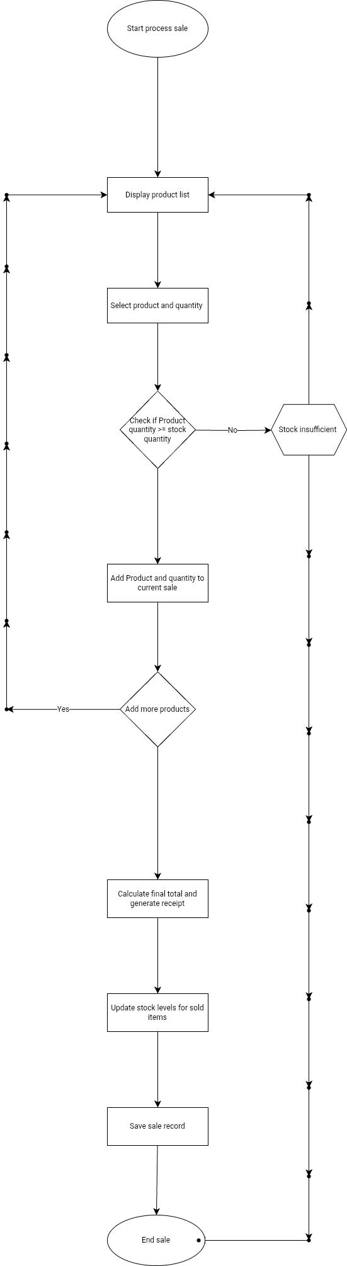
Flowchart for "Process Sale" Use Case

4. Technical Implementation
1. GUI Framework: Java Swing (JFrame, JPanel, JButton, JTextField, JTable, JLabel).
2. Event Handling: ActionListener for buttons (e.g., "Add to Sale", "Checkout", "Add Product").
3. Data Storage: ArrayList<Product>, ArrayList<Sale> for in-memory storage.
4. Data Validation and error handling: Check for number format in price/quantity fields, ensure stock is not exceeded.
5. OOP Principles:
-Encapsulation: All class fields are private with public getters/setters.
-Inheritance: We could create a User superclass later if we add login functionality with different roles.

This document provides a clear and actionable plan for developing our Retail Management System.

